CPE 1150

Lab Number: 3

Series

AC

Circuit

Analysis

Team member:

Bruce Liu

3/1/2022 – 3/6/2022

Conclusion:

I have learned that the measurement on an oscilloscope can be measured from probe 1 to probe 2. I know that the oscilloscope can add and do other math options with 2 and likely more waveforms. I have learned that the oscilloscope can be configured to measure from a ground state.

No instructions for multisim. So not included. Not enough time. To R&D it.

note: Could the instructions be a little less clustered?

Initial element measurements:

|  |  |  |
| --- | --- | --- |
| Element name | Theoretical value | Measured value |
| Resistor 620Ω | 620Ω | 615Ω |
| 15 mH inductor | 15 mH | 13.77 mH |
| 33 nF capacitor | 33 nF | 31.8 nF |

differential mode capacitor measurement:

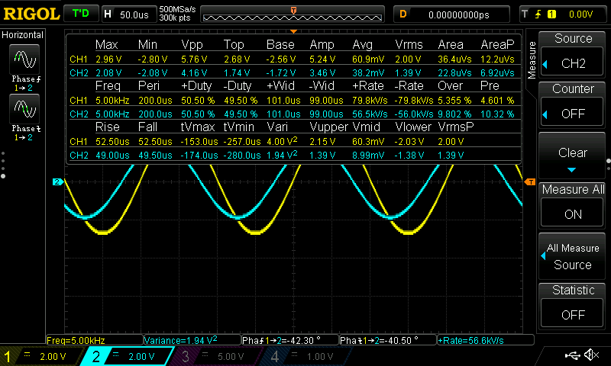

capacitor measurement second probe inverted: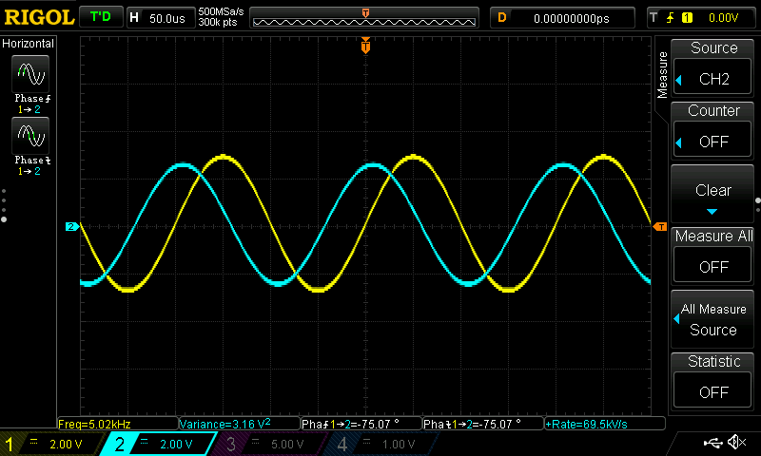

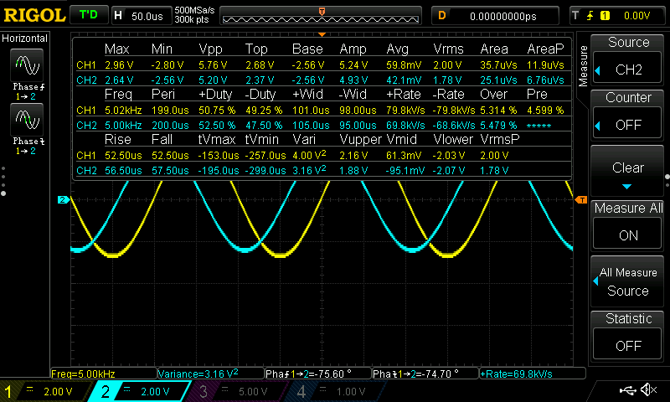

table 3:

|  |
| --- |
| V­c1 |
| 2.56<-75­o V |

Grounded component mode(resistor):

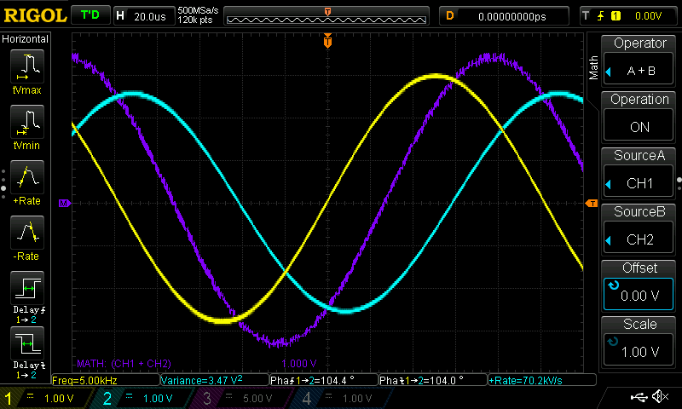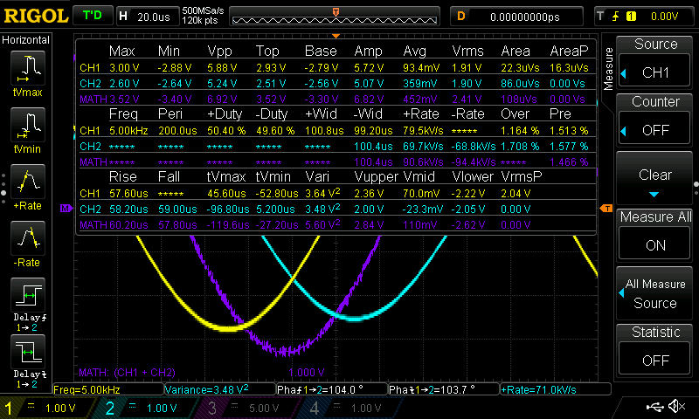

Grounded component mode(capacitor):

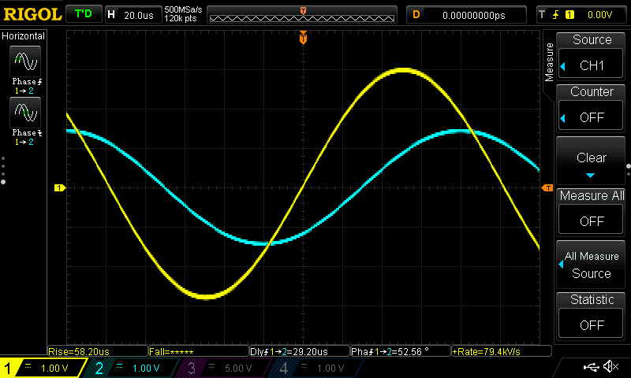

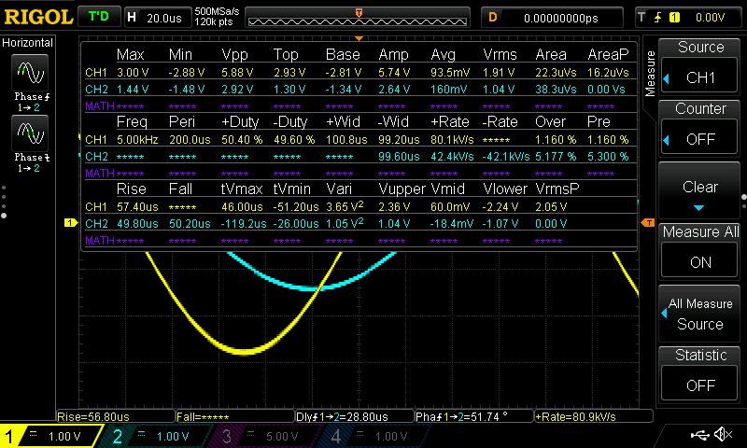

Grounded component mode(inductor):

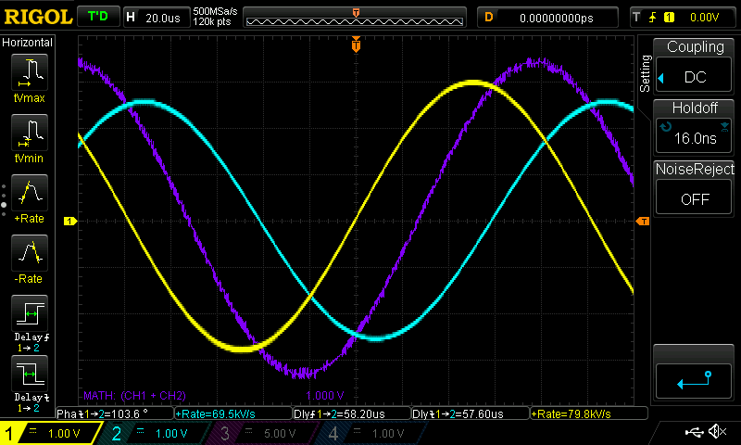

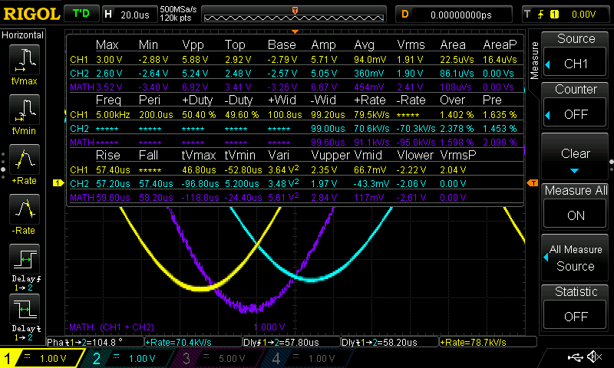

table 4:

|  |  |  |
| --- | --- | --- |
| Vr1 | Vc1 | VL2 |
| 2.60<104.8oV | 1.44<51.74oV | 3.36<131.8oV |

Pre-Lab:

The circuit of study is a series RLC.

Table 1: expected impedances

|  |  |  |
| --- | --- | --- |
| X­­­c1 | X­­­­L1 | Z­­ ­total |
| -964.4575 JΩ | 471.238 JΩ | 620 -493.2195j |

X­c1­ = = = 964.4575Ω

X­L1­ =2π f L =2π * 5000*15*10­-3 = 471.238Ω

Z­ total ­= X­c1 + X­L1­ + R­1 ­ = -964.4575j + 471.238j + 620 = 620 -493.2195j = 792.253<-38.5­o

Table 2: Voltage divider: expected voltage drop per R, L, C element

|  |  |  |
| --- | --- | --- |
| V­ ­­R1 | V ­C1 | V ­L1 |
| 3.91<38.502o | 6.086<-51.49o | 2.974<128.5o |

V ­R1­ = = = 3.91<38.502o

V ­C1 ­= = = 6.086<-51.49o

V ­ ­­L1 ­= = = 2.974<128.5o