CPE 1150

Lab Number: 5

Series

Parallel

Circuit Analysis

Team member:

Bruce Liu

3/27/2022

Lab results, conclusion:

The values in multsim seem doubled. I need to verify peak to peak vs peak voltage. The lab to prelab the phase is off. I wonder if the reverse setting is on or something. It is verified that a resonance circuit neutralized the phase in multisim.

|  |  |  |  |
| --- | --- | --- | --- |
| Prelab | IT | IR1 | IL1 |
|  | 4.127mA<71.371 | 2.694mA<121.68 | 3.201mA<31.680 |
| Lab | ITotal­ | IR1 | IR3 |
|  | 7.6mA<114.3 | 2.142mA<72.9 | $$3.400mA<138.10$$ |
| multisim | 12.688mA<0.802 | 5.2804mA<0 | 4.766 mA<1.575 |

Initial measurements:

|  |  |  |  |  |  |
| --- | --- | --- | --- | --- | --- |
| Label | C1 | L1 | R1 | R3 | Z ­­total |
| Ideal values | 33nF | 15mH | 560 | 10 | 726.769  <-71.371 |
| Measured values | 32.5nF | 13.66mH | 561 | 10.0 | 738.698  <-73.711 |

Z total measured:

XC1 = = = -979.415j

XL1 =

RR1||xL1 =

Z total = RR1||xL1 + C1 = 738.698<-73.711

Z totals:

|  |  |
| --- | --- |
| Z total current: | Z total inductor measurement: |
| 741.565<-72.969 | 744.928<-73.717 |

Z total current:

Z total current = Z total + R3 =738.698<-73.711 + 10.0 = 741.565<-72.969

Z total inductor measurement:

RR1||xL1+R3 =

Z total inductor measurement= RR1||(xL1+R1) + C1 = 744.928<-73.717

Table 3:

|  |  |
| --- | --- |
| VR3 | ITotal­ |
| 76mV<114.3 | 7.6mA<114.3 |

IR3 = =7.6<114.3

table 4 :

|  |  |
| --- | --- |
| VR1 | VR3 |
| 1.20<72.90 | 34mV<138.1 |
| IR1 | IR3 |
| 2.142mA<72.9 | $$3.400mA<138.10$$ |

IR1 = ==2.142mA<72.9

IR3 = =

R1 measurement:

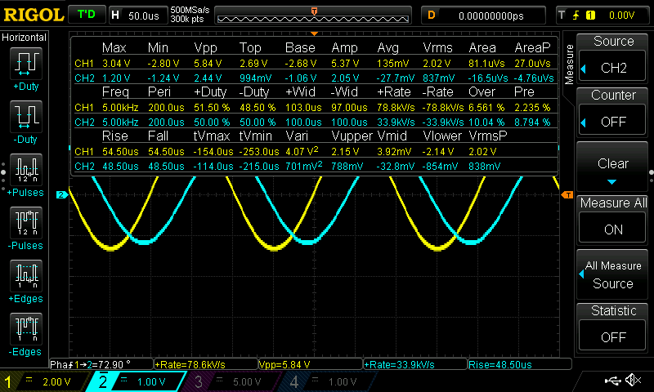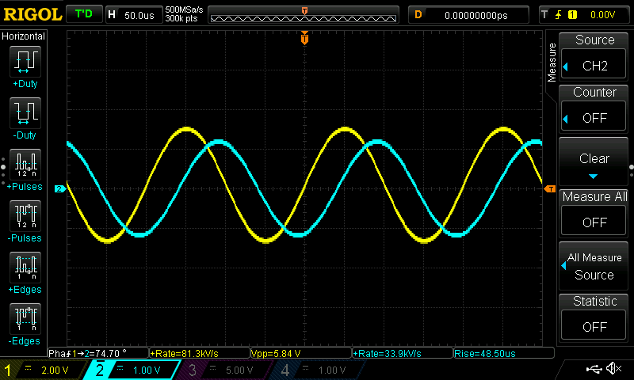

R3 measurement: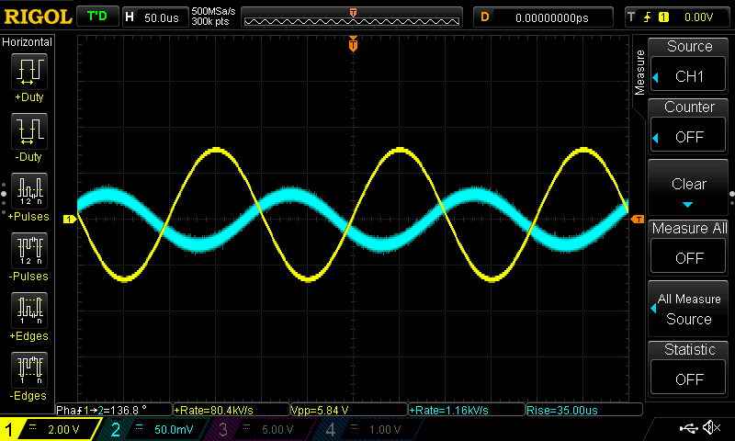

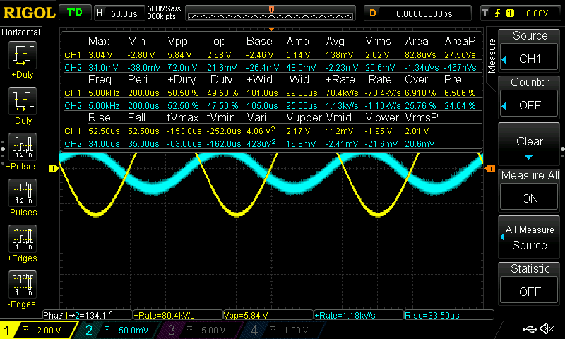

multisim:

Table 3:

|  |  |
| --- | --- |
| VR2 | ITotal­ |
| 126.884mV<0.802 | 12.688mA<0.802 |

ω =2πf

ω = 2π(5000)

θ = ω t

θ = 2π (5000)(25.538*10­-6)

θ = 0.802

IR2 = = 12.688mA<0.802

total current measurement:

table 4 :

|  |  |
| --- | --- |
| VR1 | VR3 |
| 2.957V<0 | 47.668mV<1.575 |
| IR1 | IR3 |
| 5.2804mA | 4.766 mA<1.575 |

560 resistor current measurement:

angle is in snyc no need for phase angle caluculation

IR1 = ==5.2804mA

current measurement inductor:

ω =2πf

ω = 2π(5000)

θ = ω t

θ = 2π (5000)(50.154*10­-6)

θ = 1.575

IR3 = = 4.766 mA<1.575

|  |  |  |
| --- | --- | --- |
| IT | IR1 | IL1 |
|  |  | 4.766 mA<1.575 |

Pre-lab:

|  |  |  |  |  |
| --- | --- | --- | --- | --- |
| R1 | Xc1 | XL1 | Zp | Zt |
| 560 | $$-964.575j$$ | 471.238j | 365.563  <49.919 | 726.769  <-71.371 |

$$X_{C1}= \frac{-j}{2πfC}= \frac{-j}{2π(5000)(33*{10}^{-9})}= -964.575j$$

$$x_{L1}=2πfL=2π\left(5000\right)\left(15*{10}^{-3}\right)=471.238j$$

Zp =

Zt = Zp + C1 = ( = 726.769<-71.371

|  |  |  |
| --- | --- | --- |
| IT | IR1 | IL1 |
| 4.127mA<71.371 | 2.694mA<121.68 | 3.201mA<31.680 |

I target =

IR1 =<71.731 = 2.694mA<121.68

IL1 =<71.731 = 3.201mA<31.680