CPE 1150

Lab Number: 6

Thevenin,

Norton

and

Maximum

Power Transfer

Team member:

Bruce Liu

3/27/2022

|  |  |
| --- | --- |
| Material list | |
| Component name | count |
| RCL multimeter | 1 |
| Function generator | 1 |
| oscilloscope | 1 |
| Breadboard | 3 |
| 10Ω resistor 5% tolerance 1/2Watt max power | 1 |
| 100 Ω resistor 5% tolerance 1/2Watt max power | 3 |
| 470 Ω resistor 5% tolerance 1/2Watt max power | 1 |
| 510 Ω resistor 5% tolerance 1/2Watt max power | 1 |
| 560 Ω resistor 5% tolerance 1/2Watt max power | 1 |
| 1000 Ω resistor 5% tolerance 1/2Watt max power | 2 |
| 33 nF capacitor | 2 |
| 15 mh inductor | 1 |
| Coax to coax cable | 1 |
|  |  |

Lab

element measurements

|  |  |  |
| --- | --- | --- |
| Element name | Expected values | Measured value |
| 10Ω | 10 Ω | 10.1 Ω |
| 100 Ω | 100 Ω | 99 Ω |
| 100 Ω | 100 Ω | 99 Ω |
| 510 Ω | 510 Ω | 505 Ω |
| 470 Ω | 470 Ω | 467 Ω |
| 1000 Ω | 1000 Ω | 986 Ω |
| 1000 Ω | 1000 Ω | 988 Ω |
| 560 Ω | 560 Ω | 554 Ω |
| 33nf | 33nf | 34.1 |
| 33nf | 33nf | 34.6 |
| 33nf | 33nf | 34.2 not used |
| 33nf | 33 | 34.7 not used |
| 15mh | 15mh | 13.45 |

input voltage

|  |  |  |
| --- | --- | --- |
| Input voltage Vp | 5.04V | 5000 hz |
| Waveform generator input Vpp | 5.756V | 5000 hz |

Process:

All electronic elements where measured. With the LCR multimeter. This device was chosen regardless of is lower sigfig measurement abilities due to the ability to measure the inductor the lab multimeter didn’t have the ability to measure the 15 mH inductor. Which seems to be the only component that wasn’t binned for near exact values. A piece of paper with writing on it
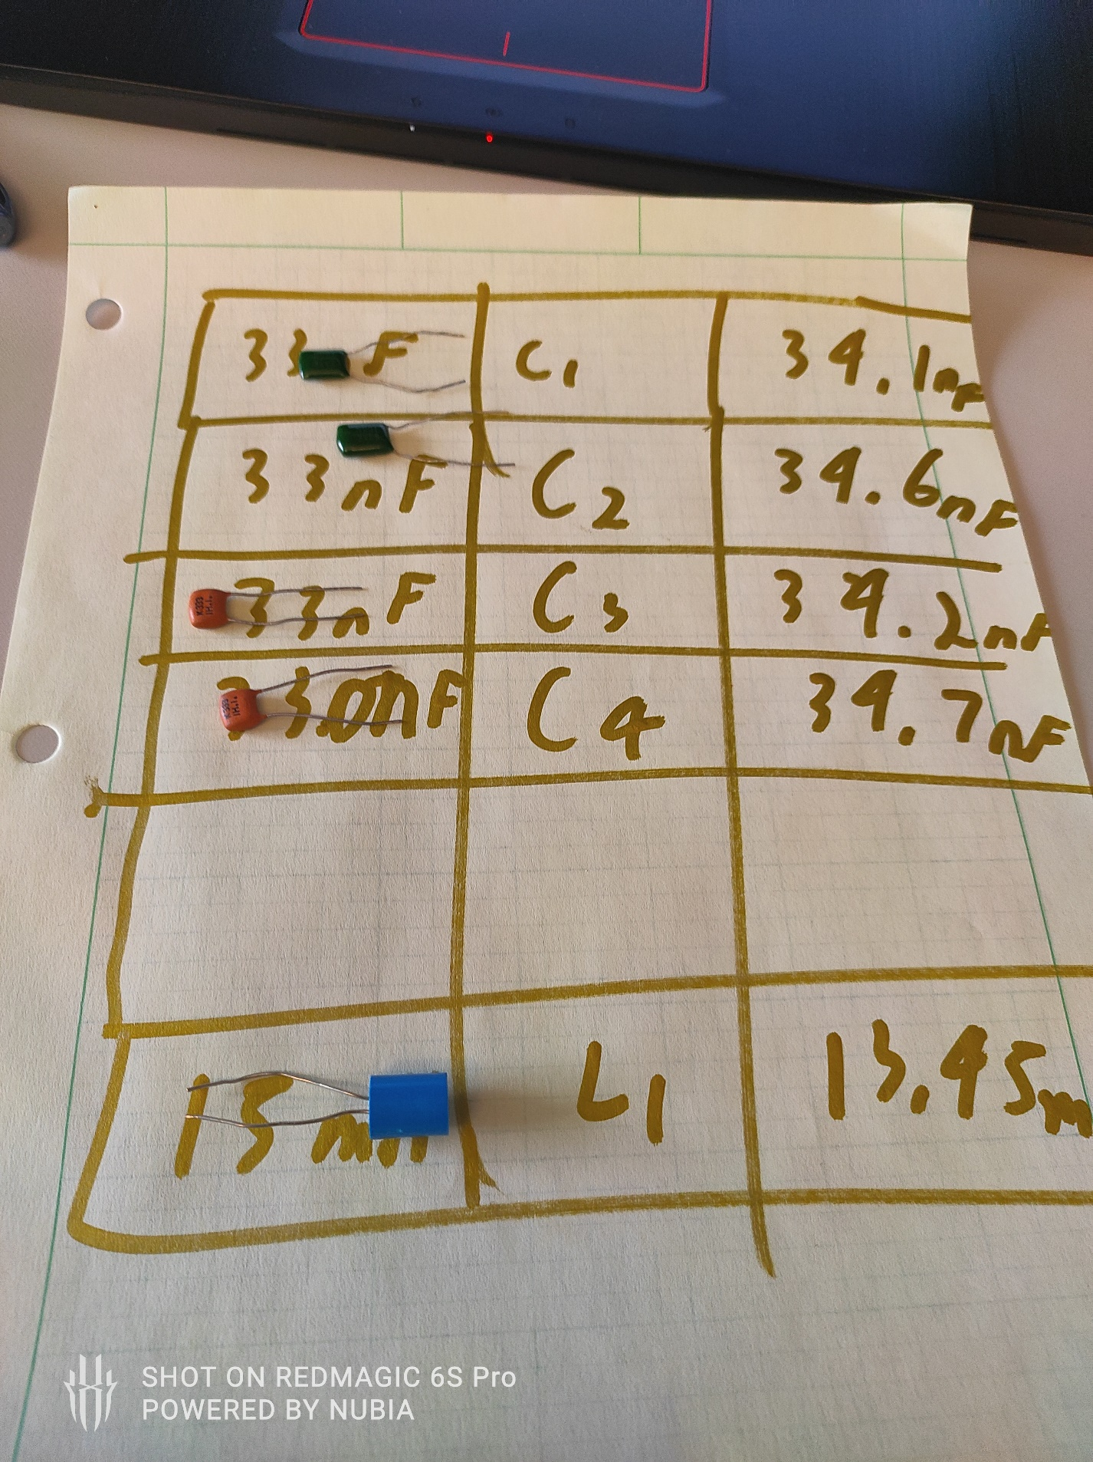

Since this lab has slightly higher number of components than other labs this semester a sheet of paper with boxes was used to track the electronic elements. An indented plastic housing with number rollers would have been better since the electronic elements rolled around the paper.

The coax-to-coax cable was used to connect the function generator to the oscilloscope for initial voltage measurements. It was noticed that the probe scaler was required to be changed to 1X for this setup to return accurate values.

This inspired a rundown of all settings. I found that the inverse setting was still on from an older lab. On the second probe port. This suggests the oscilloscope was meant for single user. I wonder if there is a default settings button.

Prelab:

A)

R2 is disconnected without the load. L1 and R3 are also removed when calculation of the Thevenin equivalent.

The remaining are Re, R1,and C1 are in series.

Zth = 50+510 + = 1.115kΩ<-59.862o

Table 1:

|  |
| --- |
| Zth |
| 1.115kΩ<-59.862o |
| 559.82-964.27j |

B)

rms conversion

Vrms = √2 *Vp

Vrms = 4.2426 V

Table 2:

|  |
| --- |
| Eth rms |
| 3.6720<-30.138o |

C)

XC= = -964.58j

R1+Re ||XC ||R2 =

1

_______________________ = Zn =83.3<-49.5

+

|  |
| --- |
| Zn |
| 84.5<-50.0 |
| 84.197-7.4063j |

table 3:

|  |
| --- |
|  |
|  |

D)

560-964.58j = Zth

√ 5602+((15*10-3*5000j)+964.58j)2=1322.1j = RL

table 4:

|  |
| --- |
| RL |
| 1.3221j |