CPE 1150

Lab Number: 8

Title:

Filter

Circuits

Team member:

Bruce Liu

4/17/2022 – 4/19/2022

Conclusion:

The Low pass filer circuit didn’t work as predicted. I another source of contamination could be the internal resistance of the inductor. In retrospect, voltage divider with measured resistance values gave me a result closer to what was measured. At the predicted cutoff frequency. Unfortunately, my inductor has a higher internal resistance compared to the college provided inductor.

$$V_{out}=\frac{\frac{R_{circuit resistor}}{R_{circuit resistor}+R_{inductor internal resistance}}V_{in}}{\sqrt{2}}$$

$$V_{out}=\frac{\frac{500}{500+62.8}*3.04}{\sqrt{2}}$$

$$V_{out calculated}=1.9097 V$$

$$V_{out measured}= 1.80 V$$

The high pass filter circuit cut off voltage was also at 1.80V. A capacitor has no internal resistance. Since it a break in the circuit by design. My capacitor is also near ideal.

It seems in the real world that the cutoff voltage is lower than the intend √2. The error in the inductor can be justified. But not the capacitor. I wonder what would happen in a low pass capacitor and a high pass inductor. An adventure for another time perhaps.

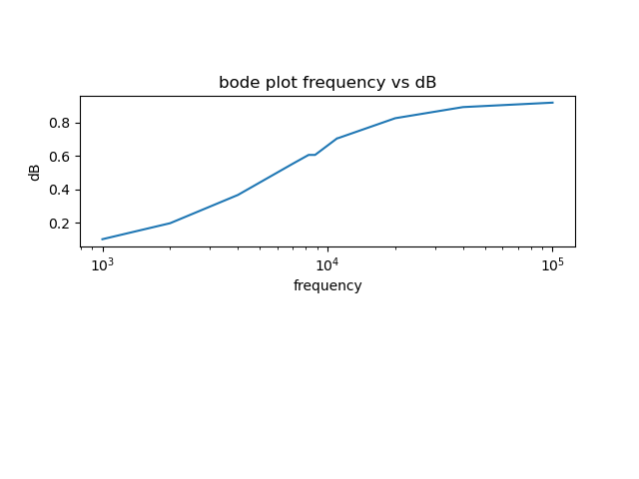

Materials:

Text:

*Electric Circuits 11th Edition:* Charles L Phillip; John M Parr; Eve A Riskin: 2019

inductor data sheet

SDS1000X&Xplus_UserManual_UM0101X-E02A

FY6800 Series User’s Manual V1.1

Hardware:

Silgent sds 1104x-e oscilloscope

Feel Elec FY6800 function generator

bread board MB -106

digital BM4070 LCR tester

smartphone

Cables:

bnc to mini-grabber cables

oscilloscope probes x2

jumper cables

Electronic elements:

510 resistor 5% tolerance

15 mH inductor 5% tolerance // data sheet is included

33 nF capacitor

Software:

python

mathplotlib.py

anaconda

Atom text editor

PowerShell

EasyscopeX

Multisim

DDS signal PC software

Process:

lab calculations

I wondered if python could plot a bode plot. Upon doing some research I found that it did. So, Vin and Vout will be arrays and computed to pushed to an Av array. Then will be plotted in 2 plots one with Db as y axis and one with phase angle as y axis.

Atom text editor is used to write python code in this case. Anaconda is used to update and to run python. When installed to path PowerShell can be used with anaconda commands.

Prelab calculations:

BM4070 LCR tester was used to measure the electronic elements for their impedance values. Calculations were done for both ideal value and measured values. The internal resistance ideal value was obtained from the data sheet. Equations were derived from $R=2πfL$. Since the rectangular case where the angle is 45o is when the (impedance real) = (impedance imaginary).

Lab

lab setup:

The frequency and adjustments were made on the Feel Elec FY6800 function generator with DDS signal PC software. Also, with the dial on the device for the tuned measurements. That was included on a disk when the function generator was purchased. Oscilloscope photos were obtained via EasyscopeX screen capture and named while saving.

The Feel Elec FY6800 function generator and the Silgent SDS 1104x-e oscilloscope are connected to the desktop PC with USB type B to A cables.

The values were recorded to the lab report from viewing the photos. Photos of the circuit board were taken and lab bench.

Multisim simulations:

Since my ideal inductor resistance is higher than the one in the lab, I will use my values instead.

Discussions:

Decisions:

I have chosen to plot on python rather than plot on paper. I did this considering human error. Since the plot is exponential the risk of error is greater.

I have chosen to do the transfer function for this lab. Even though, we were not instructed to do so. Since a lot of the lab would lose it’s meaning if I didn’t

I chose to use my home lab for this lab since I anticipated it would take more time. Also, my inductor has a lower base tolerance of 5%. fortunate for me Because I can measure the inductor with my LCR meter. My inductor is nearly ideal. Unfortunately, my resistor isn’t as binned as the lab resistors. Also, EasyscopeX allows for me to name my oscilloscope pictures as I save them so I wouldn’t lose track of my data.

I found that my oscilloscope can do a bode plot if time allows, I shall experiment with that. Doesn’t do what I want it to do yet. more experimentation required.

initial measurements

|  |  |  |  |
| --- | --- | --- | --- |
| Ordering code | element name | expected values | measured values |
| B82144B1156J000 | 15 mH inductor | 15 mH | 15.14 mH |
| B82144B1156J000 | 15 mH inductor internal resistance | 75 Ω | 62.8 Ω |
|  | 510 Ω resistor | 510Ω | 500 Ω |
|  | 33nF capacitor | 33 nF | 32.1 nF |

Lab:

Low Pass:

|  |  |  |  |  |
| --- | --- | --- | --- | --- |
| Frequency (kHz) | V(in) | V(out) | Av(dB) | Phase(degrees) |
| 0.1 | 3.04 | 2.48 | 0.827 | 0.76 |
| 0.5 | 3.04 | 2.48 | 0.827 | 1.32 |
| 1 | 3.04 | 2.44 | 0.813 | 9.44 |
| 2 | 3.04 | 2.36 | 0.787 | 18.15 |
| 3.81 (tuned low) | 3.04 | 2.12 | 0.707 | 32.27 |
| 3.9 (tuned high) | 3.04 | 2.12 | 0.707 | 32.74 |
| 5.9163 (measured) | 3.04 | 1.80 | 0.6 | 44.28 |
| 6.207(ideal) | 3.04 | 1.76 | 0.586 | 45.63 |
| 10 | 3.04 | 1.36 | 0.453 | 60.95 |
| 20 | 3.04 | 0.84 | 0.279 | 73.53 |
| 50 | 3.04 | 0.40 | 0.133 | 91.62 |

High Pass:

|  |  |  |  |  |
| --- | --- | --- | --- | --- |
| Frequency (kHz) | V(in) | V(out) | Av(dB) | Phase(degrees) |
| 1 | 3.0 | 0.304 | 0.1013 | -83.91 |
| 2 | 3.0 | 0.592 | 0.1973 | -78.69 |
| 4 | 3.0 | 1.10 | 0.3667 | -68.28 |
| 7 | 3.0 | 1.66 | 0.5533 | -55.57 |
| 8.2442 (ideal) | 3.0 | 1.82 | 0.6067 | -51.13 |
| 8.8097 (measured) | 3.0 | 1.82 | 0.6067 | -51.01 |
| 11.05(Tuned low) | 3.0 | 2.12 | 0.7067 | -42.66 |
| 11.12(Tuned high) | 3.0 | 2.12 | 0.7067 | -42.55 |
| 20 | 3.0 | 2.48 | 0.8266 | -27.16 |
| 40 | 3.0 | 2.68 | 0.8933 | -14.73 |
| 100 | 3.0 | 2.76 | 0.9199 | -6.19 |

Pre-Lab:

Low pass circuit:

­

cutoff

ω cutoff = 2πf

Ideal values:

cutoff = (6.207*103)

ω cutoff = 2π*(6.207*103) = 39 * 103

measured values:

cutoff = (5.9163*103)

ω cutoff = 2π*(6.207*103) = 37.173 * 103

Table 2:

|  |  |  |
| --- | --- | --- |
| Label | Ideal values | Measured values |
| f Cutoff low pass (kHz) | 6.207 | 5.9163 |
| ω Cutoff low pass(rads/s) | 39.0 | 3.7173 |

high pass circuit:

R =

cutoff

ω cutoff = 2πf

ideal values:

cutoff = = 8.2442*103

ω cutoff = 2πf =2π *8.2442*103= 51.80*103

measured values:

cutoff = = 8.8097*103

ω cutoff = 2πf = 2π *8.8097*103 = 55.353*103

Table 4:

|  |  |  |
| --- | --- | --- |
| Label | Ideal values | Measured values |
| f Cutoff high pass (kHz) | 8.2442 | 8.8097 |
| ω Cutoff high pass(rads/s) | 51.80*103 | 55.353*103 |