**CPE 1140 - Homework # 10**

**Chapter 10**



­

­

­ Wb/At*m

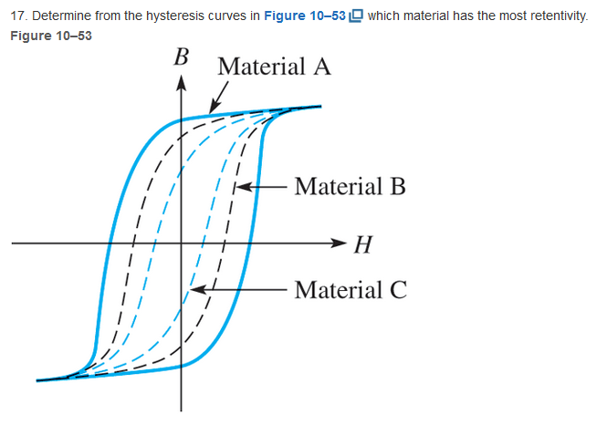

Based in definition, the material that has the highest retention of magnetic field. Without magnetic field intensity (H). So the flux density(B) intercept. In this case this would be **A.**

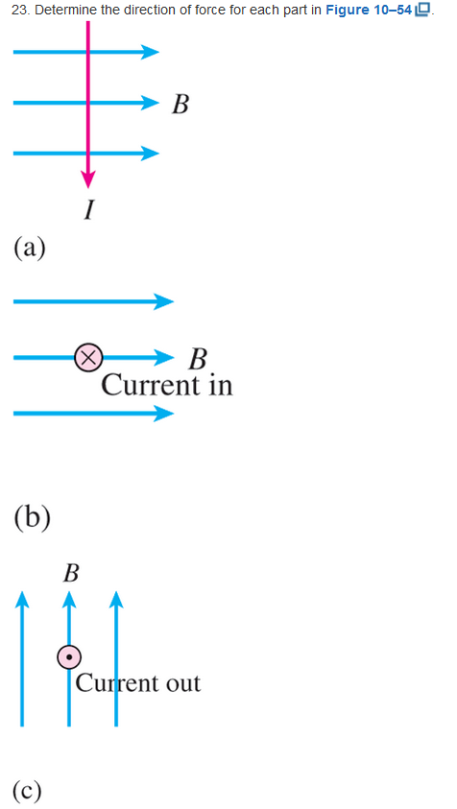

1. Direction of force out of the page.
2. Direction of force up.
3. Direction to the right of the page.

 sum of watts = 12+50 = 62 Watts



12 watts lost

50 watts used to load

50/62*100 = 80.645% efficiency