**EET/CPE 1140 - Homework # 6**

**Chapter 6**

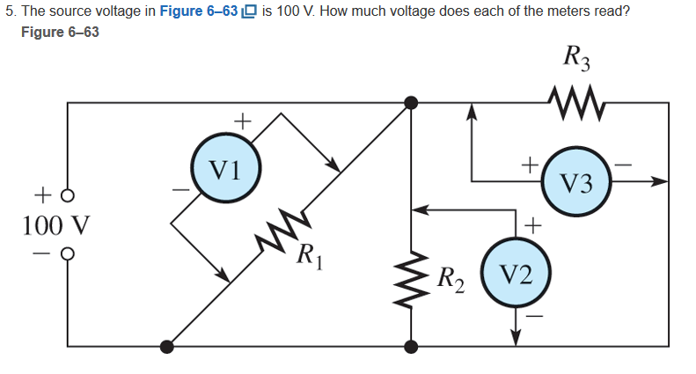

Since R­1­, R­2­, and R­3­ are in parallel. All volt meters should read approximately the same as the source voltage at 100V.



In parallel the source current and exit current should be the sum of the branches. So I­1 ­+ I­2­ + I­3­ = I ­source­ = I­ exit_wire

­

I­1 ­+ I­2­ + I­3­ = I ­source­ ­ = (250 + 300 + 800) = 1.350 amps

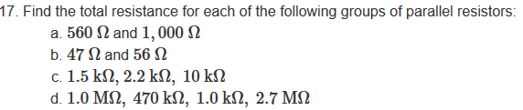

R ­parallel­ = 1/ ∑ 1/R­ index­

1. R ­parallel­ = 358.974Ω
2. R ­parallel­ = 25.553Ω
3. R ­parallel­ = 818.858Ω
4. R ­parallel­ = 996.514Ω

// related code

void parallel()

{

double parallel_equavelent = 0.0,

temp = 0.0;

double set_of_resitors [] = {1000000.0,

470000.0,

1000.0,

2700000.0};

for(int count = 0 ; count < 4; count++)

{

temp += 1/set_of_resitors[count];

}

parallel_equavelent = 1/temp;

printf("\n\nThe parallel equavelent is: %.5lf\n\n",parallel_equavelent );

}

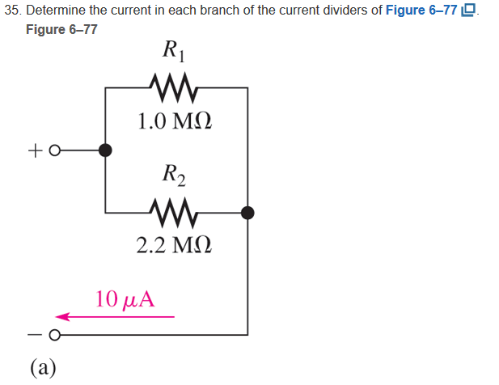

R­ parallel equivalent = 687500Ω

I­­1 ­== 6.875

I­2­ == 3.125

#include "function.h"

#include <stdio.h>

double set_of_resitors [] = {1000000.0,

2200000.0};

double parallel()

{

double parallel_equavelent = 0.0,

temp = 0.0;

for(int count = 0 ; count < 2; count++)

{

temp += 1/set_of_resitors[count];

}

parallel_equavelent = 1/temp;

printf("\n\nThe parallel equavelent is: %.5lf\n\n",parallel_equavelent );

return parallel_equavelent;

}

void current_divder()

{

double parallel_equavelent = parallel(),

source_current = 1/100000.0,

resistor_ratio = 0.0,

branch_current = 0.0;

for(int count = 0; count < 2; count++)

{

resistor_ratio = parallel_equavelent / set_of_resitors[count];

branch_current = resistor_ratio * source_current ;

printf("\n\nThe current of the resitor %.4lf is : %.9lf micro Amps\n\n", set_of_resitors[count], branch_current*1000000);

}

}

(just part a)

I assume it is each circuit element.

I­­1 ­= 6.875

I­2­ = 3.125

P=IV

V=IR

P= I­­­­2R

P1 = 47.265

P2 =21.484

#include "function.h"

#include <stdio.h>

double set_of_resitors [] = {1000000.0,

2200000.0};

double parallel()

{

double parallel_equavelent = 0.0,

temp = 0.0;

for(int count = 0 ; count < 2; count++)

{

temp += 1/set_of_resitors[count];

}

parallel_equavelent = 1/temp;

printf("\n\nThe parallel equavelent is: %.5lf\n\n",parallel_equavelent );

return parallel_equavelent;

}

void current_divder()

{

double parallel_equavelent = parallel(),

source_current = 1/100000.0,

resistor_ratio = 0.0,

branch_current = 0.0,

power = 0.0;

for(int count = 0; count < 2; count++)

{

resistor_ratio = parallel_equavelent / set_of_resitors[count];

branch_current = resistor_ratio * source_current ;

power = set_of_resitors[count]* branch_current*branch_current;

printf("\n\nThe current of the resitor %.4lf is : %.9lf micro Amps the power is %.8lf watts\n\n", set_of_resitors[count], branch_current*1000000,power*1000000);

}

}