**EET/CPE 1140 - Homework # 3**

**Chapter 3**

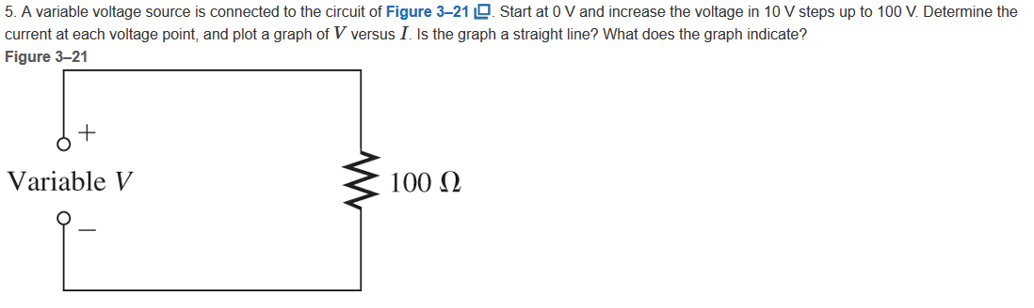

Computed in a table in next page

|  |  |
| --- | --- |
| Voltage[V]  {Volts}  (Control variable)  Resistance [R]  {Ohms}  (constant) = 100  = I | Current[I]  {Amperes}  (Dependent variable or output variable) |
|  | 0.000 |
|  | 0.100 |
|  | 0.200 |
|  | 0.300 |
|  | 0.400 |
|  | 0.500 |
|  | 0.600 |
|  | 0.700 |
|  | 0.800 |
|  | 0.900 |
|  | 1.000 |

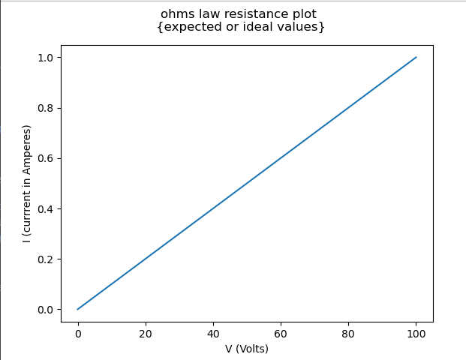

Plot made with matplot.lib in python included code.

import matplotlib.pyplot as ohms_law

#initalization of variables

current_output_data = [] # y output

resistance = 100.0 # resitance in ohms constant

voltage = [] # x control variable

temp = 0.0 # computations output temporary variable

# voltage initalization 0-100 in increments of 10

# some excess in temp but not pushed to the list

for i in range (11):

voltage.append(temp)

temp += 10.0

# computes current value using ohms law V/R =I

for k in range(len(voltage)):

current_output_data.append(voltage[k]/resistance)

# X label data first in a list

ohms_law.plot(voltage,current_output_data)

# labels section

ohms_law.suptitle("ohms law resistance plot \n{expected or ideal values}")

ohms_law.ylabel("I (currrent in Amperes)")

ohms_law.xlabel("V (Volts)")

#displays the graph

ohms_law.show()

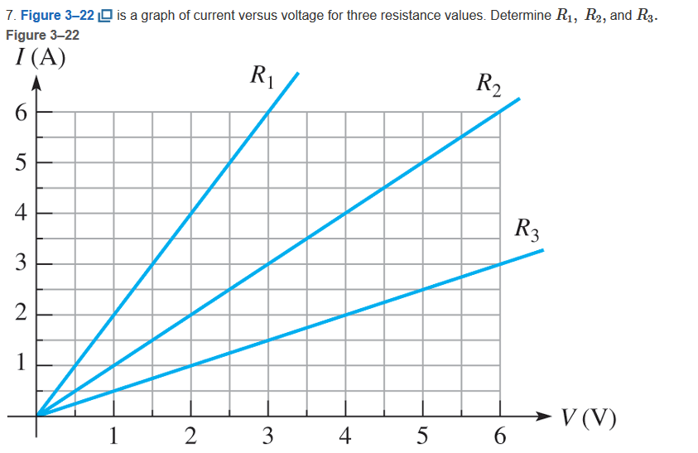

|  |  |  |
| --- | --- | --- |
| R1 | ½ , 2/4 | ½ |
| R2 | 1/1,2/2 | 1 |
| R3 | 2/1,4/2 | 2 |

Might be wire resistances



= I

= = 0.606Ω