**EET/CPE 1140 - Homework # 1**

**Chapter 1**

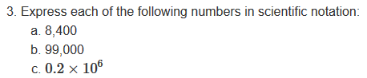

3.a) 8.4 x 103

3.b) 9.9 x 104

3.c) 2.0 x105

21.a)

21.b)

106 was chosen for easy word conversion to Mega

21.c)

10-3 was chosen for easy word conversion to mini.

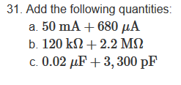

31.a)

50*10-3 + 680*10-6

50000*10-6 +680*10-6

50680*10-6

50.68 *10-3 A

50.68 mA

31.b)

120*103 + 2.2*106

120*103 + 2.2*103 *103

120*103 + 2200*103

2320*103

2.32*106 M

31.c)

0.02*10-6 + 3300*10-12

0.02*10-6 + 3300*10-6 *10-6

0.02*10-6 + 0.0033*10-6

0.0233*10-6

2.33*103*10-6

23.3*10-3

23.3 mF