**EET/CPE 1140 - Homework # 11**

**Chapter 12**

11. A student decides to construct a capacitor using two conducting plates 30 cm on a side. He separates the plates with a paper dielectric (εr = 2.5) that is 8×10−5 m thick. What is the capacitance of his capacitor?

­­­C = = 24.890 nF

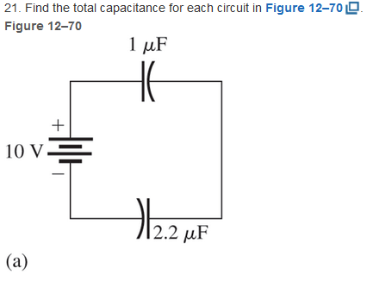

C|| = ∑ Clabel­ = 10­-6 +2.2 *10­-6

23. Two series capacitors (one 1 μF, the other of unknown value) are charged from a 12 V source. The 1 μF capacitor is charged to 8 V and the other to 4 V. What is the value of the unknown capacitor?

­

Seeking C series

= 66.666 µF

Seeking C unknown

µF

New formula

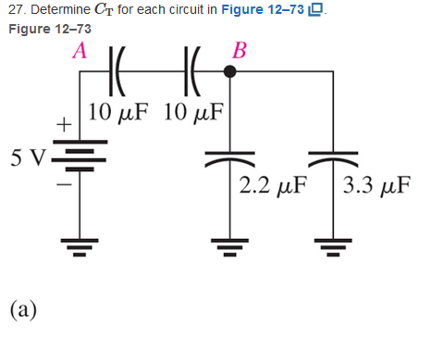

C|| = (2.2+3.3)*10-6

C|| = 5.5 * 10-6

C series = ­1/(1/(5.5*10-6) +1/(10*10-6) +1/(10*10-6)) = 2.619 µF

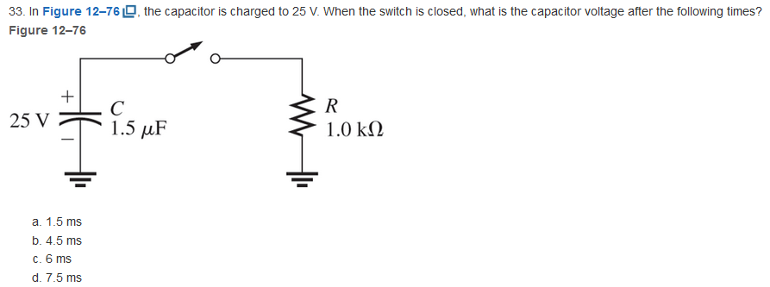

V current ­= V initial * e-t/RC

C)

D)

V

