**EET/CPE 1140 - Homework # 2**

**Chapter 2**



= (number of electrons) *1.6 * 10-19

I have found that (number of electrons )*(1.6*10-19) has the same output might be a better equation because of lesser memorization.



|  |  |
| --- | --- |
| I (Amperes || A) | current |
| Q (coulombs || C) | charge |
| T (Seconds || S) | time |

Algebra rearrangement for coulombs of charge by multiplying both sides by T.

I*T=Q

1.5*10-1

0.15coulombs

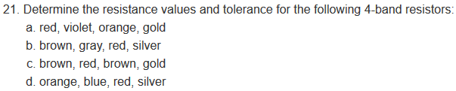

|  |  |
| --- | --- |
| 0 | Black |
| 1 | Brown |
| 2 | Red |
| 3 | Orange |
| 4 | Yellow |
| 5 | Green |
| 6 | Blue |
| 7 | Purple |
| 8 | Grey |
| 9 | White |

I have associated the wavelengths of the visible light spectrum to the color codes of the resistor ascending frequency of light is a higher number. Exemptions are at the beginning and the end. Black and brown for no light or all pigments. The high-end grey then white. White is all visible wavelengths.

a)27*103 +/- 5%

b)18*102 +/- 10%

c)120 +/-5%

d)36*102 +/-10%

