**CPE 1140 - Homework # 7**

**Chapter 7**

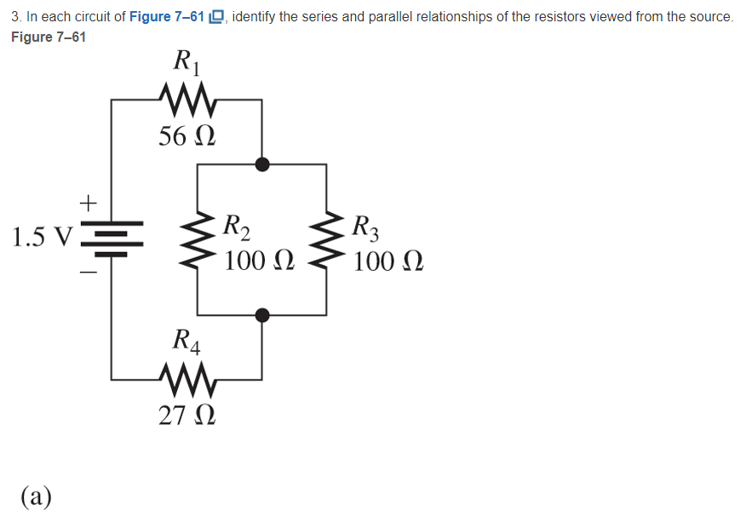

R­2 ­and R­3­ are in parallel.

The parallel set is in series with R1, R4 and the source voltage

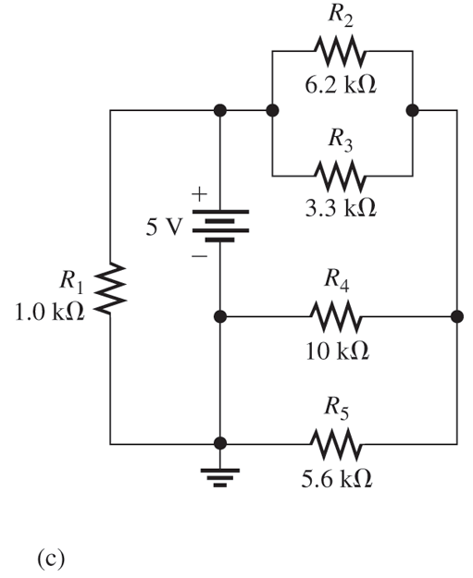

The first parallel set is R2 and R3 this set is in series with the parallel set of R4 and R5. R1 is in parallel with the voltage source.

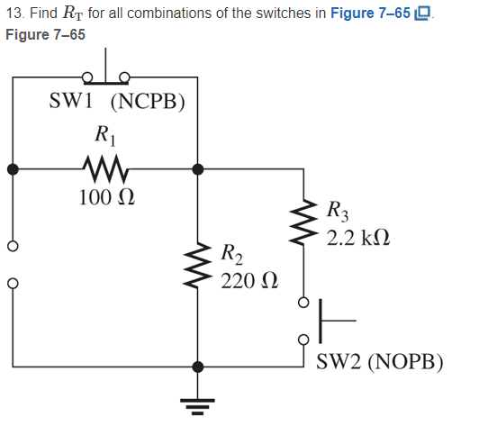

|  |  |
| --- | --- |
| Switch set binary (SW2 SW1) | Resistor output |
| 00 | R1 + R2 |
| 01 | R2 |
| 10 | R1 + (R3 || R2) |
| 11 | R3 || R2 |

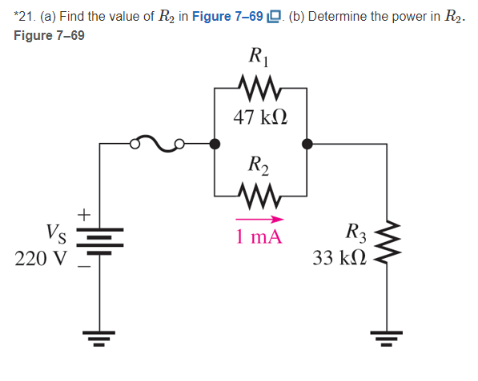

Voltage divider

V­R2 and R1 = ­ *220 = 129.250 V

Since R­1 and R­2 are in parallel they have the same voltage.

V = IR

= R

= R

R­2 = 129.250 kΩ

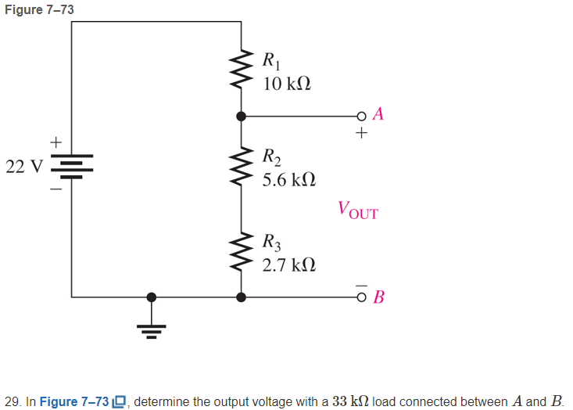

V­R2 + R3 = ­ *22

V­R2 + R3 = ­ *22 = 9.978 V

R2 and R3 taken as a single resistor.

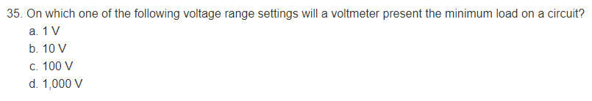

I am guessing 1000 V. Since to have an accurate reading at high voltages the load resistance might be gigantic.