**CPE 1140 - Homework # 5**

**Chapter 5**

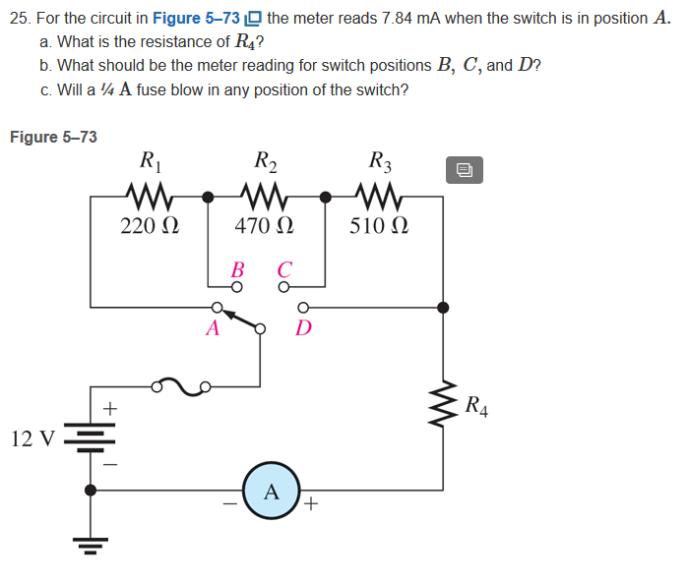

A)

­

= 1530.612Ω = R­ series

­R ­series­ = R­1­ + R­2­ + R­3­­ + R­4­

­R ­series­ = 220 Ω­ + 470 ­Ω­ + 510­ ­Ω + R­4

­R­ known­ = 1200 Ω

R ­series­ ­– R ­­known ­= R­4­

1530.612 -1200 = 330.612Ω

R­4­ = 330 Ω

Truncated due to the nearest real resistor.

B)

R­ series­ – R­1­ = R­ position B­

1530 Ω – 220 Ω = 1310Ω

R­ position B­ = 1310Ω

R­ position C­ = R­ series­ – R­1­ ­ - R­2

R­ position C­ = 1530 Ω – 220 Ω - 470 Ω

R­ position C­ = 840Ω

R­ position D­ = 330Ω

C)

­

­ All the positions are under 250 mA. Therefore, the circuit should be safe in all positions.

­

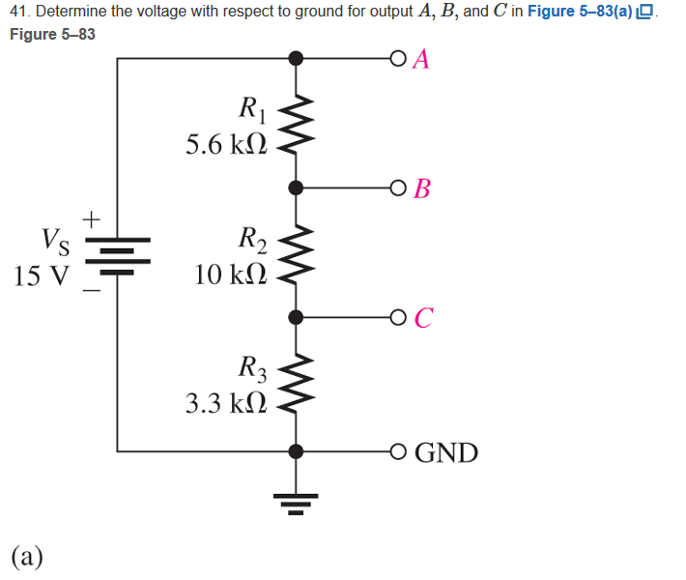

R­ series­ = (5.6+10+3.3) *103­­

R­ series­ = 18.9 kΩ

Voltage divider = V­ source ­ * ­

V ­A- Ground­ = 15V It gets all the voltage

V ­B - Ground­ = 15V­ * ­

V ­B - Ground­ = 10.555 V

V ­C - Ground­ = 15V­ * ­

V ­C - Ground­ = 2.619 V



V = IR

P= IV

four times.