

**CPE 1140**

**Circuits / DC Circuit Fundamentals Lab**

**Fall 2021**

Laboratory Report

Lab:1

Lab: Resistance, Voltage and Current

Measurements and

Ohms Law

Submitted by: Bruce Liu

Laboratory Date: 9/9/2021

Date of Submission: 9/10/2021

Part A:

|  |  |  |  |  |  |
| --- | --- | --- | --- | --- | --- |
| Resistor | Band 1 | Band 2 | Band 3  (Multiplier) | Band 4  (Tolerance) | Lower – Upper Values (ohm) |
| R1: 510Ω | Green | Brown | Brown | Gold | 484.500 – 535.500 |
| R2: 1000Ω | Brown | Black | Red | Gold | 950.000 -1050.000 |
| R3: 2000Ω | Red | Black | Red | Gold | 1900.000 – 2100.000 |
| R4: 4700Ω | Yellow | Purple | Red | Gold | 4465.000 – 4935.000 |
| R5: 10,000Ω | Brown | Black | Orange | Gold | 9500.000 – 10500.000 |

|  |  |
| --- | --- |
| Resistor | Measured Resistance (Ω) |
| R1 | 503.23 |
| R2 | 985.670 |
| R3 | 1.975 kΩ |
| R4 | 4.7667kΩ |
| R5 | 10.029kΩ |

Part a of this lab was to see if the given resistors are correct and are within expected ranges. As shown in the tables above the given resistors are within manufacturing tolerances.

I would like to obtain a measurement at 20o C since that is the measurement of the definition in a material engineering textbook, I was reading over the summer break.

Part B:

Predicted results

E = 5.0V

|  |  |
| --- | --- |
| Resistor | Current (mA) |
| R1 | 9.804 |
| R2 | 5.000 |
| R3 | 2.500 |
| R4 | 1.064 |
| R5 | 0.500 |

Simulated results

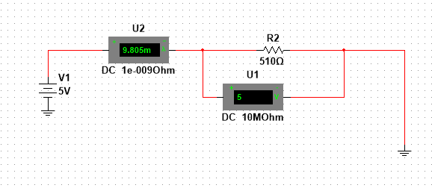

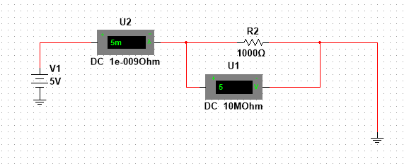

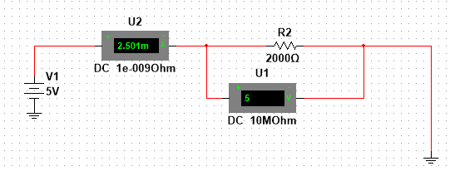

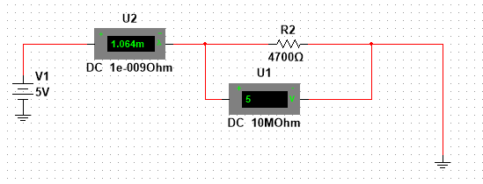

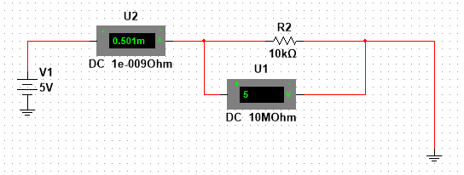

Measured results

E = 5.047V

|  |  |
| --- | --- |
| Resistor | Source Current I (mA) |
| R1 | 10.029 |
| R2 | 5.121 |
| R3 | 2.560 |
| R4 | 1.081 |
| R5 | 0.503 |

The input voltage was slightly higher than the ideal case and the resistance of all the resistors were slightly lower than the ideal.

The relationship between voltage and current appears to be the positive part of $\frac{1}{x}$.

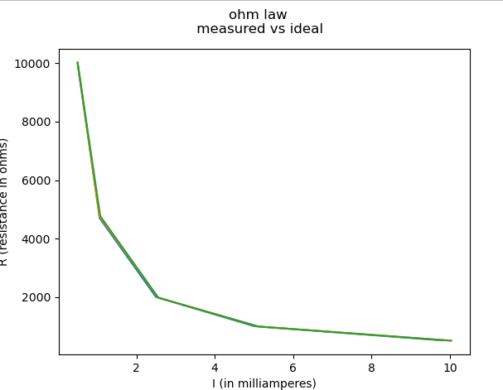

Graphed with matplotlib in python

It seems that the difference in results is negligible. Or close enough the lines are of measured, measured calculated, and ideal calculated.

$\frac{V}{R}=I$ is the formula used for the graph above. V or Voltage is held as a constant and R resistance is the changing variable for this experiment.

Part C:

Predicted results

|  |  |
| --- | --- |
| Current (mA) | Voltage (V) |
| 1 | 2.000 |
| 2 | 4.000 |
| 3 | 6.000 |
| 4 | 8.000 |
| 5 | 10.000 |

Simulated results

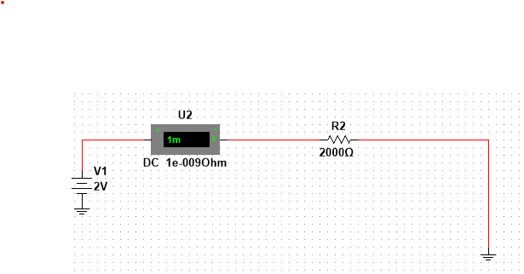

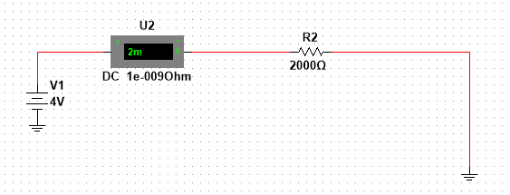

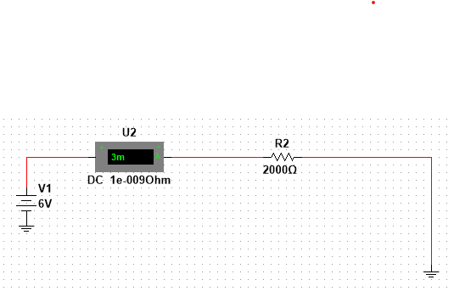

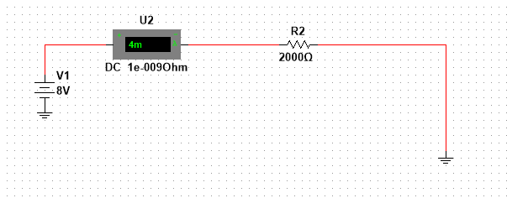

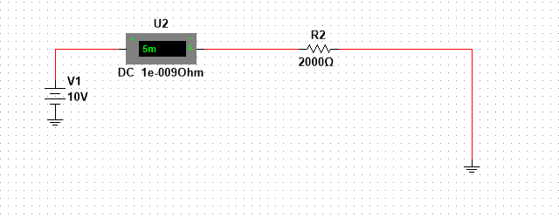

Measured results

**R = 2KΩ**

**R real = 1.975 k Ω**

|  |  |
| --- | --- |
| Source current I (mA) | Source Voltage V (volt) |
| 1 | 1.9 |
| 2 | 3.9 |
| 3 | 5.9 |
| 4 | 7.8 |
| 5 | 9.8 |

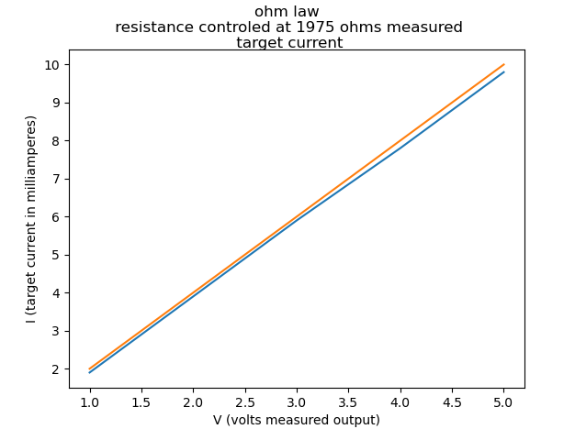

The only thing that is variable in the predicted results vs the real results is the 2k $Ω$ resistor which is measured to be 1.975 $kΩ$.

Ohms law is linear from $v=$ IR

Current and resistance were held as constants in this experiment volts was the measured variable.

A potentiometer set at 2k $Ω$ might have brought the experiment with better control.

Conclusion:

I was able to measure resistance, volts, and current in a DC circuit.

I was able to verify ohm’s law though graphing and table plotting of ideal vs real. That the relationship between the resistance, current, and voltage are linear or $\frac{1}{x}$.

I chose to use matplotlib python library to plot the graphs. To learn it. I learned to do a multi-sim simulation I plan on using MATLAB for the next lab.

Appendix: Prelab calculations:

a) Determine the Color Codes for the Resistors used in this lab and calculate the upper and lower values for the 5% tolerance.

Table 1:

|  |  |  |  |  |  |
| --- | --- | --- | --- | --- | --- |
| Resistor | Band 1 | Band 2 | Band 3  (Multiplier) | Band 4  (Tolerance) | Lower – Upper Values (ohm) |
| R1: 510Ω | Green | Brown | Brown | Gold | 484.500 – 535.500 |
| R2: 1000Ω | Brown | Black | Red | Gold | 950.000 -1050.000 |
| R3: 2000Ω | Red | Black | Red | Gold | 1900.000 – 2100.000 |
| R4: 4700Ω | Yellow | Purple | Red | Gold | 4465.000 – 4935.000 |
| R5: 10,000Ω | Brown | Black | Orange | Gold | 9500.000 – 10500.000 |

b) Using Ohm’s law (I=E/R) and a source voltage of ***5 volts***, calculate the current through each resistor:

Table 2:

|  |  |
| --- | --- |
| Resistor | Current (mA) |
| R1 | 9.804 |
| R2 | 5.000 |
| R3 | 2.500 |
| R4 | 1.064 |
| R5 | 0.500 |

c) Using Ohm’s law (E=RI) with ***R = 2KΩ***, calculate the expected source voltage E as the source current changes:

Table 3:

|  |  |
| --- | --- |
| Current (mA) | Voltage (V) |
| 1 | 2.000 |
| 2 | 4.000 |
| 3 | 6.000 |
| 4 | 8.000 |
| 5 | 10.000 |