**CPE 1140**

**1. LAB NUMBER: 2**

**2. TITLE: Series DC Circuit Analysis.**

**3. OBJECTIVES:**

After completing this lab, the student will be able to:

1. measure total resistance of a series circuit,
2. measure total current supplied by a DC source,
3. measure the voltage drop across each resistor of the circuit,
4. verify Kirchhoff’s Voltage Law,
5. verify the Voltage Divider rule
6. verify basic properties of a Series Circuit:
   1. There is a single current following in a Series Circuit.
   2. Resistor locations can be interchanged without affecting the value of the source current and the voltage drops.

**4. EQUIPMENT:**

DC Power Supply: Uni PS-2303

Digital Multimeter: RIGOL DM 3058E

Experimenter board (C.A.D.E.T.) or a Breadboard

Multisim Software

**5. COMPONENTS:**

1 - 470 Ω ½ watt 5% Resistor

1 - 620 Ω ½ watt 5% Resistor

1 - 1000 Ω ½ watt 5% Resistor

**6. TEXT REFERENCE:**

Circuit Analysis: Theory and Practice (5th Edition): A.H. Robbins and W.C. Miller

Section 2.6: Measuring Voltage and Current

Section 3.7: Measuring Resistance – the Ohmmeter

Section 4.1: Ohm’s Law

Section 4.3: Power

Chapter 5: Series Circuits

**7. PRE-LAB ASSIGNMENT:**

Study the series circuit in Figure 1 and do the followings: Figure 1:

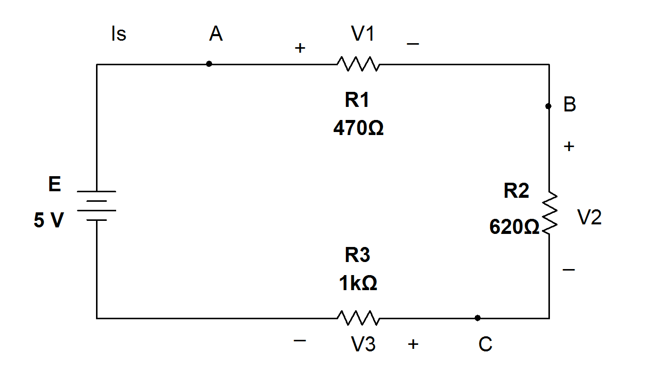

Table 1:

|  |  |
| --- | --- |
| Resistor | Voltage Drop across R (volt) |
| R1: 470 Ω | V1 =1.124 |
| R2: 620 Ω | V2 =1.483 |
| R3: 1000 Ω | V3 =2.392 |

Rt = 2090.000Ω

Is =2.000mA

1. Calculate the total Resistance (Rt = R1+R2+R3). Record your result in Table 1.

R­total = ∑ R­I­ = R­1­+R­2­+­­R­3 = ­470+620+1000 = 2090.000

void sum_of_resisitors()

{

double set_of_resistors [] = {470.0,

620.0,

1000.0},

series_of_resistors = 0.0;

for(int count = 0; count < 3 ; count++)

{

series_of_resistors += set_of_resistors[count];

}

printf("The the sum of resisitors are : %.3lf\n",series_of_resistors);

} 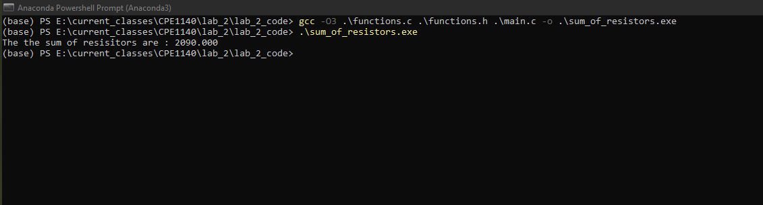

b) Calculate the source current *Is* using Ohm’s Law Is = E/Rt.

Record your result in Table 1.

V=IR

V/R = I

I = 0.002 amps *103 *10-3

I = 2.000 miliAmps

void source_current_series()

{

double value_of_sum_of_resistors = 2090.000,

source_voltage = 5.0,

expected_current = 0.0;

//v=iR

//v/R = i

expected_current = source_voltage / value_of_sum_of_resistors;

printf("The expected current is about :%.3lf \n", expected_current);

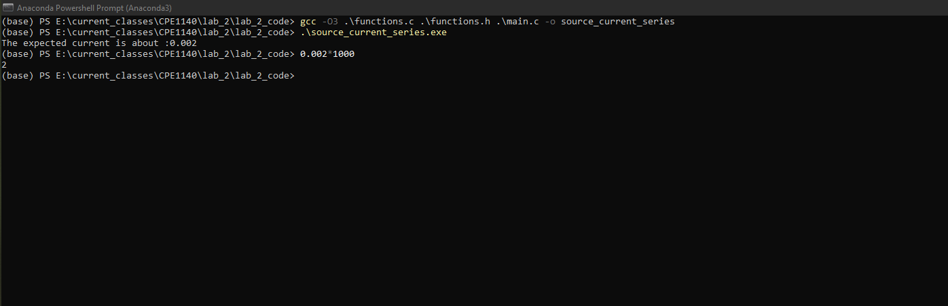}

c) Calculate the Voltage Drop across each resistor using the Voltage Diver Rule:

Record your results in Table 1.

V­470 ohm ­= ­ ­= 1.124 volts

V­620 ohm ­= ­ ­= ­1.483 volts

V­1000 ohm ­= ­ ­= 2.392 volts

void voltage_divder()

{

double set_of_resistors [] = {470.0,

620.0,

1000.0},

series_of_resistors = 2090,

source_voltage = 5.0,

voltage_target_resisitor = 0.0;

for (int count = 0 ; count < 3 ; count++ )

{

voltage_target_resisitor = source_voltage * set_of_resistors[count]/series_of_resistors;

printf("the expected voltage of %.3lf ohm resisitors is about %.3lf volts \n",

set_of_resistors[count], voltage_target_resisitor

);

}

}

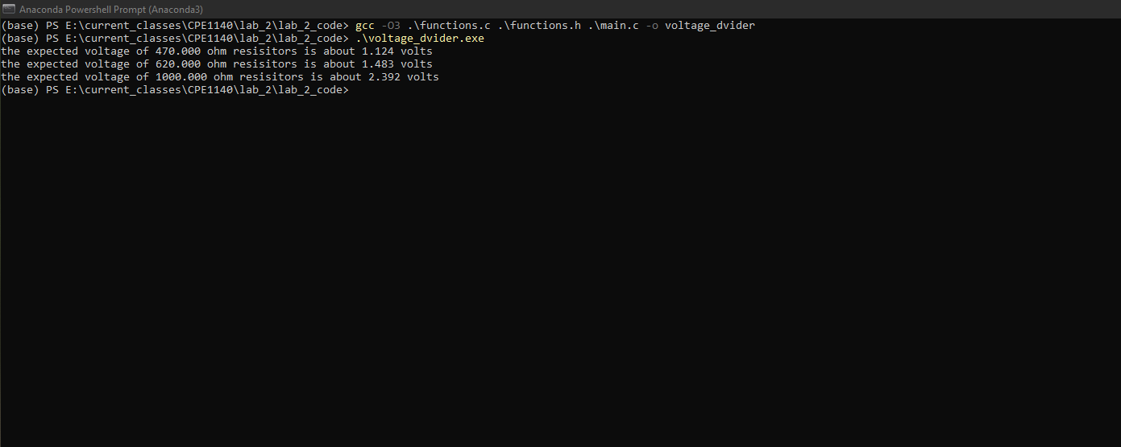

**8. MEASUREMENTS:**

**A – Resistance Measurement:**

1. Connect R1, R2, R3 in series on the experimenter board as in Fig.1

without the source E.2.

1. Set the DMM to measure Resistance (Ω). Measure the total resistance of this circuit (R123). Record your result in the following Table 2:

Table 2:

R123 = Ω

R321 = Ω

c) Interchange the location of R1 (470 Ω) and R3 (1KΩ). Measure the total resistance again (R321). Record your result in Table 2.

d) Are the two results (R123 and R321) different?

e) How are these results compared to the calculated Rt in Table 1? Is the difference within the 5% tolerance of the resistors?

**B – Source Current Measurement:**

f) Locate the **fixed 5V** source on the power supply. Connect this source to the 3 resistors in series (R3, R2, R1). Set the DMM to measure DC voltage and measure the source voltage. Record your result in Table 3:

Table 3:

|  |
| --- |
| Source E = V |
| I 321(A) = mA |
| I 123(A) = mA |
| I 123(B) = mA |
| I 123(C) = mA |

Note: The current subscript reflects the resistor sequence in the circuit.

g) Set the DMM to measure DC current and measure the source current **I321** at location **A**. Record your result in Table 3.

h) Interchange the locations of resistors R1 and R3 (the sequence is now R1- R2-R3). Measure the source current **I123** at location **A**. Record your

result in Table 3.

i) Measure the source current **I123** at locations **B** and **C**. Record your result

in Table 3.

j) Compare these results of source current to **Is** in Table 1:

1. Are they within the 5% tolerance of the resistors?

2. Did the location of measurement of current affect the values?

3. Did the interchange of Resistors affect the values of the currents?

**C- Voltage Drop Measurement:**

k) Set the DMM to measure DC voltage and measure the voltage drops across each resistor (see Fig. 1). Pay attention to the placement of the probes so that all voltage readings are positive. Record your results in Table 4:

Table 4:

|  |
| --- |
| Voltage Drop across R (volt) |
| V1 = |
| V2 = |
| V3 = |
| Vt = |

l) Calculate Vt = V1+V2+V3 and record your result in Table 4.

m) Compare the results of Table 4 to those of Table 1. Compare Vt to E in

Table 3.

**D- Multisim Simulations:**

n) Create a Multisim circuit (similar to Fig.1) with the followings:

1. One Voltmeter measures the source voltage E and 3 Voltmeters measure V1, V2, V3.

2. Three Ammeters measure source current at A, B and C.

**9. LAB-REPORT REQUIREMENT:**

Your team’s Lab Report should contain the followings:

**A Cover Page** with Lab Number, Lab Title, Team members’ Names and Date.

**Result Pages** with:

**A- Resistance Measurement:**

Results:

Show a copy of Table 2

Discussions:

1. Answer question in 8(d).
2. Answer question in 8(e).
3. What conclusion can you make about the locations of resistors in a series circuit

**B- Source Current Measurement:**

Results:

Show a copy of Table 3.

Discussions:

1. Answer questions in 8(j). Take also Multisim currents in consideration.
2. What conclusion can you make about the effect of location on the measurement of source current in a series circuit?

**C- Voltage Drop Measurement:**

Results:

Show a copy of Table 4.

Discussions:

1. Make the comparisons in 8(m). Take also Multisim voltages in consideration.
2. From the results of Table 4, what conclusion can you make about the Voltage Divider Rule

**D- Power Study:**

Results:

With the data in Table 1, calculate the Powers dissipated in R1, R2 and

R3, using the formula . Record your results in Table 5.

Table 5:

|  |  |
| --- | --- |
| Resistor | Power dissipated (W) |
| R1 | P1 = |
| R2 | P2 = |
| R3 | P3 = |

Discussions:

With the above results, discuss if the “1/2 watts” rating of the resistors is suitable for this lab.

**E- Conclusion:** (*it helps to compare your prelab with measured results*)

1. Did the above results demonstrate the validity of Kirchhoff’s Voltage Law? Explain your answer.
2. Is the Voltage Divider Rule accurate? Explain your answer.
3. Are all the Lab objectives met? Explain if some are not.

**Appendix:** Attach a printout of **Multisim** simulation and all **Pre-Lab calculations**.