**C语言作业第二次**

**自81班 刘泓尊 2018011446**

第一题

#include<stdio.h>

#include<math.h>

void main()

{

float c,f;

printf("输入摄氏温度：");

scanf_s("%f",&c);

f=32+(c*9)/5;

printf("输出华氏温度：%.2f\n",f);

}

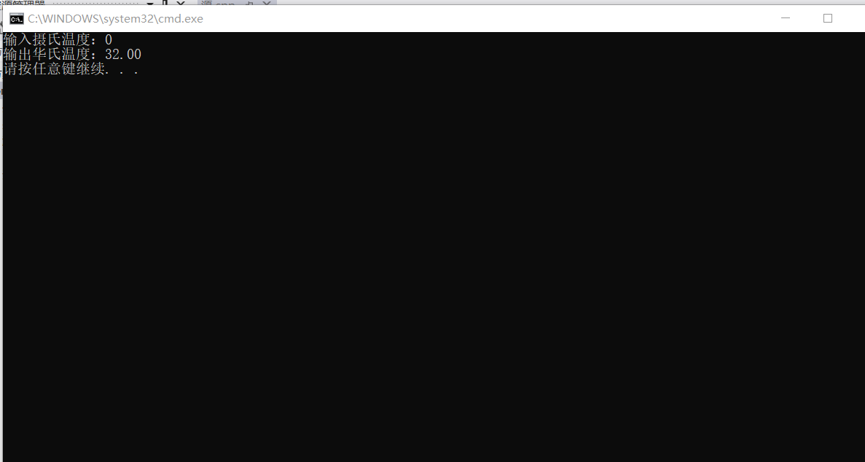

第二题

#include<stdio.h>

void main()

{

int a,b,c;

printf("输入：");

scanf_s("%d%d%d",&a,&b,&c);

printf("you input:%d %d %d;\n",a,b,c);

printf("In normal order,the new number is %d%d%d;\n",a,b,c);

a=(a%10)*10+a/10;

b=(b%10)*10+b/10;

c=(c%10)*10+c/10;//使十位和个位交换

printf("In part-reverse order,the new number is %d%d%d。\n",a,b,c);

}

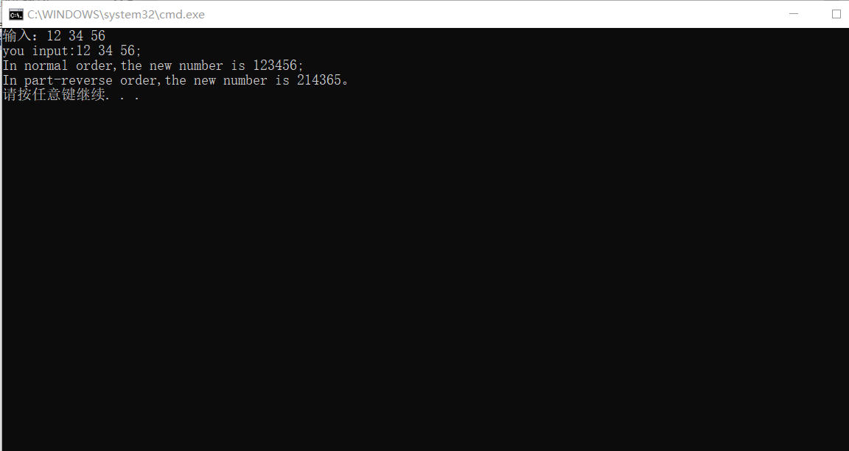

第三题

#include<stdio.h>

#include<math.h>

int main()

{

int time1,time2;

int t1,t2,t,day,hrs,mins;

scanf_s("%d%d",&time1,&time2);

t1=24*60*(time1/10000)+60*(time1%10000-time1%100)/100+(time1%100);

t2=24*60*(time2/10000)+60*(time2%10000-time2%100)/100+(time2%100);

t=t2-t1;

day=t/(24*60);

hrs=t/60-day*24;

mins=t-day*60*24-hrs*60;

printf("The time is %dday %dhrs %dmins\n",day,hrs,mins);

return 0;

}

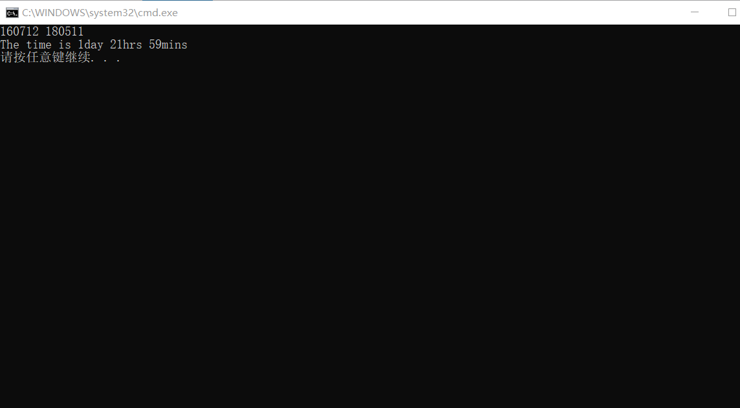

第四题

#include<stdio.h>

#include<math.h>

int main()

{

char a[4];

int i;

printf("输入:");

scanf_s("%c",&a[0]);

scanf_s("%c",&a[1]);

scanf_s("%c",&a[2]);

scanf_s("%c",&a[3]);

for(i=0;i<4;i++)

{

a[i]=(a[i]-65+9)%26+65;

}

printf("The encrypted chars are %c%c%c%c\n",a[2],a[3],a[0],a[1]);

return 0;

}

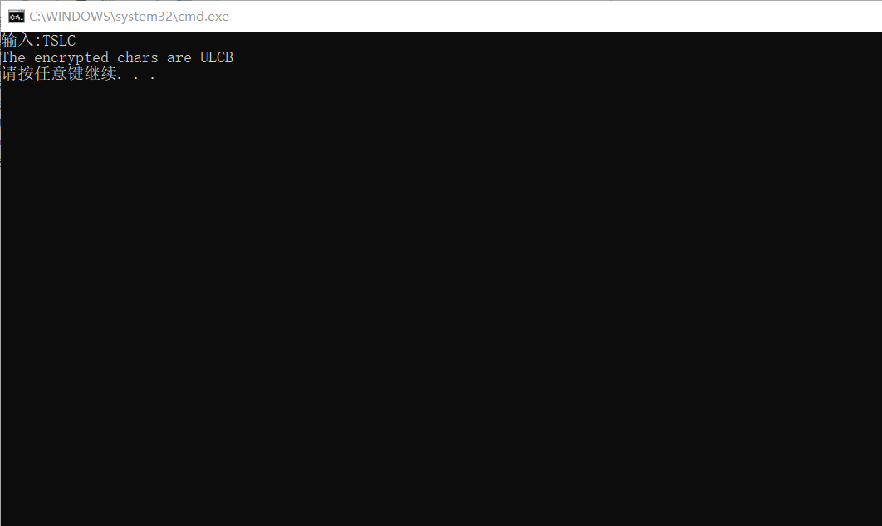

第五题

#include<stdio.h>

#include<math.h>

int main()

{

char a[4];

int i;

printf("The encrypted chars are:");

scanf_s("%c",&a[2]);

scanf_s("%c",&a[3]);

scanf_s("%c",&a[0]);

scanf_s("%c",&a[1]);

for(i=0;i<4;i++)

{

a[i]=(a[i]-65+26-9+65);

if(a[i]>90)

{

a[i]=a[i]-26;

}

}

printf("The deciphered chars are %c%c%c%c\n",a[0],a[1],a[2],a[3]);

return 0;

}

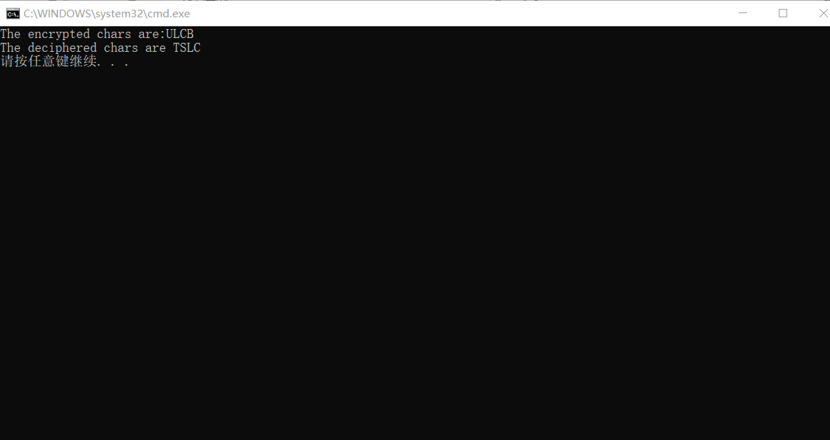

第六题

#include<stdio.h>

void main()

{

int i1,i2,i3;

unsigned int u1,u2;

char ch;

float fl;

printf(" 输入:");

scanf_s("%d%d%d",&i1,&i2,&i3);

scanf_s("%u%u",&u1,&u2);

scanf_s("%c",&ch);

scanf_s("%f",&fl);

printf(" int:%d,%d,%d,%d,%d,%d,%d\n",i1,i2,i3,(int)u1,(int)u2,(int)ch,(int)fl);

printf("unsigned int:%u,%u,%u,%u,%u,%u,%u\n",(unsigned)i1,(unsigned)i2,(unsigned)i3,u1,u2,(unsigned)ch,(unsigned)fl);

printf(" long:%ld,%ld,%ld,%ld,%ld,%ld,%ld\n",(long)i1,(long)i2,(long)i3,(long)u1,(long)u2,(long)ch,(long)fl);

printf(" short:%d,%d,%d,%d,%d,%d,%d\n",(short)i1,(short)i2,(short)i3,(short)u1,(short)u2,(short)ch,(short)fl);

printf(" signed char:%c,%c,%c,%c,%c,%c,%c\n",(signed char)i1,(signed char)i2,(signed char)i3,(signed char)u1,(signed char)u2,(signed char)ch,(signed char)fl);

printf(" float:%f,%f,%f,%f,%f,%f,%f\n",(float)i1,(float)i2,(float)i3,(float)u1,(float)u2,(float)ch,fl);

}

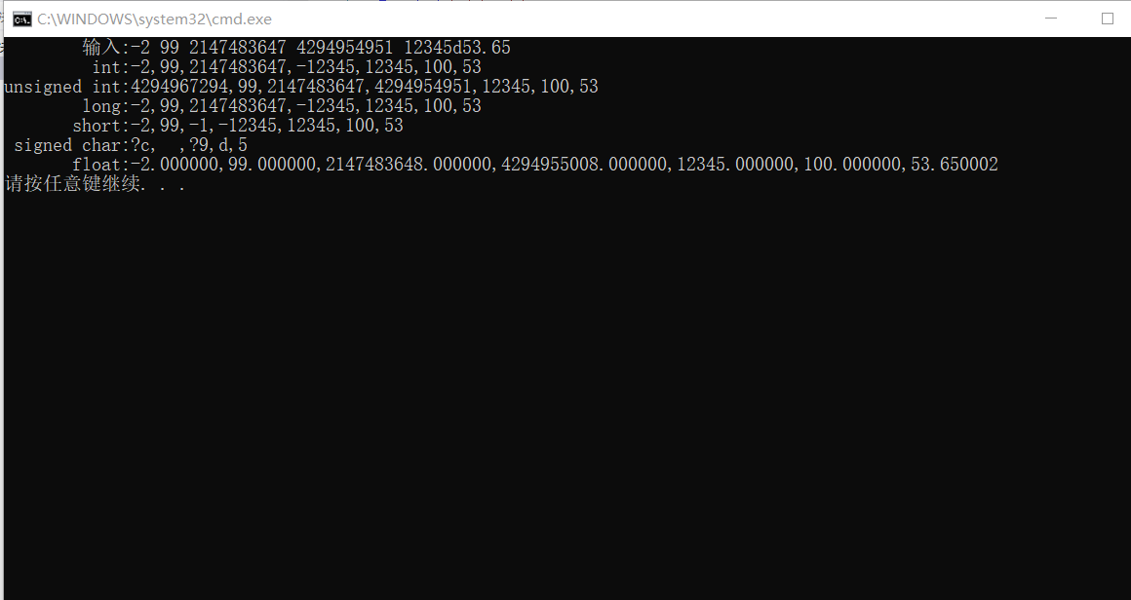

第七题

#include<stdio.h>

#include<math.h>

int main()

{

const double RATE1=0.0175,RATE2=0.0225,RATE3=0.0275,RATE5=0.0300,RATE0=0.0030;

const double CORPUS=1234.56;

double P[6];

P[1]=CORPUS*(1+RATE5);

P[2]=(CORPUS*(1+2*RATE2))*(1+3*RATE3);

P[3]=(CORPUS*(1+3*RATE3))*(1+2*RATE2);

P[4]=CORPUS*pow((1+RATE1),5);

P[5]=CORPUS*pow((1+RATE0/4),4*5);

printf("一次存五年期：%f元\n先两年期再三年期：%f元\n先三年期再两年期：%f元\n连存五次一年期：%f元\n活期：%f元\n",P[1],P[2],P[3],P[4],P[5]);

return 0;

}

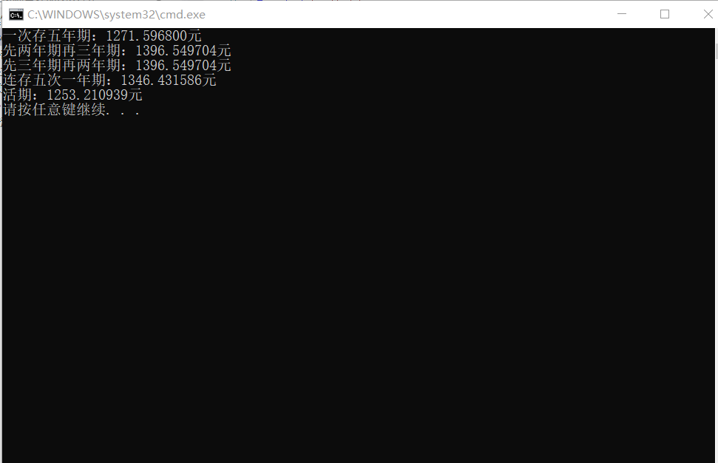

第八题

#include<stdio.h>

#include<math.h>

void main()

{

const double R=0.0030;

const double C=1234.56;

double P[4],interest[4];

int i;

P[1]=(100*C)*pow((1+R/4),20);

P[2]=C*pow((1+R/4),20);

P[3]=C*(1+R/4);

interest[3]=P[3]-C;

for(i=1;i<20;i++)

{

P[3]=P[3]*(1+R/4);

interest[3]=interest[3]+P[3]-P[3]/(1+R/4);

}

interest[1]=P[1]-100*C;

interest[2]=100*(P[2]-C);

interest[3]=100*interest[3];

printf("第一种方法:%f元\n第二种方法:%f元\n第三种方法:%f元\n",interest[1],interest[2],interest[3]);

}

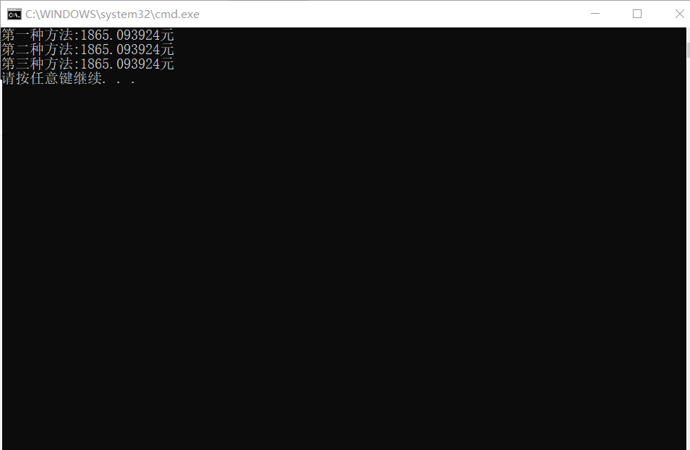

第九题

|  |  |  |  |
| --- | --- | --- | --- |
| 十进制 | 二进制 | 八进制 | 十六进制 |
| 10 | 1010 | 12 | 10 |
| 32 | 100000 | 40 | 20 |
| 75 | 100 1011 | 113 | 4B |
| 2483 | 1001 1011 0011 | 4663 | 9B3 |
| 21003 | 101 0010 0000 1011 | 51013 | 520B |

|  |  |
| --- | --- |
| 十进制负数 | 补码 |
| -111 | 1111 1111 1111 1111 1111 1111 1001 0001 |
| -617 | 1111 1111 1111 1111 1111 1101 1001 0111 |
| -28654 | 1111 1111 1111 1111 1001 0000 0001 0010 |

第十题（附加题）

#include<stdio.h>

#include<math.h>

int main()

{

int a,b,c,i;

printf("请输入十进制数:");

scanf_s("%d",&a);

b=0;

for(i=0;a>0;i++)

{

c=a%2;

b+=c*pow(10.0,(double)i);

a=a/2;

}

printf("二进制：%d\n",b);

return 0;

}

