**C语言作业第三次**

**自81 刘泓尊 2018011446**

**1.计算三角形面积和周长**

#include<stdio.h>

#include<math.h>

int main()

{

int repeat,i;

double a,b,c,s,perimeter,area;

printf("Please input the times of repetition you want(0<repeat<10)：");

scanf_s("%d",&repeat);fflush(stdin);

for(i=1;i<=repeat;i++)

{

printf("Please input the length of three sides:");

scanf_s("%lf,%lf,%lf",&a,&b,&c);

if((a+b>c)&&(b+c>a)&&(a+c>b))

{

perimeter=a+b+c;

s=perimeter/2;

area=sqrt(s*(s-a)*(s-b)*(s-c));

printf("area=%.2lf,perimeter=%.2lf\n\n",area,perimeter);

}

else printf("These sides do not correspond to a valid triangle\n\n");

}

return 0;

}

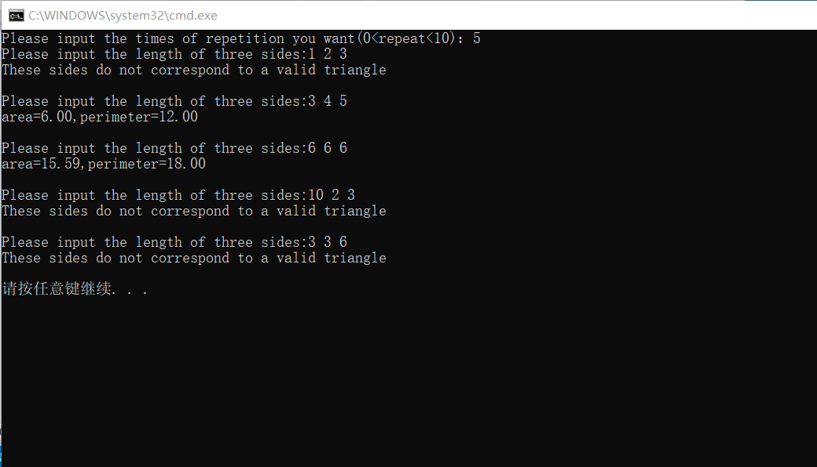

**2.竖式打印**

#include<stdio.h>

#include<math.h>

int main()

{

int a,b,c,d,result;

printf("Please input two numbers to multiply:");

scanf_s("%d %d",&a,&b);

if((11<=a&&a<=99)&&(11<=b&&b<=99))

{

c=a*(b%10);

d=a*(b/10);

result=a*b;

printf("%6d\n*%5d\n------\n%6d\n%5d \n------\n%6d\n",a,b,c,d,result);

}

else printf("Error!\n");

return 0;

}

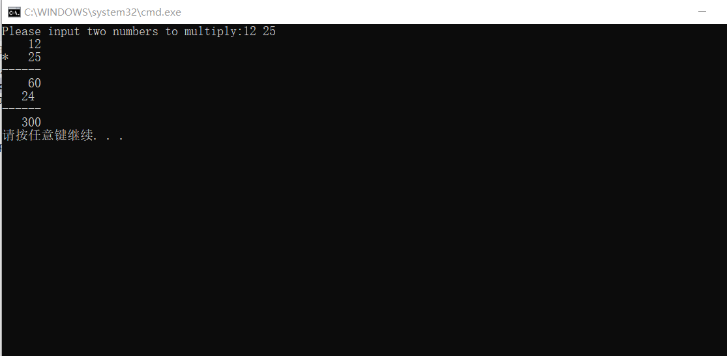

**3.数字金字塔**

#include<stdio.h>

int main()

{

int k,i,j,n;

printf("Please input the number of lines:");

scanf_s("%d",&n);

if(1<=n&&n<=10)

{

for(i=1;i<=n;i++)

{

for(j=1;j<=n-i;j++)printf(" ");

for(k=1;k<=i;k++)printf("%d ",i);

printf("\n");

}

}

else printf("Error! Please input a number between 1 and 10\n");

return 0;

}

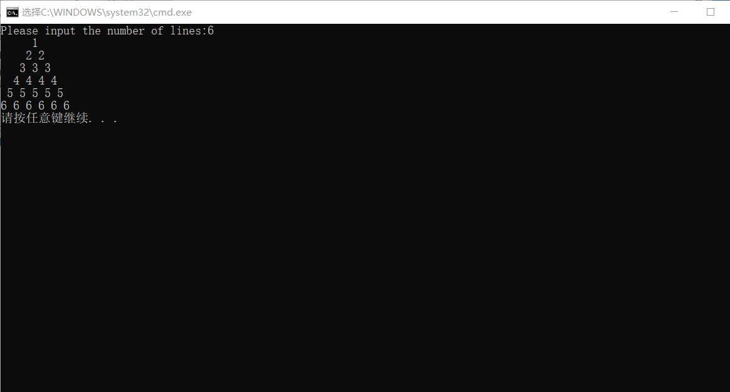

**4.铅笔工厂**

#include<stdio.h>

#include<math.h>

int main()

{

long int n,m,k,i,j;

long int normal=0,none=0,colored=0,varnish=0;

scanf_s("%ld %ld %ld",&n,&m,&k);

for(i=1;i<=k;i++)

{

if((i%(n+1))&&(i%(m+1)))normal+=1;

if((!(i%(n+1)))&&(i%(m+1)))varnish+=1;

if((i%(n+1))&&(!(i%(m+1))))colored+=1;

if((!(i%(n+1)))&&(!(i%(m+1))))none+=1;

}

printf("%ld %ld %ld %ld\n",normal,none,colored,varnish);

return 0;

}

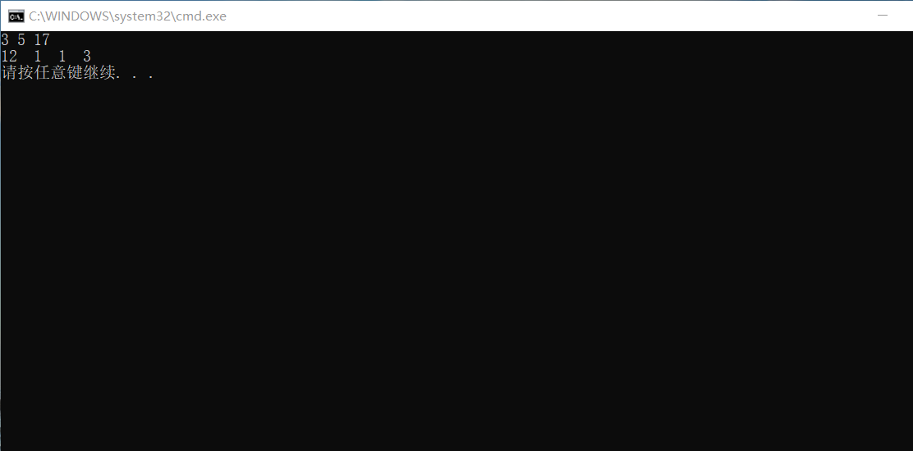

**5.计算工资**

#include<stdio.h>

#include<math.h>

int main()

{

int i;

int repeat,hrs,salary,month,days;

printf("Please input 'repeat':");

scanf_s("%d",&repeat);

for(i=1;i<=repeat;i++)

{

printf("Please input month and hours：");

scanf_s("%d %d",&month,&hrs);

switch(month)

{

case 1:case 3:case 5:case 7:case 8:case 10:case 12:

days=31;break;

case 4:case 6:case 9:case 11:

days=30;break;

case 2:days=28;break;

default: printf("Error!Invalid month!\n\n");

}

if((1<=month&&month<=12))

{

if(hrs<=160)salary=5*hrs;

else if(hrs<=160+6*days)salary=5*160+(hrs-160)*4;

else if(hrs>160+6*days)salary=5*160+6*days*4;

printf("The salary is %dyuan\n\n",salary);

}

}

return 0;

}

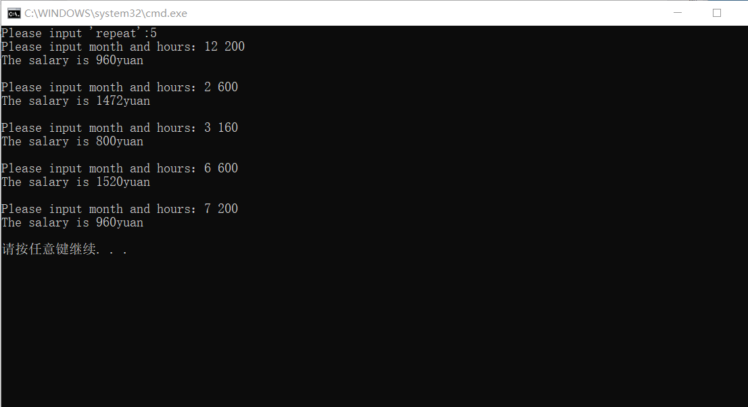

**6.个人所得税**

#include<stdio.h>

#include<conio.h>

int main()

{

int salary;

double tax;double sum[6];

double rate[7]={0.03,0.10,0.20,0.25,0.30,0.35,0.45};

char ch='a';

sum[0]=1500*rate[0];

sum[1]=sum[0]+3000*rate[1];

sum[2]=sum[1]+4500*rate[2];

sum[3]=sum[2]+26000*rate[3];

sum[4]=sum[3]+20000*rate[4];

sum[5]=sum[4]+25000*rate[5];

for(;(ch!='y')&&(ch!='Y');)

{

printf("Please input the salary:");

scanf_s("%d",&salary);

salary=salary-3500;

if(salary<=0)tax=0;

else if (salary<=1500)tax=salary*rate[0];

else if(salary<=4500)tax=sum[0]+(salary-1500)*rate[1];

else if(salary<=9000)tax=sum[1]+(salary-4500)*rate[2];

else if(salary<=35000)tax=sum[2]+(salary-9000)*rate[3];

else if(salary<=55000)tax=sum[3]+(salary-35000)*rate[4];

else if(salary<=80000)tax=sum[4]+(salary-55000)*rate[5];

else tax=sum[5]+(salary-80000)*rate[6];

printf("The tax is %.2lfyuan.\nInput y or Y to quit.\n",tax);

fflush(stdin);

ch=getchar();

}

return 0;

}

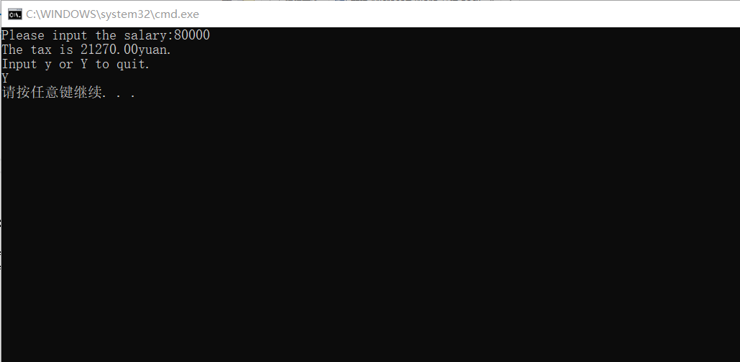

**7.极限求值**

#include<stdio.h>

#include<math.h>

void main()

{

int s=1,i,n;

float result=1;

float k=1.0;

for(i=3;(1/k)>1e-6;i+=2)

{

k=i*(i-1)*k;

s=-s;

result+=(1/k)*s;

}

n=(i-1)/2;

printf("result=%lf,n=%d\n",result,n);

}

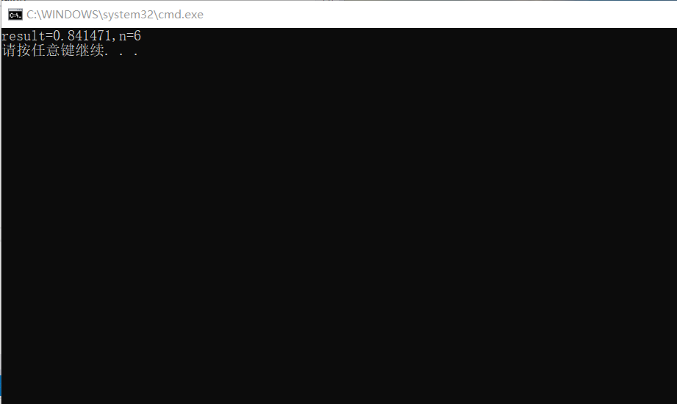

**8.数列求和**

#include<stdio.h>

#include<math.h>

int main()

{

unsigned long result=0,s;

int j,i=0,n,a;

printf("Please input n and a(1<=a<=9):");

scanf_s("%d %d",&n,&a);

s=a;

for(j=1;j<=n;j++)

{

result=result+s;

i++;

s+=pow(10.0,(double)i)*a;

}

printf("result=%u\n",result);

return 0;

}

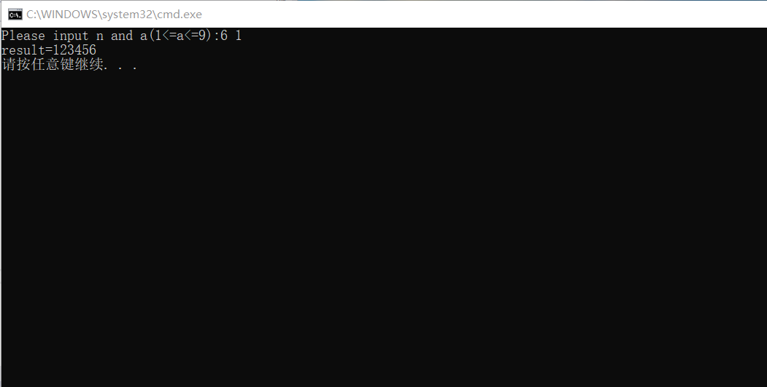

**9.素数求和**

#include<stdio.h>

#include<math.h>

int main()

{

int i,m,n,t,j,k=0,sum=0;

printf("Please input m and n:");

scanf_s("%d %d",&m,&n);

for(i=m;i<=n;i++)

{

t=sqrt((double)i);

for(j=2;j<=t+1;j++)

{

if(!(i%j))break;

if(j>=t+1){k+=1;sum=sum+i;break;}

}

}

if(m==2){k+=1;sum+=2;}

if(m==1)sum+=1;

printf("numbers are %d,sum is %d\n",k,sum);

return 0;

}

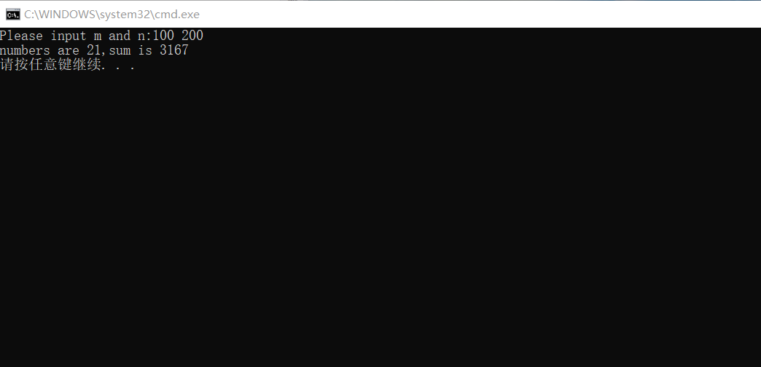

**10.谷场里的老鼠与猫**

#include<stdio.h>

#include<math.h>

int main()

{

double x1,x2,y1,y2,z1,z2,length;

double distance(double x,double y);

printf("Please input the location of the mouse:");

scanf_s("%lf,%lf,%lf",&x1,&y1,&z1);

printf("Please input the location of the cat:");

scanf_s("%lf,%lf,%lf",&x2,&y2,&z2);

if(x1!=x2||y1!=y2)length=distance(x1,x2)+distance(y1,y2)+z1+z2;

if(x1==x2&&y1==y2)length=distance(z1,z2);

printf("The distance the cat should cover is:%.2lf\n",length);

return 0;

}

double distance(double x,double y)

{

double s;

s=(x>y)?(x-y):(y-x);

return s;

}

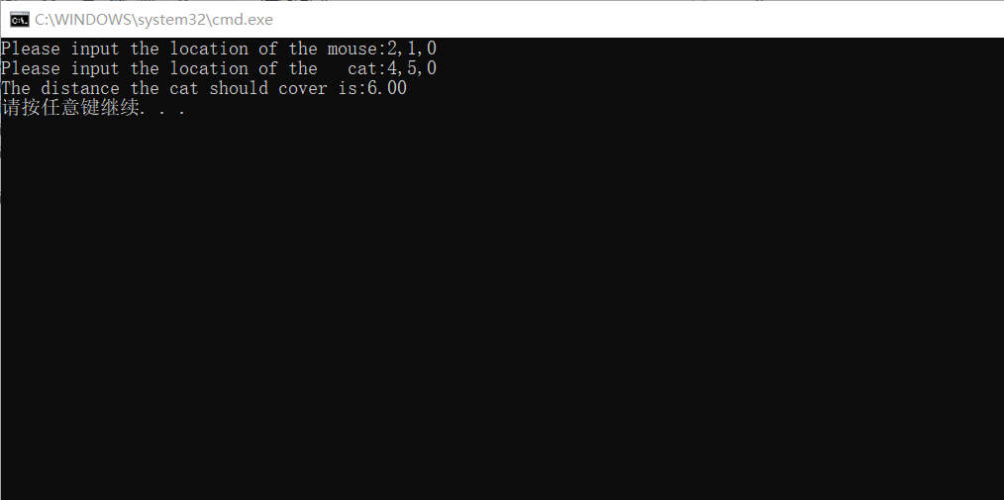

**11.方程求根**

**（1）牛顿迭代法**

#include<stdio.h>

#include<math.h>

int main()

{

double x0;

double f(double x);double f1(double x);

x0=1.5;

for(;fabs(f(x0))>1e-6;)x0=x0-f(x0)/f1(x0);

printf("The solution of the equation is: x=%lf\n",x0);

return 0;

}

double f(double x)

{

double f;

f=2*x*x*x-4*x*x+3*x-6;

return f;

}

double f1(double x)

{

double f1;

f1=6*x*x-8*x+3;

return f1;

}

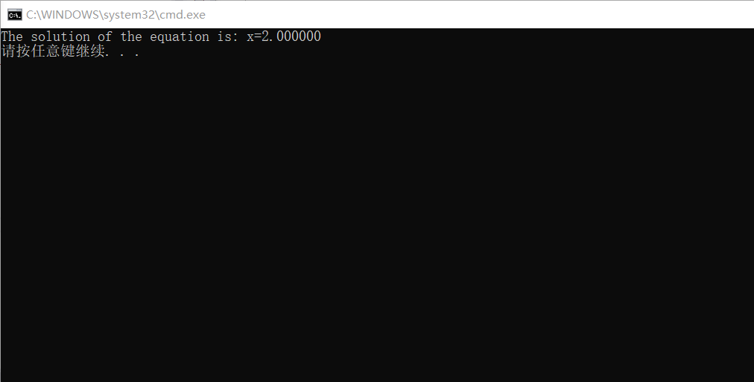

**（2）二分法**

#include<stdio.h>

#include<math.h>

int main()

{

double a,b,x;

a=10.0,b=-10.0;

double f(double x);

do{

x=(a+b)/2;

if(f(x)*f(a)<0)b=x;

if(f(x)*f(b)<0)a=x;

if(!f(x)){printf("The solution of the equation is: x=%lf\n",x);break;}

}while(fabs(f(x))>1e-6);

printf("The solution of the equation is: x=%lf\n",x);

return 0;

}

double f(double x)

{

double f;

f=2*x*x*x-4*x*x+3*x-6;

return f;

}

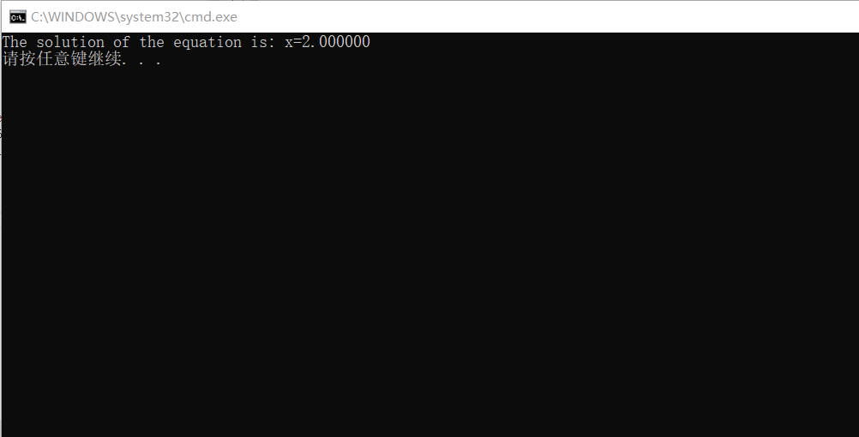

**12.案件判断**

#include<stdio.h>

int main()

{

int a,b,c,d,e;

printf("0 stands for he is sincere,1 stands for he is a criminal\n\n");

for(a=0;a<=1;a++)

for(b=0;b<=1;b++)

for(c=0;c<=1;c++)

for(d=0;d<=1;d++)

for(e=0;e<=1;e++)

{

if((a+b)&&(1<(a+d+e))&&((a+c)!=2)&&(c+d==1))

printf("the result is a=%d,b=%d,c=%d,d=%d,e=%d\n",a,b,c,d,e);

}

return 0;

}

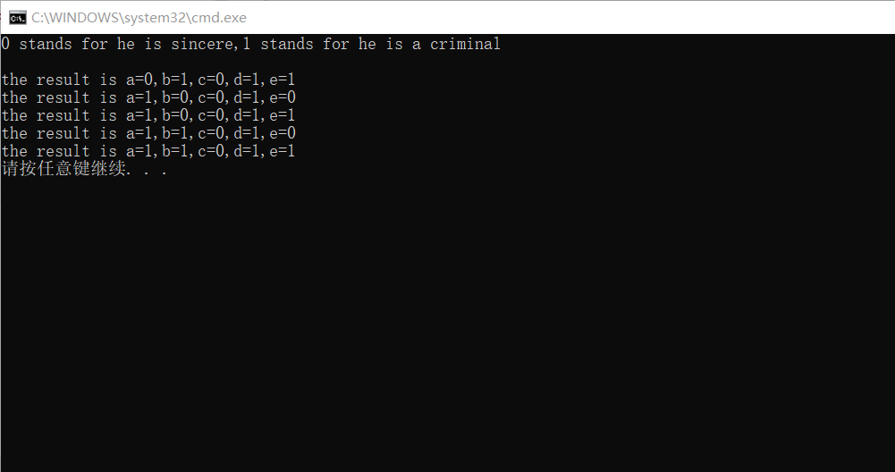

**13.数字计算**

#include<stdio.h>

#include<math.h>

int main()

{

int a1,a2,a3,b1,b2,b3,c1,c2,c3;

int m,n,k,i,t;

for(a1=1;a1<4;a1++)

for(a2=1;a2<10;a2++)

for(a3=1;a3<10;a3++)

for(b1=2;b1<7;b1++)

for(b2=1;b2<10;b2++)

for(b3=1;b3<10;b3++)

for(c1=3;c1<10;c1++)

for(c2=1;c2<10;c2++)

for(c3=1;c3<10;c3++)

{

int s[10]={0,0,0,0,0,0,0,0,0,0};

m=100*a1+10*a2+a3;

n=100*b1+10*b2+b3;

k=100*c1+10*c2+c3;

s[a1]++;s[a2]++;s[a3]++;s[b1]++;s[b2]++;s[b3]++;s[c1]++;s[c2]++;s[c3]++;

for(i=1,t=0;i<=9;i++){if(s[i]!=1)break;t++;}

if(n==2*m&&k==3*m&&t==9)

printf("%d%d%d,%d%d%d,%d%d%d\n",a1,a2,a3,b1,b2,b3,c1,c2,c3);

}

return 0;

}

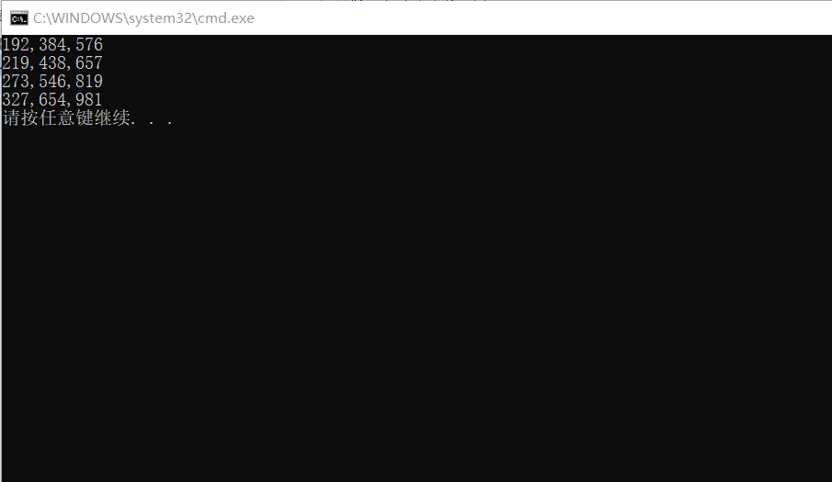

**14.数字推理**

#include<stdio.h>

int main()

{

int a[10];

int n,m,k,p;

int Judge(int x,int y);

printf("请输入整数n:");

scanf_s("%d",&n);

if(n>79||n<2)printf("Erorr!\n");

else printf("\n满足要求的表达式为:\n");

for(m=1234,2<=n<=79,m<=49383;m++;)

{

k=m*n;

p=m/10000;

if(k>=100000)break;

else if(Judge(m,k)&&!p)printf("%d/0%d=%d\n",k,m,n);//若m万位为0 则补0

else if(Judge(m,k)&&p)printf("%d/%d=%d\n",k,m,n);

}

return 0;

}

int Judge(int x,int y)//判断数字是否重复

{

int a,b,c,d,e,f,g,h,i,j;

int t=0,z=0;

int s[10]={0,0,0,0,0,0,0,0,0,0};

a=x/10000;b=(x/1000)%10;c=(x/100)%10;d=(x/10)%10;e=x%10;

f=y/10000;g=(y/1000)%10;h=(y/100)%10;i=(y/10)%10;j=y%10;

s[a]++;s[b]++;s[c]++;s[d]++;s[e]++;s[f]++;s[g]++;s[h]++;s[i]++;s[j]++;

for(i=0;i<=9;i++)

{

if(s[i]!=1)break;

else t++;

}

if(t==10)z=1;

return z;

}

