<https://github.com/liu-yuxin98/DOS5101/tree/master>

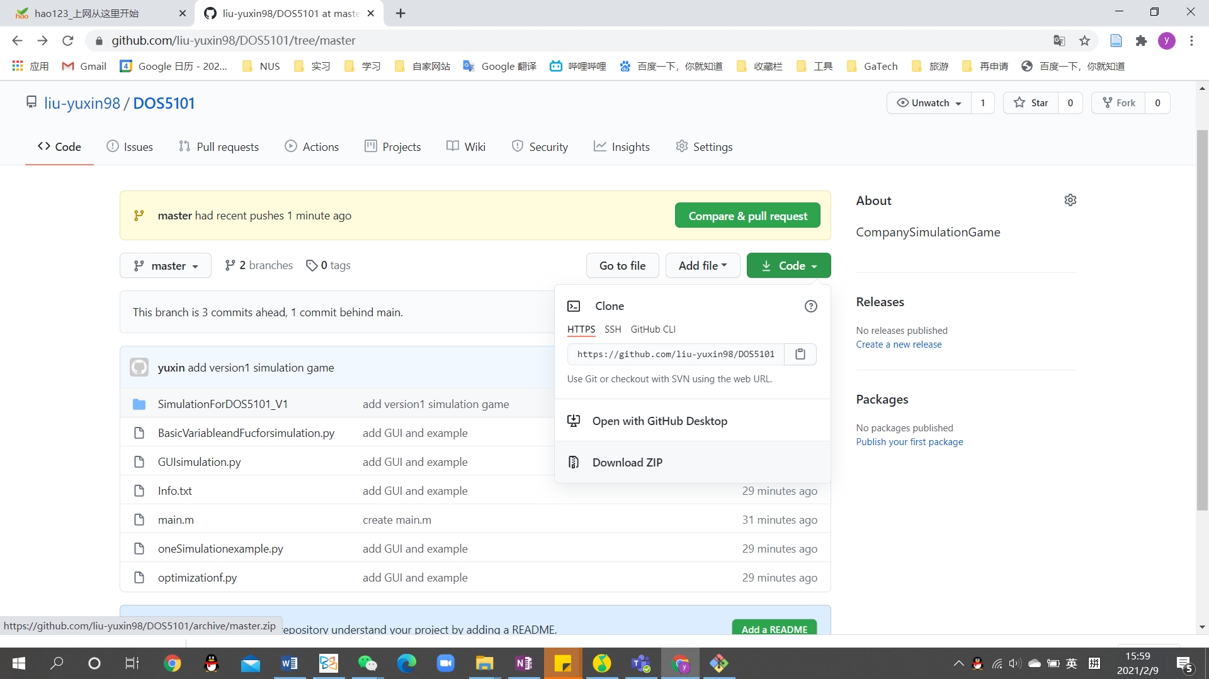

DownloadZIP

Enter simulationForDOS5101_V1 folder

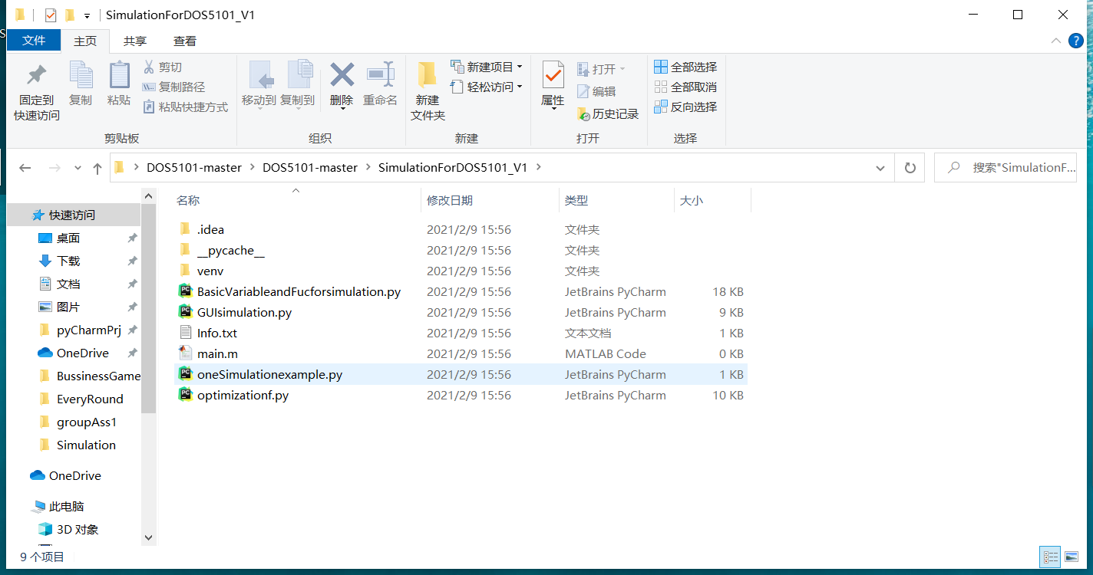

Open the oneSimulationexample.py from the folder.

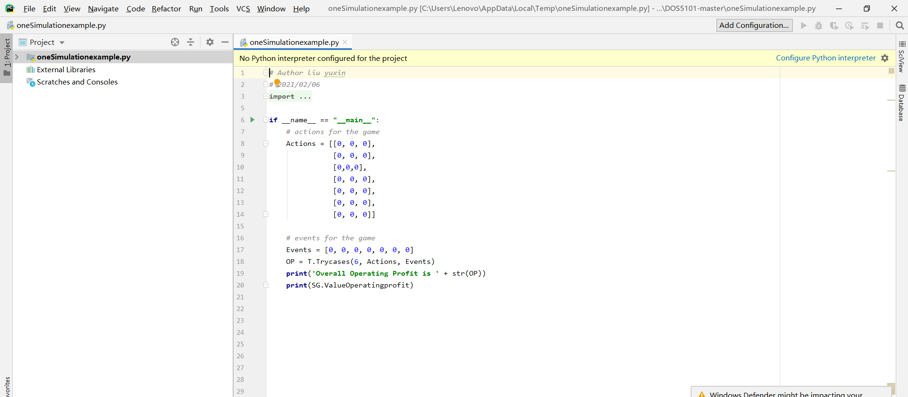

Click

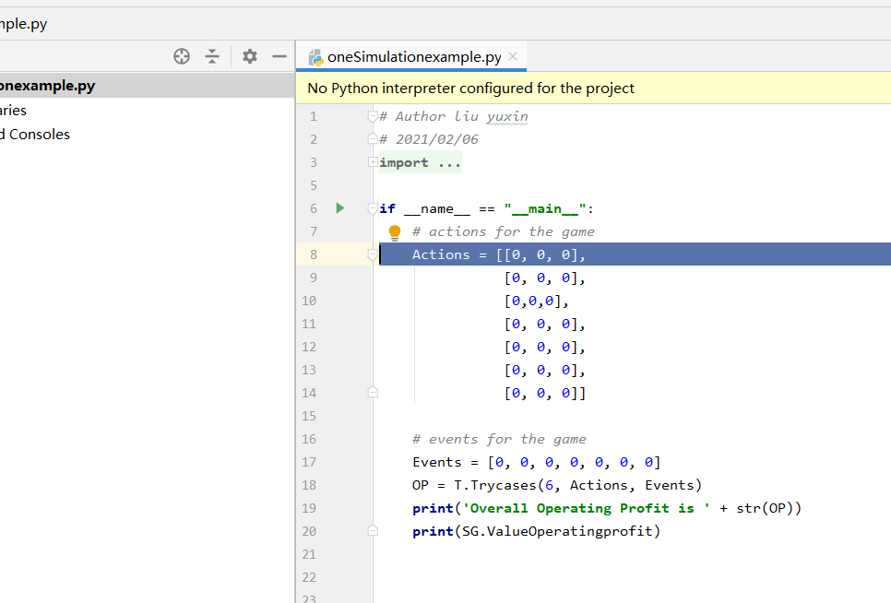

Choose the first

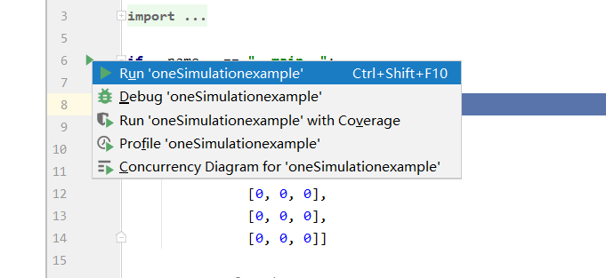

Choose Python3.7 Interpreter

results

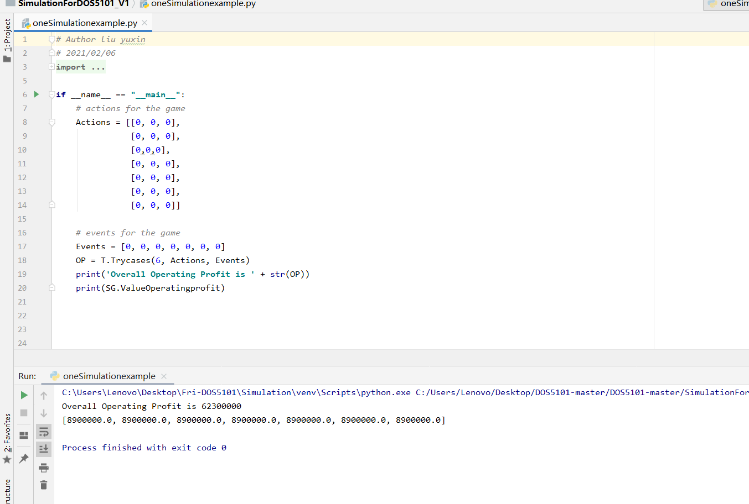

**Open GUIsimulation.py**

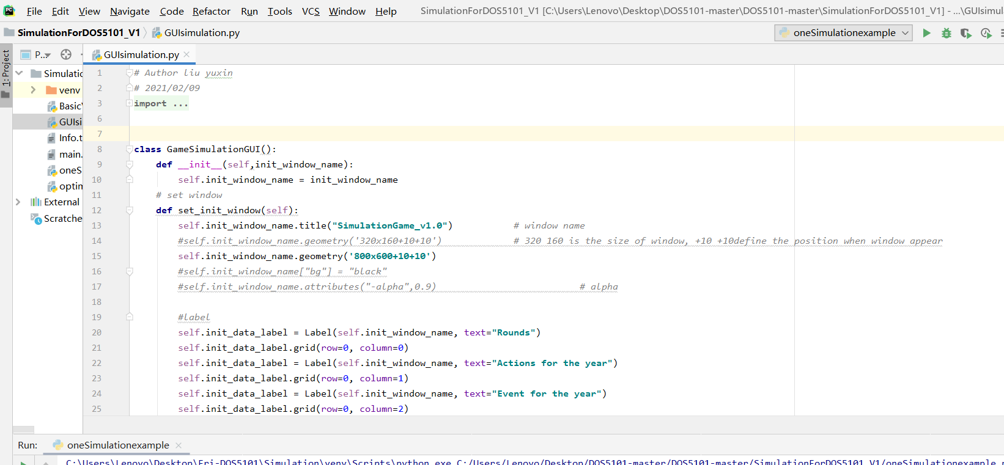

**Run**

**Choose Run not Run ‘oneSimualtionexample’**

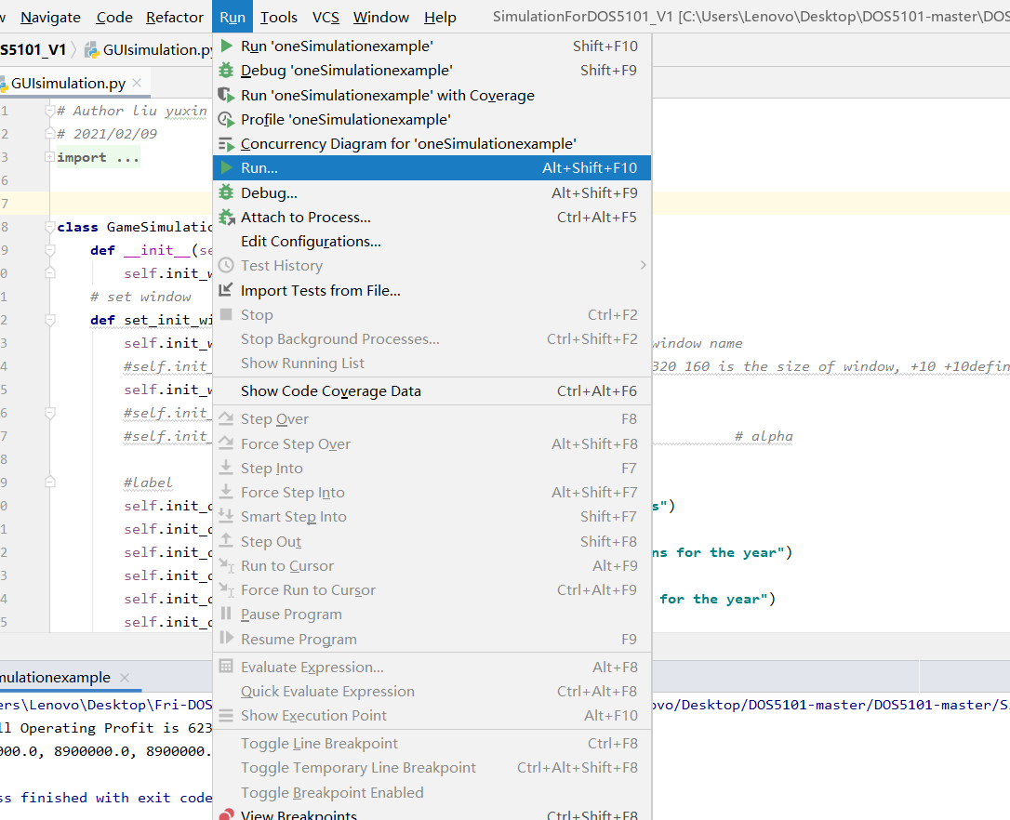

**Run GUIsimulation**

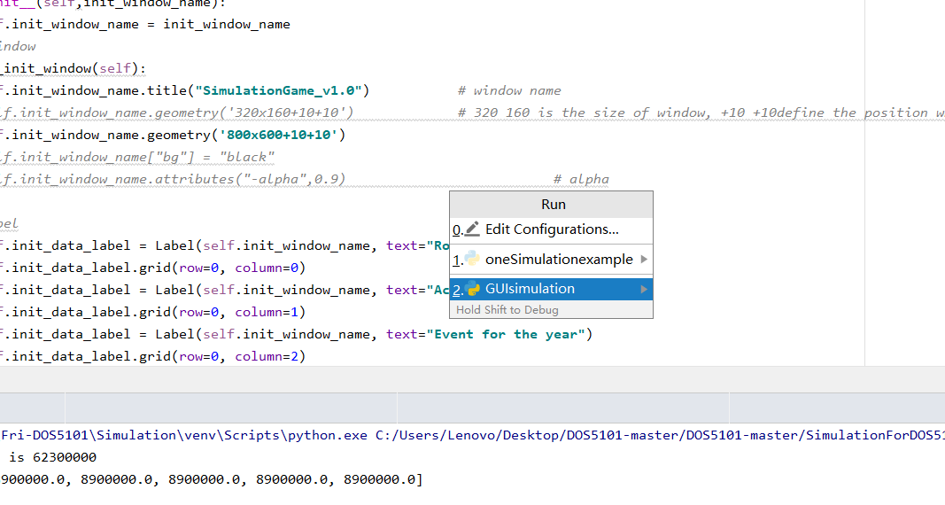

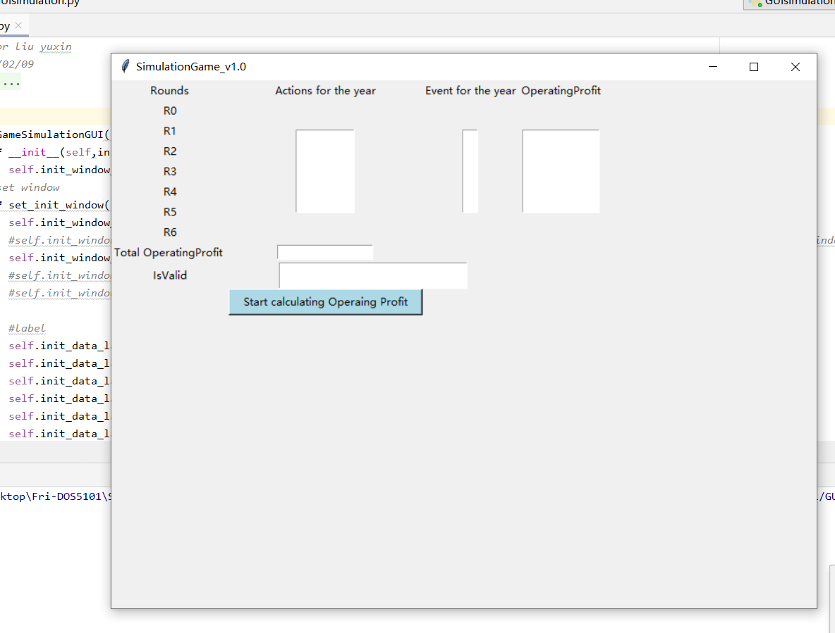

**Type in numbers stands for actions**

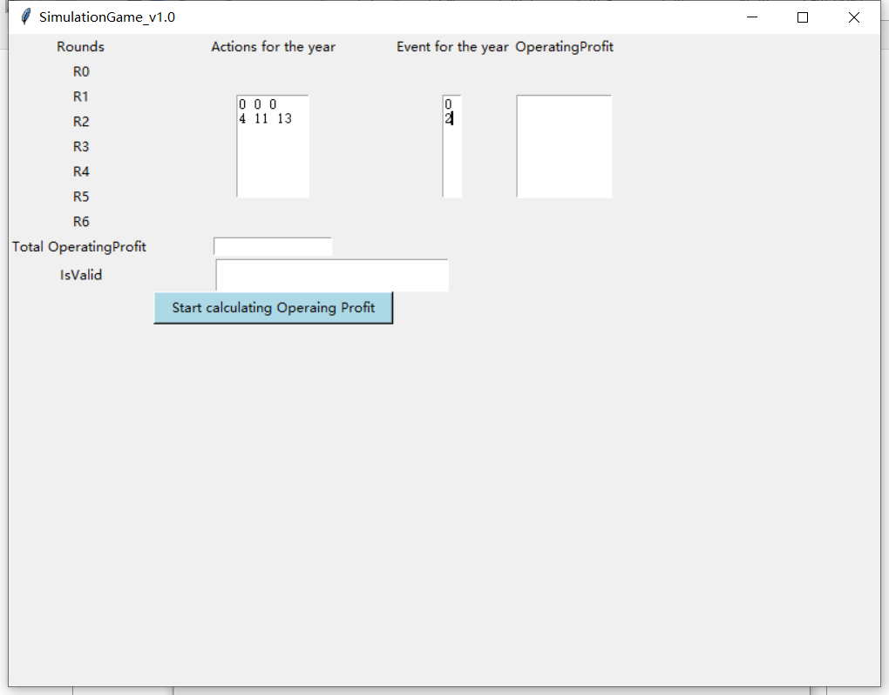

**Click start calculating**

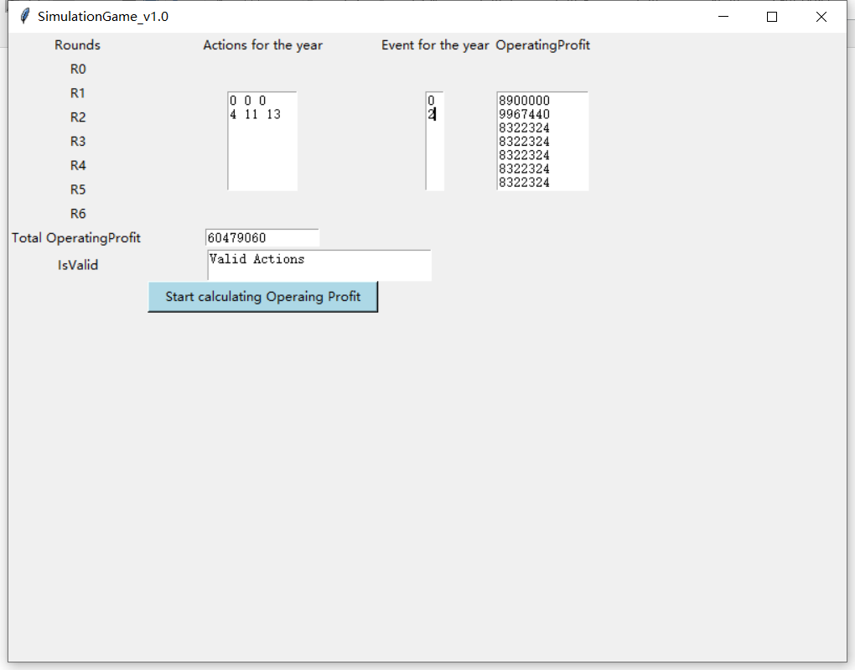

**Pay attention to the form of the number enter in.**

