Important Components:

LM7805C – 5V Voltage regulator (INPUT: 7.5V – 20V)

* From front of package: IN → GND → OUT

DS1804-100 – Nonvolatile Trimmer 100kOhm Potentiometer (INPUT:2.7V– 5.5V)

* Datasheet: <https://eu.mouser.com/datasheet/2/256/DS1804-1389127.pdf>
* INC – Input provides for W pin position chang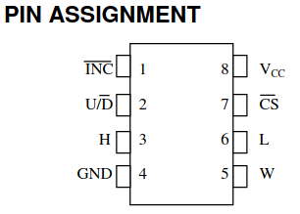es with CS pin low
* U/D – Up/Down control for the wiper movement (increase or decrease resistance)
* H – high terminal of potentiometer
* GND – ground for chip
* W – wiper of potentiometer
* L – low terminal of potentiometer
* CS – chip select with active low. High state means no activity on INC and U/D will affect W
* VCC – 2.7V – 5.5V power supply for chip
* Uses digital logic to control for 100 resistance values including L and H terminals

HEF4016BP – Quad single-pole single-throw analog switch (INPUT: 3V to 15V)

* Datasheet: <https://eu.mouser.com/datasheet/2/916/HEF4016B-1599231.pdf>
* 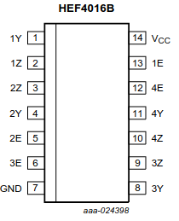Y = independent input or output
* Z = independent input or output
* E = enable input (active HIGH)
* V_CC = Supply Voltage
* GND = ground
* Digital and Analog multiplexing and signal gating (more signal gating for this PCB?)
* Basically quadruple switches

LTC6994-2 – Delay Block/Debouncer (INPUT: 2.25V – 5.5V)

* Datasheet: <https://www.analog.com/media/en/technical-documentation/data-sheets/ltc6994-1-6994-2.pdf>
* 2 at the end denotes that it delays both transitions (falling and rising edge)
* Delay determined by the resistor and the internal clock divider (8 settings)
* 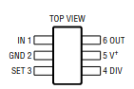IN – input waveform or signal
* GND – ground
* SET – resistor to program internal master oscillator frequency
* DIV – controls internal clock divider
  + Determined a 4 bit code determined by the pin voltage (DIVCODE)
  + MSB is polarity (inverts output for the 2 version)
  + Current circuit uses a voltage divider
* V+ - Supply voltage
* OUT – output waveform or signal with delay
* Delay Range – 1 us – 33.6 s
* 500 us start-up time

5X-1-102LF – 5-Pin 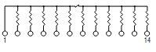Bussed 1k Ohm Resistors

Other Components

3x normal Resistors (Different Values although they are the supposed to be 22M)

* R2 and R4 are used for voltage dividers of the DIVCODE (0011 → N_DIV = 512) [Recommended for 512 uS to 8.192 ms delay]
* R2 = 1 MOhm
* R4 = 270 kOhm

1x capacitor (0.1 uF)

1x DIP Switch

2x Audio Jack

* https://cdn-reichelt.de/documents/datenblatt/C160/KB3SPRS.pdf

How the PCB works

* Input square wave in BCNIN going to delay chip
* Delay chip delays both edges of wave form based on predetermined DIVCODE from resistors and potentiometer
* Output of delay chip is sent to the enable pins of three switches controlling both jacks and BCN Bypass
  + The final enable is controlled by BNCIN and controls signal for BNC MONITOR
  + All output wave form are generated by switching on and off the V_CC source (to keep sharpness and voltage of waveform?)
  + Contains a resistor pull-up (R2) and pull-down (R1) network for maintaining the active states of pins as necessary
* K8 pin 1 to monitor output of delay chip
  + K8 pin 2 connects to pull down network and the enable of switches
* K12 pin 2 to inspect BNCIN
  + K12 pin 1 connects to input of delay chip
  + K8 pin3 connects to K12 pin 2
* K7 pin 1 to monitor the output of the digital potentiometer
  + K7 pin 2 connects to SET of delay chip
* K7 pin 3 connects to a grounded resistor part of the DIV network on delay chip
* Why does turning off power switch not shut off the waveform?

Current known functions (Outputs and Inputs)

BNCIN – Input signal

BNCBYPASS – Outputs a delayed signal of same shape as input. Delay is adjusted with the DIP switches up to a total of 1 ms. Has an inherent delay

BNCMONITOR- Output exact signal of input to pass onto next PCB in chain

DIP Switch Combos

