Camera Triggering PCB Documentation

Basic Overview
- Takes an input square wave at low frequency (3 Hz) and induces a user-controllable delay for triggering of a set of cameras via jack
- Each PCB triggers 2 cameras and has the ability to propagate the input waveform or the delayed waveform at 5 V_{p-p}

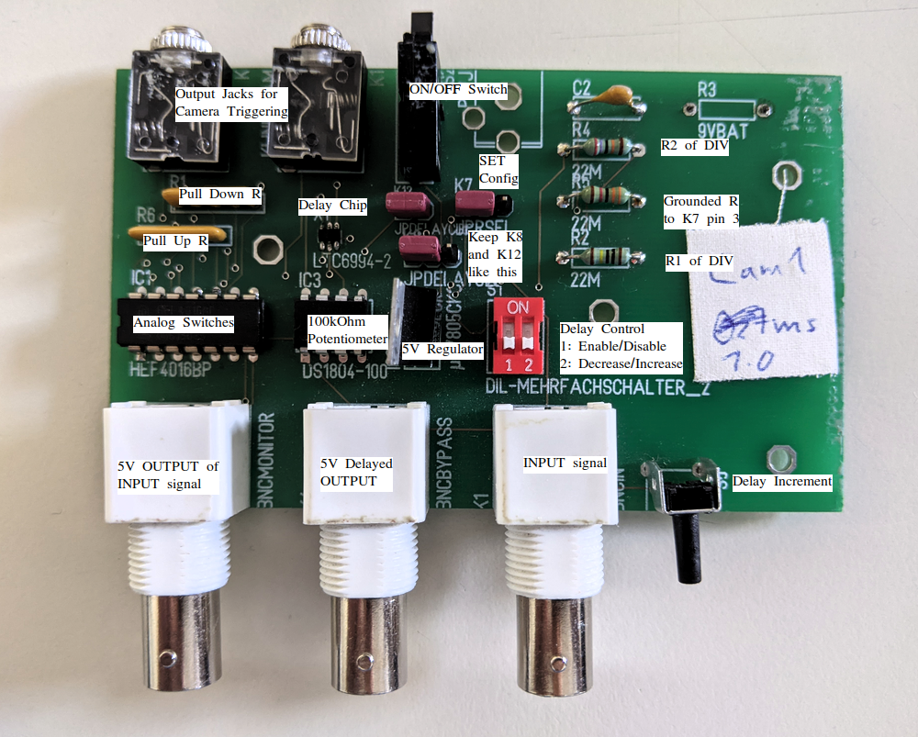

PCB Components
- LM7805C – 5 V Voltage Regulator
  - Drops 9 V DC supply to 5 V required for the other chips
  - Datasheet: https://www.digchip.com/datasheets/parts/datasheet/321/LM7805C-pdf.php

- DS1804-100 – Nonvolatile Trimmer 100kΩ Potentiometer
  - Adjusts the resistance connected to the SET pin of the delay chip to change the amount of delay for the output
  - Able to store resistance value in EEPROM
  - Datasheet: https://eu.mouser.com/datasheet/2/256/DS1804-1389127.pdf

- HEF4016BP – Quad single-pole single-throw analog switch
  - Used to trigger the cameras when enabled
  - Create 5 V_{p-p} square waves for BNCBYPASS and BNCMONITOR by enabling and disabling switch
  - Datasheet: https://eu.mouser.com/datasheet/2/916/HEF4016B-1599231.pdf

- LTC6994-2 – Dual-Edge Delay Block/Debouncer
  - Adds delay to both edges of the input signal dependent on the clock divider (DIV) and the resistance connected to the SET pin
  - Datasheet: https://www.analog.com/media/en/technical-documentation/data-sheets/ltc6994-1-6994-2.pdf

- 5X-1-102LF – 5-Pin Bussed 1kΩ Resistors
  - R6 is configured as a pull-up network for active HIGH signals
  - R1 is configured as a pull-down network for active LOW signals

- Resistors (Reference schematic for values and position)
  - Can change and configure for different delays on delay chip

- Capacitor (0.1 μF)
  - Bypass capacitor for clean signal

- Dual DIP Switch – Control delay settings through potentiometer

- Audio Jack – Output to connect to cameras

- Push Button – Adjust Potentiometer values

- Single Switch – Turn DC voltage to PCB on or off

Functional Description
- Setup Steps for PCB
  - Connect pins 1 and 2 of K12 and for K8
  - Establish a connection with pin 2 of K7 with either pin 3 K7 for fixed delay or with the potentiometer at pin 1 of K7
  - Connect to a 9 V power supply and flip power switch up to turn on
  - Input square wave to BCNIN of first PCB in chain at 3 Hz at a peak-to-peak voltage dependent on the length of the transmission line
    - Square wave should be offset to have minimum voltage at 0 V
- Functions
  - Dual DIP Switch – Controls the amount of delay to apply to input waveform
    - 1 – Enable/Disable Delay Setting
      - ON – Delay can be changed with switch 2
      - OFF – Delay cannot be changed with switch 2
    - 2 – Decrease Delay
      - ON – Able to incrementally decrease delay with push button until minimum delay is reached
      - OFF – Can incrementally increase delay with push button until maximum delay is reached
  - Push Button – Decreases or increases delay by small steps determined by resistor configuration to resistor network and Dual DIP switch settings
  - BNCIN – Input for square waveform
    - Needs high voltage for first PCB depending on distance from function generator
    - Can work with 5 V for other PCB in chains if in short proximity to each other
  - BNCBYPASS – Output 5 V_{p-p} of input waveform with induced delay
    - Connect to BCNIN of other PCB to have additive delays
  - BNCMONITOR – Output 5 V_{p-p} of non-delayed input waveform
    - Connect to BCNIN of other PCB to have the same non-delayed input
  - Schematic located at back

Delay Setting and Saving
- Dependent on configuration of the three pins and connections at K7 (without changing resistors or other soldering)
  - Pin 1 – Connected to the output of the potentiometer
  - Pin 2 – Connected to the SET pin of delay chip
  - Pin 3 – Grounded 33kΩ
- Changing resistor configuration connected to DIV pin on delay chip or resistance connected to the SET pin will affect the amount of delay
  - See detailed description for more about this
- Potentiometer value can be saved by turning switch 1 of the dual DIP switch from ON to OFF (requires LOW to HIGH transition)

Table 1. Delay Ranges for “DEFAULT” Board Settings

K7 Pin Configuration | Minimum Delay (μs) | Maximum Delay (μs) | Notes
Soldered 68kΩ between pins 1 and 2 | 700 | 1700
Connected pins 1 and 2 (jumped connection or no soldered resistors between pins 1 and 2) | 80 | 1000 | Jumps to ~590 μs of delay after hitting minimum and then flips polarity which is undesired
Soldered 68kΩ between pins 1 and 2 and connection between pins 2 and 3 | 225 | 280
Connected pins 2 and 3 with no soldered resistor or connections between pins 1 and 2 | 338 | 338 | Fixed delay due to no connection to potentiometer
Pins 1, 2, and 3 all connected with no external soldered resistors | Not Tested | Not Tested
Other Configurations:  -Soldered resistor between pins  -Changed R2 and R4 for different clock divider (refer to schematic) | 1 | 33.6 x 10⁶ | Dependent on chip and explained more in detailed description section

Camera Setup and Calibration

Recommended Settings
- Camera should be set to Mirror Up (MUP) Mode (located on spinning dial on top left of camera) to reduce delays of mirror flipping when camera is triggered
- Micro-USB connector should be used to connect the camera to audio jack of each PCB
- First PCB should have BNCIN attached to the function generator and BNCBYPASS to oscilloscope to observe triggering activity
- Second PCB in chain should have PCBIN connected to BNCMONITOR of first PCB and BNCBYPASS connected to second channel of oscilloscope
  - For successive PCB and cameras, follow same setup as second PCB
- Each PCB should only be connected to one camera unless it is known that two of the cameras have the exact same delay
- With the oscilloscope, ensure that the wave forms are equal meaning that there is no delay
- Set the server fan in the view of both cameras and adjust camera views until the fan is in focus
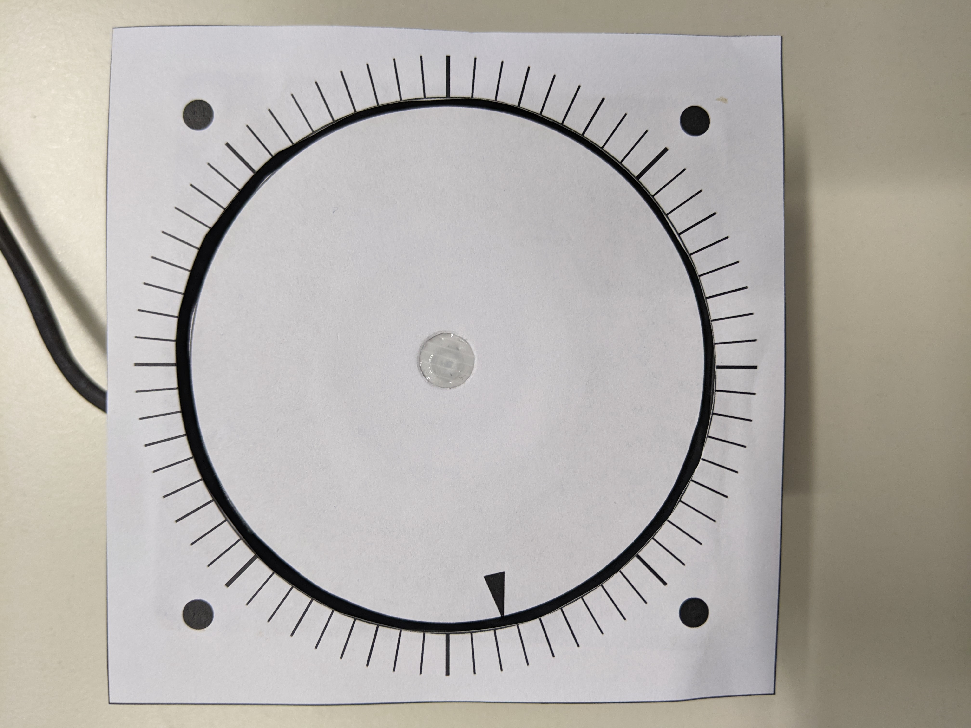
  - Put 12 V into fan with power supply to ensure max speed of ~6000 RPM for more accurate delay setting at smaller time intervals
    - The RPM can be changed depending on the desired resolution of delay by changing the voltage to the fan
  - THE FAN SPINS COUNTERCLOCKWISE (unless you use a different fan but also pay attention to fan direction then)
  - Use a stroboscope to ensure RPM before making calculations
    - Change strobe rate until there is only 1 arrow showing on fan and double that two see whether the number of arrows change
    - Real RPM is reached when doubling the current frequency shows 2 arrows (real RPM should only show 1)

Recommended Testing Procedure
- With 1 Hz wave, turning on the function generator should start triggering and taking images
  - Due to MUP Mode, an image is taken every 2 rising edges instead of just 1
- A sample size of 20 images for each camera should be sufficient for comparison for the calibration process
- Find the difference in degrees between each of the 20 images between the cameras
  - Be sure to track whether the differential is positive or negative and to which reference PCB to decide which camera to adjust or correct
- Use either MEAN or MEDIAN of the differences to begin the delay corrections
  - Median is more likely to be accurate as the mean will be skewed by some of the outlier delays from the natural jitters
- Based on the RPM of the fan, the degree difference will represent different values for average delay with faster RPM meaning less delay for the same difference
- Add delay to the faster camera and repeat the above test processes until the average delay is around 0
- Check Appendix A for conducted tests and fan specifications
Detailed Description of PCB

The PCB requires a 9 V supply either from a AC/DC converter to plug into an outlet or a battery which is dropped to 5 V by the regulator component to supply DC voltage to all the chips on the board. A switch controls the input to the regulator so the chip can be turned off at any time.

An input square signal from a function generator goes through the BNCIN connection at a minimum voltage of 0 V and maximum voltage, at the very least, equivalent to the threshold voltage for the analog switch chip plus the voltage drop off across the transmission line (can be calculated through sites various online calculators). This signal is sent to the enable of one of the analog switches, turning on and off a connection to the 5 V DC supply to create a square wave with duty cycle and frequency equivalent to the input signal causing the switching activity. The output is propagated through the BNCMONITOR connection. The signal is also sent to the input (IN) of the delay chip.

The output delay from the chip is determined by the internal clock divider (DIV) and the resistance network connected to the SET pin. The SET pin is connected to pin 2 of K7. The output of the potentiometer chip is attached to pin 1 of K7. Connecting pin 1 and 2 of K7 allows for changing of delay through changing resistance. The digital potentiometer has 100 steps of change for the resistance determined by the states of INC, U/D, and CS pins. These inputs are connected to the pull-up network with 1kΩ resistors. CS is the enable and disable of the chip, and being pulled HIGH as an active LOW pin means that it is set at disable by default. This is also connected to switch 1 on the dual DIP switch, which is connected to ground when set at ON position to enable resistance value changes. When it is not enabled, U/D and INC states have no effect on the chip. The U/D controls the direction of change for the resistance. It is connected to switch 2 of the dual DIP with the ON position setting INC to decrease resistance (LOW signal) and by default, the HIGH signal setting INC to increase the resistance. INC is the increment for stepping up or down the resistance of the potentiometer depending on the state of U/D and CS. This is connected to a push button wired to ground, so that each push changes the step only once and must be repeatedly pressed whenever change is desired. The potentiometer value can also be written to the EEPROM in chip that will boot the value every time the power supply turns on. This is done by turning switch 1 of the the dual DIP switch from ON to OFF position, as it requires a LOW to HIGH transition of the CS pin while the INC pin is HIGH (default for INC as it is connected to pull-up network).

Pin 3 of K7 can also be connected to pin 2 of K7 to create a fixed delay as pin 3 is connected to a grounded resistor. The other controlling factor for the delay is voltage divider network wired to the DIV input of the delay chip. Depending on the voltage a DIVCODE is generated for the internal clock divider which is part of the equation in for a calculated delay. The R2 and R4 resistors are used for this purpose and the currently attached values are 1 MΩ and 270kΩ. The output of the delay chip is then propagated to enable pins for the other three analog switches. More information on creating the desired delay is provided in the section below.

Two of the three analog switches are connected to the audio jacks for camera triggering. The output and input of these switch are connected to separate parts of the jack and the open circuit is closed or completed when the switch is enabled (basic functionality of camera release). The other analog switch is connected BNCBYPASS and the 5 V source to generate a square wave, in the exact method for BNCMONITOR. As these enables for the switches are controlled by delayed signal, they will trigger the camera at a later time, as desired, compared with the input signal. The delayed signal can also then be monitored through the BNCBYPASS connection. By default, these all 4 analog switches have their enables connected to a pull-down network, so the result of no output from the delay chip should theoretically yield nothing. Pin 1 of K8 is connected to the delay chip output and pin 2 of K8 is connected to the enables of the switches, so these must be connected for the output to be observed.

If a chain of cameras require triggering, this can be connected to other PCBs of the same design. The BNCIN of the first PCB in chain must have a signal with enough voltage as mentioned earlier. For the BNCIN of the other PCBs, the BNCMONITOR and BNCBYPASS should provide enough voltage if the boards are not significantly far apart. If the boards provide enough delay as is, monitor signal can be passed directly as input. Otherwise, the bypass signal can be used and the next board’s delay can be added on continuously throughout the chain. It should be noted that these signals will only have 5 V max.

Other Methods to Set Delay
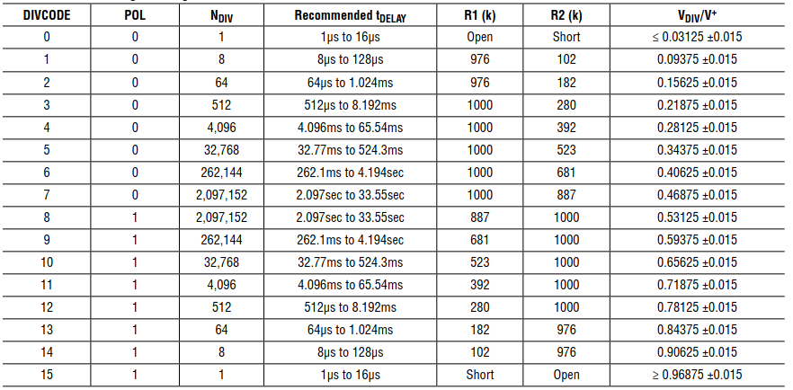
If the current board configuration does not provide the necessary delay, this can be changed by either setting the resistor configuration for the internal clock divider (DIV) for the delay chip. These are currently controlled by R2 and R4 on the PCB and can be set up using the table above. R2 corresponds with R1 and R4 with R2. This should be a quick cut and solder operation.

The next step for specifying the delay is to the configure the K7 pins or SET resistor network. With the SET pin at K7 pin 2, either the 100kΩ potentiometer network at K7 pin 1 or the grounded resistor at K7 pin 3 or both can be wired to pin 2. If an exact fixed delay is required, wire only pin 3 to pin 2 and set/replace R5 with desired value fitting equation below. To have adjustable delay, connect pin 1 to pin 2 either via jumper or soldered resistor if you want to raise the min range of delay.
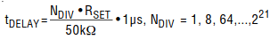

Appendix A

Table A. Calibration Photos of Two Cameras on Different Trigger Boards with No Delay with Fan at 6000 RPM

Photo # | CAM 004 | CAM 002 | Degree Difference (º) | Time Difference (μs)
1 | 325 | 300 | 25 | 694.4
2 | 150 | 165 | -15 | -416.7
3 | 295 | 285 | 10 | 277.8
4 | 130 | 135 | -5 | -138.9
5 | 280 | 290 | -10 | -277.8
6 | 100 | 80 | 20 | 555.6
7 | 275 | 270 | 5 | 138.9
8 | 95 | 50 | 45 | 1250
9 | 250 | 260 | -10 | -277.8
10 | 40 | 40 | 0 | 0
11 | 260 | 265 | -5 | -138.9
12 | 55 | 35 | 20 | 555.6
13 | 255 | 250 | 5 | 138.9
14 | 380 | 355 | 25 | 694.4
15 | 235 | 225 | 10 | 277.8
16 | 340 | 335 | 5 | 138.9
17 | 190 | 195 | -5 | -138.9
18 | 310 | 300 | 10 | 277.8
19 | 170 | 160 | 10 | 277.8
20 | 290 | 295 | -5 | -138.9
Mean: 6.75 (187.5 μs), Median: 5 (138.9 μs)

Table B. Photos with Adjusted PCB Delay of 150 μs

Photo # | CAM 004 | CAM 002 | Degree Difference (º) | Time Difference (μs)
1 | 215 | 225 | -10 | -277.8
2 | 200 | 185 | 15 | 416.7
3 | 185 | 180 | 5 | 138.9
4 | 90 | 115 | -25 | -694.4
5 | 55 | 95 | -40 | 1111.1
6 | 15 | 10 | 5 | 138.9
7 | 345 | 355 | -10 | -277.8
8 | 335 | 325 | 10 | 277.8
9 | 315 | 315 | 0 | 0
10 | 285 | 290 | -5 | -138.9
11 | 285 | 300 | -15 | -416.7
12 | 280 | 270 | 10 | 277.8
13 | 270 | 270 | 0 | 0
14 | 265 | 250 | 25 | 694.4
15 | 245 | 240 | 5 | 138.9
16 | 215 | 220 | -5 | -138.9
17 | 210 | 220 | -10 | -277.8
18 | 200 | 190 | 10 | 277.8
19 | 205 | 205 | 0 | 0
20 | 215 | 220 | -5 | -138.9
Mean: -2.5 (-69.4 μs), Median: 0

As Cam 4 was used for reference, the delay was adjusted on the board attached to Cam 2 since the average difference was positive showing that Cam 4 was faster. The difference of 5 degrees at 6000 RPM is equivalent to about 150 μs. With the delay correction, it could be seen that on table b, the median has shifted to an average of almost no difference. However, it can be seen that there are differences between many of the photos due to jitters, which can range up to 1 ms in either direction. These jitters can be due to camera or in the power supply to the fan.

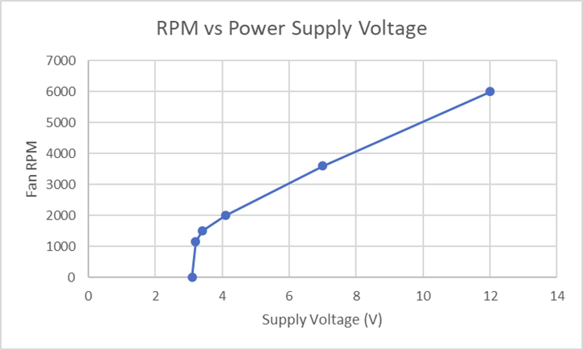

The chart above shows roughly the RPM of the fan if another testing speed is desired. Double check with a stroboscope for more accurate results.

