QuickStartGuide_VS2010

Here are the brief instructions on how to quick start using NativeViewer under Visual Studio 2010:

* Download and install the latest NativeViewer [VSIX package](https://sourceforge.net/projects/nativeviewer/files/VisualStudio2010). Or get it directly from the [Visual Studio Gallery](http://visualstudiogallery.msdn.microsoft.com/657956e4-8e02-4764-8022-72a0c9cc5b17).

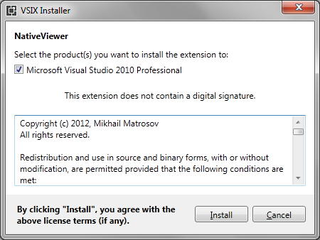

* Start Visual Studio 2010, go to *Tools -> Options... -> NativeViewer -> Integration* and follow instructions listed on that page. This step should be done again if you update to the newer version of NativeViewer.**Note!** This step requires Visual Studio to have Administrator privileges.

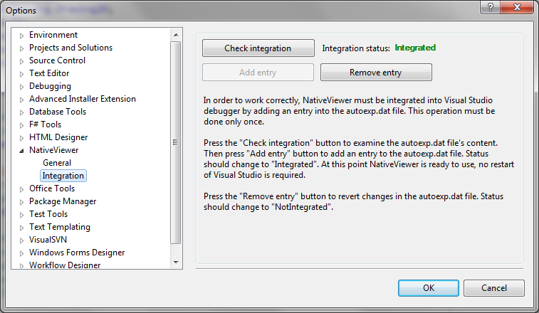

* Open your native C++ project, start debugging. Chose a variable of cv::Mat type storing 2-D matrix with CV_TYPE equal to CV_8UC1 or CV_8UC3. Hold down the CTRL key, and hover a mouse over the variable in the code editor window.

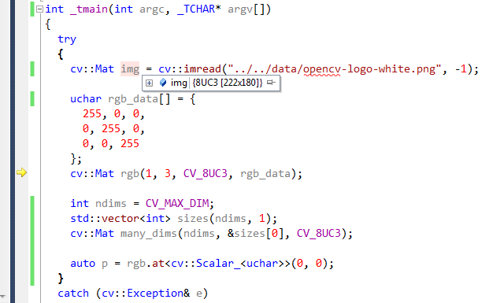

* Enjoy the thumbnail image.

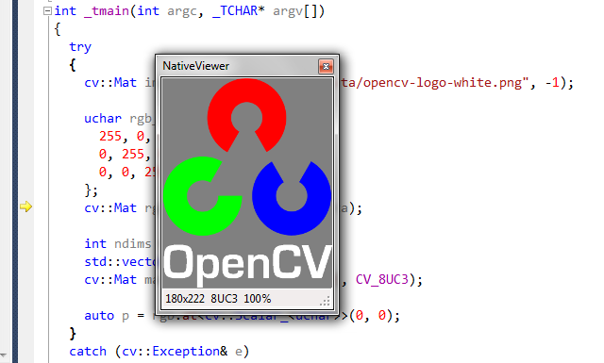

* Adjust the settings under *Tools -> Options... -> NativeViewer -> General* to optimize your usage experience. The settings are applied immediately, you don't even have to restart you current debug session.

