Project1-Part 2





The LDA and KLDA transformations of data
电 话
专 业
课程名称
班 级
学 号
姓 名

年 月 日

Abstract
It should be an explicit summary of the report that states the problem, the methods used, the major experiments, discussions and conclusions.

1. Introduction

2. LDA and KLDA
2.1 Theory of LDA and KLDA
In this section, the background, principle and derivation formula on LDA and KLDA should be described soundly.

2.2 The LDA and KLDA for "data_LDA.txt"
In this section, an actual project about classification of data sets is required to carry out with LDA and KLDA. The steps and results of processing should be given in detail. The original data was given as follows, the data from different classes in which were marked as red (1st-201th data in "data_LDA.txt") and blue (202th-402th data in "data_LDA.txt") respectively.
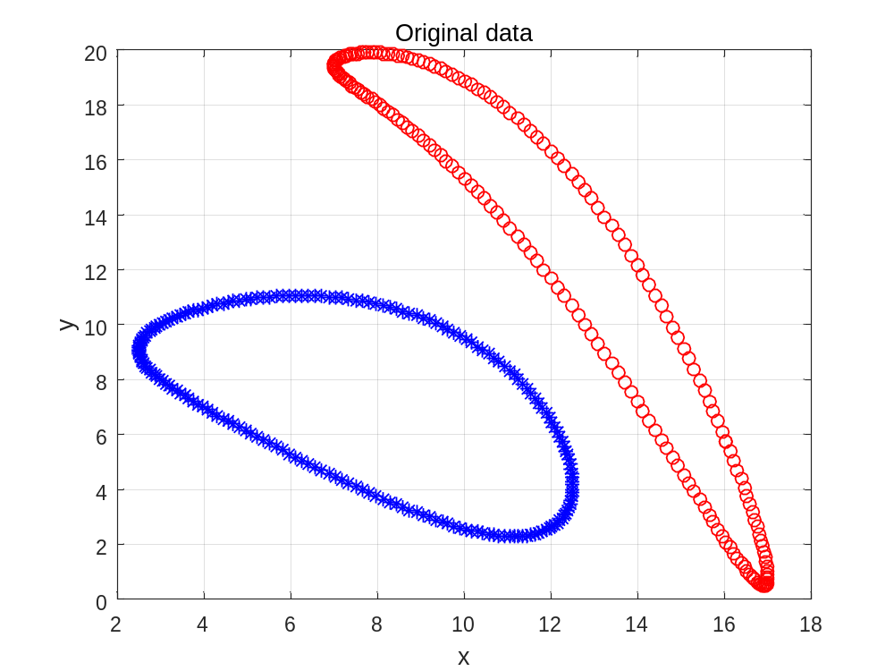

3. Conclution

Appendix
Give the used Codes
Specify your environment and how to execute.

