

Design Document

Team: NEES

Project: Interface

Date: Dec 8th, 2012

# 1 Table of Contents

1 Table of Contents 2

2 Revision History 3

3 Design Status Summary 4

4 Project Charter 5

4.1 Description of the Community Partner 5

4.2 Stakeholders 5

4.3 Project Objectives 5

4.4 Outcomes/Deliverables 5

4.5 Overall Project Timeline 5

5 Overall Project Design 6

5.1 Phase Six 6

5.2 Phase Five 7

5.3 Phase Four 8

5.4 Phase Three 9

5.5 Phase Two 10

5.6 Phase One 11

6 Semester Documentation (current semester) 12

6.1 Team Member 12

6.2 Current Status and Location on Overall Project Timeline 12

6.3 Goals for the Semester 12

6.4 Semester Timeline 12

6.5 Semester Budget 12

6.6 Transition Report 12

6.6.1 Summary of Semester Progress / Comparison of Actual Semester Timeline to Proposed Semester Timeline 12

6.6.2 Draft Timeline for (next semester) and Relationship to Overall Project Timeline 12

7 Past Semester Archive 13

7.1 Past Semester 1 13

7.1.1 Past Team Members 13

7.1.2 Past Timeline 13

7.2 Past Semester 2 13

7.2.1 Past team Members 13

7.2.2 Past Timeline 13

# 2 Revision History

|  |  |  |
| --- | --- | --- |
| **Date** | **Author** | **Revisions Made** |
| 12/8/2012 | Jingye Liu |  |
| 12/16/2012 | Jingye Liu |  |

# 3 Design Status Summary

|  |  |
| --- | --- |
| **Phase 6: Service / Maintenance** | **Status:** **Not Completed** |
| ***Gate 6: Project Partner and Advisor approve continued fielding of project. If not, retire or redesign.*** | |
| Date of Advisor approval: |  |
|  |  |
| **Phase 5: Delivery** | **Status:** **Not Completed** |
| ***Gate 5: Continue if Project Partner, Advisor and EPICS Admin agree that project is ready for delivery!*** | |
| Date of Advisor approval: |  |
|  |  |
| **Phase 4: Detailed Design** | **Status:**  **In Progress** |
| ***Gate 4: Continue if can demonstrate feasibility of solution (is there a working prototype?). Project Partner and advisor approval required.*** | |
| Date of Advisor approval: |  |
|  |  |
| **Phase 3: Conceptual Design** | **Status:**  **Completed** |
| ***Gate 3: Continue if project partner and advisor agree that solution space has been appropriately explored and the best solution has been chosen.*** | |
| Date of Advisor approval: | September 15, 2012 |
|  |  |
| **Phase 2: Specification Development** | **Status: Completed** |
| ***Gate 2: Continue if project partner and advisor agree that you have identified the “right” need, specification document is completed and no existing commercial products meet design specifications.*** | |
| Date of Advisor approval: | September 8,2012 |
|  |  |
| **Phase 1: Project Identification** | **Status:**  **Completed** |
| ***Gate 1: Continue if have identified appropriate EPICS project that meets a compelling need for the project partner.*** | |
| Date of Advisor approval: |  |

# 4 Project Charter

## 4.1 Description of the Community Partner

Network for Earthquake Engineering Simulation (NEES) is the organization working with EPICS on this project. NEES’ mission is to give researchers the tools necessary to research how earthquakes impact buildings and other structures. The project partner for NEES is Dr. Pamela McClure.

The mission is to design and create a simple and easy to use shake table and interface for teachers and students to learn about the simple dynamics of earthquakes by simulating simple earthquake properties. School teachers, NEES and the EPICS team will be those that benefit the most from the project. Institutions/organizations wishing to use the shake table will have access to it through purchase or a form of rental program.

## 4.2 Stakeholders

## Due to the potential widespread impact of this project there are several different stakeholders for this project. The primary stakeholders are school teachers, students, NEES, EPICS students, Dr. Pamela McClure, Dr. Sean Brophy and educational institutions etc.

## Students and teachers will benefit the most from this product as they will have access to an interactive easy to use learning tool. NEES on the other hand will benefit as the primary client and sponsor of this project. Moreover, EPICS students will benefit from the design experience gained while working on the project. Also, the educational institutions who are interested in purchasing interactive learning tools will benefit from the availability of this product in the market.

## The main driving forces behind this project are Dr. Sean Brophy and Dr. Pamela McClure who are there to make sure that the project is completed and delivered to the client (i.e. NEES) in a timely manner.

## 4.3 Project Objectives

The motivation of the project was to provide an affordable, fun, safe, interactive and portable shake table to schools for educators to use as a teaching aid for understanding the basic effects of earthquakes. The project consists of two teams. One team will design a functional shake table and the other team will design an interface. The interface will be a mat on the floor that students can jump on top of. A sensor in the matt will send signals to a computer and micro controller in the shake table. Here the signals can be used to drive the shake table so students can make their own earthquake. The shake table needs to be such that it is safe to use, easy to use and is durable. NEES’ mission is to provide a shake table that fits these criteria and the project currently being worked on by the assigned EPICS team aims to accomplish this task. Does your project fit within the mission of the project partner and your team?

## 4.4 Outcomes/Deliverables

## The project results will be a functional prototype that will be used to further modify and adjust to a final product that will work with the highest efficiency. When finished, the prototype will be left behind with notes on specifications and other details about the process to which the team reached the goal for others and future teams to work on. This will help future teams to replicate and improve the work done by the current team.

## 4.5 Overall Project Timeline

# The basic functional model is finished at the end of this semester, when the interface which is using ARDUINO board to control stepper motor as generating output, get acceleration from 3 ways accelerometer as input. And a serial control algorithm from acceleration to motor shaking has be done mostly.

More features and functions will be

# 

# 5 Overall Project Design

## 5.1 Phase Four

|  |  |  |
| --- | --- | --- |
| **Phase 4: Detailed Design** | **Status:** | **Evidence can be found:** |
| Goal is to design working prototype which meets functional specifications. | | |
| * Bottom-Up Development of component designs | In Progress | Notebook |
| * Develop Design Specification for components | In Progress | Notebook |
| * Design/analysis/evaluation of project, sub-modules and/or components (freeze interfaces) | In Progress | Notebook |
| * Design for Failure Mode Analysis (DFMEA) | In Progress | Notebook |
| * Prototyping of project, sub-modules and/or components | In Progress | Notebook |
| * Field test prototype/usability testing | In Progress |  |
| ***Gate 4: Continue if can demonstrate feasibility of solution (is there a working prototype?). Project Partner and advisor approval required.*** | Decision: | Rationale summary: |
| Advisor approval: | Yes / No | Date: |

**Develop Design Specification**

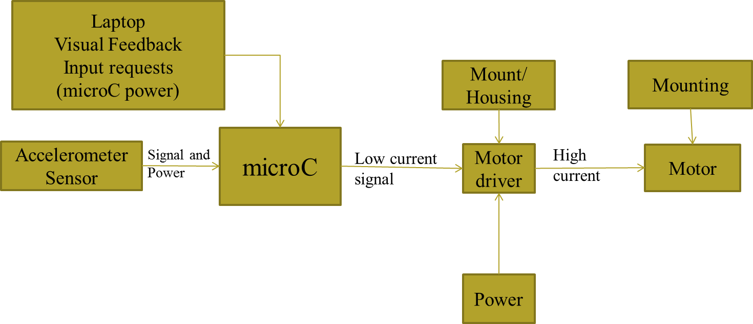

The majority parts of model are decided and settled, but there are still something detailed left undecided, like power supply, some port conversion, but we can already start working on program from the parts we have.

The motor driver for ARDUINO is Easy Driver, which is assembled by hands to connect with micro controller. The easy driver is taking power supply for motor rotation and motor control. Easy driver is chosen from several candidates, and we choose it because is most reliable and the price of it lowest from them. Unlike the Arduino Shield, which might save more labor work, but it can also cause the signal interruption when running motor, at that time, motor can be out of control and vibrating. That’ the reason we don’t not use it.

Instead of QCN, we currently are using is a 3 ways accelerometer, which is compatible with our microcontroller and can be implemented easily. QCN has more function, but more difficult to interface with, and a universal accelerometer has enough data we want, and can reduce our budget effectively.

Additional power supply for ARDUINO and motor driver kit is also needed if it’s delivered, and an 12 v is enough for one shake table.

Computer is our graphic interface, which is easier to access and more functional than the usual LCD + switcher combination.

The stepper motor we are using now seems not powerful enough to run the plate. The reason might be gear assembling problem, or the power limit of the motor.

**Wiring Interface**

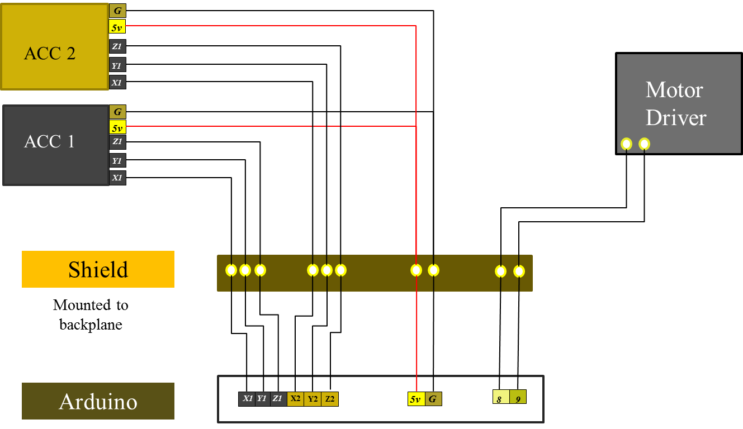

**Microcontroller**

Introduction

We are using the Arduino Uno for this project. It is programmed in Sketch, a derivative of c. The microcontroller communicates with a computer running the user interface. These two devices communicate through a USB(serial) connection. The microcontroller controls the stepper motor using a separate motor driver. An accelerometer can be connected in order to graph data on the pc. An diagram of the programs logic can be seen below. See the attached code for the complete implementation of this.

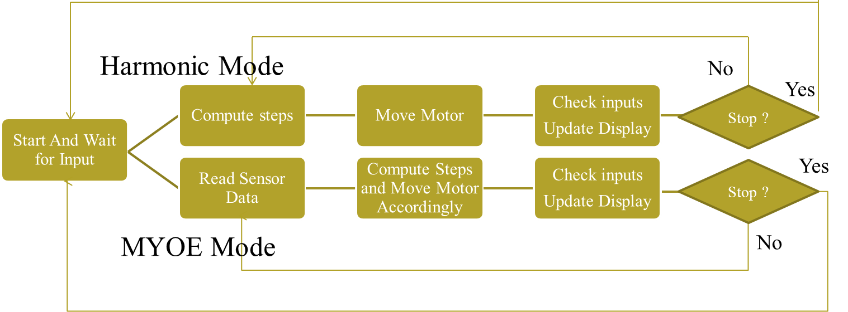

**Stepper Motor**

The stepper motor is controlled via a motor driver that is connected to the microcontroller on pin 8 and 9. A voltage change from low to high on pin 8 will cause the stepper motor to take one step in the direction of rotation. There must be a pause of at least 500 microseconds between the change from HIGH to LOW and the next change from low to high. Pin 9 controls the direction of rotation. A value of HIGH will cause it to step in one direction when given the step signal, while a value of LOW will cause it to rotate in the opposite. For the context of this project, the actual direction of the rotation does not matter because the during every iteration of the loop, the motor rotates an equal distance in both directions, causing it to return to the origin. See the attached code for the practical implementation of this.

**Serial Connection**

The Arduino Uno can communicate over a USB connection. For this project the microcontroller is connected to a computer running the interface for the project using this serial connection. Commands take the form of a series of four bytes sent in quick succession. These dictate whether the table should be running or not, what function to use in moving the table, what frequency to move the table at, and what the amplitude of the movement should be. The microcontroller collects input from the accelerometer and sends this across the serial connection to the interface. Each set of data from the microcontroller contains a known prelude in order to synchronize with the interface. See the attached code for the practical implementation of this.

**Accelerometer**

The accelerometer records the acceleration in the x, y, and z axises. The power for this device is received from the available 5v and ground pins on the Arduino. The data collected on the acceleration in the x, y, and z axises is collected on three of the analog pins available on the Arduino. This information is polled after every iteration of the loop and sent to the interface across the serial connection. See the attached code for the practical implementation of this.

**Graphic Interface**

Graphic interface is using PC in our project, which is programmed by C# code. GUI in computer should handle the serials connections with the micro controller to implement the motor control. Two main functions are divided by tab control in C# form. The function 1 in the first tab is linear motion control and signal feedback from micro controller, and the function 2 in the second tab is signal feedback from the accelerometer.

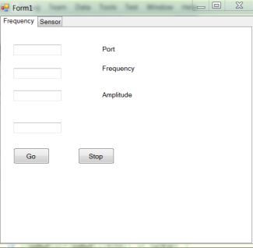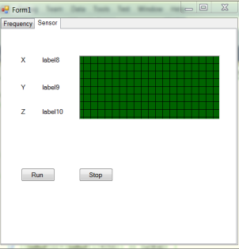

In function 1 (Frequency Tab), GUI program will send a size 4 byte array to Arduino board after click the “Go” Button. First element in the array is to control motor run or not, 0 is stop, 1 is run; Second byte is to choose the function: 0 is function 1 and 1 is function 2, and third byte and forth byte stand for the frequency and amplitude. Similarly, Stop button will send a 0 in second byte, after that the motor will stop.

When start Function 2, the program will check 8 bytes: 2 for start tag; 2 for x accelerometer; 2 for y; and 2 for z. So if the start tag is correct, then the program will get the signal from x, y, z accelerometer and do the calculation to get the sum of them. Finally the value will be display on a real time accelerometer graph.

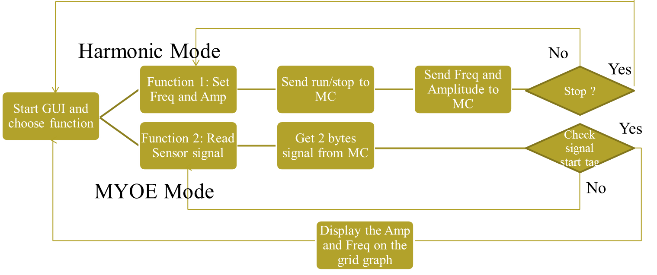

## 5.2 Phase Three

|  |  |  |
| --- | --- | --- |
| **Phase 3: Conceptual Design** | **Status:** | **Evidence can be found:** |
| Goal is to expand the design space to include as many solutions as possible. Evaluate different approaches and selecting “best” one to move forward. Exploring “how”. | | |
| * Complete functional decomposition | Complete | Sharepoint, Previous Doucument and Power Point presentation |
| * Brainstorm several possible solutions | Complete | Notebook |
| * Prior Artifacts Research | Complete | Sharepoint and Previous Doucument |
| * Create prototypes of multiple concepts, get feedback from users, refine specifications | Complete | Sharepoint, Previous Doucument and Power Point presentation |
| * Evaluate feasibility of potential solutions (proof-of-concept prototypes) | Complete | Sharepoint, Previous Doucument and Power Point presentation |
| * Choose "best" solution | Complete | ARDUINO board and Shield |
| ***Gate 3: Continue if project partner and advisor agree that solution space has been appropriately explored and the best solution has been chosen.*** | Decision: | Rationale summary: |
| Advisor approval: | Yes / No | Date: |

**Functional Decomposition**



Input: Computer; Accelerometer Sensor

Processor: Micro Controller;

Output: Motor with Motor Driver; Computer

And Motor needs individual power supply to run it. Each circuit except the PC and accelerometer sensor of the final product will be mounted in the table/box.

**Several Possible Solutions**

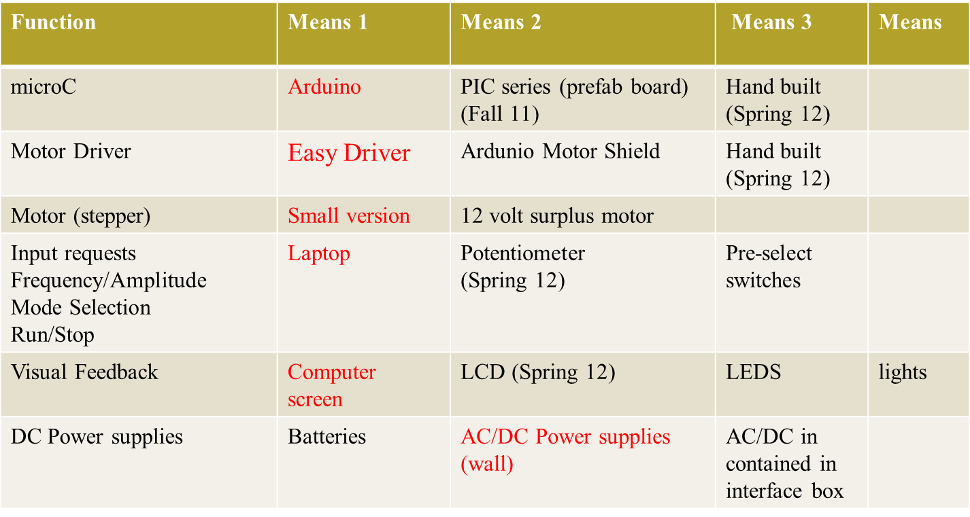



## Considering about the materials from last semester, intuitively, QCN accelerometer was used as our input, a sensor can get date from jumping, which can be easily connected with PC but don’t have any advantage over the universal 3 ways accelerometer which is more compatible with our micro controller.

## Based on the size and weight of the plate we determined the necessary stepper motor (a motor that rotates in both directions, clockwise and counterclockwise) to drive the machine and the motor should be powerful enough to shake the table, and so far the motor cannot run the frequency more than 5 Hz, which is blow our expectation.

## However, there are several choose in control unit, such DIY board, or the control unit from Digi Key, but ARDUINO board is our final decision, because it’s easy to program, compared with the micro-processor which using low level language, and it has strong extension ability can easily compatible with different kinds of motor driver and input pattern.

## 5.3 Phase Two

|  |  |  |
| --- | --- | --- |
| **Phase 2: Specification Development** | **Status:** | **Evidence can be found:** |
| Goal is to understand “what” is needed by understanding the context, stakeholders, requirements of the project, and why current solutions don’t meet need, and to develop measurable criteria in which design concepts can be evaluated. | | |
| * Understand and describe context (current situation and environment) | Complete | Notebook and Power Point presentation |
| * Create stakeholder profiles | Complete | Power Point presentation |
| * Create mock-ups and simple prototypes: quick, low-cost, multiple cycles incorporating feedback | Complete | Power Point presentation |
| * Develop a task analysis and define how users will interact with project (user scenarios) | Complete | Power Point presentation and Plan document |
| * Identify other solutions to similar needs and identify benchmark products (prior art) | Complete | Power Point presentation |
| * Define customer requirements in more detail; get project partner approval | Complete | Power Point presentation and Plan document |
| * Develop specifications document | Complete | Notebook and Plan document |
| * Establish evaluation criteria | Complete | Plan document |
| ***Gate 2: Continue if project partner and advisor agree that you have identified the “right” need, specification document is completed and no existing commercial products meet design specifications. [This includes their agreeing that you have captured and documented the critical requirements and specifications for this project]*** | Decision:  Continue | Rationale summary:  Specification document is completed and no existing commercial products meet design specifications at same price. |
| Advisor approval: | Yes / No | Date: |

**Task analysis**

A general concept of what the final product will be was conceived and from there ideas were presented on what was needed to meet these criteria. The obvious specification was that the project required a control unit, which part will control from generating input to output. A 3 ways accelerometer is used as sensor to get input from jumping. Based on the size and weight of the plate we determined the necessary stepper motor (a motor that rotates in both directions, clockwise and counterclockwise) to drive the machine and the motor should be powerful enough to shake the table. With safety being an important concern, it must be taken into consideration in every decision made. Additionally, computer is our graphic user interface, where we can set the frequency and amplitude of the motor, and get signal feedback from Arduino. The program of micro controller will stop automatically if something unexpected happened, such as motor move beyond limit, program crash, some parts of shake table not working. Considering about mobility, the control unit and motor control unit may be embedded and housed into shake table, which also can be thought as one way to protect the control unit.

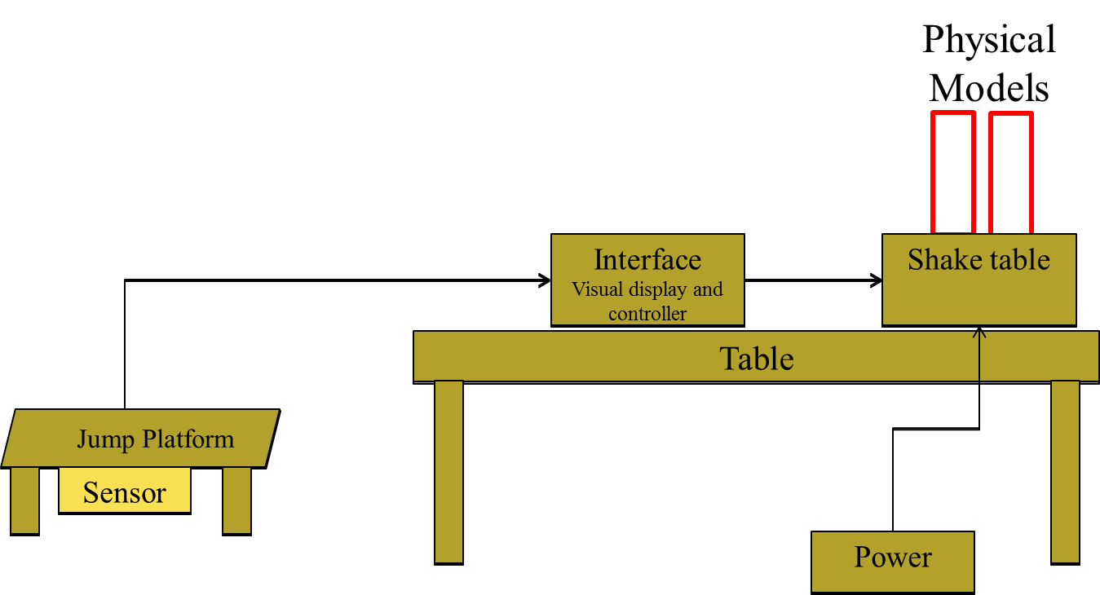

**General Goals and simple prototypes**

* Develop a low cost, controlled motion table (shake table)
* Supports three modes
  1. Harmonic motion with variable frequency and amplitude
  2. Make your own earthquake input to control motion
  3. Replicate prior earthquake motion

**Customer and Technical Requirements**

|  |  |  |
| --- | --- | --- |
| # | Client defined needs | Technical requirements |
| 10 | Safety – won’t harm children (ST) | Minimize number of exposed gaps that could pinch number of sharp edges |
| 10 | Portable size | minimum lift requirement (<50 lbs) |
| 10 | Durability | Run continuous demonstration of twin KNEX for 60 minutes |
| 9 | Anchor the table to the table | No slip of shake table from mounting surface |
| 9 | Rigidly mount physical models | No slip of physical model from table |
| 9 | Easy to mount physical models | 1 person can point model in less than 30 seconds (no more than 4 steps) |
| 8 | Easy to disassemble | 1 person can disassemble and store in less than 5 minutes |
| 8 | Easy to manufacture | Requires basic tools to assemble |
| 8 | Easy to repair | Access major components in one step |
| 8 | Variable harmonic frequency | 0-10 Hz +/1 .25 Hz |
|  | Simple user interface to input commands for freq/amp | 1 pages instructions – < 5 minutes to learn to operate |

**Benchmark products (prior art)**

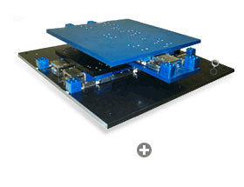 MTS Shake Table

* Current use of MTS shake Table
  + Demonstrate dynamic motion
  + Be used with design competitions
* Constraints
  + expensive, immobile

## 5.6 Phase One

|  |  |  |
| --- | --- | --- |
| **Phase 1: Project Identification** | **Status:** | **Evidence can be found:** |
| Goal is to identify a specific, compelling need to be addressed | | |
| * Conduct needs assessment (if need not already defined) | Complete | Power Point presentation |
| * Identify stakeholders (customer, users, person maintaining project, etc.) | Complete | Power Point presentation |
| * Understand the Social Context | Complete | Power Point presentation |
| * Define basic stakeholder requirements (objectives or goals of projects and constraints) | Complete | Power Point presentation |
| * Determine time constraints of the project | Complete | Power Point presentation |
| ***Gate 1: Continue if have identified appropriate EPICS project that meets a compelling need for the project partner [This includes a Project Charter]*** | Decision:  Continue | Rationale summary:  Product meets stakeholders’ need, and concept of design is rational. |
| Advisor approval: | Yes / No | Date: |

# The main objective of this project will be to provide a fun and interactive way for K-12 students to learn about the effects of earthquakes on structures and buildings. The current focus is for demonstrations used in outreach programs and for teachers to use in science instruction.

# The project identification is to create a shake table that makes the learning process of the effects of earthquakes on structures and buildings fun and interactive. This shake table will be able to simulate an earthquake based on jumping motions created by the K-12 students. The students will jump on a platform that contains an accelerometer to detect the jumping motion of the students. This jumping motion will be translated to the shaking motion of the shake-table. The table has to be such that it is safe and easy to use for K12 students.

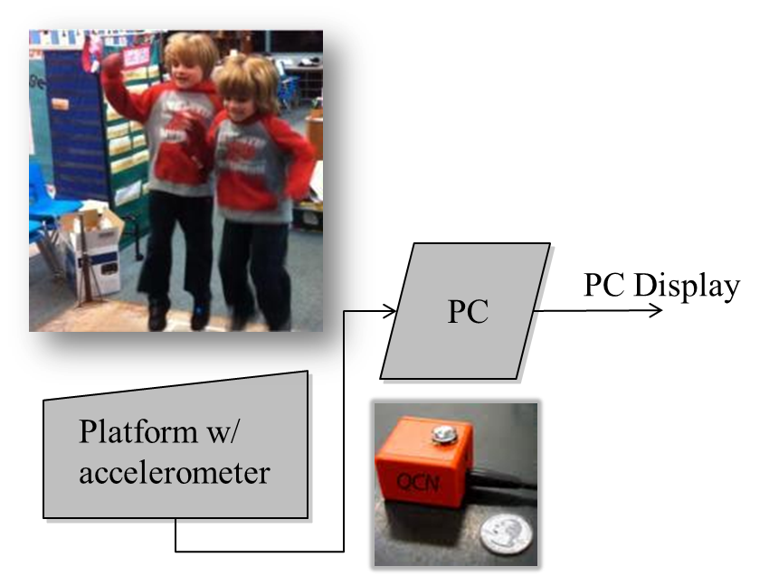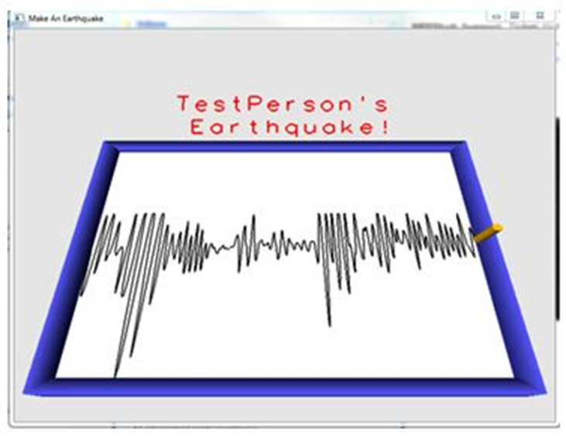

There exist an similar model (MTS Shake Table) can do the same as our shake table, but the advantage of our model is 50 times cheaper, so the school can afford as a teaching equipment, who will be our biggest coms we consider. And MTS Shake Table is too heavy to be mobile.

Future goals for this project include figuring out a way to produce these tables in a cost effective manner.

Future goals for this project include figuring out a way to produce these tables in a cost effective manner.

# 6 Semester Documentation (current semester)

## 6.1 Team Member

Jingye Liu

Dongyang Fu

Zachary Golden

Andrew Grosinger

Nikhilgandhi Manojkumar

## 6.2 Current Status and Location on Overall Project Timeline

This is week 14, and our team has finished our development process, the concept for interface model was decided. According to the concept, we have chosen our parts for the final product, like micro controller, stepper motor, PC interface, and accelerometer sensor. Power supply choosing will be considered in next semester concurrently with developing. So far we already can get something out, using ADRUINO control unit to run motor and generate data form QCN sensor before week 7’s design review.

## 6.3 Goals for the Semester

The goal of this semester is to have basic interface prototype can working on shake table, which can be showed to stakeholder.

## 6.4 Semester Timeline

|  |  |  |
| --- | --- | --- |
| **Task** | **Start By** | **Complete By** |
| Review/Understand Previous Semester’s Documents | Week 1 | Week 3 |
| Design the new concept model and specification from previous work and Plan Document | Week 3 | Week 5 |
| Design Document | Week 6 | Week 6 |
| Sensor based programing | Week 9 | Week 12 |
| Stepper Motor controlling | Week 7 | Week 12 |
| Sensor and Stepper Motor work together | Week 12 | Week 14 |
| Computer interface design | Week 10 | Week 14 |
| Final Design Presentation | Week 15 | Week 15 |

## 6.5 Semester Budget

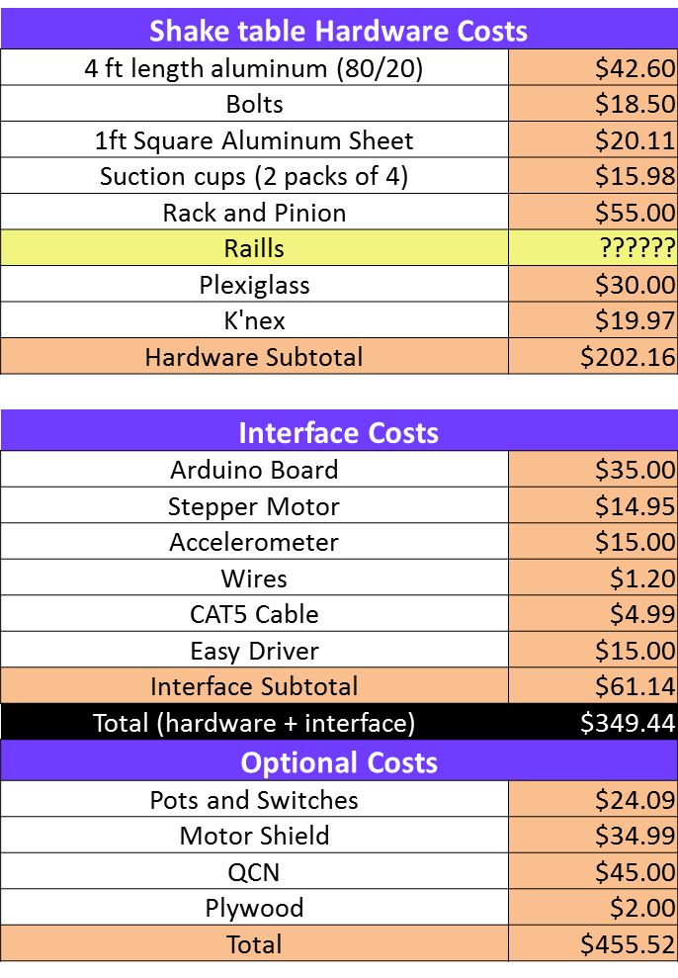

## 6.6 Transition Report

### 6.6.1 Summary of Semester Progress / Comparison of Actual Semester Timeline to Proposed Semester Timeline

Compare actual semester timeline to proposed semester timeline (if different). What aspects varied the most from proposed to actual?

Discuss the progress made during the current semester, including any pitfalls that you encountered that would be helpful for future teams to avoid as well as any best practices you found that helped you to advance the status of the project or work well as a team.

### 6.6.2 Draft Timeline for (next semester) and Relationship to Overall Project Timeline

|  |  |  |
| --- | --- | --- |
| **Task** | **Start By** | **Complete By** |
| Review/Understand Previous Semester’s Documents and code | Week 1 | Week 3 |
| Modify design if needed for more features for the interface | Week 3 | Week 10 |
| Build working prototype(s) | Week 10 | Week 14 |

# 7 Past Semester Archive

## 7.1 Past Semester 1

Spring 2011

The calculations and CAD model of shake table were completed on time. With the delays, the ordering and delivery of the parts took more time than anticipated. These delays also set back the progress of constructing the prototype. The previous team for the most part stuck to the original timeline however some unforeseen circumstances caused delays and changes to the timeline. They were not able to get a complete working prototype constructed by the end of the semester. However, a partially constructed shake table is finished and available.

### 7.1.1 Past Team Members

### Mohammad Faizan Azam

### Benjamin Eng

### Bilal Khan

### Amit Soni

### 7.1.2 Past Timeline

