# ST

Folder ST contains all code needed to run the PC side GUI. ST include 2 C# projects, one is the ST project, which is used to do serials control with Arduino, and the other one is SpPerfChart, which is online resource used to draw real time graph. There is no need to change the SpPerfChart, but main function in ST is the place where to do the modification.

Graphic interface is using PC in our project, which is programmed by C# code. GUI in computer should handle the serials connections with the micro controller to implement the motor control and signal feedback from accelerometer. Two main functions are divided by tab control in C# form. The function 1 in the first tab is linear motion control and signal feedback from micro controller, and the function 2 in the second tab is signal feedback from the accelerometer.

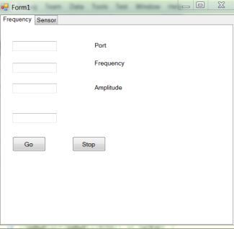 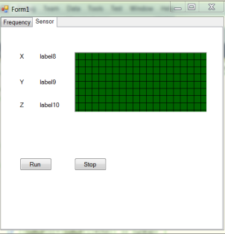

In function 1 (Frequency Tab), GUI program will send a size 4 byte array to Arduino board after click the “Go” Button. First element in the array is to control motor run or not, 0 is stop, 1 is run; Second byte is to choose the function: 0 is function 1 and 1 is function 2, and third byte and forth byte stand for the frequency and amplitude. Similarly, Stop button will send a 0 in second byte, after that the motor will stop.

When start Function 2, the program will check 8 bytes: 2 for start tag; 2 for x accelerometer; 2 for y; and 2 for z. So if the start tag is correct, then the program will get the signal from x, y, z accelerometer and do the calculation to get the sum of them. Finally the value will be display on a real time accelerometer graph.

How to used SpPerfChart?

<http://www.codeproject.com/Articles/17564/Simple-Performance-Chart>

# NEES_ino.ino

The NEES_ino.ino is the embedded program for our micro controller Arduino, so this program should be installed in the Arduino board via the Arduino software before use, after that PC GUI program should be used with Arduino program.

Before each time to use it, remember to check the port number, which can be found in device manager or Arduino program.