**Dog-Friendly Neighbourhoods of Stockholm**

## INTRODUCTION

Hello, My name is Liuba and I live in Gothenburg with my dog and sidekick called Watson. We live in a neighbourhood called Olskroken. When I was buying my appartment I chose this neighbourhood for it's dog-friendliness (before I even met Watson!).

**What does a dog-friendly neighbourhood mean?** From my point of view a neighbourhood can be called dog-friendly if it has the following attributes:

* A forest or a park
* An Animal Hospital
* A Dog Park (Called "hundrasgarden" in Swedish)
* Doggy Daycare (Called "hunddagis" in Swedish)
* A Pet Store
* A Pet Salon
* Dog-friendly cafes and restaurants

It is not necessary for a neighbourhood to have all the attributes mentioned above to be called dog-friendly but the more checkboxes it ticks the higher it would be on my list.

Now to the problem and goal of this project:I am looking into moving to Stockholm and I would like to find a dog-friendly area to live in. The goal of this project would be to determine and compare dog-friendly neighbourhoods in Stockholm.

I believe the end results of this analysis would be beneficial to any dog owner living in Stockholm or someone who wants to move with their furry buddy to this city.

I will be using Foursquare API to retrieve venue information and any data that I can scrape on the Wikipedia or the internet about the neighbourhoods of Stockholm.

## DATA

After a bit of search for map data about the districts of Stockholm, I ended up manually scrapping the Wikipedia page https://en.wikipedia.org/wiki/Districts_of_Sweden for information about the districts. I have created the file called stockholm_districts.csv containing the Boroughs and Districts of Stockholm.

Next I added the columns for lattitude and longitude of each district and I retrieved this information using Nominatim that we learned about during the labs.

Next I proceed to create the map of Stockholm and I added markers for the districts as well. I noticed that a couple of districts where mapped wrong so I manually corrected their coordinates.

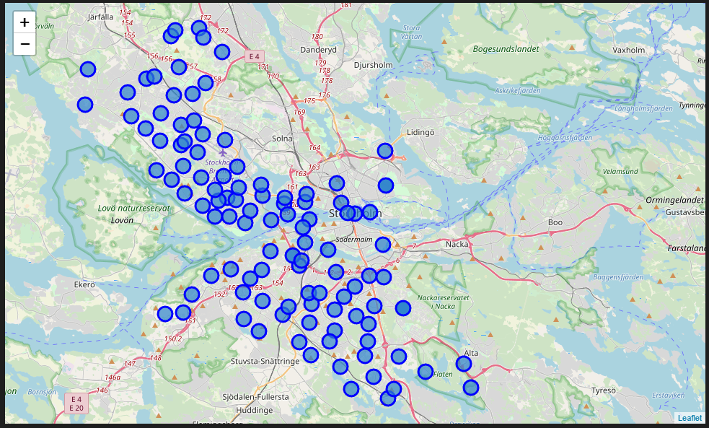

I am not sure if I retrieved ALL Stockholm districts and whether all the markers are placed correctly but I believe at this point we have enough data to start exploring the districts with the help of Foursquare.

## METHODOLOGY

**Utilizing the Foursquare API to search for dog-friendly venues of Stockholm**

First I examined the Foursquare venue categories (https://developer.foursquare.com/docs/resources/categories) to determine which ones will be relevant for the goal of this analysis.

I think the following categories will by the key features for dog-friendly districts.

* Pet Café 56aa371be4b08b9a8d573508
* Dog Run 4bf58dd8d48988d1e5941735
* Park 4bf58dd8d48988d163941735
* Trail 4bf58dd8d48988d159941735
* Veterinarian 4d954af4a243a5684765b473
* Pet Service 5032897c91d4c4b30a586d69
* Pet Store 4bf58dd8d48988d100951735

I wanted to see the venues that corespond to the categories mentioned above in the radius of 15 km of Stockhom.

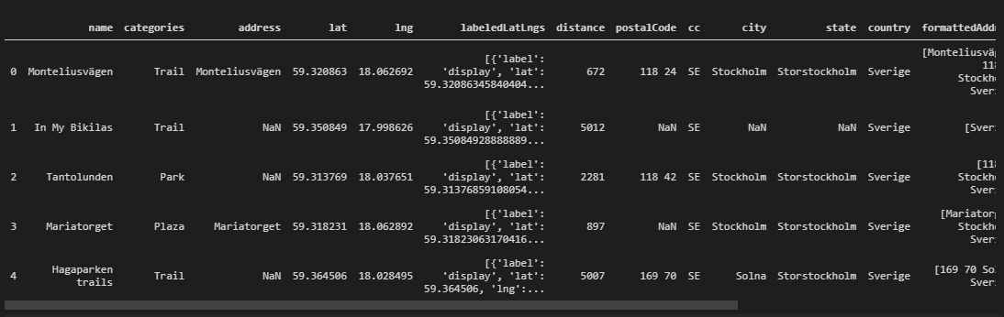

Looks like there were found 50 venues that corespond our search criteria. Let's display their location on the map.

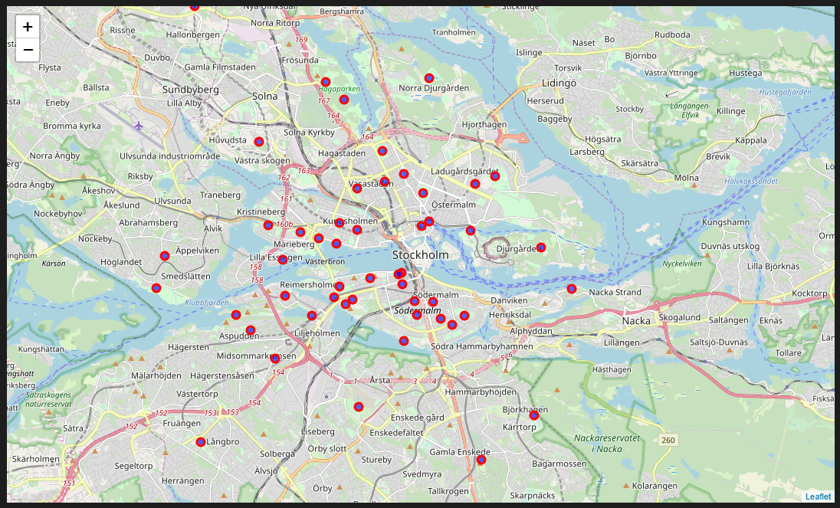

Finally I proceeded to Utilize the Foursquare API to examine Stockholm districts and their dog-friendly venues.

First I am building a dataframe that will display the dog-friendly venues per district. Then I run the function above for all Stockholm districts. I verified that the categories that were found are in fact dog-friendly and I dropped information about the venues that were not dog-friendly. The result was a dataframe that contained the dog-friendly venues availabel in each Stockholm district.

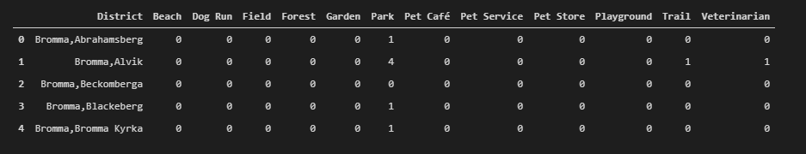

I finished by adding a ’Total’ column both in the result dataframe and in the original dataframe.

## ANALYZING THE RESULTS

I started by reviewing the amount of dog-friendly venues per district. I plotted the number of districts vs the number of dog-friendly.

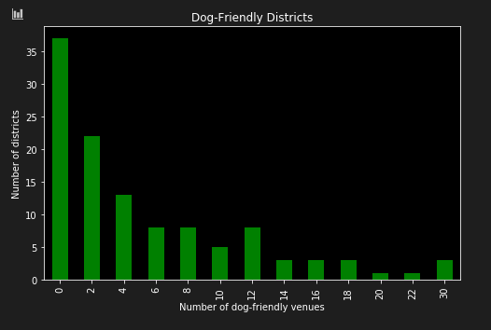

Let's mark districts according to the amount of dog-friendly venues.

* I will categorise the districts having 0 dog-friendly venues in their vicinity as not dog-friendly.
* Districts having at least 3 dog friendly venues will be mildly dog-friendly.
* Districts having more than 3 dog friendly venues will be very dog-friendly.

I will mark them on the map with Grey, Yellow and Green markers accordingly.

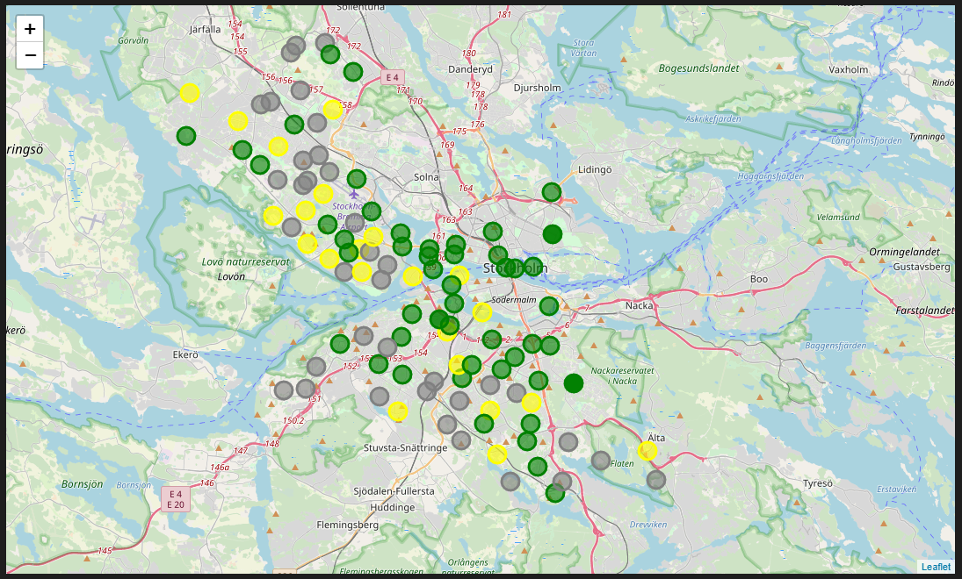

## RESULTS

I have managed to categorize the districts of Stockholm based on the number of dog-friendly venues in their neighbourhood. According to the results it looks like Stockholm is quite dog-friendly with plenty of venues open for dogs in multiple districts.

## CONCLUSIONS

Basing on this results, I would suggest any dog owner moving to Stockholm to look further into the districts that have been categorized as dog-friendly based on my analysis and filter them further based on thier personal preferences: proximity to city center, urban/rural areas, etc.