Exploratory salivary gene expression analysis in primary Sjögren's syndrome
Output level: L1 | Evidence boundary: candidate / exploratory | P1 input mode: series_matrix

Exploratory salivary gene expression analysis in primary Sjögren's syndrome

One-sentence positioning
This project evaluates whether a reproducible Affymetrix expression workflow can transform GSE7451 salivary expression data into traceable candidate evidence for primary Sjögren's syndrome research.

Logical chain P0–P4
- **P0 Background problem**: salivary molecular profiles may differ between primary Sjögren's syndrome and healthy controls.
- **P1 Main finding**: the current validation package contains a balanced 10-control/10-pSS design [L-E001].
- **P2 Supporting evidence**: an expression matrix and limma/BH comparison were produced; the run reports 0 multiple-testing-significant probes under its current input mode [L-E002].
- **P3 Limitation**: this local run is series_matrix; it does not replace the raw-CEL RMA/MAS5 run.
- **P4 Outlook**: execute the same configuration in GitHub Actions, then review pathway-tool compatibility and independent validation needs.

Abstract (structured draft)

Background
Primary Sjögren's syndrome is an autoimmune disease for which minimally invasive molecular signals remain of interest. This work uses a reproducible workflow to test an exploratory salivary expression analysis.

Methods
The GSE7451 series contains 20 samples, including 10 controls and 10 pSS samples [L-E001]. The target pipeline is RMA preprocessing, removal of probe sets absent in more than 75% of samples, limma differential expression with Benjamini–Hochberg correction, and pathway enrichment. The present local run used series_matrix; the raw-CEL path is scheduled on GitHub Actions.

Results
The current run produced an expression matrix with 54675 retained rows and a differential-expression table. 0 rows met the configured adjusted-P and effect-size thresholds in this run [L-E002]. Figure 1 is a QC visualization, not a clinical-performance plot.

Conclusions
The repository now records a traceable P1-to-P2 evidence path. The findings are exploratory and candidate-level; independent validation and the raw-CEL execution remain necessary.

Introduction
Primary Sjögren's syndrome affects exocrine tissues and can be studied with molecular measurements from saliva. The present workflow is designed to separate data processing, evidence extraction, writing, and journal strategy. It therefore treats the GSE7451 result as a candidate signal rather than a validated diagnostic marker.

Materials and methods

Dataset and sample groups
GSE7451 is an expression-profiling-by-array series on whole saliva. The downloaded package contains Affymetrix GPL570 raw files and a GEO series matrix. The tracked sample sheet records 20 samples, with balanced control and pSS groups [L-E001].

Reproducible analysis workflow
The confirmed workflow is: input integrity and sample check → RMA → MAS5 present/absent filtering at the pre-registered 75% threshold → limma comparison of pSS versus control with BH correction → pathway enrichment. Every step is configured through files rather than hard-coded user paths. In the local validation run, the series matrix was used only to validate downstream contracts; the full raw-CEL workflow is assigned to GitHub Actions.

Evidence and claim boundary
All numerical statements in this draft are anchored to the P1 run and its evidence interface. The terms “candidate”, “exploratory”, “associated”, and “requires independent validation” are intentional. This workflow does not support claims of diagnosis, clinical utility, causality, mechanism confirmation, or external validation.

Results

Input and workflow integrity
The input package was downloaded from NCBI GEO, recorded with checksums, and parsed into a sample sheet. The group balance was control=10 and pSS=10 [L-E001].

Differential expression output
The P1 run generated normalized/filtered matrix files and a limma table. The current interface records 54675 rows after the configured input-mode handling and 0 threshold-qualified rows [L-E002]. These values are run-specific and must be regenerated after the GitHub Actions raw-CEL run.
**Figure 1.** GSE7451 expression QC boxplot. The figure is exploratory and does not establish diagnostic performance. Exact sample size and processing mode are defined in the P1 manifest [L-E001].

Discussion
The main contribution of the current stage is a reproducible handoff rather than a definitive biological conclusion. The interface keeps the raw-CEL requirement, the pathway-tool distinction, and the evidence boundary visible to downstream writing and typesetting. The next technical checkpoint is the GitHub Actions full_raw execution.

Limitations
The dataset is a single cohort with 10 samples per group, all recorded as female in the GEO sample metadata. There is no independent validation cohort or experimental validation in the downloaded package. The local matrix-only run does not execute raw-CEL RMA or MAS5 calls, and the pathway step is not presented as an original MAPPFinder result.

Outlook
A future version should compare the full_raw output with the matrix-only validation, activate independent validation if data become available, and update the P4-b journal assessment using verified journal sources.

Declarations

Ethics approval and consent to participate
Not applicable to the public GEO reanalysis at this stage; confirm against the target journal and source study.

Consent for publication
Not applicable; confirm against the target journal.

Availability of data and materials
The GEO accession is GSE7451. Local file checksums and provenance are recorded in `inputs/migration_log.yaml`.

Code availability
The workflow scripts are maintained in the `shengxinceshi-arena` repository; remote push is pending GitHub credentials in the execution environment.

Competing interests
Not assessed; author input required.

Funding
Not provided in the current project inputs; author input required.

Authors' contributions
Not provided in the current project inputs; author input required.

Declaration of generative AI use
The project uses an agent to execute and record workflow steps. The final disclosure must be adapted to the target journal and author policy.

References
See `02_writing/refs/refs.bib`. References are limited to records present in the supplied workflow specification or GEO metadata.
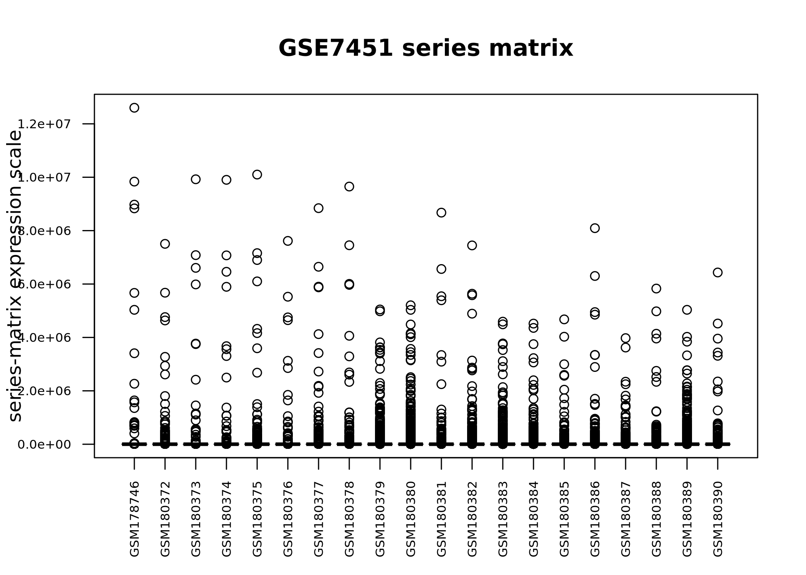
Figure 1. GSE7451 expression QC boxplot; exploratory only.

