Overview
This file is a specification of the model created by UML definition

Package List
Full Name | Summary
[Root]
com::bonc::common
com::bonc::common::domain
com::bonc::monitor
com::bonc::monitor::controller
com::bonc::monitor::dao
com::bonc::monitor::domain
com::bonc::monitor::service
com::bonc::monitor::service::impl
java::lang
java::util
org::springframework::data::jpa::repository

[Root] Package

Classifier List
Name | Type | Summary
Redis缓存服务器 | Node
pc浏览器 | Node
主机性能监控代理 | Component
关系型数据库服务器（主） | Node
关系型数据库服务器（从） | Node
前端界面(epm-ui) | Component
安全门户 | Component
应用服务器 | Node
手机app | Component
手机端 | Node
数据采集服务端 | Component
监控、管理、分析服务端 | Component
负载均衡器 | Node
车载设备 | Node

Diagram

Class Diagram0[Class Diagram]



figure 1: Class Diagram0[Class Diagram]

包层次[Class Diagram]

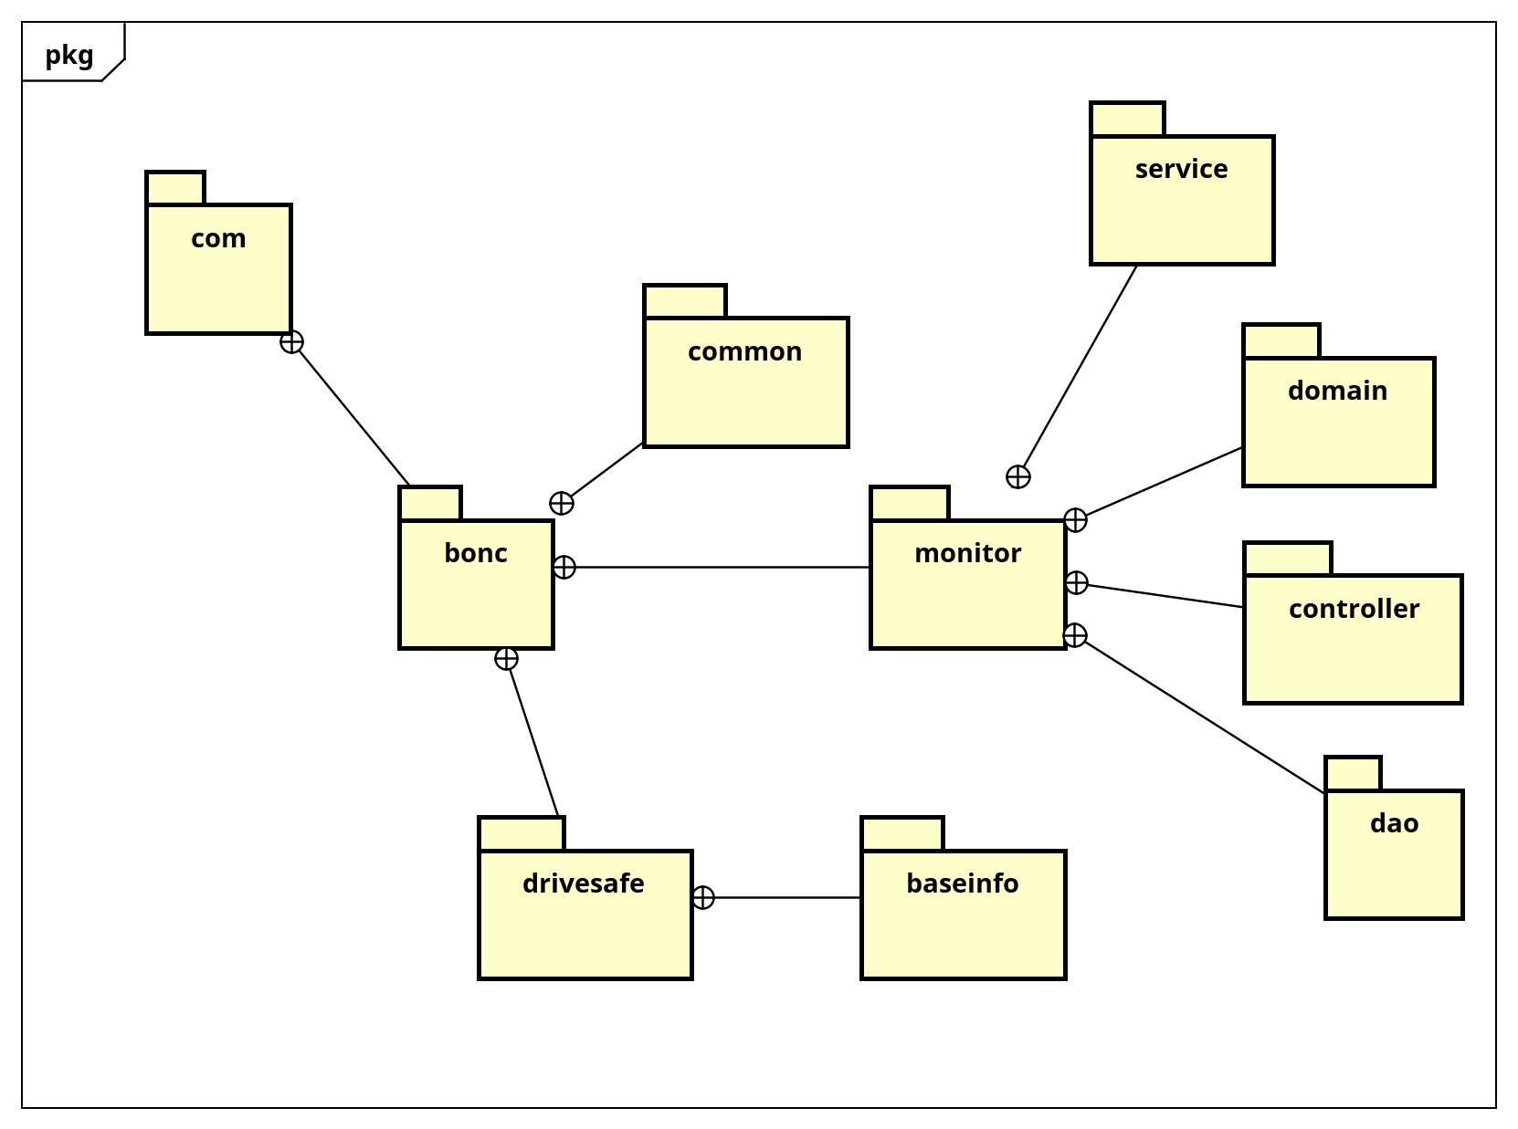

figure 2: 包层次[Class Diagram]

技术架构图[Deployment Diagram]

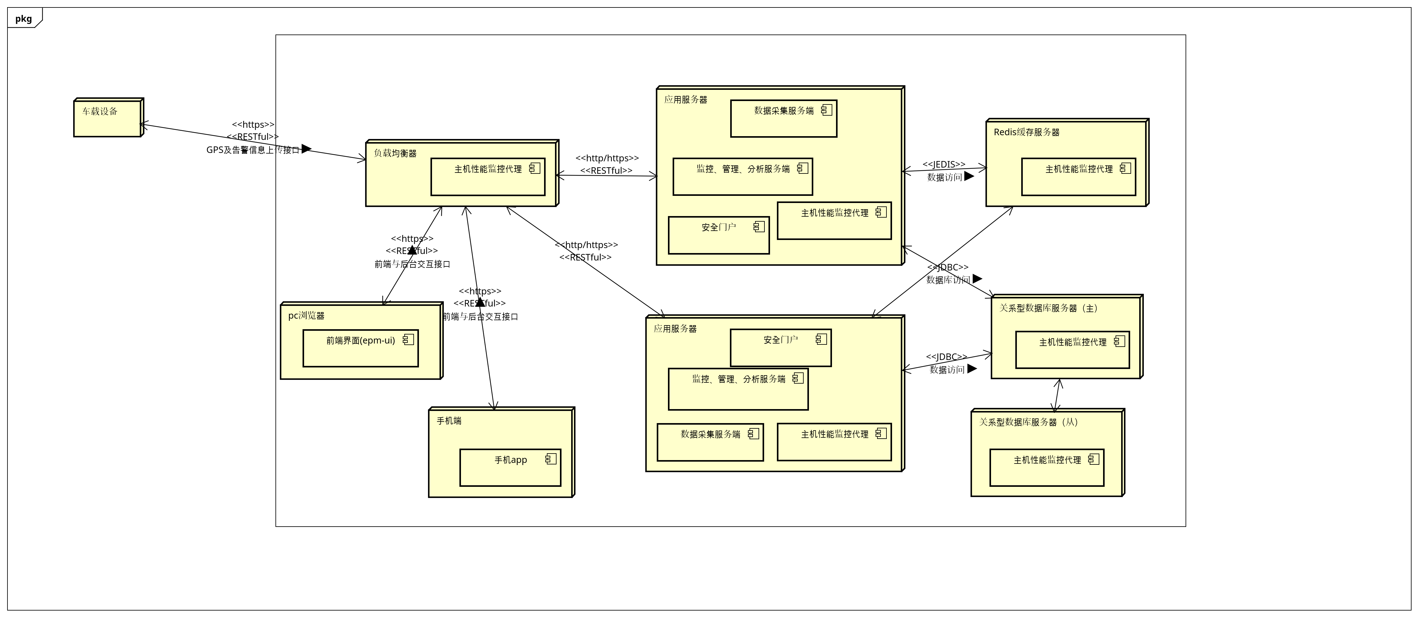

figure 3: 技术架构图[Deployment Diagram]

Class

Redis缓存服务器 [Node]

Declaration
public class Redis缓存服务器

Namespace
[Root]

pc浏览器 [Node]

Declaration
public class pc浏览器

Namespace
[Root]

Relation (From Source To Target)
Name | Type | Target | Summary
前端与后台交互接口 | Association | 负载均衡器

主机性能监控代理 [Component]

Declaration
public class 主机性能监控代理

Namespace
[Root]

关系型数据库服务器（主） [Node]

Declaration
public class 关系型数据库服务器（主）

Namespace
[Root]

Relation (From Source To Target)
Name | Type | Target | Summary
 | Association | 关系型数据库服务器（从）

关系型数据库服务器（从） [Node]

Declaration
public class 关系型数据库服务器（从）

Namespace
[Root]

前端界面(epm-ui) [Component]

Declaration
public class 前端界面(epm-ui)

Namespace
[Root]

安全门户 [Component]

Declaration
public class 安全门户

Namespace
[Root]

应用服务器 [Node]

Declaration
public class 应用服务器

Namespace
[Root]

Relation (From Source To Target)
Name | Type | Target | Summary
数据库访问 | Association | 关系型数据库服务器（主）
数据访问 | Association | 关系型数据库服务器（主）
数据访问 | Association | Redis缓存服务器
 | Association | Redis缓存服务器

手机app [Component]

Declaration
public class 手机app

Namespace
[Root]

手机端 [Node]

Declaration
public class 手机端

Namespace
[Root]

Relation (From Source To Target)
Name | Type | Target | Summary
前端与后台交互接口 | Association | 负载均衡器

数据采集服务端 [Component]

Declaration
public class 数据采集服务端

Namespace
[Root]

监控、管理、分析服务端 [Component]

Declaration
public class 监控、管理、分析服务端

Namespace
[Root]

负载均衡器 [Node]

Declaration
public class 负载均衡器

Namespace
[Root]

Relation (From Source To Target)
Name | Type | Target | Summary
 | Association | 应用服务器
 | Association | 应用服务器

车载设备 [Node]

Declaration
public class 车载设备

Namespace
[Root]

Relation (From Source To Target)
Name | Type | Target | Summary
GPS及告警信息上传接口 | Association | 负载均衡器

com::bonc::common Package

Classifier List
Name | Type | Summary
CRUDController | Interface
CRUDService | Interface | 实体对象crud通用的基础接口

Class

CRUDController [Interface]

Declaration
public class CRUDController

Namespace
com::bonc::common

Stereotype
<<interface>>

Operation
Name | Type | Summary
post  (Object) | public ResultMessage  [Parameters]  in obj: Object | [Definition]  新增
put  (Object) | public ResultMessage  [Parameters]  in obj: Object | [Definition]  更新
delete  (long) | public ResultMessage  [Parameters]  in id: long | [Definition]  删除
getOne  (long) | public ResultMessage  [Parameters]  in id: long | [Definition]  查询出一个
getAll | public ResultMessage | [Definition]  查询出所有的

Relation (From Source To Target)
Name | Type | Target | Summary
 | Dependency | ResultMessage

CRUDService [Interface]

Declaration
public class CRUDService

Namespace
com::bonc::common

Stereotype
<<interface>>

Definition
实体对象crud通用的基础接口

Operation
Name | Type | Summary
create  (Object) | public void  [Parameters]  in obj: Object | [Definition]  创建/新增实体
read  (long) | public Object  [Parameters]  in id: long | [Definition]  根据id获取一个实体对象
update  (Object) | public void  [Parameters]  in obj: Object | [Definition]  用新的实体对象更新库里的实体数据，要保证id不变。
delete  (long) | public void  [Parameters]  in id: long | [Definition]  根据id删除对应的实体对象
findAll | public List | [Definition]  查出所有的对象列表

com::bonc::common::domain Package

Classifier List
Name | Type | Summary
ResultMessage | Class | 返回消息对象
SysConfig | Class | 系统配置信息

Class

ResultMessage [Class]

Declaration
public class ResultMessage

Namespace
com::bonc::common::domain

Definition
返回消息对象

Attribute
Name | Type | Summary
success | private boolean | [Definition]  成功失败标志
msg | private String | [Definition]  提示信息
result | private Object | [Definition]  返回业务结果对象

SysConfig [Class]

Declaration
public class SysConfig

Namespace
com::bonc::common::domain

Definition
系统配置信息

Attribute
Name | Type | Summary
key | private String | [Definition]  参数名
value | private String | [Definition]  参数值

com::bonc::monitor Package

Classifier List
Name | Type | Summary
Actor0 | Actor
SSHUtil | Class

Diagram

com::bonc::monitor::host监控类图示例[Class Diagram]

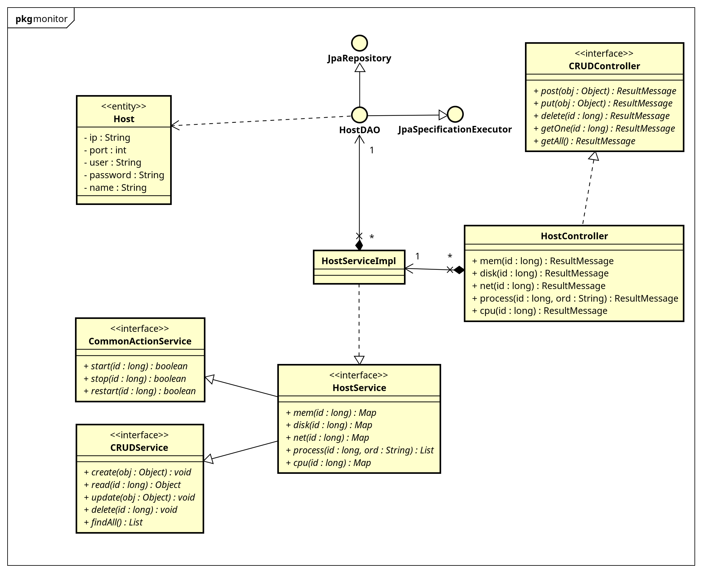

figure 4: com::bonc::monitor::host监控类图示例[Class Diagram]

com::bonc::monitor::全类图[Class Diagram]

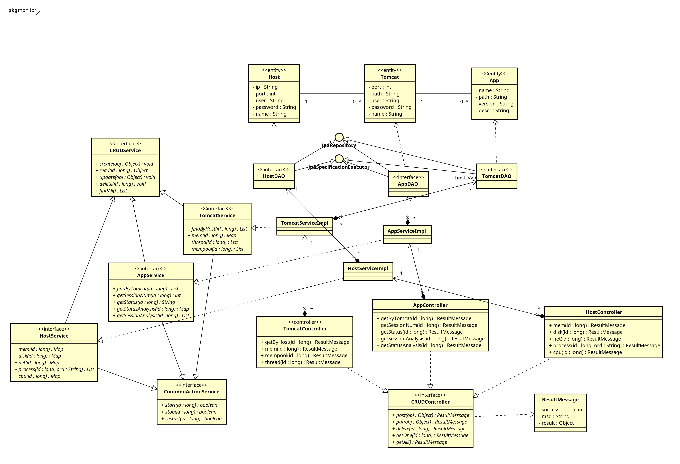

figure 5: com::bonc::monitor::全类图[Class Diagram]

com::bonc::monitor::实体类关系图[Class Diagram]

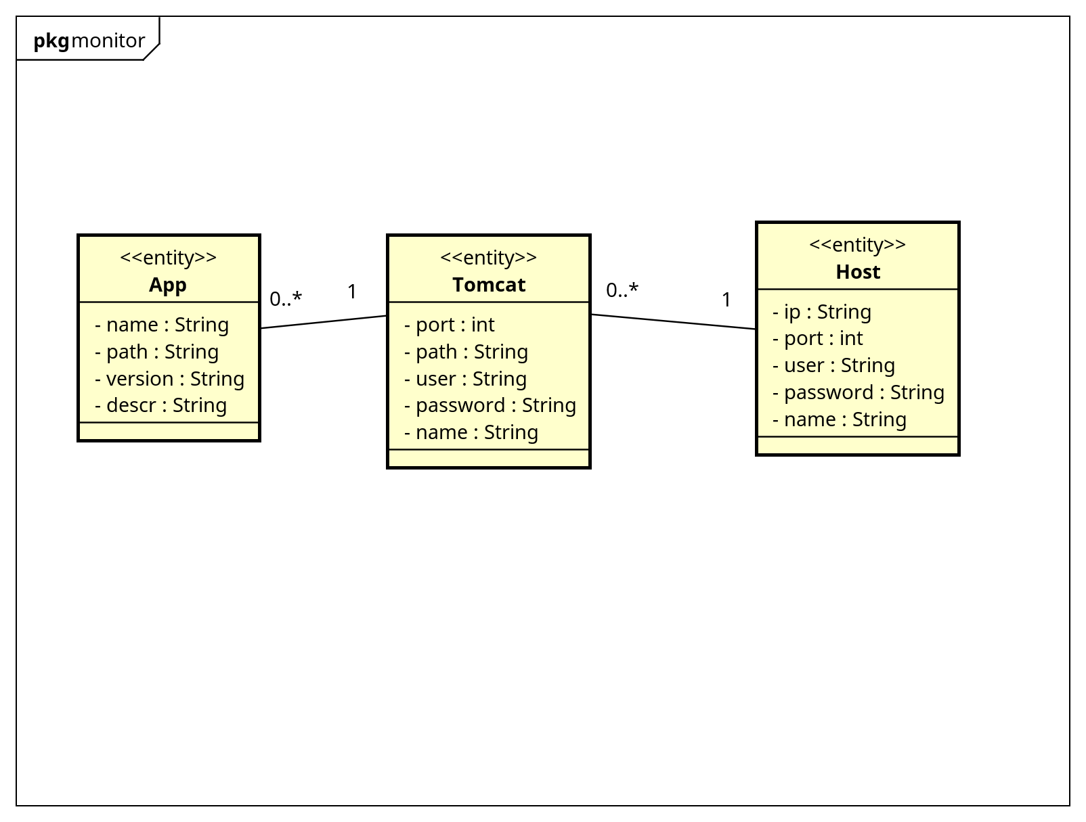

figure 6: com::bonc::monitor::实体类关系图[Class Diagram]

com::bonc::monitor::继承关系图[Class Diagram]

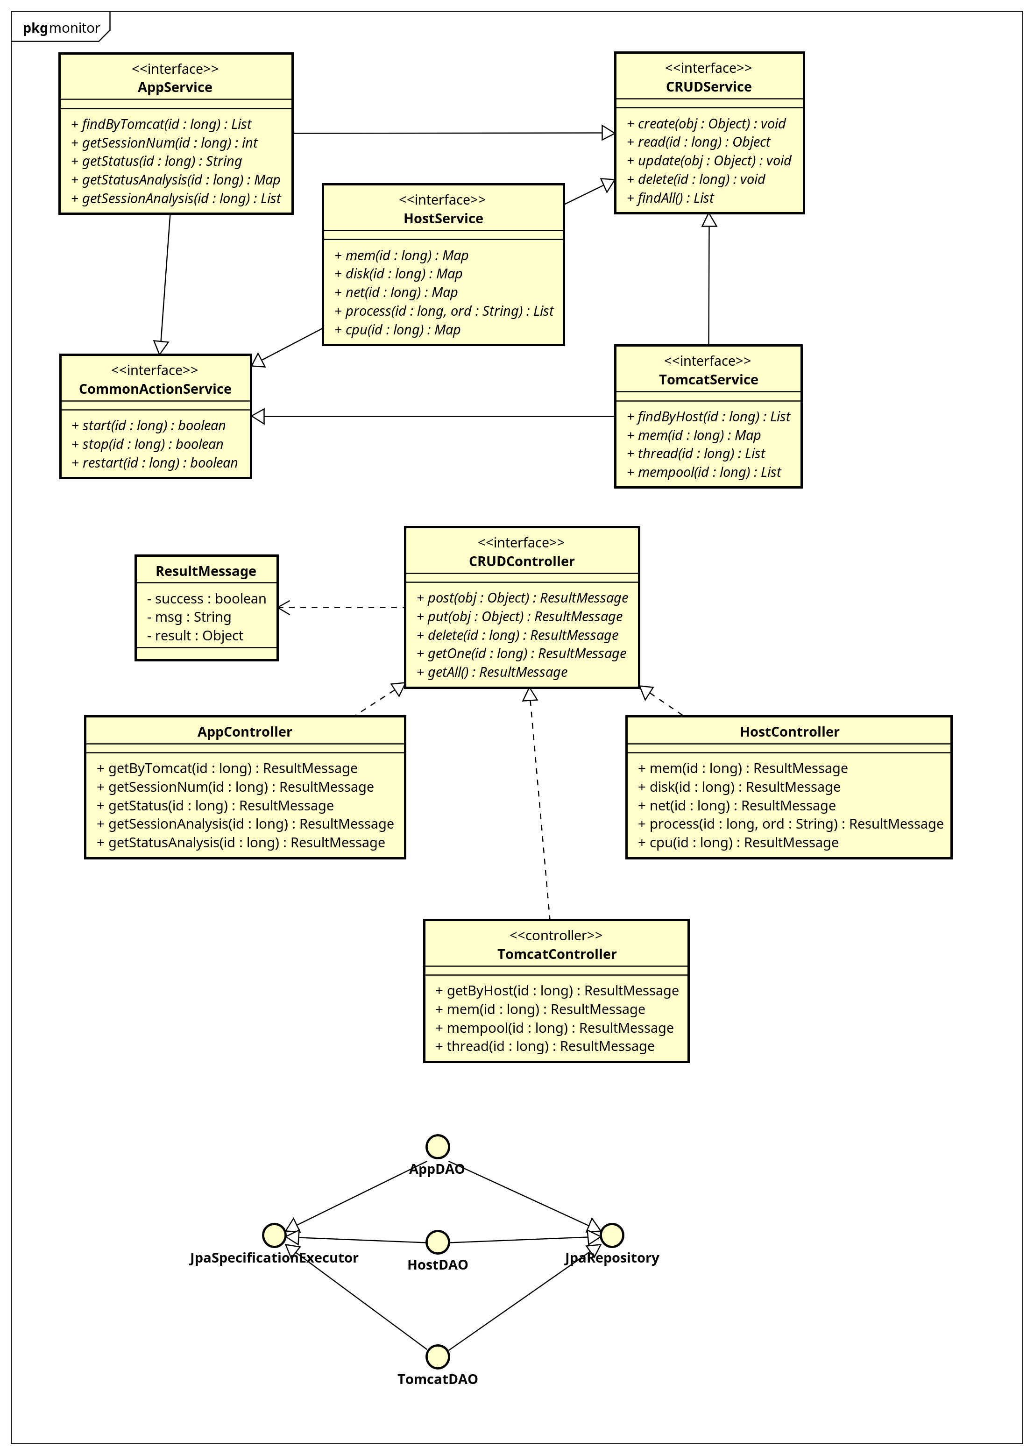

figure 7: com::bonc::monitor::继承关系图[Class Diagram]

com::bonc::monitor::host实体信息存取时间图[Sequence Diagram]

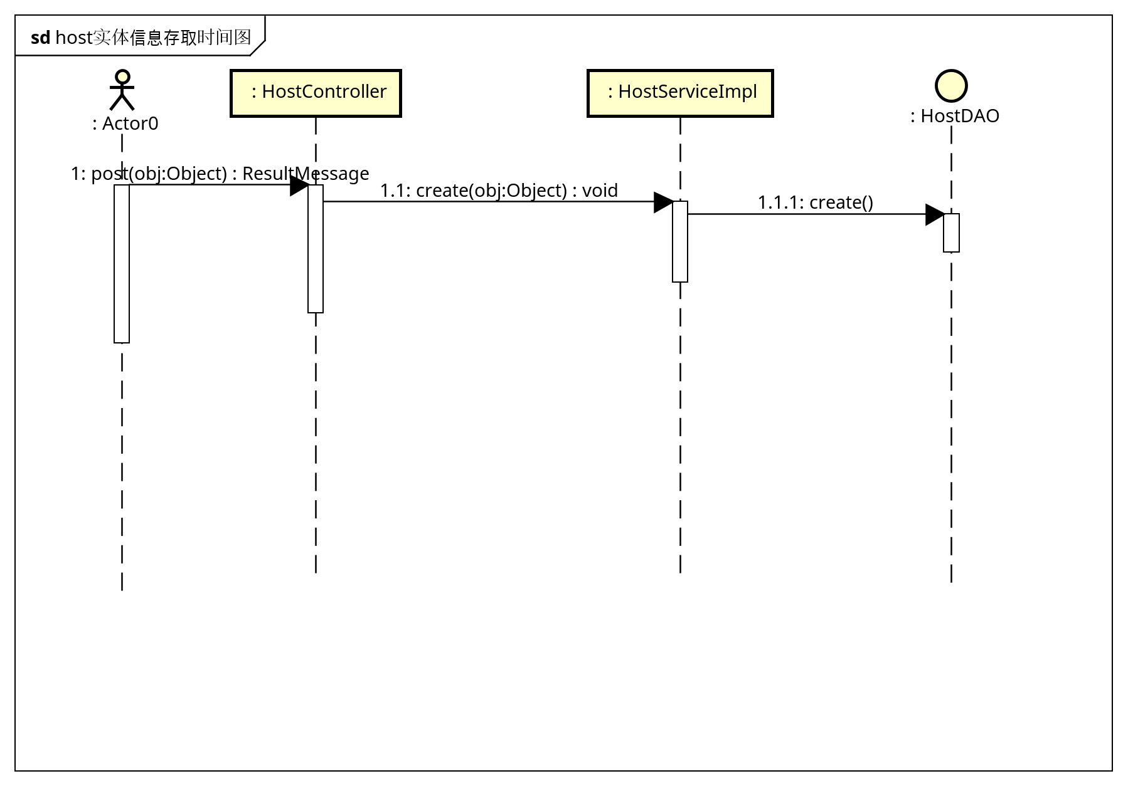

figure 8: com::bonc::monitor::host实体信息存取时间图[Sequence Diagram]

com::bonc::monitor::host监控时序图[Sequence Diagram]

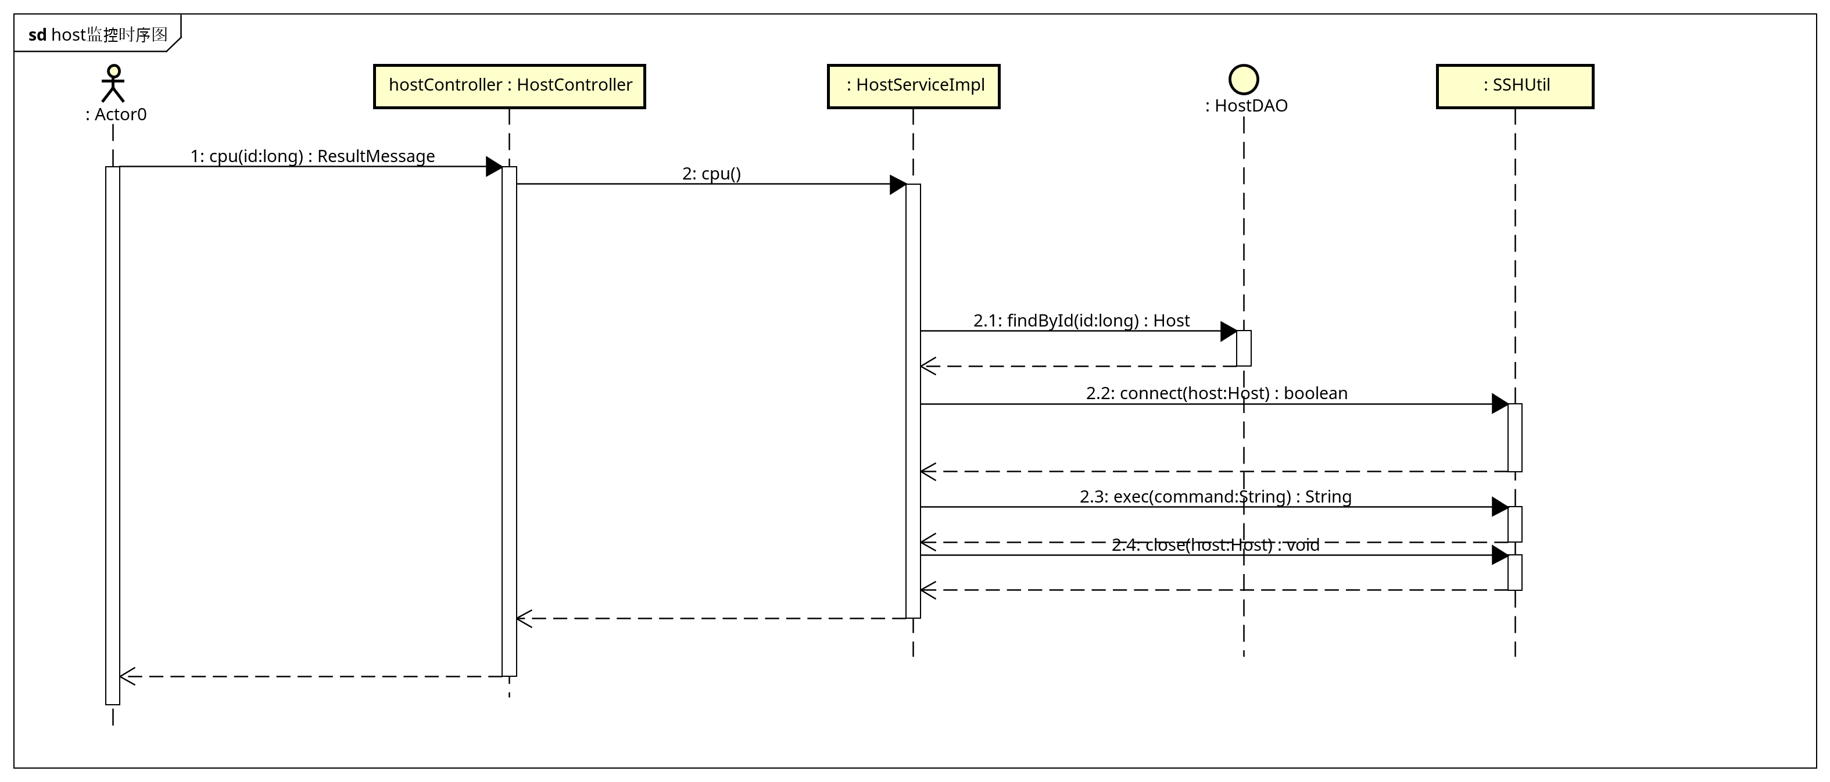

figure 9: com::bonc::monitor::host监控时序图[Sequence Diagram]

Class

Actor0 [Actor]

Declaration
public class Actor0

Namespace
com::bonc::monitor

Stereotype
<<actor>>

SSHUtil [Class]

Declaration
public class SSHUtil

Namespace
com::bonc::monitor

Operation
Name | Type | Summary
connect  (Host) | public boolean  [Parameters]  in host: Host
close  (Host) | public void  [Parameters]  in host: Host
exec  (String) | public String  [Parameters]  in command: String

com::bonc::monitor::controller Package

Classifier List
Name | Type | Summary
AppController | Class | 应用信息控制器类
HostController | Class | 主机控制器类
TomcatController | Class | tomcat控制器类

Class

AppController [Class]

Declaration
public class AppController
implements CRUDController

Namespace
com::bonc::monitor::controller

Definition
应用信息控制器类

Operation
Name | Type | Summary
getByTomcat  (long) | public ResultMessage  [Parameters]  in id: long | [Definition]  根据tomcat查询出所有应用
getSessionNum  (long) | public ResultMessage  [Parameters]  in id: long
getStatus  (long) | public ResultMessage  [Parameters]  in id: long
getSessionAnalysis  (long) | public ResultMessage  [Parameters]  in id: long
getStatusAnalysis  (long) | public ResultMessage  [Parameters]  in id: long

Relation (From Source To Target)
Name | Type | Target | Summary
 | Realization | CRUDController
 | Association | AppServiceImpl

HostController [Class]

Declaration
public class HostController
implements CRUDController

Namespace
com::bonc::monitor::controller

Definition
主机控制器类

Operation
Name | Type | Summary
mem  (long) | public ResultMessage  [Parameters]  in id: long
disk  (long) | public ResultMessage  [Parameters]  in id: long
net  (long) | public ResultMessage  [Parameters]  in id: long
process  (long, String) | public ResultMessage  [Parameters]  in id: long,  in ord: String
cpu  (long) | public ResultMessage  [Parameters]  in id: long | [Definition]  取得ｃｐｕ使用信息

Relation (From Source To Target)
Name | Type | Target | Summary
 | Realization | CRUDController
 | Association | HostServiceImpl

TomcatController [Class]

Declaration
public class TomcatController
implements CRUDController

Namespace
com::bonc::monitor::controller

Stereotype
<<controller>>

Definition
tomcat控制器类

Operation
Name | Type | Summary
getByHost  (long) | public ResultMessage  [Parameters]  in id: long | [Definition]  根据host查询出所有的tomcat
mem  (long) | public ResultMessage  [Parameters]  in id: long
mempool  (long) | public ResultMessage  [Parameters]  in id: long
thread  (long) | public ResultMessage  [Parameters]  in id: long

Relation (From Source To Target)
Name | Type | Target | Summary
 | Realization | CRUDController
 | Association | TomcatServiceImpl

com::bonc::monitor::dao Package

Classifier List
Name | Type | Summary
AppDAO | Interface | 应用数据访问对象
HostDAO | Interface | 主机数据库访问对象
TomcatDAO | Interface | tomcat数据访问对象

Class

AppDAO [Interface]

Declaration
public class AppDAO
extends JpaRepository, JpaSpecificationExecutor

Namespace
com::bonc::monitor::dao

Stereotype
<<interface>>

Definition
应用数据访问对象

Relation (From Source To Target)
Name | Type | Target | Summary
 | Generalization | JpaRepository
 | Generalization | JpaSpecificationExecutor
 | Dependency | Tomcat

HostDAO [Interface]

Declaration
public class HostDAO
extends JpaRepository, JpaSpecificationExecutor

Namespace
com::bonc::monitor::dao

Stereotype
<<interface>>

Definition
主机数据库访问对象

Relation (From Source To Target)
Name | Type | Target | Summary
 | Generalization | JpaRepository
 | Generalization | JpaSpecificationExecutor
 | Dependency | Host

TomcatDAO [Interface]

Declaration
public class TomcatDAO
extends JpaRepository, JpaSpecificationExecutor

Namespace
com::bonc::monitor::dao

Stereotype
<<interface>>

Definition
tomcat数据访问对象

Relation (From Source To Target)
Name | Type | Target | Summary
 | Generalization | JpaRepository
 | Generalization | JpaSpecificationExecutor
 | Dependency | App

com::bonc::monitor::domain Package

Classifier List
Name | Type | Summary
App | Entity | 应用
Host | Entity | 主机
Tomcat | Entity | tomcat

Class

App [Entity]

Declaration
public class App

Namespace
com::bonc::monitor::domain

Stereotype
<<entity>>

Definition
应用

Attribute
Name | Type | Summary
name | private String | [Definition]  应用名称
path | private String | [Definition]  访问路径
version | private String | [Definition]  版本
descr | private String | [Definition]  描述

Host [Entity]

Declaration
public class Host

Namespace
com::bonc::monitor::domain

Stereotype
<<entity>>

Definition
主机

Attribute
Name | Type | Summary
ip | private String | [Definition]  ip地址
port | private int | [Definition]  ssh服务端口号
user | private String | [Definition]  管理账号
password | private String | [Definition]  密码
name | private String | [Definition]  主机名称

Relation (From Source To Target)
Name | Type | Target | Summary
 | Association | Tomcat

Tomcat [Entity]

Declaration
public class Tomcat

Namespace
com::bonc::monitor::domain

Stereotype
<<entity>>

Definition
tomcat

Attribute
Name | Type | Summary
port | private int | [Definition]  服务端口号
path | private String | [Definition]  安装路径
user | private String | [Definition]  管理账号
password | private String | [Definition]  管理密码
name | private String | [Definition]  tomcat的名称

Relation (From Source To Target)
Name | Type | Target | Summary
 | Association | App

com::bonc::monitor::service Package

Classifier List
Name | Type | Summary
AppService | Interface | 应用服务接口
CommonActionService | Interface | 公共的操作类接口
HostService | Interface | 主机服务接口
TomcatService | Interface | tomcat服务接口

Class

AppService [Interface]

Declaration
public class AppService
extends CRUDService, CommonActionService

Namespace
com::bonc::monitor::service

Stereotype
<<interface>>

Definition
应用服务接口

Operation
Name | Type | Summary
findByTomcat  (long) | public List  [Parameters]  in id: long | [Definition]  根据tomat的id查询出应用集合
getSessionNum  (long) | public int  [Parameters]  in id: long | [Definition]  得到当前会话数
getStatus  (long) | public String  [Parameters]  in id: long | [Definition]  得到当前运行状态
getStatusAnalysis  (long) | public Map  [Parameters]  in id: long
getSessionAnalysis  (long) | public List  [Parameters]  in id: long

Relation (From Source To Target)
Name | Type | Target | Summary
 | Generalization | CRUDService
 | Generalization | CommonActionService

CommonActionService [Interface]

Declaration
public class CommonActionService

Namespace
com::bonc::monitor::service

Stereotype
<<interface>>

Definition
公共的操作类接口

Operation
Name | Type | Summary
start  (long) | public boolean  [Parameters]  in id: long | [Definition]  启动节点
stop  (long) | public boolean  [Parameters]  in id: long | [Definition]  停止节点
restart  (long) | public boolean  [Parameters]  in id: long | [Definition]  重启节点

HostService [Interface]

Declaration
public class HostService
extends CRUDService, CommonActionService

Namespace
com::bonc::monitor::service

Stereotype
<<interface>>

Definition
主机服务接口

Operation
Name | Type | Summary
mem  (long) | public Map  [Parameters]  in id: long | [Definition]  返回内存数据
disk  (long) | public Map  [Parameters]  in id: long | [Definition]  返回磁盘空间数据
net  (long) | public Map  [Parameters]  in id: long | [Definition]  得到网络数据
process  (long, String) | public List  [Parameters]  in id: long,  in ord: String | [Definition]  得到进程数据
cpu  (long) | public Map  [Parameters]  in id: long

Relation (From Source To Target)
Name | Type | Target | Summary
 | Generalization | CRUDService
 | Generalization | CommonActionService

TomcatService [Interface]

Declaration
public class TomcatService
extends CRUDService, CommonActionService

Namespace
com::bonc::monitor::service

Stereotype
<<interface>>

Definition
tomcat服务接口

Operation
Name | Type | Summary
findByHost  (long) | public List  [Parameters]  in id: long | [Definition]  根据主机id查询出tomcat对象集合
mem  (long) | public Map  [Parameters]  in id: long
thread  (long) | public List  [Parameters]  in id: long
mempool  (long) | public List  [Parameters]  in id: long

Relation (From Source To Target)
Name | Type | Target | Summary
 | Generalization | CRUDService
 | Generalization | CommonActionService

com::bonc::monitor::service::impl Package

Classifier List
Name | Type | Summary
AppServiceImpl | Class | 应用服务接口实现类
HostServiceImpl | Class | 主机服务接口实现类
TomcatServiceImpl | Class | tomcat服务接口实现

Class

AppServiceImpl [Class]

Declaration
public class AppServiceImpl
implements AppService

Namespace
com::bonc::monitor::service::impl

Definition
应用服务接口实现类

Relation (From Source To Target)
Name | Type | Target | Summary
 | Realization | AppService
 | Association | AppDAO

HostServiceImpl [Class]

Declaration
public class HostServiceImpl
implements HostService

Namespace
com::bonc::monitor::service::impl

Definition
主机服务接口实现类

Relation (From Source To Target)
Name | Type | Target | Summary
 | Realization | HostService
 | Association | HostDAO

TomcatServiceImpl [Class]

Declaration
public class TomcatServiceImpl
implements TomcatService

Namespace
com::bonc::monitor::service::impl

Definition
tomcat服务接口实现

Relation (From Source To Target)
Name | Type | Target | Summary
 | Realization | TomcatService
 | Association | TomcatDAO

java::lang Package

Classifier List
Name | Type | Summary
Object | Class
String | Class

Class

Object [Class]

Declaration
public class Object

Namespace
java::lang

String [Class]

Declaration
public class String

Namespace
java::lang

java::util Package

Classifier List
Name | Type | Summary
List<E> | Interface
Map<K,V> | Interface

Class

List [Interface]

Declaration
public class List<E>

Namespace
java::util

Stereotype
<<interface>>

Template Parameter
Name | Type | Default Value
E

Map [Interface]

Declaration
public class Map<K,V>

Namespace
java::util

Stereotype
<<interface>>

Template Parameter
Name | Type | Default Value
K
V

org::springframework::data::jpa::repository Package

Classifier List
Name | Type | Summary
JpaRepository | Interface
JpaSpecificationExecutor | Interface

Class

JpaRepository [Interface]

Declaration
public class JpaRepository

Namespace
org::springframework::data::jpa::repository

Stereotype
<<interface>>

JpaSpecificationExecutor [Interface]

Declaration
public class JpaSpecificationExecutor

Namespace
org::springframework::data::jpa::repository

Stereotype
<<interface>>

