# Ubuntu学习笔记

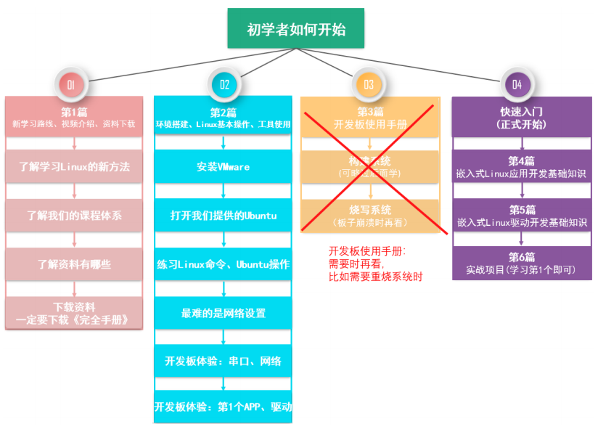

ubuntu IP地址

192.168.2.128

windows ip地址

192.168.31.101

ping www.openedv.com

韦东山bilibili主页

https://space.bilibili.com/275908810

**https://www.bilibili.com/video/BV12A411J7DG**

https://e.coding.net/weidongshan/01_all_series_quickstart.git

## Makefile

GNU make 地址

参考文档：https://www.gnu.org/software/make/manual/make.html