# Git学习笔记

菜鸟教程

https://www.runoob.com/git/git-tutorial.html

MobaXterm使用Git Bash

<https://www.cnblogs.com/runsky87/p/15880543.html>

D:\Program Files\Git\bin\sh.exe

GitHub账号

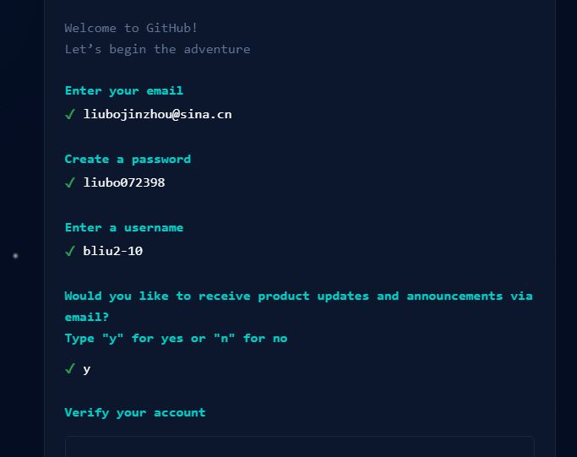

ssh-rsa AAAAB3NzaC1yc2EAAAADAQABAAABgQDghPD9hy+IbOZdMYK9KgB+DsXuySuS2/2sxfN63pA5r

yKPybXuA08IDHVKv1qQ1OUAd9VpVQDk/tgqsLsAwBJq75kXmmOlsJSbnW7Ll6url7eeE8pUhQBCkYp5HA

GJpwRJ6uaywp/9aAntix49otYJ6nr5IeqAlLSJlZhTSZKAxgz92oyyenYlZp/h1DAjnqEAsWbhVQB/We0

HpIKkxEU/GZLan+R0ulJvuB2uHIELJqN2naDAUMr+xA53V1jlXROxud3hxUks/cSSsxWuMffIs9XlIYah

bTpQGlTUV852Lfi2sRQp9dJaRnzYw1t/S9gzcFi8SIRQ20l7gB5LPY6BCu2yW3VrYYPfLTop2MWQrPt4o

HKMehU4O++7zojkoUFTJxNSlarJ4a/o2kn0suZBxGR+aGWqJSS9mOpFkUYgUCcl9jEUpOlBqn4w1Wv6Av

pkSXe46wfiWgxVWjcl4252y6L/NJbuXsN+IYOXtXkPM+YtRO1ZpZoHGY1MxnDqG3M= Administrator@

SC-201901211747