Sakai Course Management, an Overview

Date: November 28, 2006
Version: 2

- Introduction
Sakai introduced an optional and completely redesigned Course Management Service for the 2.3 release (Fall 2006). This new service will completely replace the legacy course management service by the 2.4 release. The new service provides support for a hierarchical organization of courses, sections, and higher level units of organization, such as departments, schools, and colleges. Sakai 2.3 also provides a means to inform site creation. The new service is based on a substantial requirements gathering process and multiple reviews.

This document is intended to provide a conceptual overview of Course Management. The reader is referred to the project’s confluence wiki for deeper insight into requirements and technical design details.

See http://bugs.sakaiproject.org/confluence/display/CM .

- Purpose
The purpose of the Course Management Service is to define service model that represents course organization in institutions of higher education. The Course Management API doesn’t require or imply any dependencies on other Sakai services.

It specifically doesn’t require the Sakai Authorization or Site Management services for implementation. While information about sets of people and the relationship between courses and sections may be used to instantiate and maintain Sakai sites and authorization groups, this is not a requirement.

- Basic Concepts
The Sakai course structure is one of containment. CourseSets describe a collection of CanonicalCourses. CanonicalCourses can contain other CanonicalCourses or CourseOfferings. CourseOfferings contain Sections. Sections may contain other Sections (sub-sections).
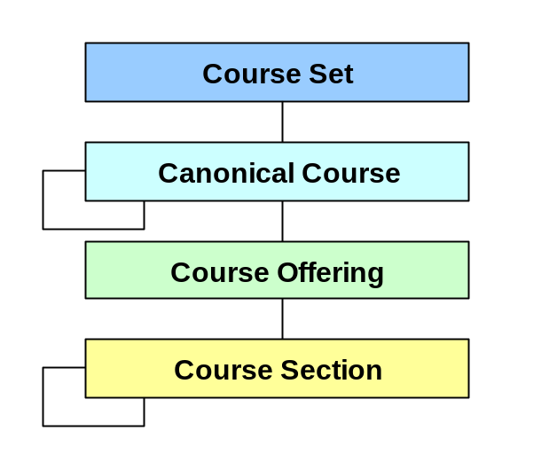
This hierarchical relationship between objects is maintained by the course management implementation. The reference implementation uses hibernate-managed database tables, but alternative implementations could be written using the upcoming hierarchy service, for example.

  - Course Sets
A Course Set is a collection of Canonical Courses and/or Course Offerings that can be used to describe majors, departments and other high level collections of courses. They provide a way to group Canonical Courses into useful collections. However, there is no requirement that a Canonical Course must belong to a Course Set.

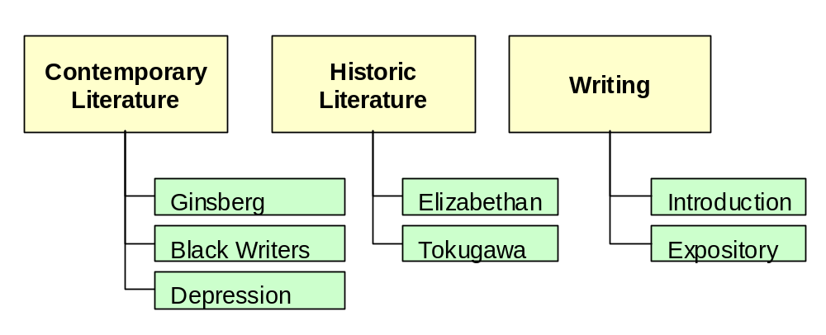

In this example, three Course Sets are used to define subject areas in an English department: Contemporary Literature, Historic Literature, and Writing. Canonical Courses included in the various sets are shown.

  - Canonical Courses
A Canonical Course is a general course that exists across terms. It is an abstract course. One way of thinking about canonical courses is that they are courses that could be offered at a university. Not that all courses are not offered every term, which is why there is a course offering (see below).

Canonical Courses define the long-term aspects of a course. It has a title, catalog description, course number, default credits, a list of topics, a list of prerequisites, and a list of equivalent Canonical Courses. Canonical Courses may be derived from other Canonical Courses, which could be used to keep track of major changes to the course.

Not all universities explicitly represent their canonical courses. However, the Sakai Course Management service uses Canonical Course objects to contain all properties that are the same across sessions and school years (topic list, for example).

As stated above, Canonical Courses are not required to be organized by Course Sets or by an organizational structure. However, without some high level organization, Canonical Courses are collected in to a flat pool, as shown here:

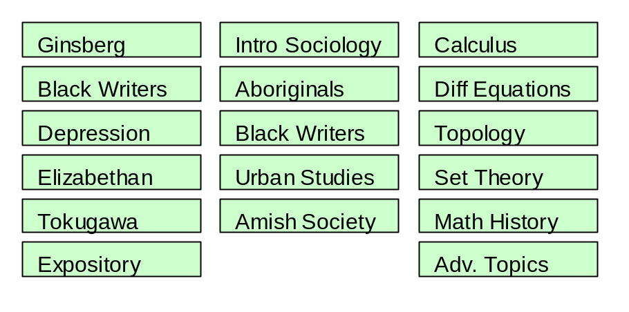

Please note that “Black Writers” appear twice in this collection: as a canonical course offered by the English Department and a different course of the same name in Sociology. While these likely have different course numbers, the need for higher levels of organization becomes more obvious.

  - Course Offerings
A Course Offering is a course that is offered in a specific term or semester. To avoid confusion, an AcademicSession object has been defined in the Sakai Course Management service that describes a section of time within a school year. AcademicSessions are usually defined as “spring, fall, or winter” but could also be define as “first quarter, second quarter, etc.”
A course offering is, therefore, a canonical course associated with a specific academic session. An offering is what is typically listed in a course catalog. It may have a set of default leaders and other people associated with it.

Course Offerings (and Course Sections as well) have sets of people associated with them, and each “member” has a role. Students enrolled in a course offering will typically be assigned to one or more sections derived from the offering, and will be enrolled in one or more EnrollmentSets attached to these sections.

The list of students associated with a course offering is an aggregate list of all students enrolled in Course Sections derived from this offering. This list may contain duplicate enrollment records unless filtered by a section type.

Each Course Offering has a title, a description, a course offering number, a set of members, and an academic session reference. Additional information is derived from the Canonical Course for this offering.

Course Offerings are abstract entities. An offering doesn’t actually meet. Course Sections are the only concrete Course Management entity since they represent actual classes (or groups) that physically meet.

  - Course Sections
Sections are perhaps the most important object defined in Course Management. A section is a way to represent a group of people who meet at specific times and locations. These groups may include everyone in the class or course, or may be subsets of that whole group. Sections may be of different types. Because of this a student (or person) may belong to more than one section associated with a particular course offering.

Sections are defined differently in different universities. Some define sections strictly in a student information or registrar system. Others define them completely within the course management systems. Still others use a mix of both approaches.

Sets of sections of a uniform type are often created. For example, a course may have 4 lecture sections and four lab sections. Lecture sections are a set of sections of the same type. Students enrolled in a course are often distributed across these section sets such that a student is a member of only one of a section in a typed set.

Examples of section types include:
- Lecture
- Lab
- Discussion
- Studio
- Recitation
- Seminar

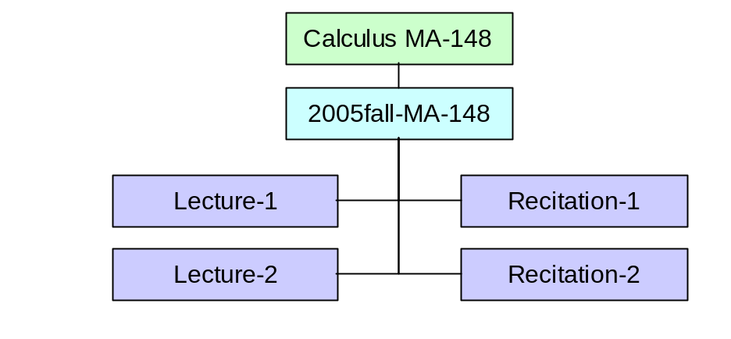
In this example, The Fall 2005 offering of Calculus, MA-148, has two lecture sections and two recitation sections. Students are split between the two lecture sections and the two recitation sections. For schedule convenience, students in lection 1 are not required to be in recitation 1, but might be in recitation 2, instead. Sakai’s Course Management Service does not provide a mechanism for enforcing business rules around section memberships. That is the responsibility of the student information system that implements Sakai’s read-only Course Management API.

Each Course Section has a title, a description, a section number, a maximum number of students who can enroll, a section type, and a list of meetings, which describe the days, times, and locations that the section meets. As with Course Offering, each Course Section has a set of memberships, which constitute a user and a role.

Some sections may have an official meaning beyond just a place to meet and learn. Some sections are graded and will appear on a transcript, while others meet as a requirement of another section. Sections that are graded individually have an EnrollmentSet, while non-graded / non-official sections have none.

  - Enrollment Sets
An Enrollment Set models the collection of Enrollments and official graders in an official, gradable section. A section that does not carry credits or official grades does not have an enrollment set.

Students may be associated with any section as a “member,” or they may be associated with a section by having an Enrollment Record in an Enrollment Set that is associated with the section. A “member” of a section can not have credits or enrollment status, so implementations of the Course Management Service should choose to model students as section “members” only if these fields are not applicable. Enrollment records include a status, which can be used to mark an enrollment as waitlisted, for example. Enrollment records also specify how much credit the student may earn.

  - Sub-sections as Ad Hoc Groups
Discussions around section requirement clearly pointed out the need for sub-sections. A sub-section is a section derived from another one. It usually represents some subset of the students and participants of the main section. One use of this kind of organization is ad hoc groups. A lecture section, for example, may have one or more project, study, or discussion groups associated with it.

Here is an example of ad hoc groups associated with a lecture section:

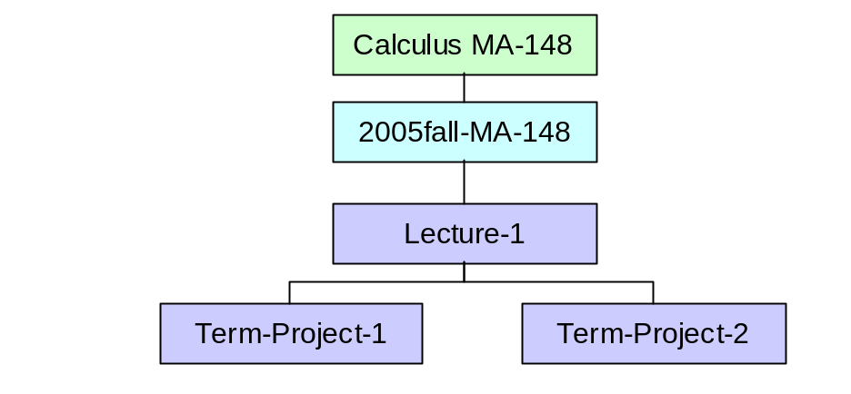
Here, the instructor of MA-148, lecture section 1 has decided to give a term project to his students concerning the applications of calculus in daily life. Two term project groups are formed (presuming a small class size). Each of these is essentially an ad hoc group created for the term.

Clustering is another use of sub-sections. Consider a popular (or required) course like Business Ethics. At a large school, there might be a dozen or more sections offered in a single semester. Naturally, professors are likely to be teaching more than one section at a time, and may desire to have a single website shared between the students in their sections. Thus:

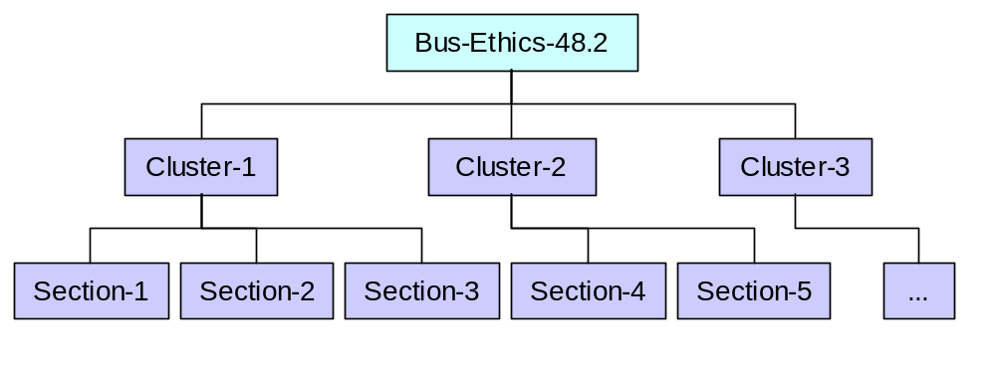
Here we have Cluster 1, taught by Prof. Leigh, a second Cluster 2, taught by Prof. Jamieson, etc. Cluster allows a structural organization to section setup. This can be accomplished in other ways, such as filtering on section leaders.

- Enterprise Integration
The Course Management Service is first and foremost an API. It is a description of official course structures and memberships rather than a repository for Sakai to store its own notion of course “Sites” and their members. Therefore, the Course Management API can be thought of as the enterprise integration contract between Sakai and the enterprise. The only other required integration point is authentication, which is handled by the UserDirectoryProvider.

Sakai 2.3 does include a reference implementation, which can be populated via a bundled quartz job or via an administrative API called the Course Management Administration Service. A Sakai installation may choose to use the reference implementation by synchronizing it with an external data source, or they may choose to implement the API from scratch against an existing set of database tables or an existing web service.

- Framework Integration
A Sakai installation typically contains a large number of course sites and groups, each of which contain members with roles like “Instructor” and “Student”. It’s therefore important to distinguish these “internal” structures and memberships from those provided by the Course Management Service. From Sakai’s point of view, the Course Management Service is a read-only view into an external repository of course information. In order to access this repository, Sakai can be configured to use a bundled CM-backed GroupProvider implementation. This allows the Course Management Service to answer Sakai’s simple group+user+role authorization and roster queries. More information on the framework integration is available in the 2.3 source. See https://source.sakaiproject.org/svn/course-management/branches/sakai_2-3-x/xdocs/readme.txt for more information on configuring this integration.

