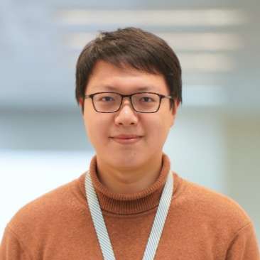

**Boqian Liu (刘博谦)**

**Cell Phone**: (+86) 176 2137 9964

**Email**: [liuboqian2015@outlook.com](mailto:liuboqian2015@outlook.com)

**Github Page**: <https://github.com/liuboqian>

**Seeking for**: Senior Full Stack Developer

**Check online resume here**: [Boqian Liu CV (https://boqian-resume.azurewebsites.net)](https://boqian-resume.azurewebsites.net/)

## SKILL STACKS

Frontend: **Angular**, React, **AG Grid**, echarts

Backend: **Asp.Net Core**, EF Core, SignalR

Programming language: **Typescript**, **C#**, python

Could: **Azure Devops** and **Azure** services

## Certificates

*Certified Kubernetes AZ-900 AZ-204 Azure*

*Application Developer Azure Fundamentals Developer Associate*

## WORK EXPERIENCE

**Elekta** as Full Stack Developer **2021 - Present**

1. Lead frontend rewrite, from jQuery to Angular 12, then upgrade to Angular 16. Use Nx to manage multiple libraries in a monorepo.
2. Heavy use on Angular Material, AgGrid.
3. Cloud based, use Azure DevOps deploy to Azure App Service, Log Analytics, Storage Account.
4. Implement on feature level, including FE and BE, db schema and sometimes UI design with figma.
5. Receive and process requirements from US team, provide proposals and system design in most cases.
6. Organize tech talk and legacy code review, provide support to other teams.

**Aspen Tech** as Developer **2018 - 2021**

1. Develop an Angular project with echarts, maintain a small react project.
2. Maintain a small legacy react project.
3. Develop features on a complex WPF project.
4. Petroleum process simulation using Aspen Plus and Aspen Hysys.

**Graduated student 2014 - 2017**

1. CAPEOPEN Basic Class Library, a COM compatible library, with 3 examples. Check here: <https://github.com/liuboqian/CasterUnitCore>
2. Develop chemical reactor module, work on numeric algorithm.
3. Process simulation for a real world petroleum equipment in Shandong, analyze result and provide evaluation report.

## EDUCATION

Master Ch.E., Chemical Engineering and Technology. Sep.2014 – July.2017 Qingdao University of Science & Technology Qingdao, Shandong

Bachelor Ch.E., Chemical Engineering and Technology. Sep.2010 – July.2014 Qingdao University of Science & Technology Qingdao, Shandong