Shadow, 2D/3D Texture, Reflect/Refraction, Phong Model
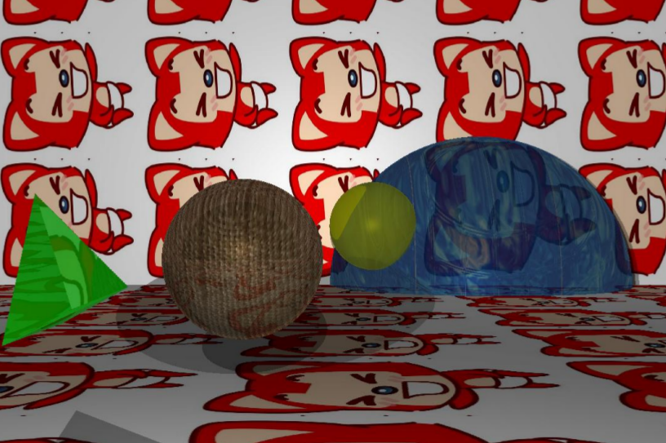

Rotation Effect
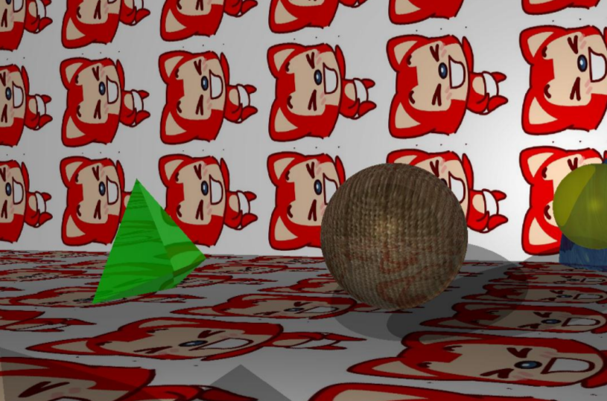

Depth of Focus
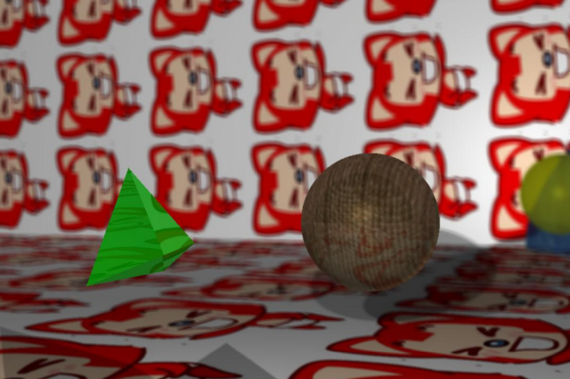

Complex Objects (Rabbit, described as 2113 3-D points)
