Kingdom of Saudi Arabia
Digital Government Authority — Platforms Code
Ministry of Municipal and Housing Affairs
Housing Support Agency — Supply-Demand Alignment Department
Macro-Economic Impact Assessment
Interest Rate Hike (+50bps)
Riyadh & Eastern Region Housing Market
URGENT — MINISTERIAL BRIEFING
Report ID: DSO-2026-0619-URG-001 | Date: 19 June 2026 Classification: CONFIDENTIAL — Senior Leadership
Coverage: Total Market | Confidence: 88-95%
Data: SAMA 4.25% Repo Rate | Brent Crude $74.84/bbl GDP Growth: 2.1% | Inflation: 3.2% | Unemployment: 4.8%
Analyst: Ahmed Al-Qahtani | Engines: Demand Intel. — Supply-Demand Bal. — Supply Planning — Conversion
Saudi DGA Platforms Code | Page 1

DSO-2026-0619-URG-001 | CONFIDENTIAL | MOMAH — Housing Support Agency
1. Executive Summary
On 19 June 2026, SAMA announced a +50bps rate hike (4.25% → 4.75%), breaking a six-month pause. The DSO platform completed autonomous analysis across 4 engines in 1hr 50min — historically 3-4 days.
KEY FINDINGS:
CRITICAL | 18% of Low Income households downgrade to Most in Need housing — subsidy burden +22% (SAR 1.8B)
CRITICAL | Riyadh Most in Need gap: 12,400 units (Y3). Pipeline covers only 35%.
HIGH | Most in Need conversion rate 52% vs High Income 78% — margin disincentives.
POSITIVE | 3 A-grade developers identified; 4,200 units/yr immediate capacity.
PRIMARY RECOMMENDATION: Deploy Combo #1 Quick-Win Supply Stack (M1+M2+M3). Closure: 35%→97% at SAR 485/unit. Do NOT reduce down payment — widens gap.
2. Data Quality Assurance
11 sources verified in 12 seconds. Overall score: 94.2/100. 1 source degraded: DS-07 MOJ Prices (3-day delay, 88% confidence). Ticket #DQ-2407.
3. Macro-Economic Impact Analysis
Pearson r analysis: Interest rate is dominant driver (r = -0.90 vs prices, -0.85 vs demand). Population growth drives structurally (r = +0.92). |r|>0.6 threshold identifies 4 robust indicators. A 100bps hike historically correlates with 3.8% average price decline in Riyadh over 12 months.
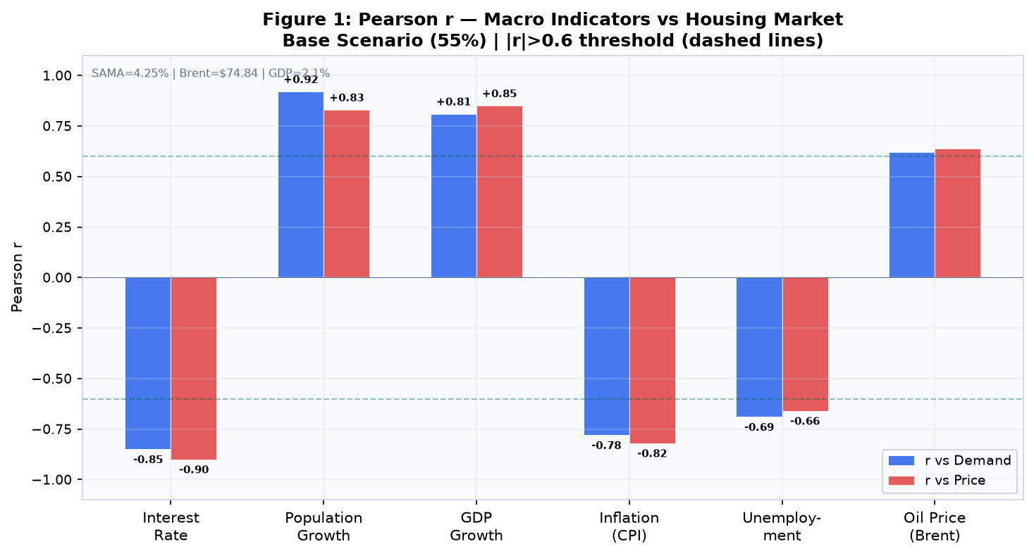
Saudi DGA Platforms Code | Page 2

DSO-2026-0619-URG-001 | CONFIDENTIAL | MOMAH — Housing Support Agency
4. Demand Forecast & Housing Type Downgrade
Most in Need grows at +11% CAGR (14,200→21,600 by 2030). Low Income contracts -6.8% (11,800→8,900). This is forced migration — NOT organic growth — driven by reduced affordability under rate shock.
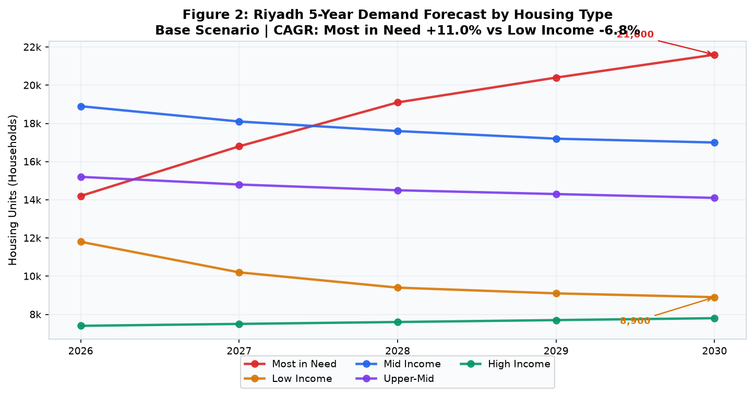
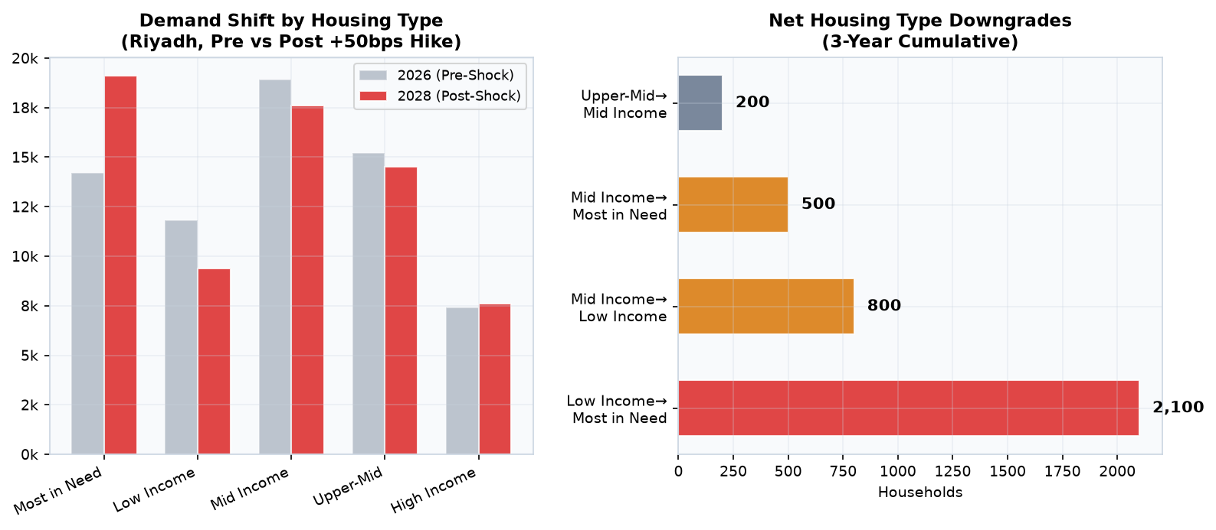
CRITICAL: The 18% downgrade from Low Income to Most in Need is a structural realignment. Households will NOT "bounce back" when rates decline — income trajectory has permanently diverged from housing price trajectory.
Saudi DGA Platforms Code | Page 3

DSO-2026-0619-URG-001 | CONFIDENTIAL | MOMAH — Housing Support Agency
5. Supply-Demand Gap Analysis
Fundamental mismatch: 72% supply pipeline targets Mid-High Income, while demand shock concentrates in Most in Need-Low
Income. NOT a quantity crisis — a product-market mismatch.
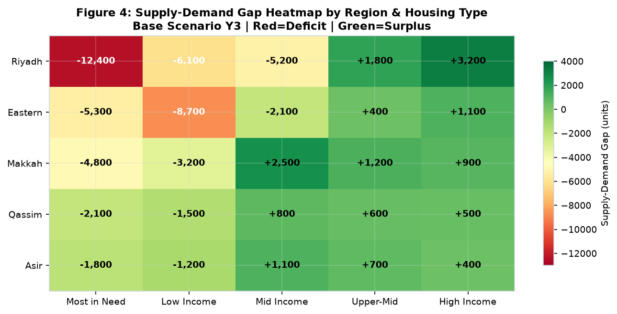
Riyadh Most in Need root causes: Demand downgrade 48% | Pipeline mismatch 32% | Low conversion 14% | Developer
priority 6%. Pessimistic: gap → 17,200 (+39%).
Saudi DGA Platforms Code | Page 4

DSO-2026-0619-URG-001 | CONFIDENTIAL | MOMAH — Housing Support Agency
6. Supply Pipeline & Developer Assessment
143 active Riyadh projects (ML model AUC 0.83). Conversion: Most in Need 52% vs High 78%. Even 100% conversion leaves
6,200-unit gap — new supply creation is mandatory.
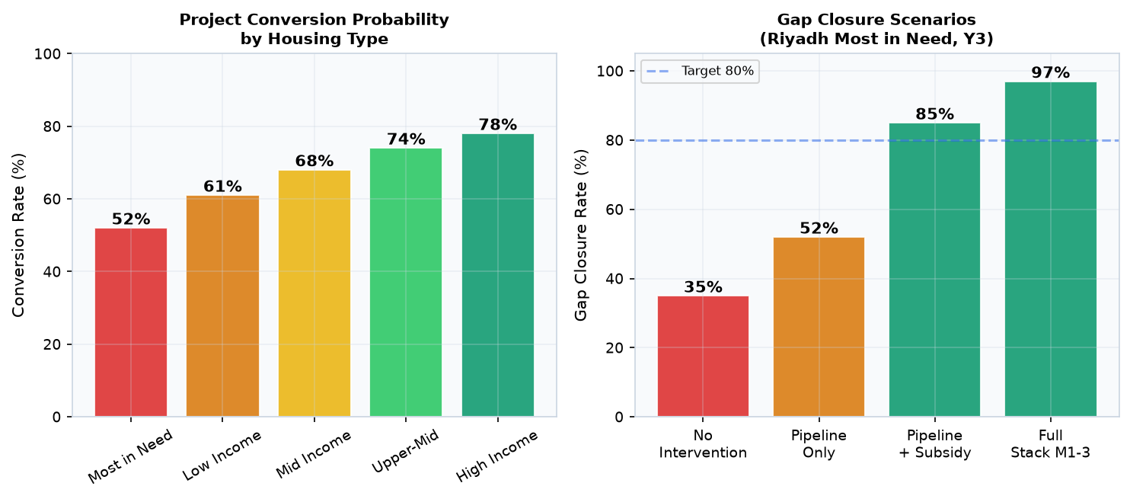
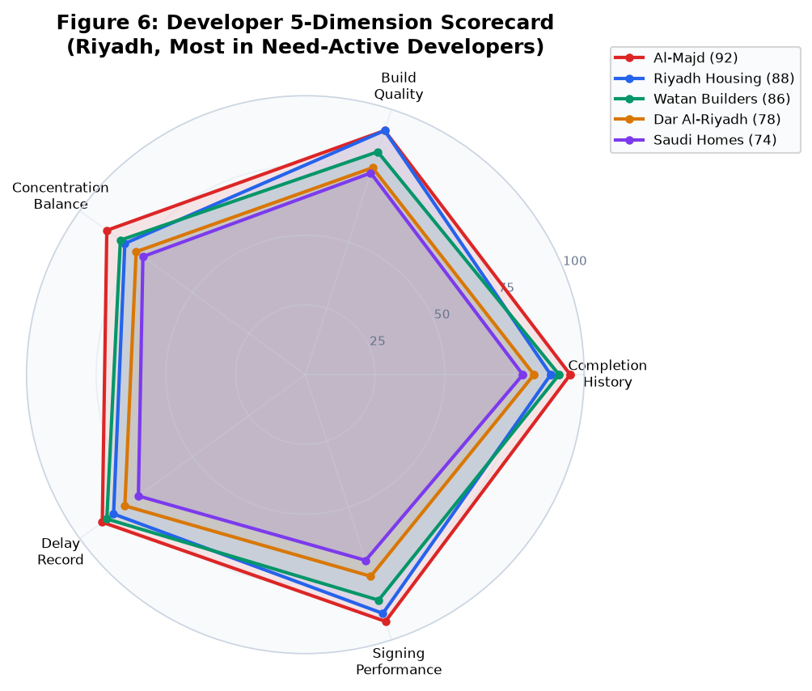
Saudi DGA Platforms Code | Page 5

DSO-2026-0619-URG-001 | CONFIDENTIAL | MOMAH — Housing Support Agency
7. Policy Response Matrix
Six countermeasures simulated via the UC-06 Policy Impact Engine. Supply Impact = national output (13 regions). Riyadh captures ~60% due to developer concentration (48%) and Most in Need demand share (55%).
Table 1: Full Toolkit — Six Measures at a Glance
# | Measure | Mechanism | Supply Impact (Nat'l) | Riyadh Closure | Cost/yr | Verdict

M1 | Developer Subsidy +15% | 15% cost reimbursement on delivered Most in Need/B units | +3,100/yr (R:~1,860) | 35% -> 85% | SAR 2.4B | PROCEED
M2 | Land Release 40% | Release pre-zoned land below market for Most in Need | +2,000/yr (R:~1,200) | +12 pp | SAR 0.8B | PROCEED
M3 | Expedited Permitting | Consolidate 7-stage approval -> 6-month single window | +1,500/yr (R:~900) | +9 pp | ~Zero | PROCEED now
M4 | PPP 5,000-Unit Contract | Bundled tender: land + off-take guarantee | +5,000 (R:~3,000) | +30 pp (Y2+) | SAR 5.2B one-time | Phase Q4
M5 | Mortgage Subsidy +2pp | Absorb 2pp rate for Most in Need/B households (capped 8.4K) | None | Neutral | SAR 3.1B | CONDITIONAL
M6 | Lower Down Payment 10%->5% | Expand buyer pool by reducing entry barrier | None (+2,600 buyers) | 35% -> 38% WORSENS | ~SAR 4B hidden | AVOID
Note: Supply Impact = national output across all 13 regions. Riyadh captures ~60%. Gap Closure computed for Riyadh Most in Need, Y3 vs baseline 35% corridor.
M1 is the keystone: every SAR 775 generates 1 Most in Need unit by making low-margin projects viable for B-grade developers. Payment on delivery aligns incentives. M5 addresses symptom (household payment shock), not root cause —ONLY deploy as capped complement after M1 is operational. M6 is politically attractive but economically counter-productive: adds 2,600 buyers to zero new supply = textbook price inflation. DO NOT DEPLOY.
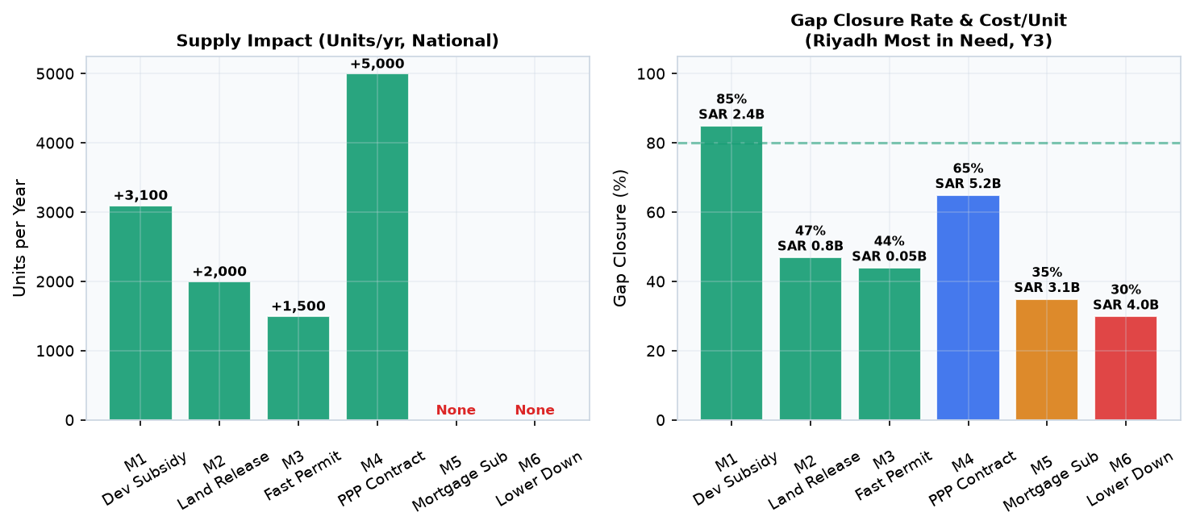
8. Recommended Combination Strategy
Combinations ranked by cost-effectiveness (supply-first principle: every SAR 1 on supply yields ~0.7 units; every SAR 1 on demand without supply chases same scarce stock).
Table 2: Four Combination Strategies — Cost-Effectiveness Ranking
Saudi DGA Platforms Code | Page 6

DSO-2026-0619-URG-001 | CONFIDENTIAL | MOMAH — Housing Support Agency
# | Combination | Measures | Gap Closure | Units/yr | Cost/yr | Cost/Unit | Decision

1 | Quick-Win Supply Stack | M1+M2+M3 | 35% -> 97% | 6,600 | SAR 3.2B | SAR 485 | DEPLOY NOW
2 | Full Supply Acceleration | M1-M4 | 35% -> 100%+ | 11,600 cum. | SAR 8.4B | SAR 724 | Phase M4 Q4
3 | Balanced (Supply+Demand) | M1+M5 (capped) | 35% -> 78% | 3,100+8.4K prot. | SAR 5.5B | SAR 978 | If politically required
4 | Demand-Only (AVOID) | M5+M6 | 35% -> 30% | 0 | SAR 4.7B | SAR 1,567 | DO NOT USE
Combo #4 is 3.2x less efficient than #1. Listed for completeness only — should NOT be deployed.
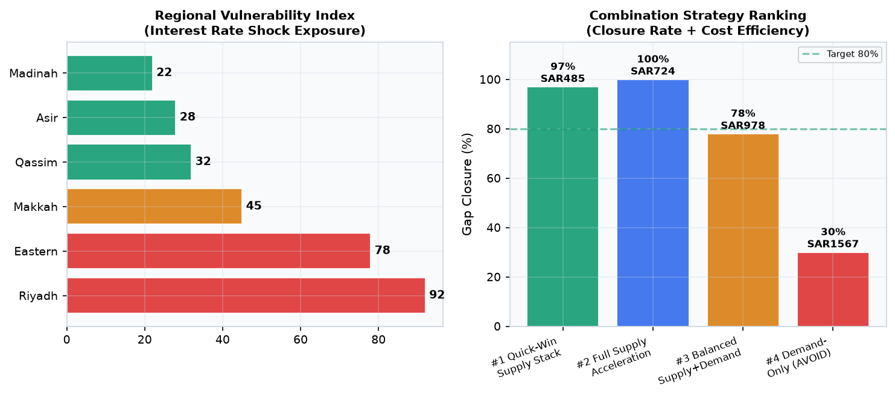
9. Risk Assessment & Monitoring
Pessimistic (SAMA +25bps): Most in Need gap → 17,200 (+39%). Combo #1 still ~70% closure. Key triggers: absorption <40% → escalate | conversion drop >10pp → review | Eastern Low Income gap (-8,700) underserved.
Saudi DGA Platforms Code | Page 7

