a)

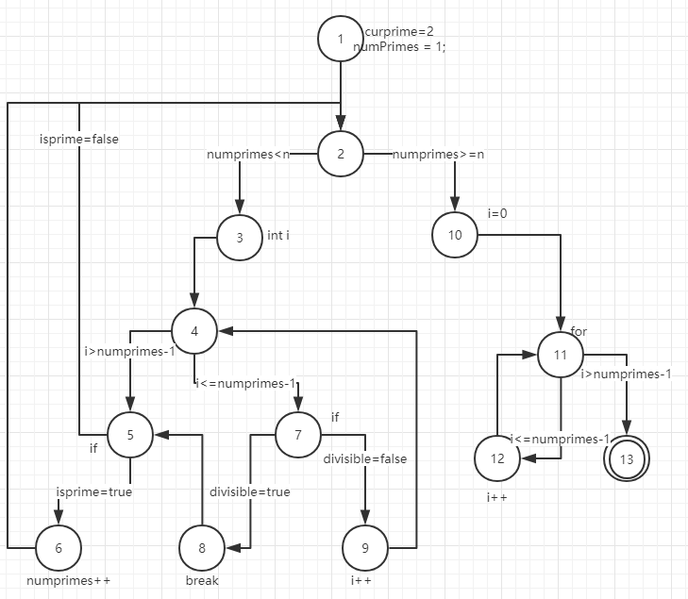

b)

while循环里的 numPrimes<n 改成numPrimes<3

c)

t=(n=1)

d)

节点覆盖：

{1,2,3,4,5,6,7,8,9,10,11,12,13};

边覆盖:

{(1,2),(2,3),(3,4),(4,5),(4,7),(5,6),(5,8),(6,2),(7,9),(8,5),(9,4),(5,2),(10,11),(11,12),(11,13),(12,11),(2,10)}

主路径覆盖

{(1,2,3,4,7,8),(1,2,3,4,5,8),(1,2,3,4,7,8,5),(1,2,10,11,12),(1,2,10,11,13), (3,4,8,9,2,10,11,13),(3,4,8,2,10,11,13),(4,5,7,4),(4,5,6,8,9,2,3,4),(4,5,6,8,2,3,4),(4,8,9,2,3,4),

(2,3,4,8,9,2),(2,3,4,8,2),(2,3,4,5,7),(2,3,4,5,6,8,9,2),(2,3,4,5,6,8,2),(2,10,11,12),(2,10,11,13),

(3,4,5,6,8,9,2,3),(3,4,5,6,8,2,3),(3,4,8,9,2,3),(3,4,8,2,3),(3,4,5,6,8,9,2,10,11,12),(3,4,5,6,8,2,10,11,12),(3,4,5,6,8,9,2,10,11,13),(3,4,5,6,8,2,10,11,13),(3,4,8,9,2,10,11,12),(3,4,8,2,10,11,12),

(4,8,2,3,4),(5,7,4,5),(5,6,8,9,2,3,4,5),(5,6,8,2,3,4,5),(6,8,9,2,3,4,5,6),(6,8,9,2,3,4,5,6),(6,8,9,2,3,4,5,7),

(6,8,2,3,4,5,7),(7,4,5,7),(7,4,8,9,2,3),(7,4,8,2,3),(7,4,5,6,8,9,2,3),(7,4,5,6,8,2,3),

(7,4,5,6,8,9,2,10,11,12),(7,4,5,6,8,9,2,10,11,13),(7,4,5,6,8,2,10,11,12),(7,4,5,6,8,2,10,11,13),

(7,4,8,9,2,10,11,12),

(7,4,8,9,2,10,11,13),(7,4,8,2,10,11,12),(7,4,8,2,10,11,13),(8,2,3,4,8),(8,9,2,3,4,8),(8,2,3,4,5,6,8),

(8,9,2,3,4,5,6,8),(9,2,3,4,8,9),(9,2,3,4,5,6,8,9),(11,12,11),(12,11,12),(12,11,13)}.