**Git 提交错误**

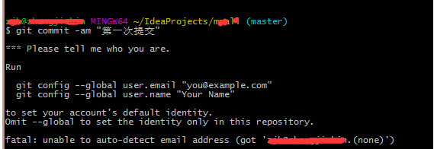

**解决：**git  config --global user.email "Author Email"

git config --global user.name "Author Name"