Supporting Information
Unified interplay of chemical bonding and structural evolution in Co-doped α-Mn₂O₃ mesoporous cathodes for high-energy aqueous zinc-ion batteries
Yuyan Qiuª, Yuhang Sunª, Shuo Zhangª, Lei Gaoª, Xuebin Wangª*, Yuefeng Tangª*
ª National Laboratory of Solid State Microstructures (NLSSM), Collaborative Innovation Center of Advanced Microstructures, Jiangsu Provincial Laboratory for Nanotechnology, College of Engineering and Applied Sciences, Nanjing University, Nanjing 210093, China
*Corresponding authors: wangxb@nju.edu.cn, yftang@nju.edu.cn.
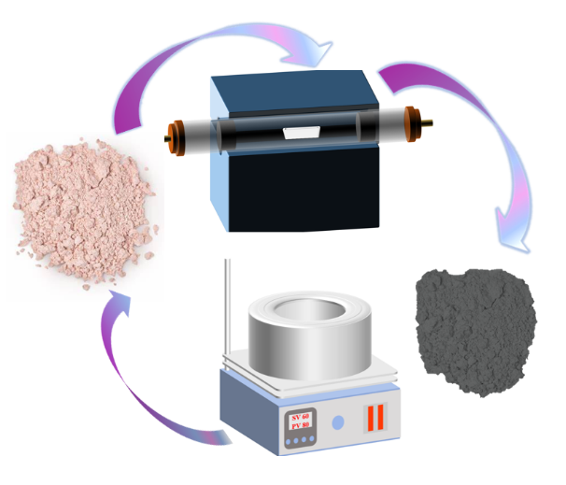
Figure S1 Schematic strategy for Co-doped Mn₂O_{3.}

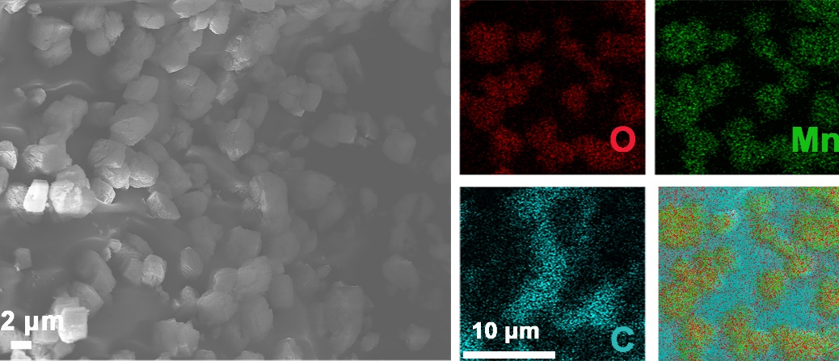
Figure S2 SEM image and the elements mapping images of O, Mn, and
C in MNO.

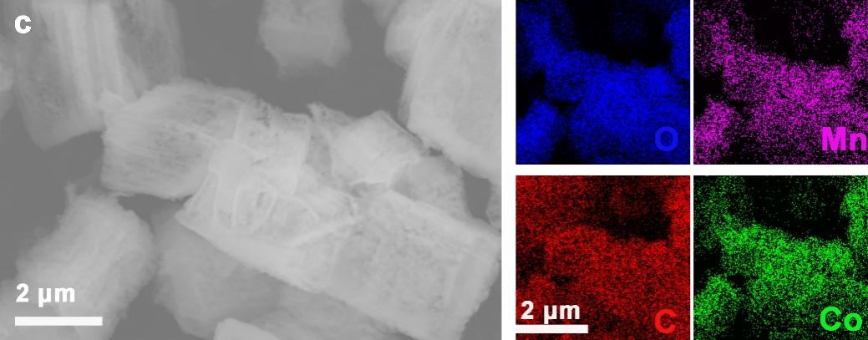
Figure S3 SEM image and the elements mapping images of O, Mn, C, and Co in MCO-0.3.

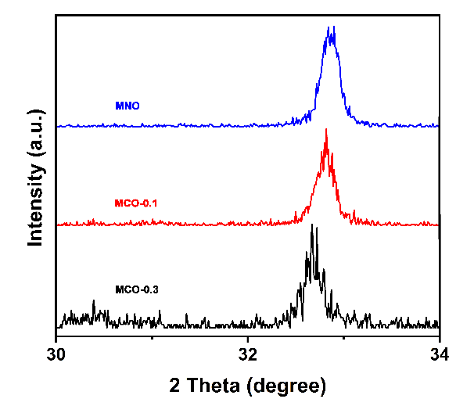
Figure S4 XRD image of MNO, MCO-0.1 and MCO-0.3.
Figure S5 Raman pattern of MNO, MCO-0.1 and MCO-0.3.
Figure S6 GCD profiles of MNO and MCO-0.3.
Figure S7 Long-cycle performance at a current density of 2 A g⁻¹ without MnSO₄ additive in the electrolyte.
Figure S8 Mn dissolution of MNO and MCO-0.1 after 50 cycles at 2 A g⁻¹.
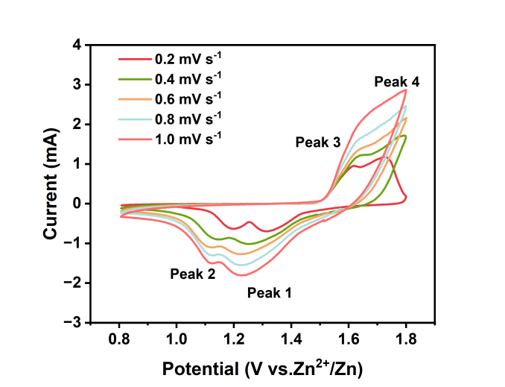
Figure S9 CV curves of MNO.
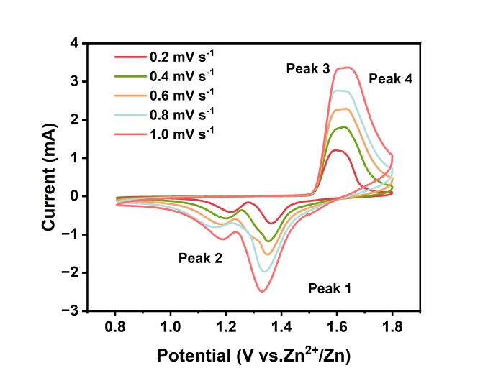
Figure S10 CV curves of MCO-0.3.
Upon discharge, the peak broadens and shifts to lower binding energies: at 1.2 V, deconvolution reveals coexisting Mn²⁺/Mn³⁺ (642.3 eV), with a satellite peak confirming Mn²⁺ formation. Further discharge to 1.0 V reduces the peak to 641.9 eV, with Mn³⁺ diminishing significantly, consistent with progressive reduction to Mn²⁺.
During charging to 1.6 V, the Mn 2p_{3/2} peak shifts to 642.1 eV, corresponding to Mn⁴⁺ in MnO₂ (Figure S10).
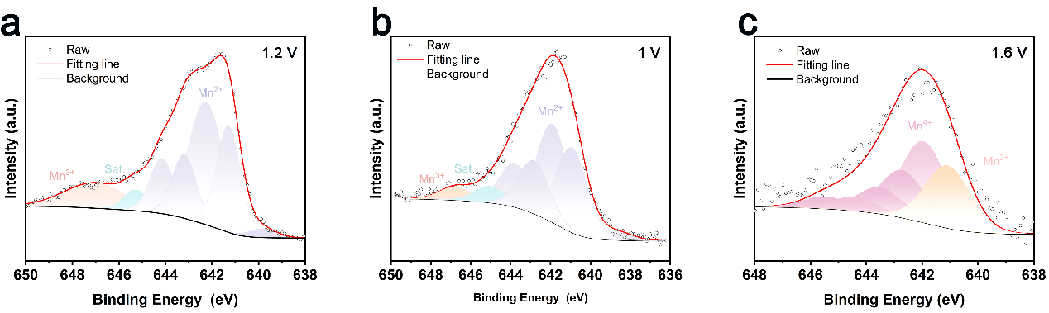
Figure S11 High-resolution Mn 2p3/2 spectra of the electrode (a) after discharging to 1.2 V; (b) after discharging to 1 V; (c) after charging to 1.6 V.

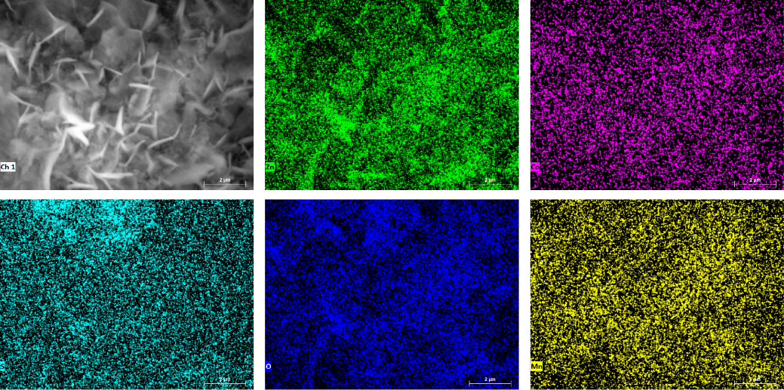
Figure S12 SEM image of MCO-0.1 cathode in fully discharged state and corresponding EDS images.

Figure S13 Discharge specific capacity curves of MCO-0.1 cathode using MnSO₄ as electrolyte solute for the first 15 cycles at a current density of 0.2 A g⁻¹.

Figure S14 Discharge specific capacity curves of MCO-0.1 cathode using DMSO as electrolyte solvent for the first 15 cycles at a current density of 0.2 A g⁻¹.

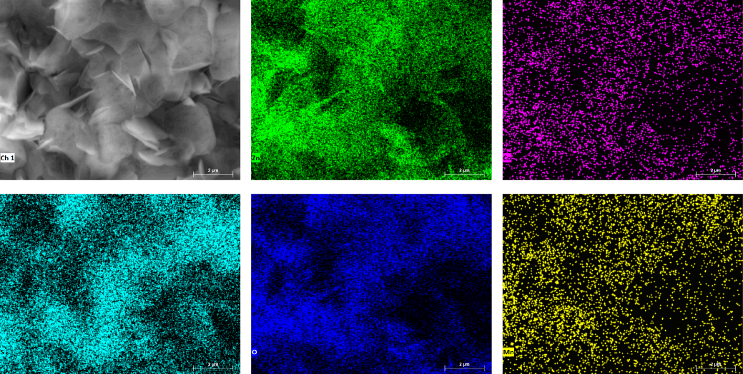

Figure S15 SEM image of MCO-0.1 cathode in fully charged state and corresponding EDS images.

