Supporting Information
Oxygen-Site Engineering Guided Bonding Coupling and Intrinsic Distortion: Enabling High-Rate Long-Lasting Zn-MnO₂ Batteries

Experimental Section
1. Preparation materials
Materials
Potassium permanganate (KMnO₄, ≥ 99.5%) was purchased from Shandong Institute of Chemical Industry. Manganese sulfate monohydrate (MnSO₄·H₂O, ≥ 99.0%) was acquired from Aladdin (China). Anhydrous ethanol (AR), sulfur powder (AR), Nitromethyl pyrrolidone (NMP, AR), Zinc sulfate heptahydrate (ZnSO₄·7H₂O, AR) and Sodium hypophosphite monohydrate (NaH₂PO₂·H₂O, AR) were provided by Sinopharm Chemical Reagent Co. Ltd. Super P and PVDF were obtained from Shanghai Saibo Chemical Co. Ltd and Anhui Zesheng Technology Co. Ltd, respectively. Deionized water was used in all experimental processes.
Preparation of cathodes
δ-MnO₂ was prepared by a facile hydrothermal method. In brief, 0.016 mol of KMnO₄ was dissolved into 80 mL of deionized water under stirring for 15 min. The solution was transferred into a Teflon-lined stainless-steel autoclave and kept at 160 °C for 12 h. After cooling down to room temperature, the obtained δ-MnO₂ was washed with deionized water several times, and further dried at 80 °C for 6 h.
The preparation of sulfur/phosphorus co-doped MnO₂ (S/P-MnO₂) was achieved in a two-temperature zone tube furnace. Firstly, a ceramic boat containing δ-MnO₂ (0.1 g) was placed in the downstream section of the furnace tube, and two ceramic boats containing sulfur (0.003 g) and NaH₂PO₂·H₂O (0.05 g), respectively, were positioned in the upstream zone. Then, with a rate of 5 °C/min in an argon atmosphere, the downstream region was heated to 250 °C for 100 min. The upstream region was heated to 350 °C for 30 min, followed by heating to 450 °C for 30 min. After the entire process, the tube furnace was naturally cooled to room temperature.
For the preparation of sulfur-doped MnO₂ (S-MnO₂) and phosphorus-doped MnO₂ (P-MnO₂), only one ceramic boat containing sulfur (0.003 g) or NaH₂PO₂·H₂O (0.05 g) was placed in the upstream region of the furnace tube, with other conditions kept consistent with the above process. And the control group δ-MnO₂ (0.1 g) was only placed in the downstream region without sulfur/phosphorus condition, while the other experimental parameters remain identical.
2. Characterization
X-ray diffraction (XRD) patterns were collected by a Rigaku SmartLab 9 kW diffractometer with Cu Kα radiation (Cu Kα radiation, λ = 1.5416 Å) at a speed of 20° min⁻¹ from 5° to 80° (2θ). The morphology information of samples was obtained from scanning electron microscopy (SEM, ZEISS, G500) with an energy-dispersive X-ray spectroscopy (EDS) attachment. Raman spectra was recorded at room temperature using a 532 nm solid-state laser as the excitation source on the LabRAM HR Evolution. X-ray photoelectron spectroscopy (XPS) was performed on a Thermo Fisher Scientific ESCALAB Xi+ electronic spectrometer with monochromated Al-Kα radiation (1486.8 eV). Transmission electron microscopy (TEM, FEI Tecnai F20) was applied to observe the internal microstructure and dimensions of the materials. Additionally, high-resolution transmission electron microscopy (HRTEM) was used to investigate the crystal structure and crystal morphology of samples. Nitrogen adsorption-desorption isotherms were recorded to calculate the specific surface area and analysis of the pore size distribution using the Brunauer-Emmett-Teller (BET) method on a High-Speed Automated Surface Area and Pore Size Analyzer system (Autosorb-iQ-MP, Quantachrome Instruments U.S.). The electron paramagnetic resonance (EPR) spectra were collected by Germany Bruker Magnettechn EPR MS 5000X. X-ray absorption spectra (XAS) of Mn K-edge were performed in transmission mode at the beamline 4B9A station of the Beijing Synchrotron Radiation Facility (BSRF). The pH values of a series of electrolytes with different cycles were collected by LiChen (LC23010687). For ex-situ characterizations, the tested electrodes were retrieved from cycled aqueous batteries in a 2032 coin-cell configuration, which were then carefully rinsed with deionized water and dried at 80 °C for 12 h under a vacuum oven.
3. Electrochemical measurements
In a typical process, the synthesized samples were mixed with Super P and PVDF with a weight ratio of 7:2:1 to form a homogeneous slurry, which was then uniformly cast onto a hydrophilic carbon cloth and dried in a vacuum oven at 100 °C for 12 h. All testing CR2032-type coin cells were assembled in an open-air environment, where zinc foils (100 μm thick) and glass fibers with the diameter of 16 mm (GF/A, Whatman) functioned as the anodes and separators, respectively. An aqueous mixture solution containing 2.0 M ZnSO₄ and 0.2 M MnSO₄ was utilized as the electrolyte. The galvanostatic charge-discharge (GCD), cycling performance, rate performance and galvanostatic intermittent titration technique (GITT) tests were conducted at room temperature using LAND battery testing system (LAND CT2001A) and analyzed by LAND software. The cyclic voltammetry (CV) curves in a voltage range extended from 0.8 to 1.9 V with different scan rates and electrochemical impedance spectroscopy (EIS) with a frequency range from 0.01 Hz to 100 kHz at 5 mV amplitude were collected by an electrochemical workstation (Chenhua, CHI 760E). The thickness of the zinc metal used is 100 μm, the active mass loading of the electrode used is about 3 mg cm⁻² (unless otherwise specified).
Capacitive and diffusion-controlled contributions
To quantitatively analyze the electrode kinetics, the cyclic voltammetry curves at different sweep rates were measured, in which the measured peak current (i) and sweep rate (ν) obey a power-law relationship:
i = av^{b}
In logarithmic form：
log(i) = log(a) + b·log(ν)
where a and b are adjustable parameters, and the b value can be obtained by fitting the slopes of the log(i) and log(ν). A b value of 1.0 corresponds to a predominantly capacitive charge storage mechanism, whereas a b value of 0.5 reflects a process controlled by ion diffusion.
Furthermore, for a quantitative analysis of diffusion-controlled and capacitive contributions in current response, assumption of an integration of semi-infinite diffusion and capacitive like process were carried out by the following equation:
i = k₁ν + k₂ν^{1/2}
where i is the current (mA) at a specific potential V, v refers to scan rate (mV s⁻¹), k₁ and k₂ are the fitted constants, and the terms k₁ν and k₂ν^{1/2} correspond to the capacitive-controlled and diffusion-controlled contributions, respectively.
GITT
The diffusion coefficient (D_{Zn}²⁺) was obtained based on the equation:
$$D=\frac{4}{πτ}{\left(\frac{mV}{MS}\right)}^{2}{(\frac{ΔEs}{ΔEτ})}^{2}$$
where τ is the duration time (s) of the current pulse; m is the loading mass (g) of active material; V is the molar volume (cm³ mol⁻¹); M is the molecular weight (g mol⁻¹) of cathode material; S represents the loading area (cm²) of active material; ΔEs is the steady-state potential change (V) by the current pulse; and ΔEτ is the potential change (V) during the constant current pulse after eliminating the iR drop. During the GITT process, current pulse of 100 mA g⁻¹ was applied for 300 s while the followed relaxation time is 300 s.
4. Theoretical calculations
All calculations were carried out for the material in the framework of Density Functional Theory (DFT) using the Vienna Ab initio Simulation Package (VASP 6.3.0) [1-3]. The generalised gradient approximation (GGA) of the Perdew-Burke-Ernzerhof (PBE) function was used to describe the exchange-correlation energy [4]. The projected augmented wave (PAW) method and pseudopotentials were used to describe the interactions between valence electrons and ions [5]. To ensure the efficiency of the computational results and parallel computing. A 3×3×2 k-point grid under Monkhorst-Pack is used in the optimisation process and 500 eV truncation energy is set. The lattice parameters and ionic positions of all crystals were fully relaxed, and the convergence criteria for the total energy of all relaxed atoms and the final force were 10⁻⁶ eV and 0.03 eV/Å, respectively. To correct the localization effect of D-orbital electrons in transition metal atoms, the Hubbard+U method is adopted, where the effective U value of Mn is 2.5 eV.
For the calculation of the migration barrier, the convergence criteria for energy were set at 10⁻⁶ eV, and for force at 0.02 eV/Å, to ensure that the structure can fully relax. Additionally, the climbing-image nudged elastic band (CI-NEB) method was employed to study the kinetics of ion (Zn²⁺ and H⁺) migration. This method mainly uses linear interpolation, inserting 5 intermediate states between the reactants and products to search for the minimum reaction activation energy.
The binding energies (E_{b}) were calculated by using the following definition:
E_{b} = E_{total} - E_{sample} -E_{intercalation atom}
Where the E_{total} is the total electronic energy for the sample with Zn²⁺/H⁺ intercalation; E_{sample} is the electronic energy of the sample without ion intercalation, E_{intercalation atom} is the electronic energy of a single intercalation atom. The corresponding energy values were shown in the Table S3.

Supplementary Figures and Tables
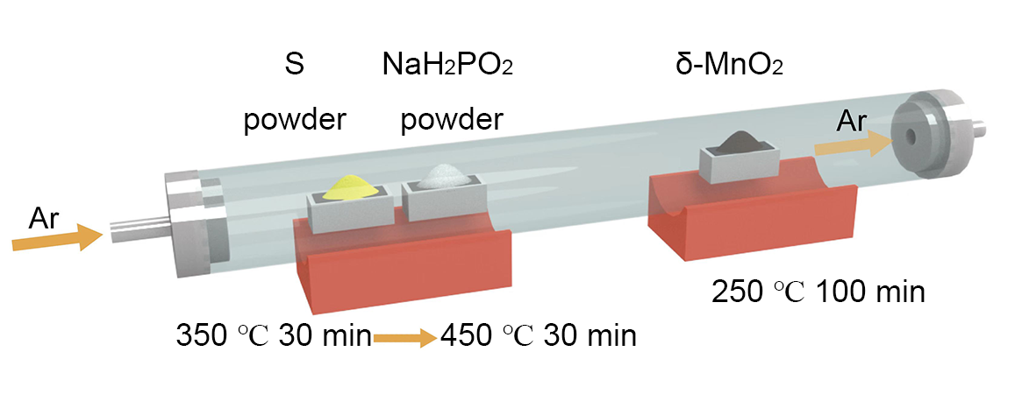
Fig. S1. Synthesis process of S/P-MnO₂ materials.

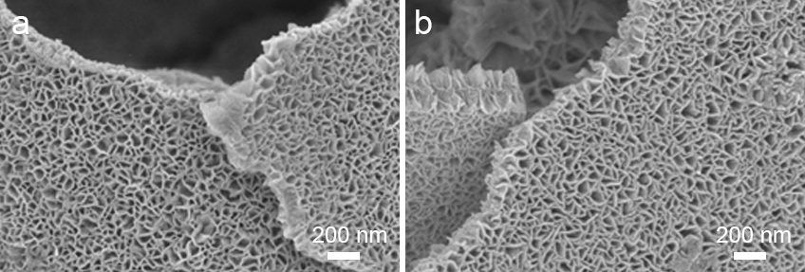
Fig. S2. SEM images of (a) S-MnO₂ and (b) P-MnO₂.

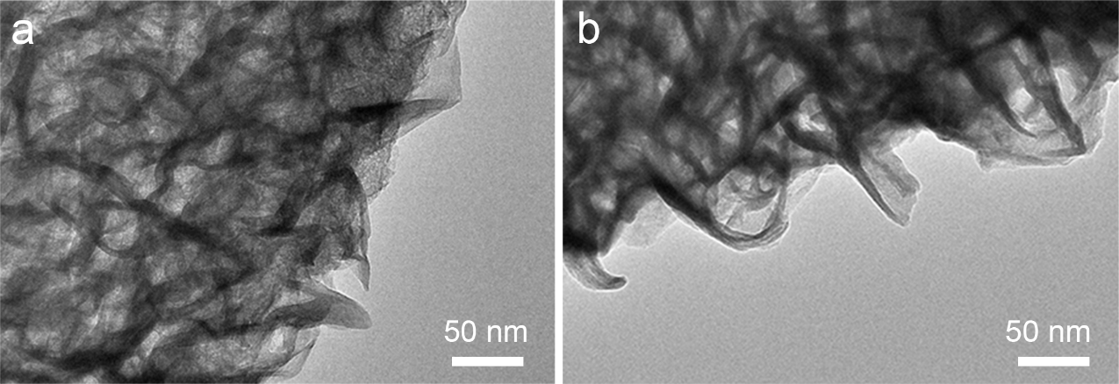
Fig. S3. TEM images of (a) δ-MnO₂ and (b) S/P-MnO₂.

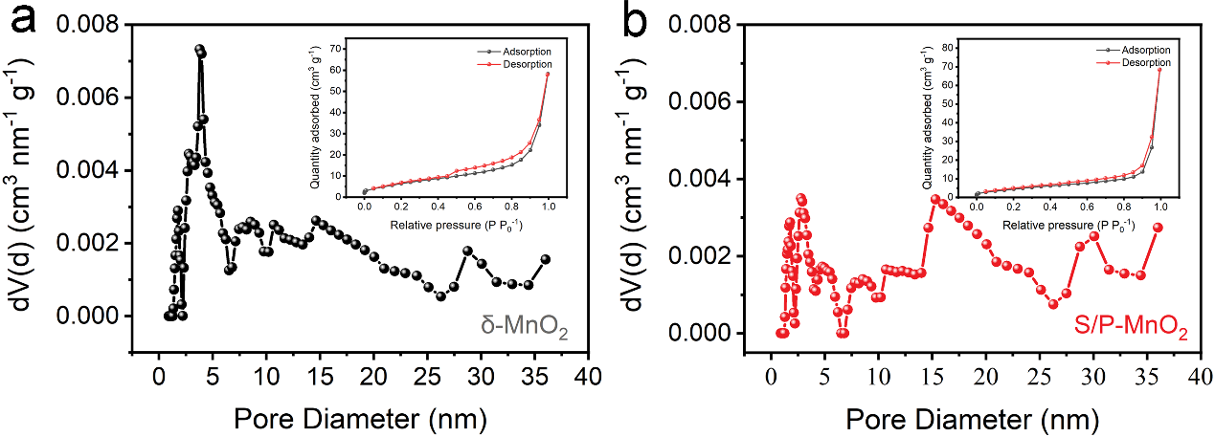
Fig. S4. Pore size distributions and nitrogen adsorption-desorption isotherms of (a) δ-MnO₂ and (b) S/P-MnO₂.

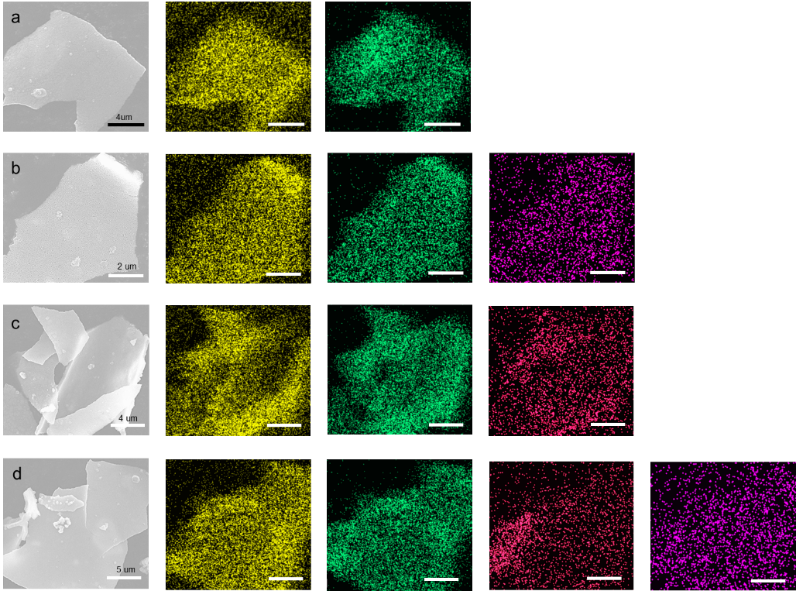
Fig. S5. Elemental mapping images of (a) MnO₂, (b) S-MnO₂, (c) P-MnO₂ and (d) S/P-MnO₂.

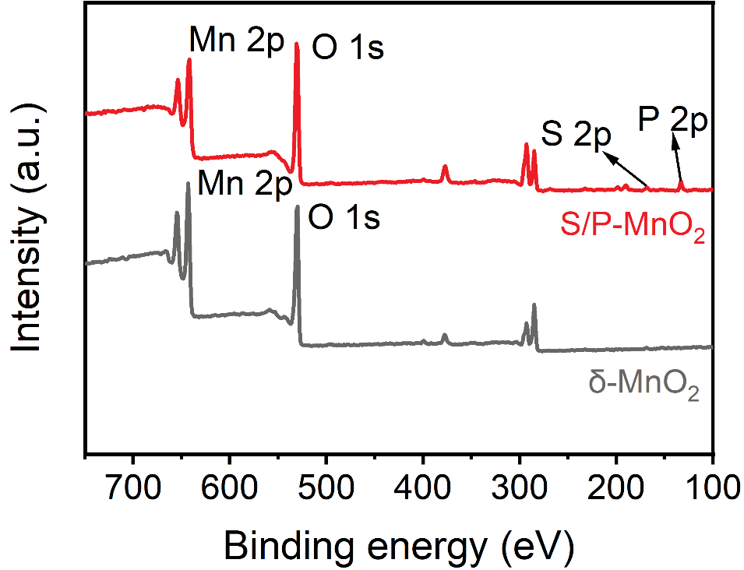
Fig. S6. Full XPS spectra of δ-MnO₂ and S/P-MnO₂.

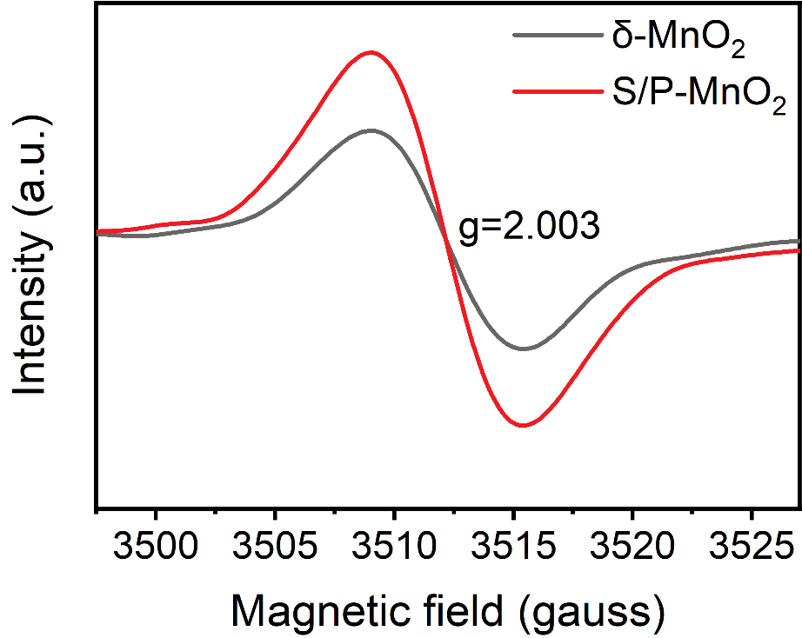
Fig. S7. EPR curves of δ-MnO₂ and S/P-MnO₂.

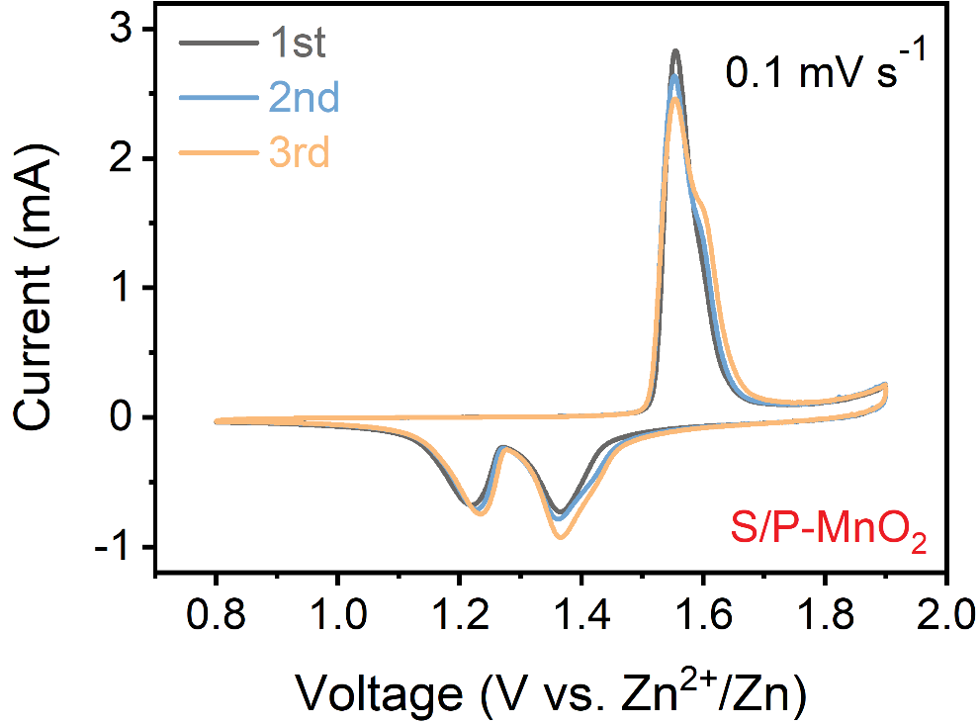
Fig. S8. CV curves of S/P-MnO₂ for initial three cycles at 0.1 mV s⁻¹.

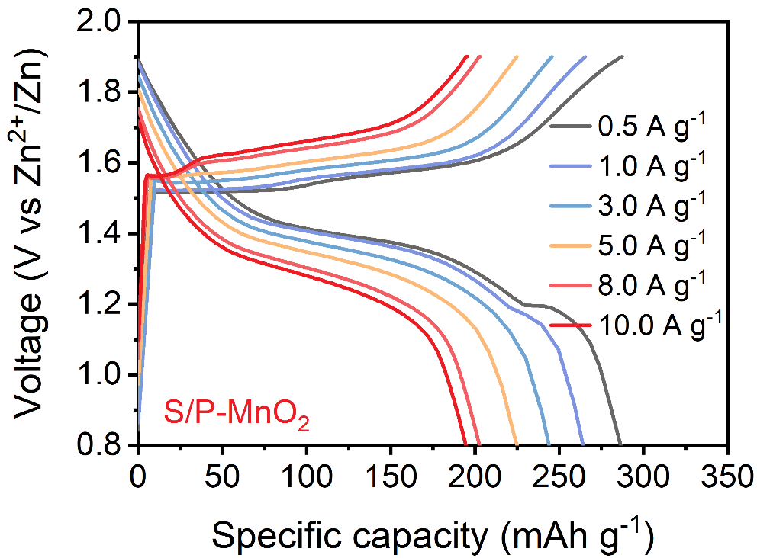
Fig. S9. GCD curves of S/P-MnO₂ at different current densities.

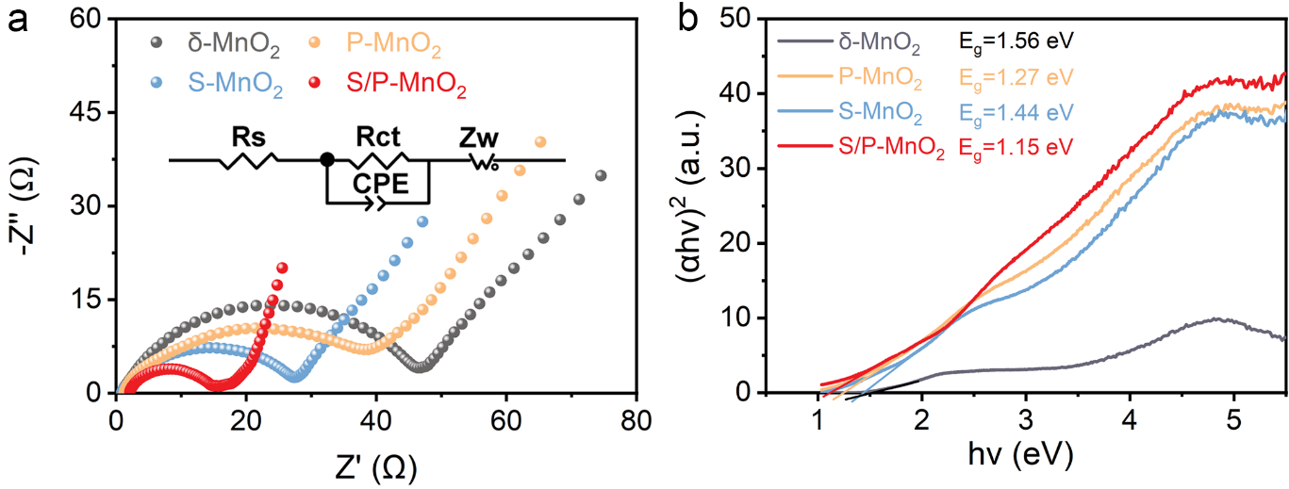
Fig. S10. (a) EIS plots and (b) energy bandgaps of δ-MnO₂, S-MnO₂, P-MnO₂ and S/P-MnO₂.

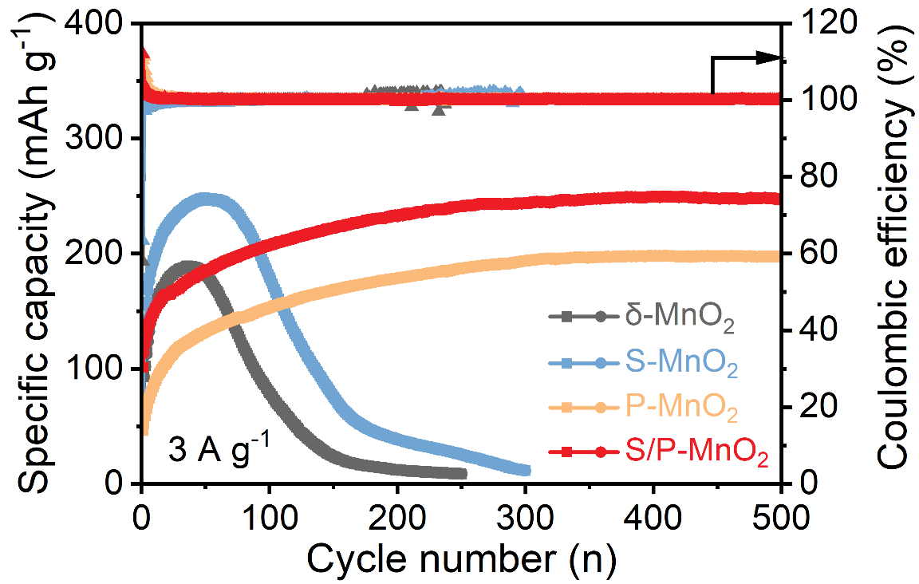
Fig. S11. Cycling stability comparison of δ-MnO₂, S-MnO₂, P-MnO₂ and S/P-MnO₂ at 3 A g⁻¹.

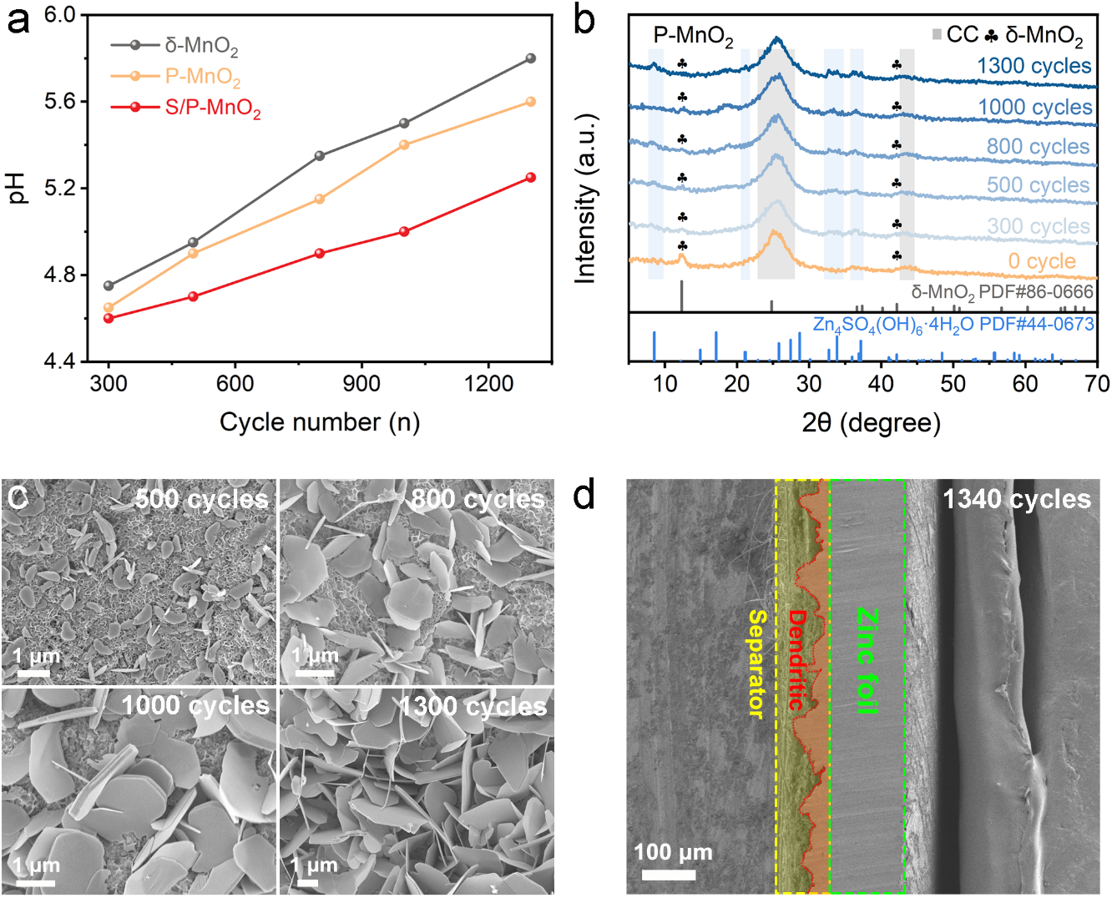
Fig. S12. (a) pH evolution of the cathode surface during various cycles. (b) Ex-situ XRD patterns and (c) SEM images of P-MnO₂ at different cycles. (d) Cross section SEM image of Zn anode after 1340 cycles.

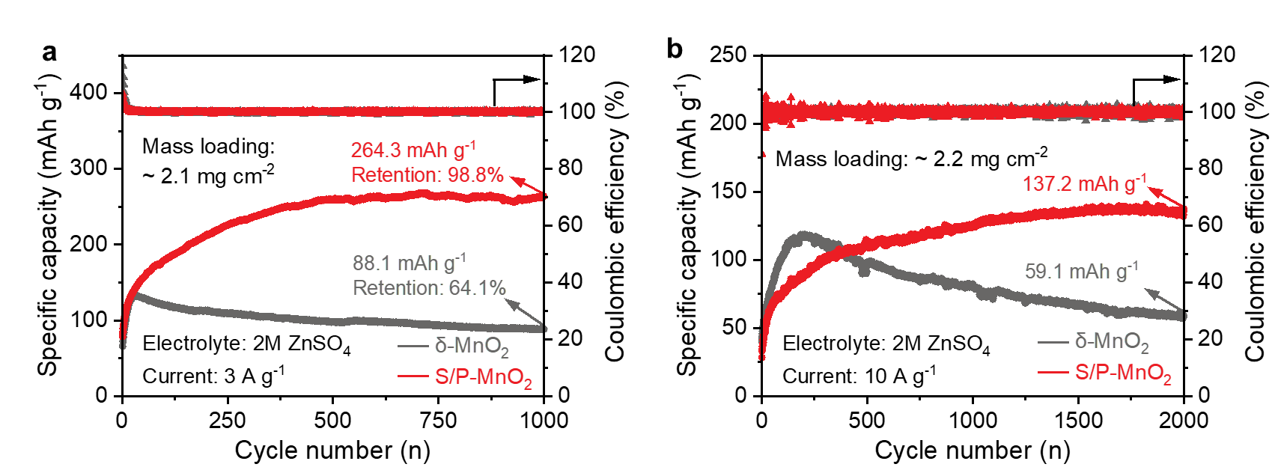
Fig. S13. Cycling performance of MnO₂ and S/P-MnO₂ in 2 M ZnSO₄ electrolyte at (a) 3 A g⁻¹ and (b) 10 A g⁻¹.

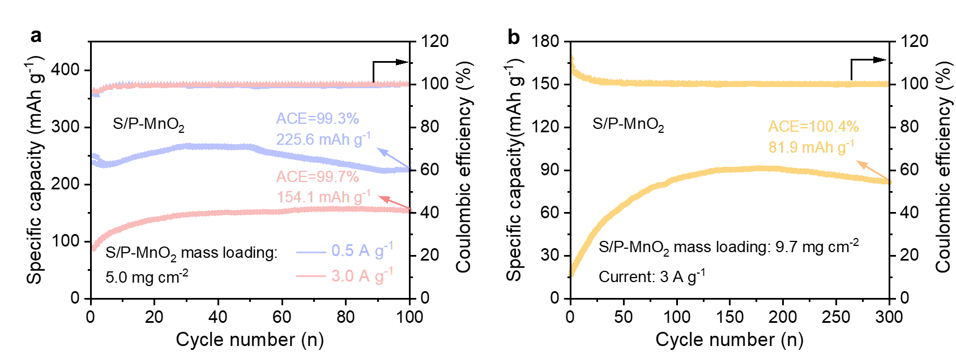
Fig. S14. (a) Rate and cycling performance of the S/P-MnO₂ cathode at a mass loading of 5 mg cm⁻². (b) Cycling performance of the S/P-MnO₂ cathode at a higher mass loading of 9.7 mg cm⁻².

Fig. S15. Cycling performance of the Zn||S/P-MnO₂ full battery at a low N/P ratio.

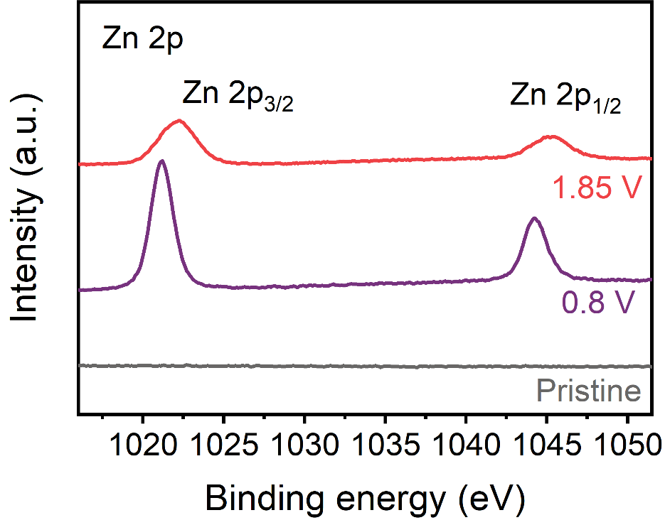
Fig. S16. Ex-situ Zn 2p XPS spectra of S/P-MnO₂ at different charge/discharge states.

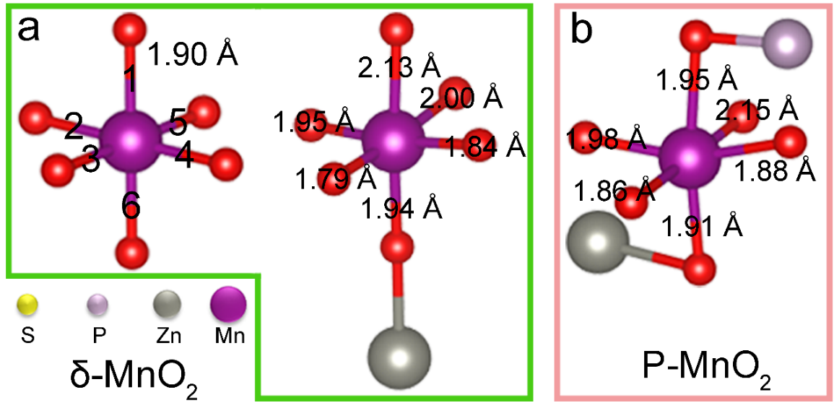
Fig. S17. Simulated bond length information of [MnO₆] octahedra in (a) δ-MnO₂ and (b) P-MnO₂ during ion insertion.

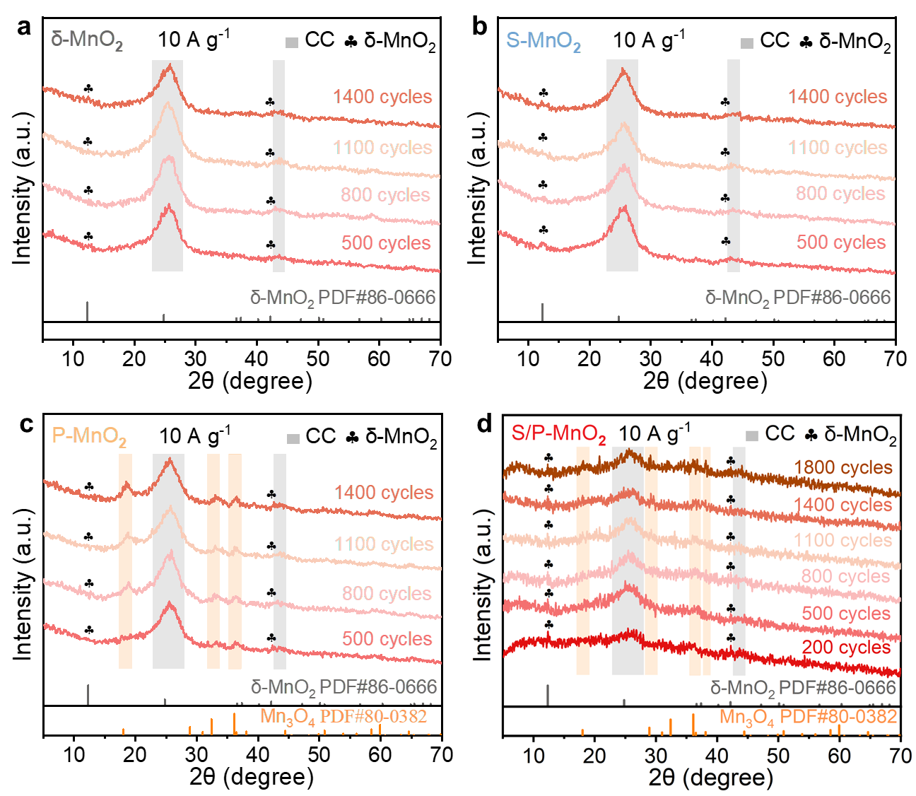
Fig. S18. Ex-situ XRD patterns of δ-MnO₂, S-MnO₂, P-MnO₂, and S/P-MnO₂ electrode at different cycle numbers under 10 A g⁻¹.

Fig. S19. (a) TEM image of the mixed electrode of MnO₂ and Mn₃O₄ materials after cycling. (b) Cycling performance of the mixed electrode.

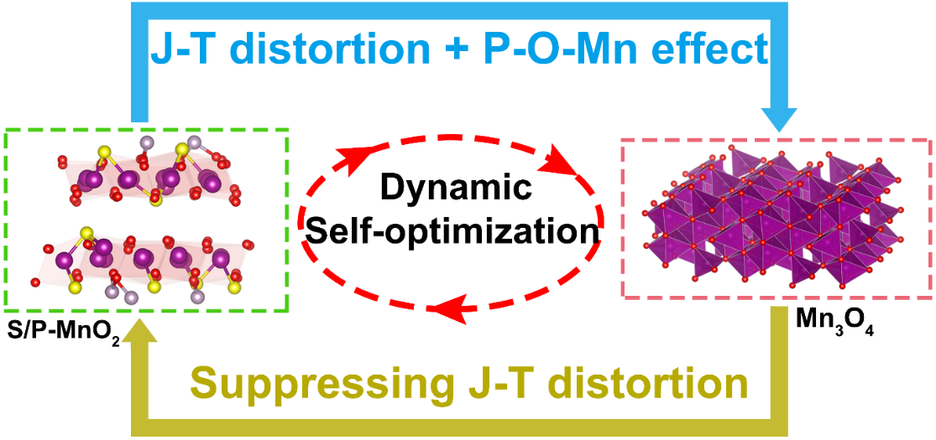
Fig. S20. Dynamic self-optimization process of S/P-MnO₂ under high current density.

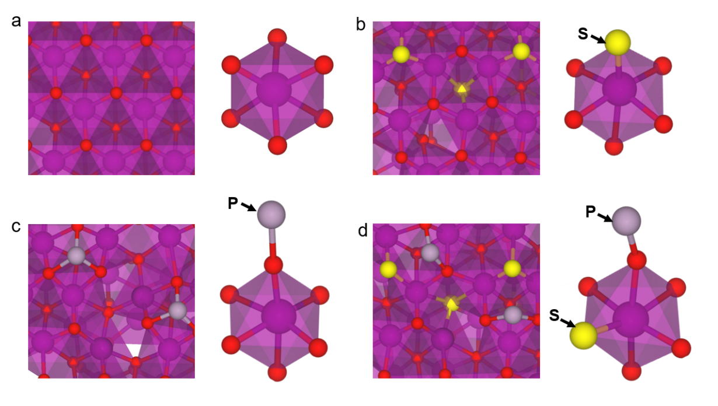
Fig. S21. Optimized crystal structure of (a) δ-MnO₂, (b) S-MnO₂, (c) P-MnO₂ and (d) S/P-MnO₂.

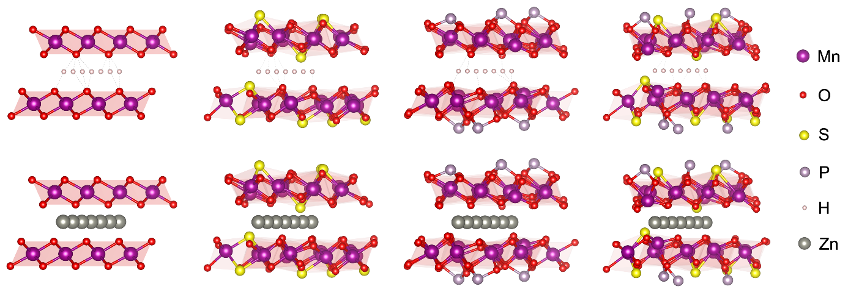
Fig. S22. The H⁺ and Zn²⁺ transport pathways in the δ-MnO₂, S-MnO₂, P-MnO₂ and S/P-MnO₂ hosts.

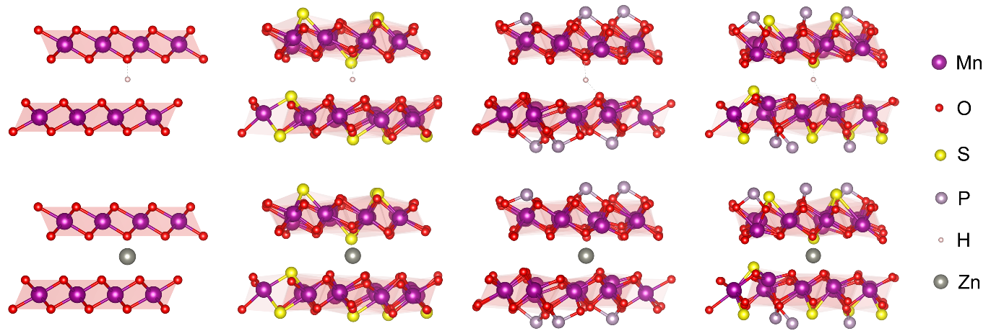
Fig. S23. The optimized crystal structures of δ-MnO₂, S-MnO₂, P-MnO₂, and S/P-MnO₂ hosts with H⁺/Zn²⁺ intercalation for the binding energy calculation.

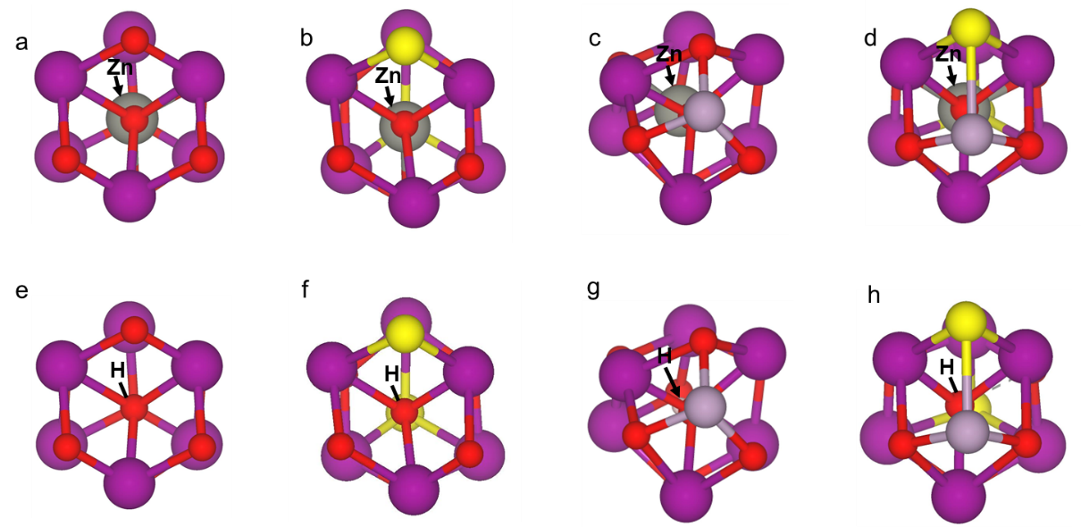
Fig. S24. The binding sites of (a-d) Zn²⁺ and (e-h) H⁺ in MnO₂, S-MnO₂, P-MnO₂ and S/P-MnO₂, respectively.

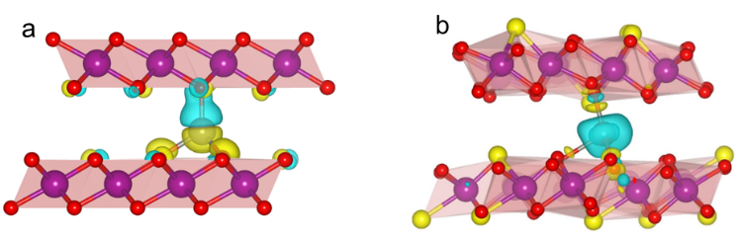
Fig.S25. Charge density difference distribution diagrams for Zn²⁺ in (a) δ-MnO₂ and (b) S-MnO₂ hosts.

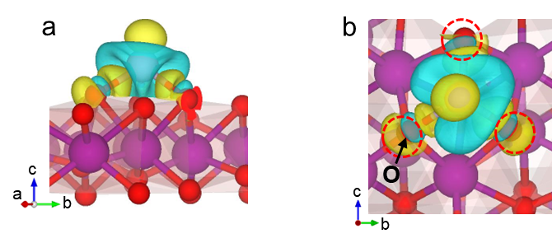
Fig. S26. Charge density difference distribution diagrams near the P-O-Mn linkage structure in different directions.

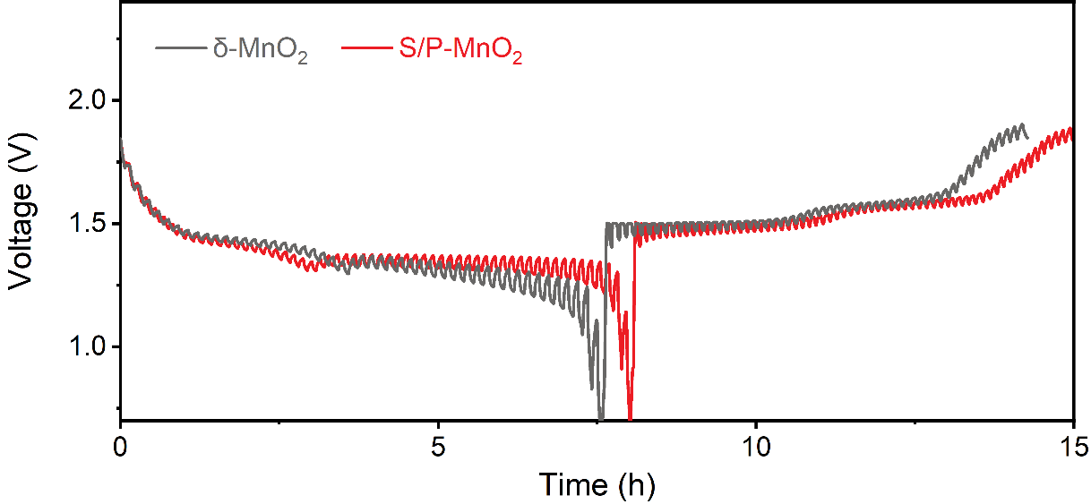
Fig. S27. GITT curves of δ-MnO₂ and S/P-MnO₂.

Fig. S28. (a) CV curves at various scan rates. (b) Log i vs. log v plots of four peaks for δ-MnO₂. (c) Proportion of capacitance contribution and diffusion contribution of δ-MnO₂.

Table S1. The molar ratio of different elements in MnO₂, S-MnO₂, P-MnO₂, and S/P-MnO₂ materials.
Materials | Element | Atom (%)
MnO₂ | O | 68.2
 | Mn | 31.8
S-MnO₂ | O | 76.0
 | Mn | 18.1
 | S | 5.9
P-MnO₂ | O | 70.0
 | Mn | 22.6
 | P | 7.4
S/P-MnO₂ | O | 70.5
 | Mn | 19.8
 | S | 5.8
 | P | 4.0

Table S2. Comparison of the electrochemical performance of Zn-Mn battery in this work with the recently reported works in the literatures.
Samples | Current density (A g⁻¹) | Capacity  (mAh g⁻¹) | Cycle number | Capacity retention | Ref.
Mn₃O₄ | 1 | 112 | 4500 | ~78 | 6
 | 2 | 114
Co-Mn₃O₄/CNA | 2 | 102.85 | 1100 | 80% | 7
O_{d}-Mn₃O₄@C NA/CC | 5 | 84.1 | 12000 | 95.7% | 8
NH₄V₃O₈-coated MnO₂ | 1 | 201 | 2000 | 80.4% | 9
NS-MnO₂ | 2 | ~92 | 2000 | 90% | 10
IS-MnO₂ | 2 | 112 | 4000 | 90.3% | 11
 | 6 | 80
2.5% Sr-MnO₂ | 2 | 167.5 | 1000 | 87.9% | 12
 | 10 | 114.1
KMO-MnOOH | 2 | 239.3 | 900 | 100% | 13
 | 4 | 233.2
100TiO₂@MnO₂ | 1 | 172.8 | 1000 | 80% | 14
PVP-MnO₂ | 10 | 140 | 20000 | 100% | 15
P-MnO₂ | 5 | 151 | 14000 | 87% | 16
β-MnO₂ | 0.1 | 246 | 100 | 100% | 17
S/P-MnO₂ | 0.5 | 320.1 |  |  | This work
 | 10 | 146 | 4500 | 96%

Table S3. The corresponding energy values for the binding energy calculation (E_{b}).
Composite structure | E_{total} /eV | Sample | E_{sample}/eV | Intercalation atom | E_{intercalation atom}/eV | E_{b}/eV
MnO₂-H | -629.556 | MnO₂ | -624.951 | H | -0.039 | -4.566
S-MnO₂-H | -619.039 | S-MnO₂ | -614.686 | H | -0.039 | -4.314
P-MnO₂-H | -682.449 | P-MnO₂ | -678.516 | H | -0.039 | -3.894
S/P-MnO₂-H | -658.31 | S/P-MnO₂ | -654.875 | H | -0.039 | -3.396
MnO₂-Zn | -627.994 | MnO₂ | -624.951 | Zn | -0.004 | -3.039
S-MnO₂-Zn | -616.546 | S-MnO₂ | -614.686 | Zn | -0.004 | -1.856
P-MnO₂-Zn | -680.943 | P-MnO₂ | -678.516 | Zn | -0.004 | -2.423
S-P-MnO₂-Zn | -656.151 | S/P-MnO₂ | -654.875 | Zn | -0.004 | -1.272

Supplementary References
[1] J. Hafner, Ab‐initio simulations of materials using VASP: Density‐functional theory and beyond, J. Comput. Chem. 29 (2008) 2044–2078, https://doi.org/10.1002/jcc.21057.
[2] G. Kresse, J. Furthmüller, Efficient iterative schemes for ab initio total-energy calculations using a plane-wave basis set, Phys. Rev. B 54 (1996) 11169–11186, https://doi.org/10.1103/PhysRevB.54.11169.
[3] G. Kresse, D. Joubert, From ultrasoft pseudopotentials to the projector augmented-wave method, Phys. Rev. B 59 (1999) 1758–1775, https://doi.org/10.1103/PhysRevB.59.1758.
[4] J.P. Perdew, K. Burke, M. Ernzerhof, Generalized gradient approximation made simple, Phys. Rev. Lett. 77 (1996) 3865–3868, https://doi.org/10.1103/PhysRevLett.77.3865.
[5] P.E. Blöchl, Projector augmented-wave method, Phys. Rev. B 50 (1994) 17953–17979, https://doi.org/10.1103/PhysRevB.50.17953.
[6] X. Zheng, B. Han, S. Liu, S. Huang, S. Wu, M. Chuai, F. Wang, Y. Wu, From charge storage rulebook rewriting to commercial viability of zinc-manganese batteries, Adv. Sci. 12 (2025) e09520. https://doi.org/10.1002/advs.202509520.
[7] J. Ji, H. Wan, B. Zhang, C. Wang, Y. Gan, Q. Tan, N. Wang, J. Yao, Z. Zheng, P. Liang, J. Zhang, H. Wang, L. Tao, Y. Wang, D. Chao, H. Wang, Co²⁺/³⁺/⁴⁺-regulated electron state of Mn-O for superb aqueous zinc-manganese oxide batteries, Adv. Energy Mater. 11 (2021) 2003203. https://doi.org/10.1002/aenm.202003203.
[8] Q. Tan, X. Li, B. Zhang, X. Chen, Y. Tian, H. Wan, L. Zhang, L. Miao, C. Wang, Y. Gan, J. Jiang, Y. Wang, H. Wang, Valence engineering via in situ carbon reduction on octahedron sites Mn₃O₄ for ultra-long cycle life aqueous Zn-ion battery, Adv. Energy Mater. 10 (2020) 2001050. https://doi.org/10.1002/aenm.202001050.
[9] J. Ma, C. Li, Q. Ji, C. Liu, B. Tang, R. Liu, Y. Liu, N. Li, C. Wang, J. Zeng, K. Zheng, W. Yan, V-induced low-spin state Mn³⁺ suppresses Jahn-Teller distortion for high-performance aqueous zinc ion batteries. Angew. Chem. Int. Ed. 137 (2025) e202513148. https://doi.org/10.1002/anie.202513148.
[10] J. Liang, Y. Zhao, L. Ren, M. Li, Q. Zhang, Y. Wang, X. Sun, M. Chuai, X. Wang, W. Liu, Dual anions doping enhanced conductivity and stability of layered δ-MnO₂ cathode for aqueous zinc-ion battery, Adv. Funct. Mater. 35 (2025) 2501135. https://doi.org/10.1002/adfm.202501135.
[11] X. Li, D. He, Q. Zhou, X. Zhou, Z. Wang, C. Wei, Y. Shi, X. Hu, B. Huang, Z. Yang, X. Han, Y. Lin, Y. Yu, Deciphering anomalous zinc ion storage in intermediate-state MnO₂ during layer-to-tunnel structural transition, Energy Environ. Sci. 17 (2024) 17 9195-9204. https://doi.org/10.1039/D4EE03293D.
[12] M. Yang, J. Zhu, J. Lin, L. He, M. Chen, Y. Wang, J. Chen, S. Zhong, H. Mi, C. He, D. Ma, P. Zhang, A guest cation screening principle for enabling customized cathode/electrolyte interface chemistry and self-enhanced aqueous zinc-ion batteries, Angew. Chem. Int. Ed. 64 (2025) e202510893. https://doi.org/10.1002/anie.202510893.
[13] X. Zhao, Y. Li, H. Li, C. Yan, Y. Song, K. Zheng, J.-J. Wang, H. Chen, Y. Sang, J. Fan, H. Liu, S. Wang, Manganese-based proton reservoir trigger proton diversion effect for ultrahigh-capacity aqueous zinc-ion batteries, Adv. Mater. 2026 e08780. https://doi.org/10.1002/adma.202508780.
[14] K. Zhao, C. Wang, Y. Yu, M. Yan, Q. Wei, P. He, Y. Dong, Z. Zhang, X. Wang, L. Mai, Ultrathin surface coating enables stabilized zinc metal anode, Adv. Mater. Inter. 5 (2018) 1800848. https://doi.org/10.1002/admi.201800848.
[15] A. Zhang, R. Zhao, Y. Wang, J. Yue, J. Yang, X. Wang, C. Wu, Y. Bai, Hybrid superlattice‐triggered selective proton grotthuss intercalation in δ‐MnO₂ for high‐performance zinc‐ion battery, Angew. Chem. Int. Ed. 62 (2023) e202313163. https://doi.org/10.1002/anie.202313163.
[16] Q. Li, M. Xu, S. Wei, A. Kumar, K.K. Abdalla, Y. Wang, L. Yu, M. Liu, X. Jin, J. Li, L. Song, Y. Zhao, X. Sun, Zn²⁺-blocking effects of a proton-rich polyaniline layer enable Ah-level Zn-MnO₂ batteries, Energy Environ. Sci. 18 (2025) 7939–7949. https://doi.org/10.1039/D5EE02213D.
[17] L. Wu, Z. Li, Y. Xiang, W. Dong, H. Wu, Y. Xu, Z. Ling, M.S. Chae, D. Sharon, N. Shpigel, X. Zhang, Unraveling the charge storage mechanism of β-MnO₂ in aqueous zinc electrolytes, ACS Energy Lett. 9 (2024) 5801–5809. https://doi.org/10.1021/acsenergylett.4c02559.

