Supporting Information
Simultaneous interlayer expansion and structural stabilization of δ-MnO₂ via sodium/molybdenum co-doping for ultra-stable aqueous zinc-ion batteries
Wujie Gao ^{a,1}, Jiayue Feng ^{a,1}, Xin Wang ª, Yishen Zhang ª, Songcan Wang ^{a,b,}*
ª State Key Laboratory of Flexible Electronics & Institute of Flexible Electronics, Northwestern Polytechnical University, 127 West Youyi Road, Xi'an, 710072, China.
^{b} Research & Development Institute of Northwestern Polytechnical University in Shenzhen, Sanhang Science & Technology Building, Shenzhen 518063, China.
¹ These authors contributed equally to this work.
*Corresponding Author: iamscwang@nwpu.edu.cn (S. Wang)

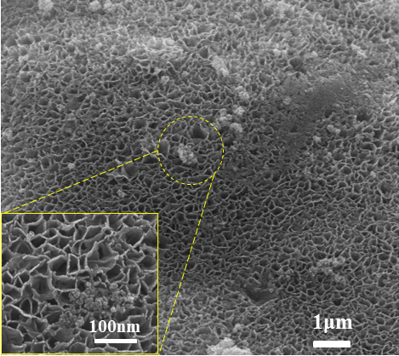
Fig. S1. SEM image of MnO₂ with hydrothermal time of 10 h.

Fig. S2. (a) SEM image of Na-MnO₂, (b) SEM image of Mo-MnO₂.

Fig. S3. (a) HRTEM image of MnO₂, (b) IFFT image converted from the MnO₂ HRTEM image, (c) IFFT image converted from the NaMo-MnO₂ HRTEM image.

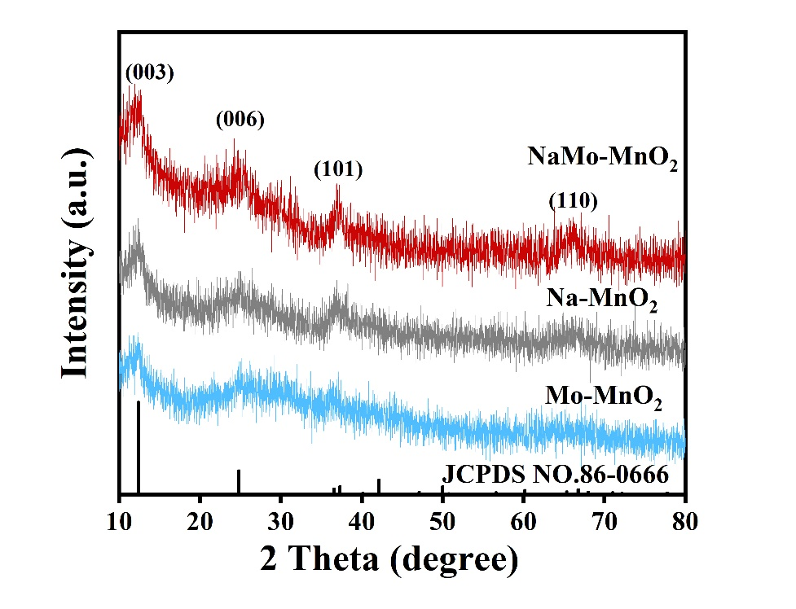
Fig. S4. XRD patterns of Na-MnO₂, Mo-MnO₂ and NaMo-MnO₂.
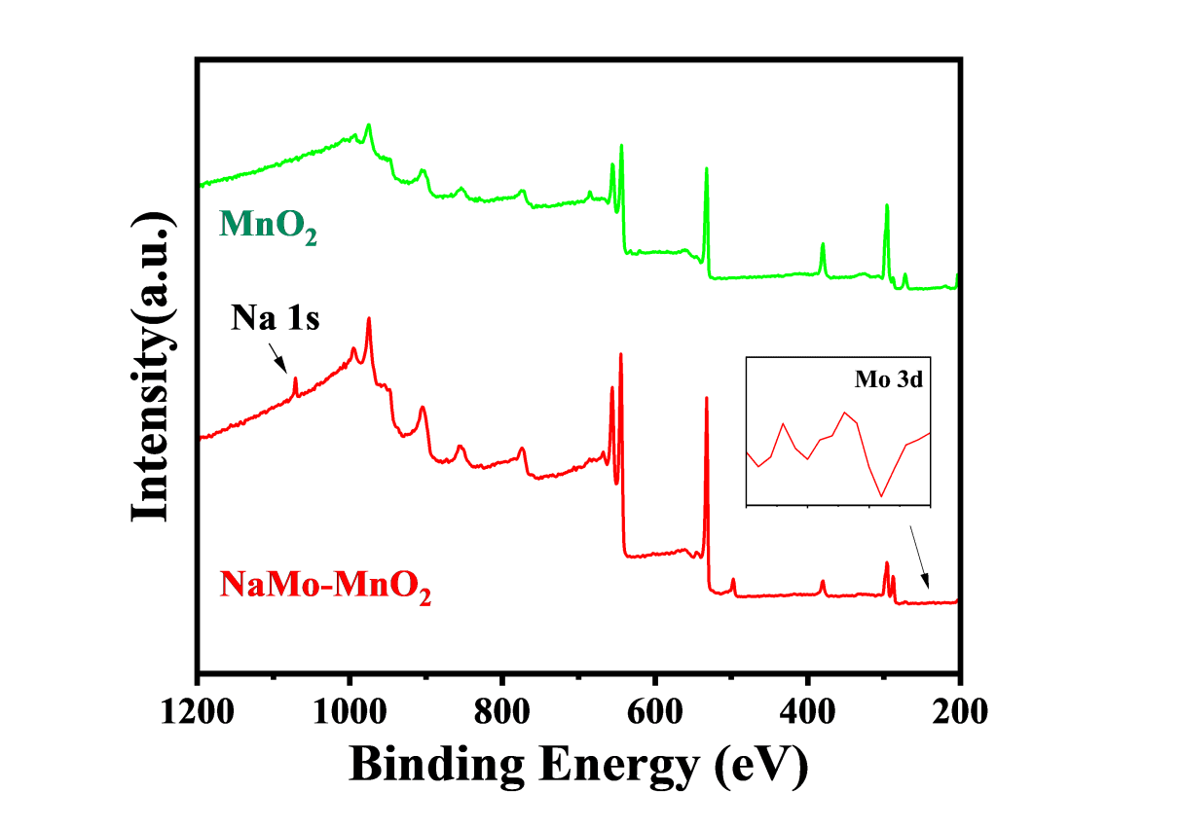
Fig. S5. XPS full spectra of MnO₂ and NaMo-MnO₂. Insert: enlarged spectrum of Mo 3d.
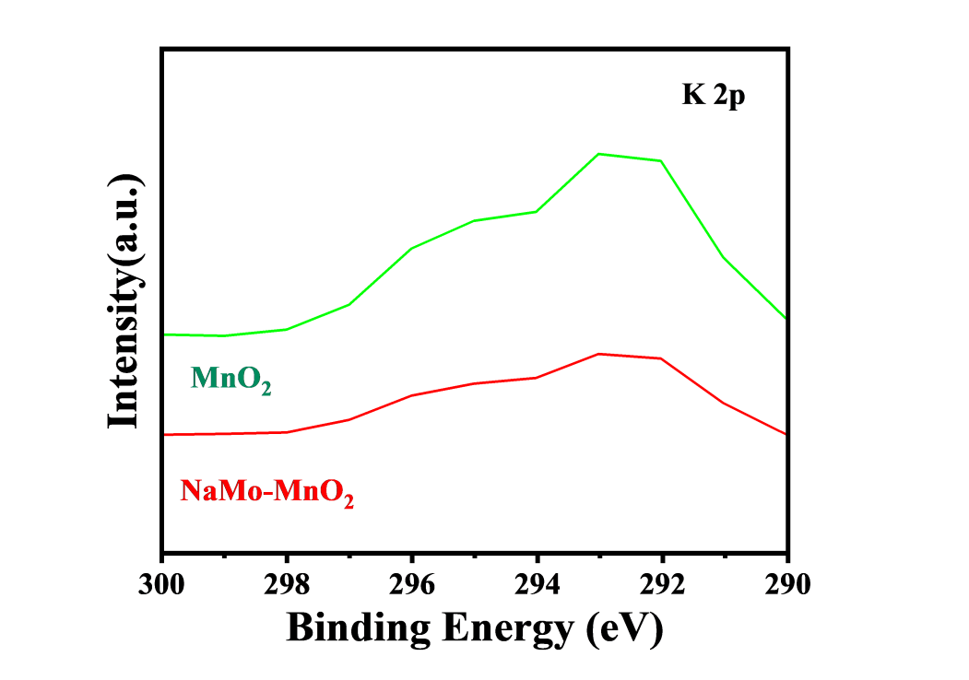
Fig. S6. K 2p XPS spectra of MnO₂ and NaMo-MnO₂.

Fig. S7. (a-b) GCD curves of MnO₂ and NaMo-MnO₂, Cycling stability of MnO₂ (c) and NaMo-MnO₂ (d) at 0.1 A g⁻¹.
Fig. S8. Exploration of optimal ratios at different ion doping concentrations. Cycling stability of (a) Na-MnO₂, (b) Mo-MnO₂, (c) Na-MnO₂ with various Mo doping, and (d) Mo-MnO₂ with various Na doping.
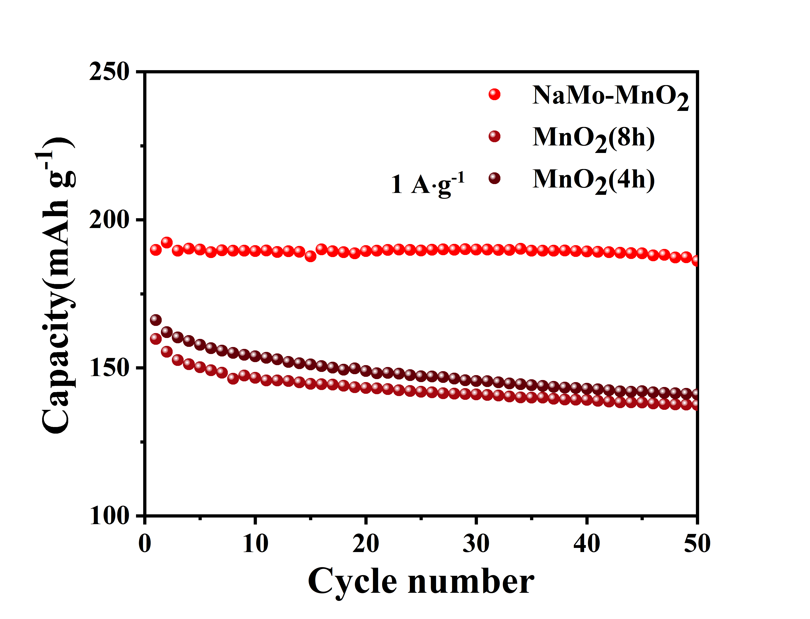
Fig. S9. Cyclic stability of MnO₂ obtained at different hydrothermal durations of time (Current density: 0.1 A g⁻¹).

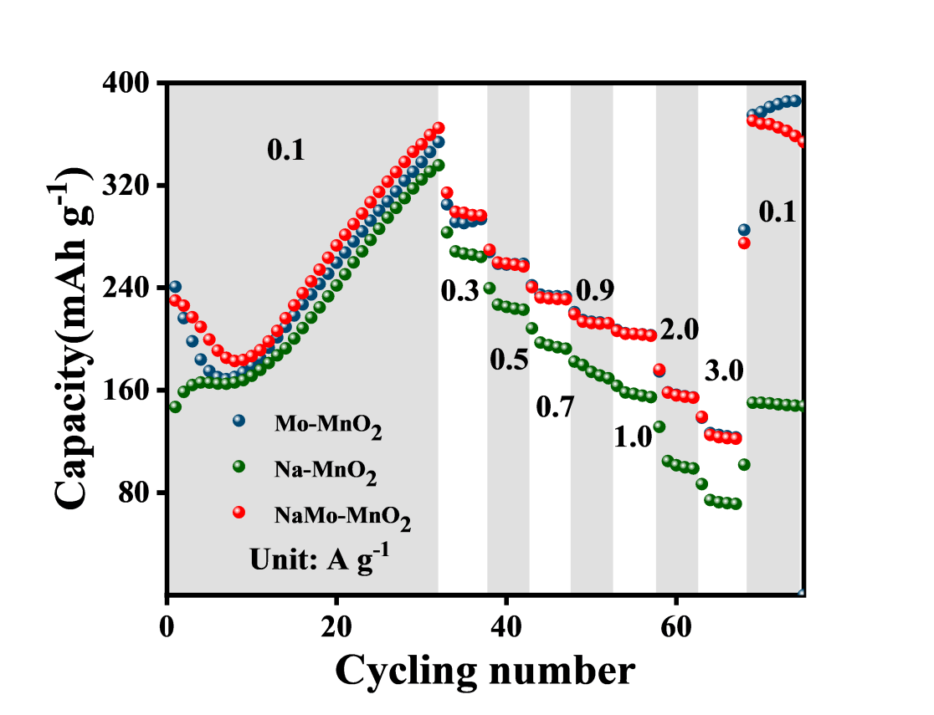
Fig. S10. Single ion doping vs. double ion doping: comparison of rate performance at current densities from 0.1 A g⁻¹to 3.0 A g⁻¹.
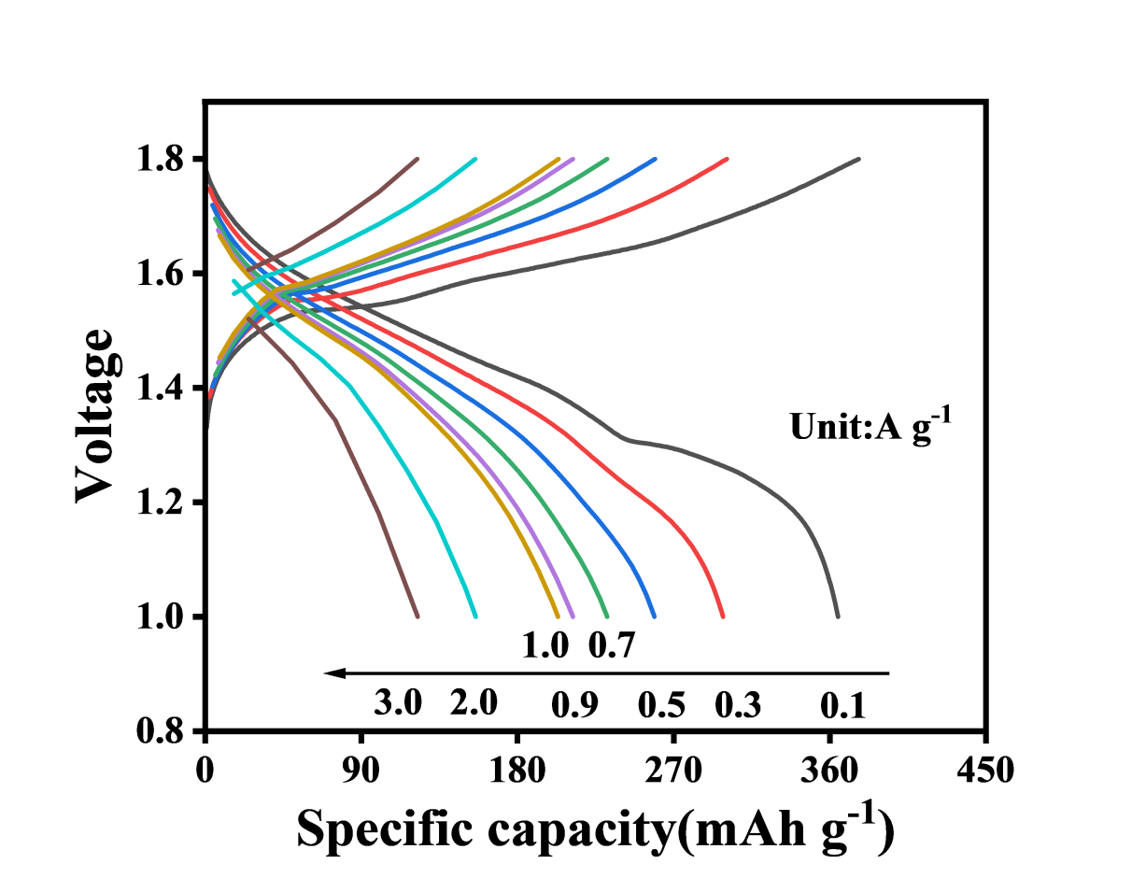
Fig. S11. GCD curves of NaMo-MnO₂ with different current density.
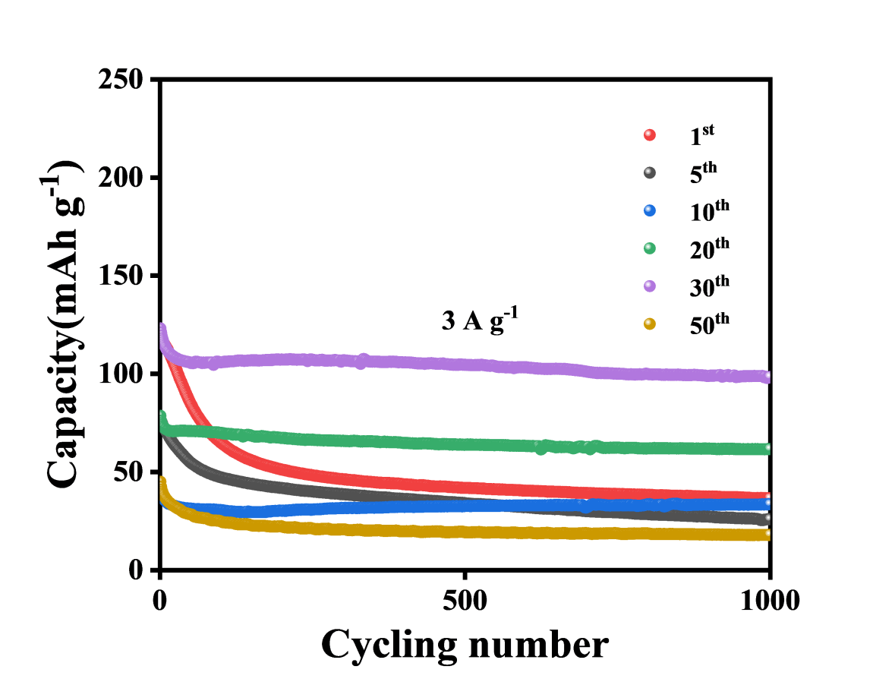
Fig. S12. Long cycle stability of NaMo-MnO₂ at 3 A g⁻¹ after different activation cycles.

Fig. S13. (a) Ex situ SEM image of NaMo-MnO₂ after 50 cycles of activation, (b) Ex situ SEM image of NaMo-MnO₂ after 6500 cycles at 3 A g⁻¹ after optimal concentration, optimal number of the activation cycles.

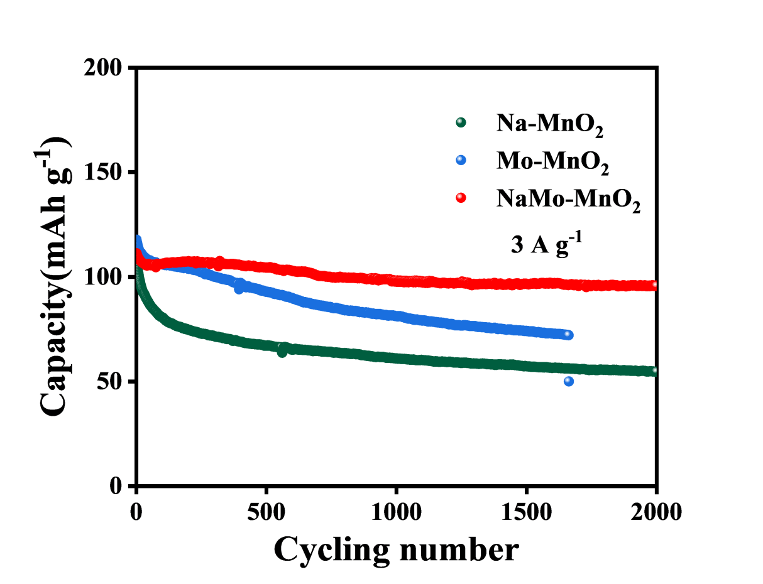
Fig. S14. Cycling stability of Mo-MnO₂, Na-MnO₂, and NaMo-MnO₂ at a current density of 3 A g⁻¹.

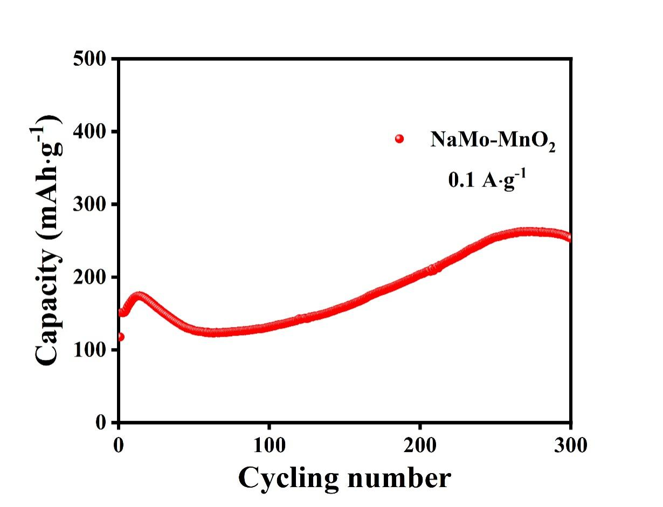
Fig. S15. Cycling stability of high mass loaded NaMo-MnO₂ at a current density of 0.1 A g⁻¹.
Fig. S16. EIS mapping of Mo-MnO₂, Na-MnO₂, and NaMo-MnO₂.

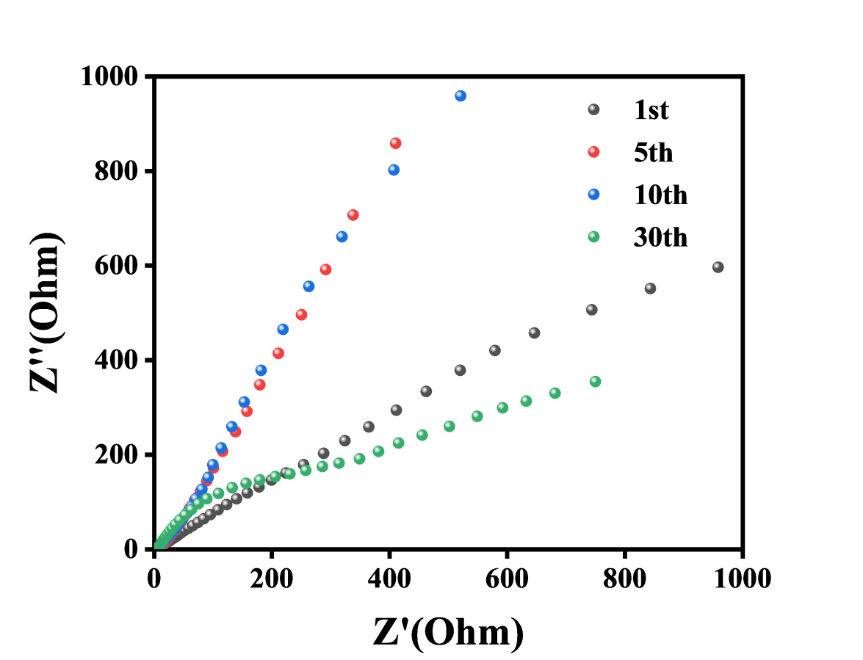
Fig. S17. EIS maps of NaMo-MnO₂ at different numbers of activation cycles.

Fig. S18. (a) CV curves for different sweep speeds, (b) fitted curves corresponding to the peak currents of the CV curves, (c) pseudocapacitance contributions corresponding to the different sweep speeds in the MnO₂ cathode.

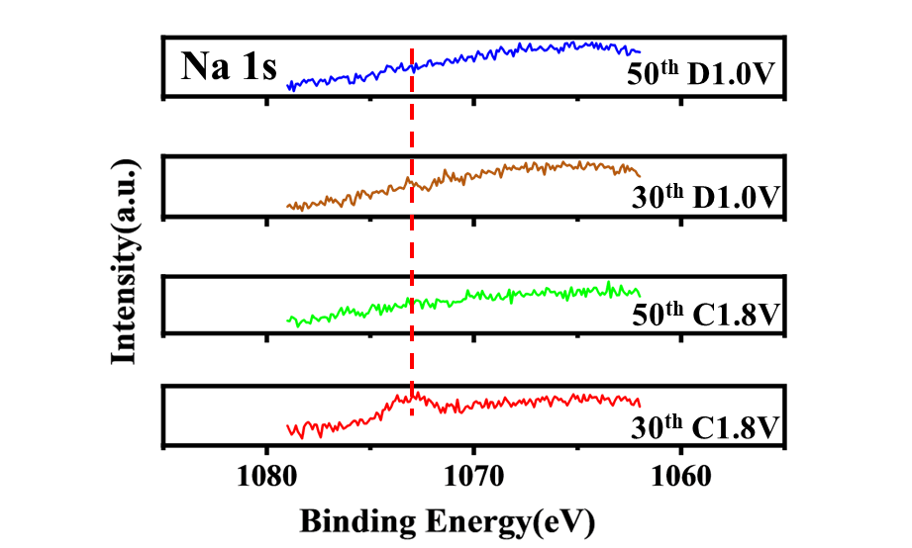
Fig. S19. XPS spectra of Na 1s for NaMo-MnO₂ with different activation cycles after discharging to 1. 0 V (D1.0 V) and charging to 1.8 V (C1.8V).

Fig. S20. XPS spectra of (a) Mn 2p and (b) Zn 2p for NaMo-MnO₂ after activated for 30 cycles at the discharged stage of 1. 0 V (D1.0V) and charged stage of 1.8 V (C1.8V).

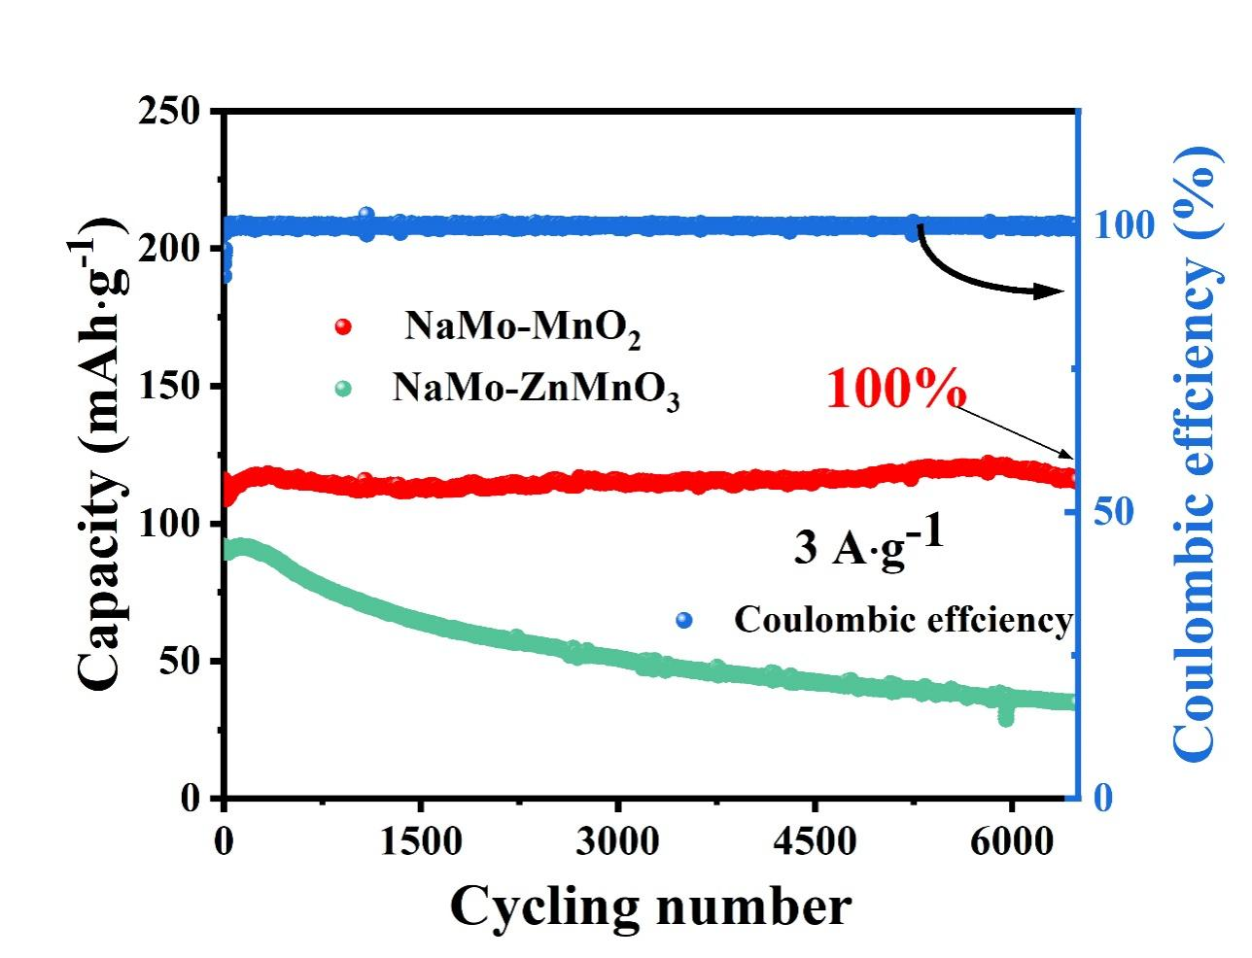
Fig. S21. Cycling stability of NaMo-MnO₂ and NaMo-ZnMnO₃ at a current density of 3 A g⁻¹.

Fig. S22. Schematic diagram of working principle of NaMo-MnO_{2.}

Table S1. Comparison of NaMo-MnO₂ and other MnO₂-based cathode materials.
Cathode materials | Structural characteristics | Electrolyte | Specific capacity | Cyclability | Ref.
W-MnO₂ | Nanosheet | 2 M ZnSO₄ + 0.1 M MnSO₄ | 251 mAh g⁻¹@ 100 mA g⁻¹ | After 1000 cycles, the capacity retention rate was 79.8% at 1 A g⁻¹. | [1]
Cr-MnO₂ | Nanoflower | 2 M ZnSO₄ + 0.1 M MnSO₄ | 229.2 mAh g⁻¹@ 100 mA g⁻¹ | After 300 cycles, the capacity retention rate was 86% at 100 mA g⁻¹. | [2]
CuCe-MnO₂ | Nanoflakes/Small amounts of nanorods | 2 M ZnSO₄ + 0.1 M MnSO₄ | 330 mAh g⁻¹@ 200 mA g⁻¹ | After 1500 cycles, the capacity retention rate was 95% @ 2 Ag⁻¹. | [3]
Ca_{0.10}MnO₂ ·0.61H₂O（CaMnO） | Nanoflower | 3 M Zn(OTf)₂ | 260 mAh g⁻¹@ 300 mA g⁻¹ | After 1000 cycles, the capacity retention rate was 80% at 1.5 A g⁻¹. | [4]
KMO-NAPD | Nanoflower | 2 M ZnSO₄ + 0.4 M MnSO₄ | 233 mAh g⁻¹@ 1000 mA g⁻¹ | After 1000 cycles, the capacity retention rate was 85% at 4 A g⁻¹. | [5]
Fe-doped a-MnO₂/rGO | Nanowire | 2 M ZnSO₄ + 0.2 M MnSO₄ | 263.5 mAh g⁻¹@ 100 mA g⁻¹ | After 2000 cycles, the capacity retention rate was 54% at 1 A g⁻¹. | [6]
ZN_{0.5}MO/NCNTs | Nanoparticles grow on carbon nanotubes | 2 M ZnSO₄ + 0.05 M MnSO₄ | 239.2 mAh g⁻¹@ 100 mA g⁻¹ | After 3000 cycles, the capacity retention rate was 42% @ 1 A g⁻¹. | [7]
Bi/rGO/MnO₂-60 | nanosheet | 2 M ZnSO₄ + 0.2 M MnSO₄ | 138.4 mAh g⁻¹@ 2000 mA g⁻¹ | After 2500 cycles, the capacity retention rate was 82% at 1 A g⁻¹. | [8]
CrNiMnO₂ | nanosheet | 2 M ZnSO₄ + 0.1 M MnSO₄ | 221 mAh g⁻¹@ 1500 mA g⁻¹ | After 1600 cycles, the capacity retention rate was 86% at 1.5 A g⁻¹. | [9]
MO/NMF | Nanoflower | 2 M ZnSO₄ + 0.1 M MnSO₄ | 178 mAh g⁻¹@ 3000 mA g⁻¹ | After 2000 cycles, the capacity retention rate was 80.4% at 3 A g⁻¹. | [10]
This work | Cabbage-like nanosheets | 2 M Zn(OTf)₂ + 0.1 M MnSO₄ | 369 mAh g⁻¹@ 100 mA g⁻¹ | After 6500 cycles, the capacity retention rate was 100% at 3 A g⁻¹. | This work

Table S2. Molar ratios of NaMo-MnO₂ analyzed by inductively coupled plasma optical emission spectrometry (ICP-OES).

Table S3. ICP-MS analysis of Mn and Mo in NaMo-MnO₂ electrolyte at different cycle numbers.
Sample number | Element | Test solution element concentration  C0（ug/L)
5th | Mn | 160.5178
5th | Mn | 158.8912
5th | Mn | 161.9371
40th | Mn | 164.3716
40th | Mn | 168.0278
40th | Mn | 167.8170
5th | Mo | 1.3421
5th | Mo | 1.3832
5th | Mo | 1.3481
40th | Mo | 0.4402
40th | Mo | 0.4546
40th | Mo | 0.4836

References
[1] Y. Gan, P. Shi, J. Pan, Y. Yang, J. Yao, L. Lv, H. Wan, H. Wang, Journal of Energy Storage, 127 (2025) 117176.
[2] X. Ding, Y. Wen, C. Qing, Y. Wei, P. Wang, J. Liu, Z. Peng, Y. Song, H. Chen, Q. Rong, Journal of Alloys and Compounds, 986 (2024) 174041.
[3] Z. Song, M. Cui, Y. Zhang, N. Zhang, H. Yang, K. Ren, L. Chen, Z.-L. Liu, Y. Xie, T.-F. Yi, Journal of Energy Chemistry, 114 (2026) 835-847.
[4] D. Xie, Y. Wang, L. Tian, H. Huang, J. Sun, D.-W. Kim, J. Zhao, J. Mao, Advanced Functional Materials, 35 (2025) 2413993.
[5] Y. Huang, Y. Peng, Q. Ouyang, Q. Feng, H. Wang, D. Zheng, F. Wang, X. Lu, Q. Liu, Energy Storage Materials, 70 (2024) 103476.
[6] Q. Zhang, H. Fan, Q. Liu, Y. Wu, E. Wang, Journal of Materials Chemistry A, 12 (2024) 8167-8174.
[7] C. Wang, B.-H. Xiao, J. Huang, K. Xiao, Z.-Q. Liu, Advanced Functional Materials, 34 (2024) 2405680.
[8] Y. Cai, L. Sun, Z. Chen, Y. Zhang, H. Morikawa, C. Zhu, Electrochimica Acta, 509 (2025) 145297.
[9] Y. Zhao, X. Xia, Q. Li, Y. Wang, Y. Fan, Y. Zhao, W. Liu, X. Sun, Energy Storage Materials, 67 (2024) 103268.
[10] J. Tang, S. Ma, Y. Jiang, L. Yang, J. Chen, X. Yan, B. Chen, Z. Huang, Chemical Engineering Journal, 500 (2024) 157529.

