Supporting Information
ε-MnO₂@C Cathode with High Stability for Aqueous Zinc-ion Batteries
Wenyu Zhaoª, Qingquan Kongª, Xiaoqiang Wuª, Xuguang Anª, Jing Zhangª, Xiaonan Liu^{b*}, Weitang Yao^{a*}
- School of Mechanical Engineering, Chengdu University, No. 2025, Chengluo Avenue, Chengdu 610106, P. R. China
- School of Chemical Engineering, Sichuan University of Science & Engineering, Zigong 643000, P. R. China
Corresponding author* E-mail: lxn@suse.edu.cn, E-mail: yaoweitang@cdu.edu.cn
Author E-mail: 578646244@qq.com,kongqingquan@cdu.edu.cn, wuxiaoqiang@cdu.edu.cn, anxuguang@cdu.edu.cn, 917600223@qq.com

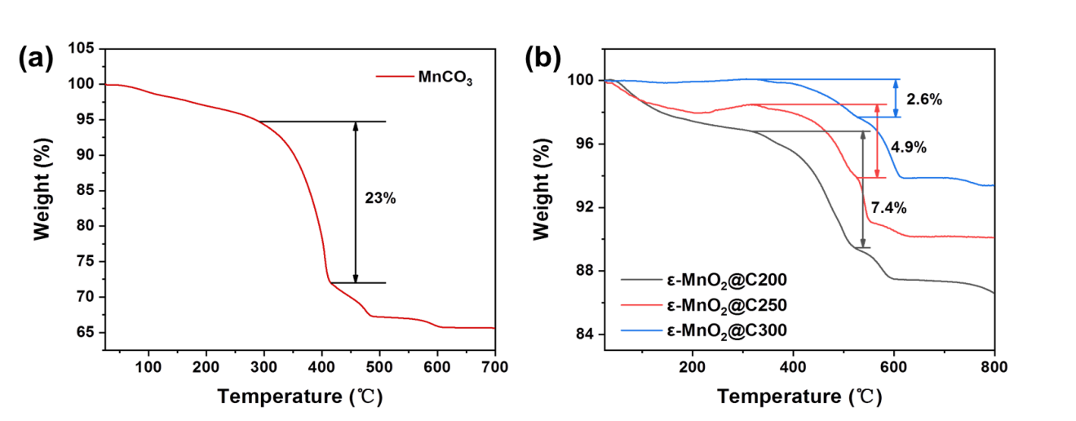
Fig. S1. (a) TGA results of MnCO₃. (b) TGA results of ε-MnO₂@C at different carbonization temperatures.

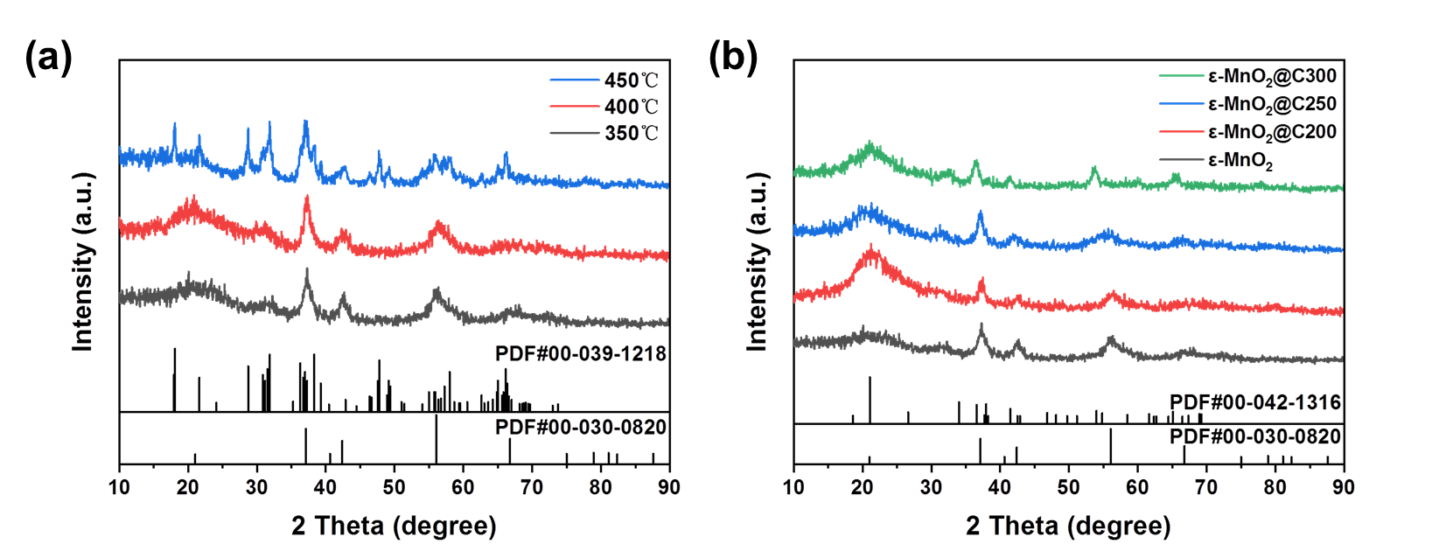
Fig. S2. (a) XRD patterns of MnCO₃ at different temperatures of decomposition. (b) XRD patterns of precursor (ε-MnO₂ in glucose concentration) at different carbonization temperatures.
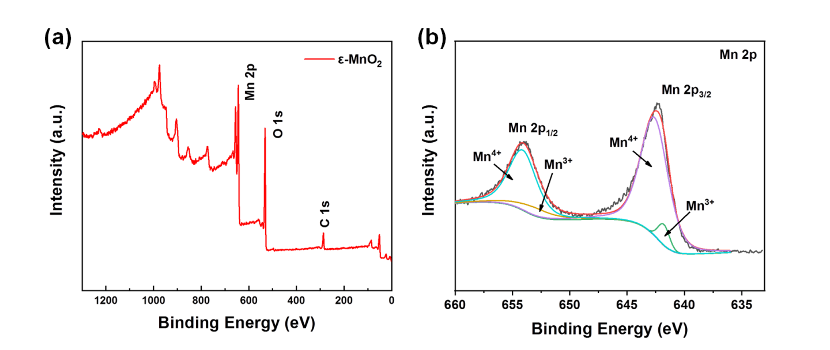
Fig. S3. XPS of ε-MnO₂. (a) XPS wide spectrum. (b) Mn 2p spectrum.
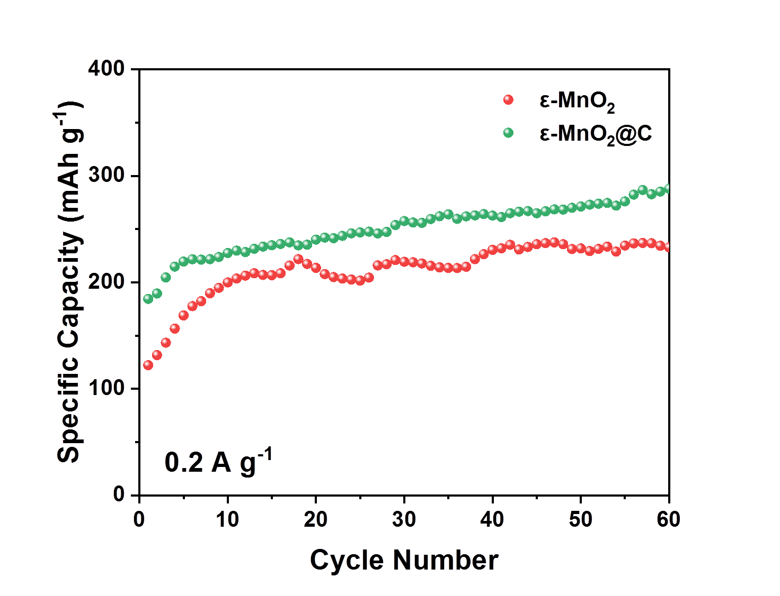
Fig. S4. Cycle performance of ε-MnO₂@C at 0.2 A g⁻¹.
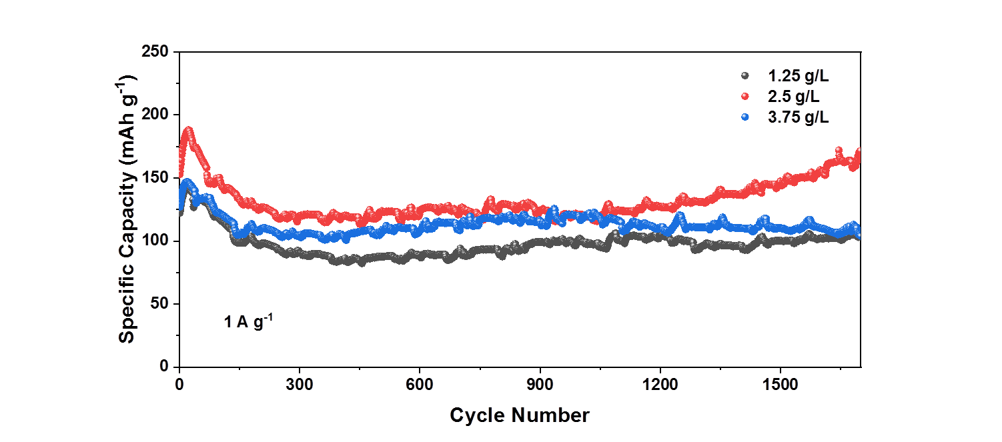
Fig. S5. Cycling performance of precursor (ε-MnO₂ in different glucose concentrations) at 1 A g⁻¹. (carbonization temperature at 250 °C)
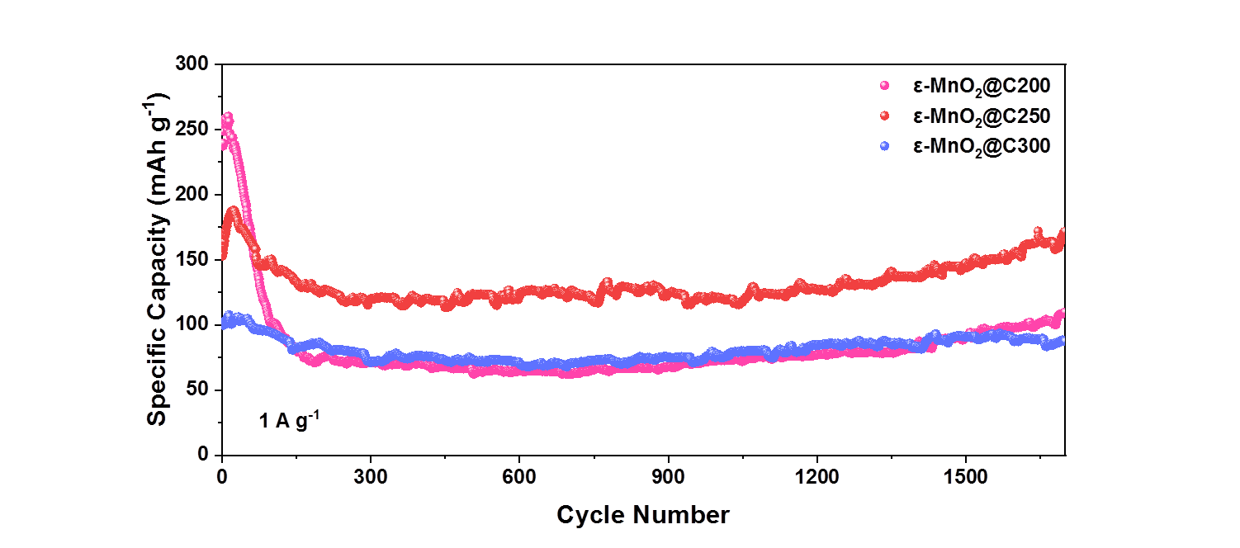
Fig. S6. Cycling performance of ε-MnO₂ at different carbonization temperatures at 1 A g⁻¹. (glucose concentration:2.5 g L⁻¹)
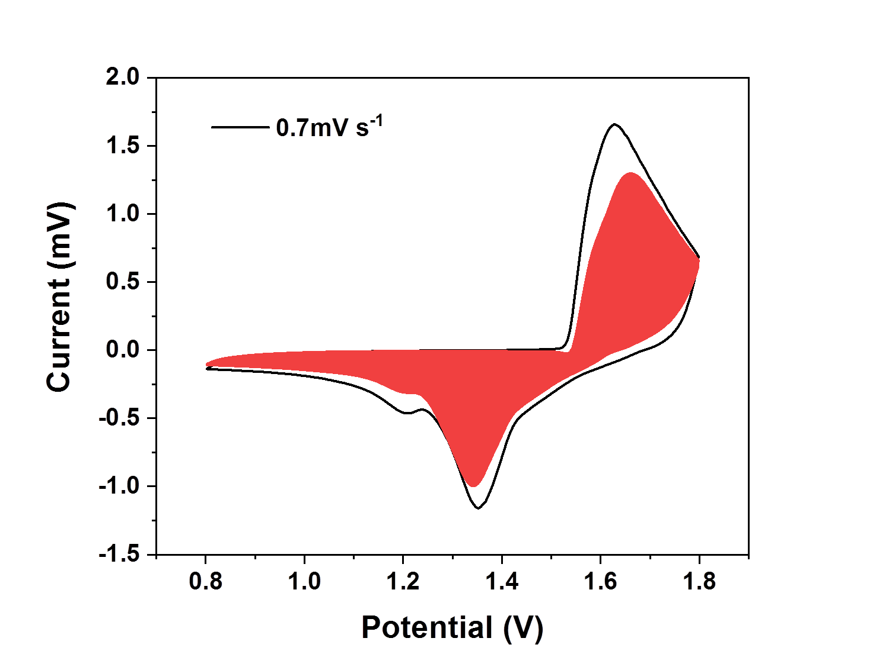
Fig. S7. Rate of contribution. (capacitive and diffusion-controlled capacities).

Table S1 Comparison of MnO₂ and its composites as aqueous ZIB cathodes.
Cathodes | Current Density | capacity retention | reference
Akhtenskite MnO₂ | 0.5 A g⁻¹ | 92 % (132 mAh g⁻¹) over 500 cycles | Ref[1]
ε-MnO₂ | 3 C | (100 mAh g⁻¹) over 500 cycles | Ref[2]
ε-MnO₂@N | 5 A g⁻¹ | 83 % (124 mAh g⁻¹) over 1000 cycles | Ref[3]
ε-MnO₂/Graphite | 1 A g⁻¹ | 80.1 % (152 mAh g⁻¹) over 1000 cycles | Ref[4]
Cu²⁺-Intercalated γ-MnO₂ | 4 A g⁻¹ | 99 % over 1500 cycles | Ref[5]
NHCSs@MnO₂ | 0.5 A g⁻¹ | 98.3 % over 650 cycles | Ref[6]
polypyrrole on MnO₂/Mn₂O₃ | 1 A g⁻¹ | 96.7 % over 1000 cycles | Ref[7]
α-MnO₂/super-P | 1 A g⁻¹ | 47 % (84.6 mAh g⁻¹) over 1000 cycles | Ref[8]
Al³⁺-Intercalated α-MnO₂ | 2 A g⁻¹ | 94.5 % over 2000 cycles | Ref[9]
PPy@MnO₂/CNT | 1 A g⁻¹ | 85.7 % (210 mAh g⁻¹) over 1000 cycles | Ref[10]
Ni²⁺-Intercalated γ-MnO₂ | 3 A g⁻¹ | 100 % (63.9 mAh g⁻¹) over 11000 cycles | Ref[11]
3D δ-MnO₂ microflowers | 10C | 76.5 % over 1000 cycles | Ref[12]
β-MnO₂@C | 0.3 A g⁻¹ | (130 mAh g⁻¹) over 400 cycles | Ref[13]
Uncovering sulfur doping in MnO₂ | 3 A g⁻¹ | (150 mAh g⁻¹) over 1000 cycles | Ref[14]
Mg²⁺-Intercalated γ-MnO₂ | 0.8 A g⁻¹ | 93 % over 800 cycles | Ref[15]
ε-MnO₂@C | 1 A g⁻¹ | 91 % (172 mAh g⁻¹) over 1700 cycles | This work

Reference
[1] L.L. Wang, X. Cao, L.H. Xu, J.T. Chen, J.R. Zheng, Transformed Akhtenskite MnO₂ from Mn₃O₄ as Cathode for a Rechargeable Aqueous Zinc Ion Battery, Acs Sustainable Chemistry & Engineering, 6 (2018) 16055-16063.
[2] L.X. Huang, X.F. Luo, C. Chen, Q. Jiang, A high specific capacity aqueous zinc-manganese battery with a epsilon-MnO₂ cathode, Ionics, 27 (2021) 3933-3941.
[3] Y.A. Zhang, Y.P. Liu, Z.H. Liu, X.G. Wu, Y.X. Wen, H.D. Chen, X. Ni, G.H. Liu, J.J. Huang, S.L. Peng, MnO₂ cathode materials with the improved stability via nitrogen doping for aqueous zinc-ion batteries, Journal of Energy Chemistry, 64 (2022) 23-32.
[4] Z.N. Zhang, H.J. Shang, X.L. Zhang, C. Liu, S. Li, Z.S. Wen, S.J. Ji, J.C. Sun, Enhancing the Electrochemical Performances by Wet Ball Milling to Introduce Structural Water into an Electrolytic MnO₂/Graphite Nanocomposite Cathode for Zinc-Ion Batteries, Acs Applied Energy Materials, 4 (2021) 5113-5122.
[5] T.H. Wu, W.Y. Liang, Y.Q. Lin, Facile synthesis of Cu-intercalated MnO₂ nanoflakes cathode for enhanced energy storage in zinc-ion batteries, Journal of the Taiwan Institute of Chemical Engineers, 131 (2022) 104172.
[6] D.S. Li, Q.L. Gao, H. Zhang, Y.F. Wang, W.L. Liu, M.M. Ren, F.G. Kong, S.J. Wang, J. Chang, MnO₂ particles grown on the surface of N-doped hollow porous carbon nanospheres for aqueous rechargeable zinc ion batteries, Applied Surface Science, 510 (2020) 145458.
[7] A.X. Huang, W.J. Zhou, A.R. Wang, M.F. Chen, J.Z. Chen, Q.H. Tian, J.L. Xu, Self-initiated coating of polypyrrole on MnO₂/Mn₂O₃ nanocomposite for high-performance aqueous zinc-ion batteries, Applied Surface Science, 545 (2021) 149041.
[8] C. Yang, Q. Wu, Y. Cao, Y.Y. Gao, A.R. Li, X.J. Liu, X.L. Zhang, Z.L. Tian, R.M. Liu, α-MnO₂/super-P with conductive carbon network for rechargeable aqueous Zinc ion batteries, Materials Letters, 302 (2021) 130419.
[9] C. Chen, M.J. Shi, Y. Zhao, C. Yang, L.P. Zhao, C. Yan, Al-Intercalated MnO₂ cathode with reversible phase transition for aqueous Zn-Ion batteries, Chemical Engineering Journal, 422 (2021) 130375.
[10] X.F. Shen, X.N. Wang, N.S. Yu, W. Yang, Y.R. Zhou, Y.H. Shi, Y.L. Wang, L.Z. Dong, J.T. Di, Q.W. Li, A Polypyrrole-Coated MnO₂/Carbon Nanotube Film Cathode for Rechargeable Aqueous Zn-Ion Batteries, Acta Physico-Chimica Sinica, 38 (2022) 2006059.
[11] J. Ji, J. Yao, Y.C. Xu, H.Z. Wan, B. Zhang, L. Lv, J.Y. Li, N.Z. Wang, Z.H. Zheng, J. Zhang, G.K. Ma, L. Tao, H.B. Wang, Y. Wang, H. Wang, Promoting Proton Migration Kinetics by Ni²⁺ Regulating Enables Improved Aqueous Zn-MnO₂ Batteries, Energy & Environmental Materials, (2021) 1-10.
[12] P.Y. Liu, M.R. Wang, J. Li, H.T. Cui, T. Zeng, S.B. Yang, H. Wang, Y.Y. Liu, Microwave-induced structural tunability of 3D delta-MnO₂ microflowers for high-performance aqueous Zn-ion batteries, Ceramics International, 47 (2021) 25558-25566.
[13] W.W. Jiang, X.J. Xu, Y.X. Liu, L. Tan, F.C. Zhou, Z.W. Xu, R.Z. Hu, Facile plasma treated β-MnO₂@C hybrids for durable cycling cathodes in aqueous Zn-ion batteries, Journal of Alloys and Compounds, 827 (2020) 154273.
[14] Y.J. Zhao, P.J. Zhang, J.R. Liang, X.Y. Xia, L.T. Ren, L. Song, W. Liu, X.M. Sun, Uncovering sulfur doping effect in MnO₂ nanosheets as an efficient cathode for aqueous zinc ion battery, Energy Storage Materials, 47 (2022) 424-433.
[15] P. Xu, H.M. Yi, G.J. Shi, Z.N. Xiong, Y.Y. Hu, R.L. Wang, H.H. Zhang, B.F. Wang, Mg ion pre-intercalated MnO₂ nanospheres as high-performance cathode materials for aqueous Zn-ion batteries, Dalton Transactions, 51 (2022) 4695-4703.

