Supporting Information

Electrodeposition-Engineering MnO₂-Mn₂O₃ Dual-Phase Cathode for Binder-Free Zinc-ion Batteries

Yuanning Gao,ª Rumeng Wang,ª Pan Feng,ª Xiao Tao,ª Jian Chen*ª
a. Jiangsu Key Laboratory of Advanced Metallic Materials, School of Materials Science and Engineering, Southeast University, Nanjing 211189, Jiangsu, China
* Corresponding authors. E-mail addresses: j.chen@seu.edu.cn (J. Chen)

- The pseudocapacitive effect calculation
1.1 Capacitive and diffusion-dominant contributions
In cyclic voltammetry (CV) measurements, different scan rates produce different peak current values. The relationship between peak current and scan rate can be used to examine capacitance and diffusion behavior. The peak current $i$ at a given scan rate $v$ follows the following formula:
$i=av^{b}$ (1)
where $a$ and $b$ are adjustable constants. Logarithmic transformation of the formula can yield the $\log{i}$ and $\log{v}$ plot:
$\log{i=\log{a+blog v}}$ (2)
The $b$-value of 0.5 indicates a diffusion-controlled process, whereas $b$-value of 1.0 indicates a capacitive-dominated process.
The current at a specific potential $V$can be separated into capacitive and diffusion-controlled contributions according to ^{[1]}
$i\left(V\right)=k_{1}v+k_{2}v^{1/2}$ (3)
where $v$ is the scan rate at that potential and ​$k_{1}$ and $k_{2}$​ are adjustable parameters. Fitting this relation at each potential to obtain the coefficients. The $k_{1}v$ represents the capacitive contribution and the $k_{2}v^{1/2}$represents the diffusion contribution. In this work, the closed curves of $k_{1}v$ and $i$ values at different voltages during the complete cycle are integrated to evaluate the overall capacitance contribution rate at this specific scan rate.

1.2 Warburg factor (σ) calculation
Electrochemical impedance spectroscopy (EIS) was used to probe the reaction kinetics of the cells. All Nyquist plots consist of a high-frequency semicircle and a low-frequency linear region, which reflect charge-transfer and ion-diffusion processes, respectively. The Warburg coefficient ($σ$) of the electrode can be derived from the low-frequency region of the EIS data using the following expression ^{[2]}:
$D=\frac{R^{2}T^{2}}{2A^{2}π^{4}F^{4}C^{2}σ^{2}}$ (4)
Where $R$ is the gas constant, $T$ the absolute temperature, A is the surface area of the electrode, $F$ is the Faraday constant, and $C$ is the concentration of the ion. After a series of algebraic transformations and derivations, the relationship between $σ$ and the real component of impedance $Z_{re}$ is
$Z_{re}=R_{D}+R_{L}+σω^{1/2}$ (5)
where $Z_{re}$ is the real component of the impedance and $ω$ is the angular frequency. Consequently, $Z_{re}$ is linearly related to $ω^{1/2}$, and the Warburg coefficient $σ$ can be obtained from the slope of a linear fit. Under steady-state conditions, the diffusion process in the system can be approximately regarded as semi-infinite diffusion. Accordingly, the Warburg diffusion model is employed to compare the diffusion kinetics, where a larger σ value indicates higher diffusion resistance. However, it should be noted that the Warburg diffusion model relies on several idealized assumptions, such as semi-infinite, planar, purely concentration-gradient-driven, Fickian diffusion of neutral species in the dilute limit, whereas the actual diffusion processes are often non-ideal.^{[3]} Therefore, diffusion coefficients derived from Warburg analysis should be treated as qualitative or representative parameters and used for relative comparison among different samples under the same evaluation criteria.

1.3 GITT measurements and the calculation of the ion diffusion coefficient (D_{ion}) calculation
Galvanostatic intermittent titration technique (GITT) is an experimental method that obtains information on reaction kinetics by analyzing the time-dependent variation of electrode potential. The ionic diffusion coefficient (D_{ion}) can be determined from Fick’s second law as follows: ^{[4,5]}
$D_{ion}=\frac{4}{πt}{(\frac{m_{a}V_{M}}{M_{a}S})}^{2}{(\frac{{ΔE}_{S}}{{ΔE}_{τ}})}^{2}$ (6)
where $m_{a}$ is the mass of active material in the electrode, $M_{a}$ is the molar mass of the electrode material (g mol⁻¹) and $V_{M}$ is the molar volume (cm³ mol⁻¹), $S$ is the geometric area of the electrode (contacting area of the electrode with electrolyte), ${ΔE}_{S}$ is the change in the steady-state open-circuit potential measured after two consecutive relaxation steps, and ${ΔE}_{τ}$ is the potential change occurring during the charge/discharge pulse. By measuring ${ΔE}_{S}$ and ${ΔE}_{τ}$ for each pulse-relaxation unit in the experiment, the relationship between the ion diffusion rate and the potential/charge-discharge depth during the entire discharge process can be calculated. In this model, by applying short current pulses the potential response exhibits an approximately linear dependence on $τ^{1/2}$; together with the low current density and long relaxation times, this allows the potential after each pulse to relax sufficiently toward a quasi-equilibrium state, thereby supporting the applicability of the GITT assumptions.^{[6]} However, owing to uncertainties in effective diffusion length and active-material thickness, deviations from ideal ionic diffusion, and other practical effects, the derived values cannot be taken as the material’s intrinsic bulk diffusion coefficients. Rather, these should be regarded as apparent diffusion parameters that reflect the overall ion-transport kinetics within the electrochemically active electrode.
1.4 Theoretical Calculations
First-principles calculations based on density functional theory (DFT) were conducted with projector-augmented wave (PAW) pseudopotentials. The exchange-correlation effects were described using the Perdew-Burke-Ernzerhof (PBE) functional ^{[7]} within the generalized gradient approximation (GGA). ^{[8]} A plane-wave cutoff energy of 500 eV and k-point meshes with a k-spacing of 0.2 Å-1 was employed. The energy convergence criterion was set to 10-7 eV, and the maximum Hellmann-Feynman force after ionic relaxation was constrained to less than 0.005 eV/Å per atom. A Hubbard U correction was applied to the Mn atoms.

- The supporting figures
Figure S1. XPS survey spectra (a) and the specific fitting of the O 1s XPS peaks (b) of the (MnO₂-Mn₂O₃)-80 electrode.
Figure S2. The specific fitting of the Mn 2p (a), Mn 3s (b) and O 1s XPS peaks (c) of the MnO₂-25 electrode.
Figure S3. Cycle performance at 0.1 A g⁻¹ of the electrodes.
Figure S4. Warburg factor of the MnO₂-25 electrode (a) and MnO₂-40 electrode (b).
Figure S5. CV curves of MnO₂-25 (a), MnO₂-40 (b), MnO₂-60 (c)-based ZIBs tested at various scan rates.
Figure S6. The GCD curve corresponds to different redox intervals.

Figure S7. GITT test for MnO₂-25 (a), MnO₂-40 (b), MnO₂-60 (c), (MnO₂-Mn₂O₃)-80 (d)-based ZIBs
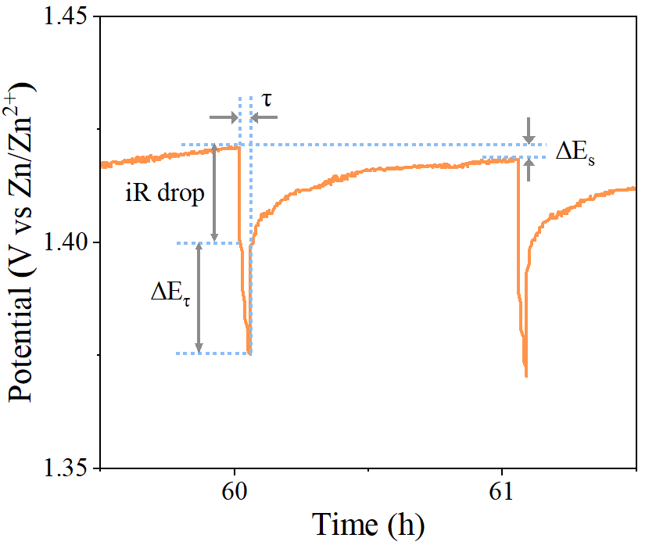
Figure S8. Schematic illustration of selected processes in GITT curves.

Figure S9. (MnO₂-Mn₂O₃)-80 ex-situ XPS spectra of Mn 3s (a) and O 1s (b) in fully discharged and charged states.
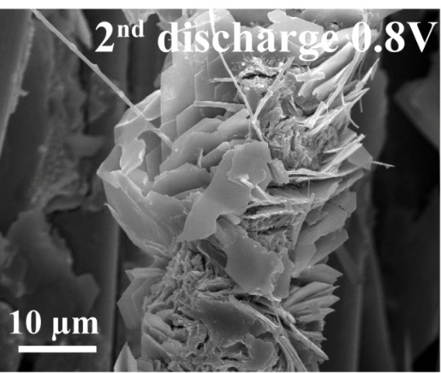
Figure S10. SEM images of (MnO₂-Mn₂O₃)-80 at 2nd discharge 0.8V.
References
[1] Y. Y. Song, J. M. Li, R. Qiao, X. Dai, W. T. Jing, J. X. Song, Y. Z. Chen, S. W. Guo, J. J. Sun, Q. Tan, Y. N. Liu, Binder-free flexible zinc-ion batteries: one-step potentiostatic electrodeposition strategy derived Ce doped-MnO₂ cathode, Chem. Eng. J. 431 (2022) 133387. https://doi.org/10.1016/j.cej.2021.133387.
[2] H. Liu, C. Li, H. P. Zhang, L. J. Fu, Y. P. Wu and H. Q. Wu, J. Kinetic study on LiFePO₄/C nanocomposites synthesized by solid state technique, Power Sources 159 (2006) 717-720. https://doi.org/10.1016/j.jpowsour.2005.10.098.
[3] J. Huang, Diffusion impedance of electroactive materials, electrolytic solutions and porous electrodes: Warburg impedance and beyond, Electrochim. Acta 281 (2018) 170-188, https://doi.org/10.1016/j.electacta.2018.05.136.
[4] S. Zhao, S. Wang, J. B. Guo, L. Li, C. S. Li, Y. Sun, X. Pan, D. L. Wu, L. Wei, Y. J. Wang Q. C. Zhang, Sodium-ion and polyaniline co-intercalation into ammonium vanadate nanoarrays induced enlarged interlayer spacing as high-capacity and stable cathodes for flexible aqueous zinc-ion batteries, Adv. Funct. Mater. 33 (2023) 2305700, https://doi.org/10.1002/adfm.202305700.
[5] C. J. Yin, L. Li, J. S. Hu, Layered V₂O₅ assisted using benzene tetracarboxylic acid as soft template for zinc ion aqueous batteries cathodes to improve the kinetics, Colloids and Surfaces A: Physicochemical and Engineering Aspects 733 (2026) 139248, https://doi.org/10.1016/j.colsurfa.2025.139248.
[6] C. J. Yin, L. Li, H. Y. Yao, J. S. Hu, Q. Liu, G. Z. Fang, Porous Mn₂O₃@C cathode with high activity and long lifespan for aqueous zinc ion batteries, Rare Metals, 45 (2026) e70008, https://doi.org/10.1002/rar2.70008.
[7] P. E. Blöchl, Projector augmented-wave method, Phys. Rev. B 50 (1994) 17953, https://doi.org/10.1103/PhysRevB.50.17953.
[8] J. P. Perdew, K. Burke, M. Ernzerhof, Phys. Rev. Lett. 77 (1996) 3865, https://doi.org/10.1103/PhysRevLett.77.3865.

