Dual-ion (K⁺/Cu²⁺) Intercalated δ-MnO₂ as an Advanced Cathode Material for High Performance Aqueous Zinc-Ion Batteries
Chao Duan^{a,b}, Guizhao Zhu ^{a,b}, Yiyin Zhang^{a,b}, Yawei Li^{a,b}, Haixiang Huang^{a,b}, Bogu Liu^{a,b}, Tingting Xu^{a,b}, Xiaohong Chen^{a,b}, Hong Zeng^{a,b}, Ying Wu^{a,b*}

ª School of Energy Power and Mechanical Engineering, North China Electric Power University. No.2 Beinonglu Changping District, Beijing 102206, China
^{b} Institute of Energy Power Innovation, North China Electric Power University, No. 2 Beinonglu Changping District, Beijing 102206, China

*Corresponding author.
Email: yingwu2000@hotmail.com, wuying@ncepu.edu.cn

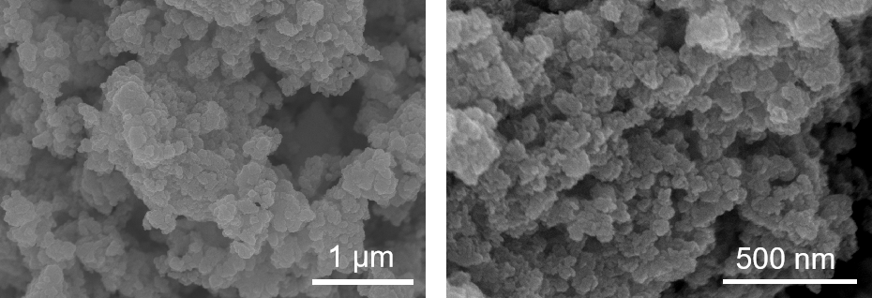
Fig. S1 SEM image of K-MO.

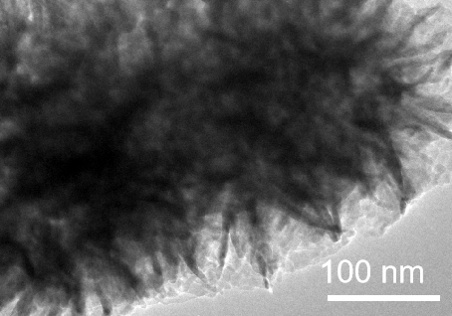
Fig. S2 TEM image of KCu-MO.

Fig. S3 HRTEM image of K-MO.

Fig. S4 Cycling performance of KCu-MO, KCu-MO-0.5, KCu-MO-2 and K-MO electrodes at 0.1 A g⁻¹ current density.

Fig. S5 Cycling performance of KCu-MO, KCu-MO-0.5, KCu-MO-2 and K-MO electrodes at 0.5 A g⁻¹ current density.

Fig. S6 GCD curves at various current densities of K-MO.
Fig. S7 Comparison diagram of power density and energy density of KCu-MO compared to other reported cathode materials.

Fig. S8 GITT curve and diffusion coefficient of K-MO .

Fig. S9 GCD curve of KCu-MO at 0.1 A g⁻¹ and related different charge-discharge states.

Fig. S10 Ex-situ XPS spectra of O 1s.

Material | K-MO | KCu-MO
Mn⁴⁺ peak area ratio fitted (%) | 28.04% | 21.56%
Table S1 Fitted Mn⁴⁺ XPS peak area ratio of the samples.

Sample | K(wt %) | Cu(wt %) | Mn(wt %)
KCu-MO | 6.6667% | 5.3339% | 48.4327%
Table S2 ICP-OES element contents analysis of KCu-MO

Materials | Electrolyte | Specific capacity | Cycling performance | Ref.
MnO₂@AEPA | 2M ZnSO₄+ 0.1M MnSO₄ | 223 mA h g⁻¹ at 0.5 A g⁻¹ | 97% after 1700 cycles at 1A g⁻¹ | [1]
α-Mn₂O₃ | 2M ZnSO₄+ 0.2M MnSO₄ | 225 mA h g⁻¹ at 0.05A g⁻¹ | 53.3% after 1700 cycles at 2A g⁻¹ | [2]
β‐MnO₂-TA | 3M Zn(CF₃SO₃)₂ + 0.1M Mn(CF₃SO₃)₂ | 268.24 mA h g⁻¹ at 0.1 A g⁻¹ | 86.77% after 50 cycles at 0.1 A g⁻¹ | [3]
Mo-MnO₂ | 2M ZnSO₄+ 0.2M MnSO₄ | 222.8 mA h g⁻¹ at 0.1 A g⁻¹ | 82.6% after 1000 cycles at 2A g⁻¹ | [4]
NS-MnO₂ | 2M ZnSO₄+ 0.1M MnSO₄ | 295 mA h g⁻¹ at 0.2 A g⁻¹ | 94% capacity after 1500 cycles at 1A g⁻¹ | [5]
K-δ-MnO₂ | 2M ZnSO₄+ 0.1M MnSO₄ | 282.8 mA h g⁻¹ at 0.3 A g⁻¹ | over 50% after 1000 cycles at 2A g⁻¹ | [6]
Se, P co-doping MnO₂ | 2M ZnSO₄+ 0.2M MnSO₄ | 295 mA h g⁻¹ at 0.5 A g⁻¹ | 66% after 1000 cycles at 1 A g⁻¹ | [7]
This work | 2M ZnSO₄+ 0.1M MnSO₄ | 257.49 mA h g⁻¹ at 0.5 A g⁻¹ | 84% after 5000 cycles  at 1 A g⁻¹
Table S3 Performance comparison of AZIBs with manganese oxide-based materials as cathodes.

 | Rs/Ω | Rct/Ω
KCu-MO | 2.043 | 262.4
K-MO | 2.213 | 469.9
Table S4 Impedance value based on equivalent ciruit diagram fitting

Reference
[1] X. He, M. Kwon, J. Chung, K. Lee, Y. Choi, Y. Im, J. Jang, Y. Choi, H.J. Yoon, Self-assembled molecular layers as interfacial engineering nanomaterials in rechargeable battery applications,Small 20 (2024) 2403537.
[2] M. Mao, X.X. Wu, Y. Hu, Q.H. Yuan, Y.B. He, F.Y. Kang, Charge storage mechanism of MOF-derived Mn₂O₃ as high performance cathode of aqueous zinc-ion batteries, Journal of Energy Chemistry 52 (2021) 277-283.
[3] S. Paik, I. Choi, S. Lee, K.W. Nam, Chelating effects of polyphenolic biomolecules to improve β-MnO₂ cathode performance for aqueous rechargeable zinc-ion batteries, Acs Applied Materials & Interfaces 16 (2024) 50775-50784.
[4] Z.H. Zheng, G.C. Yang, J. Yao, J.Y. Li, J.J. Zheng, Z. Wu, Y. Gan, C. Wang, L. Lv, H.Z. Wan, C. Chen, H.B. Wang, L. Tao, J. Zhang, H. Wang, High-valence molybdenum promoted proton migration and inhibited dissolution for long-life aqueous Zn-MnO₂ batteries, Applied Surface Science 592 (2022) 153335.
[5] J. Liang, Y. Zhao, L. Ren, M. Li, Q. Zhang, Y. Wang, X. Sun, M. Chuai, X. Wang, W. Liu, Dual anions doping enhanced conductivity and stability of layered δ-MnO₂ cathode for aqueous zinc-ion battery, Advanced Functional Materials 35 (2025) 2501135.
[6] Q.X. Xie, G. Cheng, T. Xue, L.H. Huang, S.H. Chen, Y. Sun, M. Sun, H.Z. Wang, L. Yu, Alkali ions pre-intercalation of δ-MnO₂ nanosheets for high-capacity and stable Zn-ion battery, Materials Today Energy 24 (2022) 100934.
[7] K. Ma, S. Ge, R. Fu, C. Feng, H. Zhao, X. Shen, G. Liang, Y. Zhao, Q. Jiao, Uncovering Se, P co-doping effect in MnO₂ toward high-performance aqueous zinc-ion batteries, Chemical Engineering Journal 484 (2024) 149525.

