Supplementary Materials for
Ti⁴⁺-induced dual-functional α-MnO₂ nanowires: boosting transport kinetics and interfacial optimization for aqueous zinc-ion batteries
Min Wangª, Tianyi Liª, Yuncheng Huangª, Xin Liuª, Yixuan Liangª,Wen Zhangª, Guoqing Yangª, Fan Su^{c}, Wei Zhangª, Chuan Dingª, Qilin Gu^{d}, Chao Huangfu^{a,}*, Hailin Shen^{a,}*, Zhenghui Pan^{b,*}
ª School of Chemical Engineering and Materials, Changzhou Institute of Technology, Changzhou 213032, P. R. China
^{b} School of Materials Science and Engineering, Tongji University, Shanghai 201804, P. R. China
^{c} Advanced Analysis and Testing Center, Nanjing Forestry University, Nanjing 210037, P. R. China
^{d} State Key Laboratories of Materials-Oriented Chemical Engineering, NJTECH University Suzhou Future Membrane Technology Innovation Center, College of Chemical Engineering, Nanjing Tech University, Nanjing, 211816, P. R. China
*Corresponding author: huangfc@czu.cn; shenhailin@czu.cn;
zhenghuipan@tongji.edu.cn

Figure S1 The refined XRD pattern of pristine α-MnO₂ material.

Table S1 Calculated parameters of the pristine and Ti-doped α-MnO₂ material.
 | a/Å | b/Å | c/Å | V/(Å³) | R_{p} | R_{wp}
pristine | 9.8652 | 9.8652 | 2.8617 | 278.51 | 5.64% | 7.08%
Ti-doped | 9.8615 | 9.8615 | 2.8625 | 278.38 | 6.12% | 7.17%

Figure S2 XPS wide spectra of as-prepared Ti-doped and pristine α-MnO₂ material.

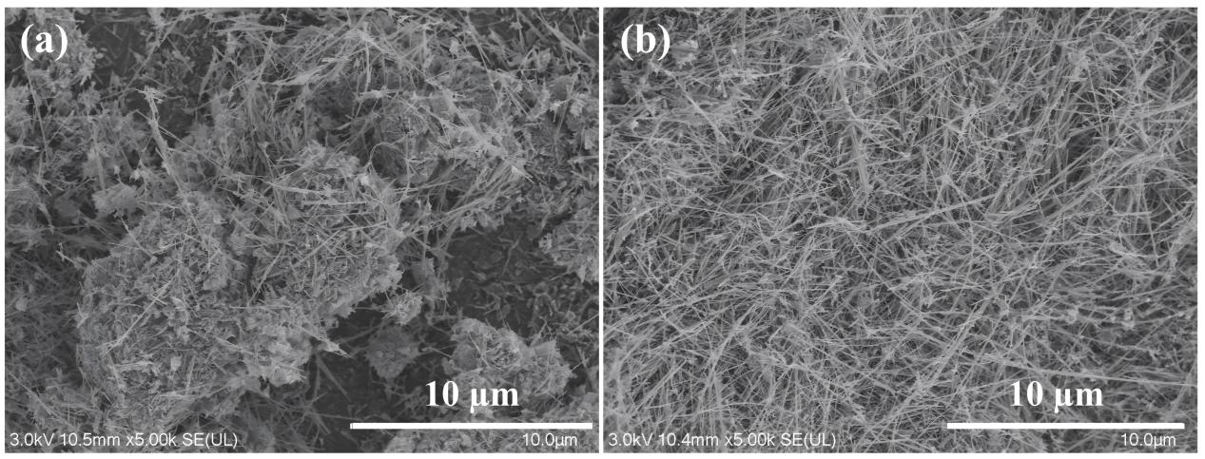
Figure S3 FESEM images of pristine and Ti-doped α-MnO₂ materials.

Figure S4 The electrochemical properties of as-prepared pristine α-MnO₂ electrodes in 1M ZnSO₄ + 0.1Mn MnSO₄ aqueous electrolyte. (a) CV curves at 0.2 mV·s⁻¹; (b) CV curves at various scan rates; (c) the relationship of peak current(i) and scan rate (ν) in the Figure S4b; (d) Galvanostatic charge/discharge profiles in initial three cycles at 100 mA·g⁻¹ between 1.0 and 1.8 V.
Figure S5 Galvanostatic charge/discharge profiles at the 200th cycle at 100 mA·g⁻¹ between 1.0 and 1.8 V.

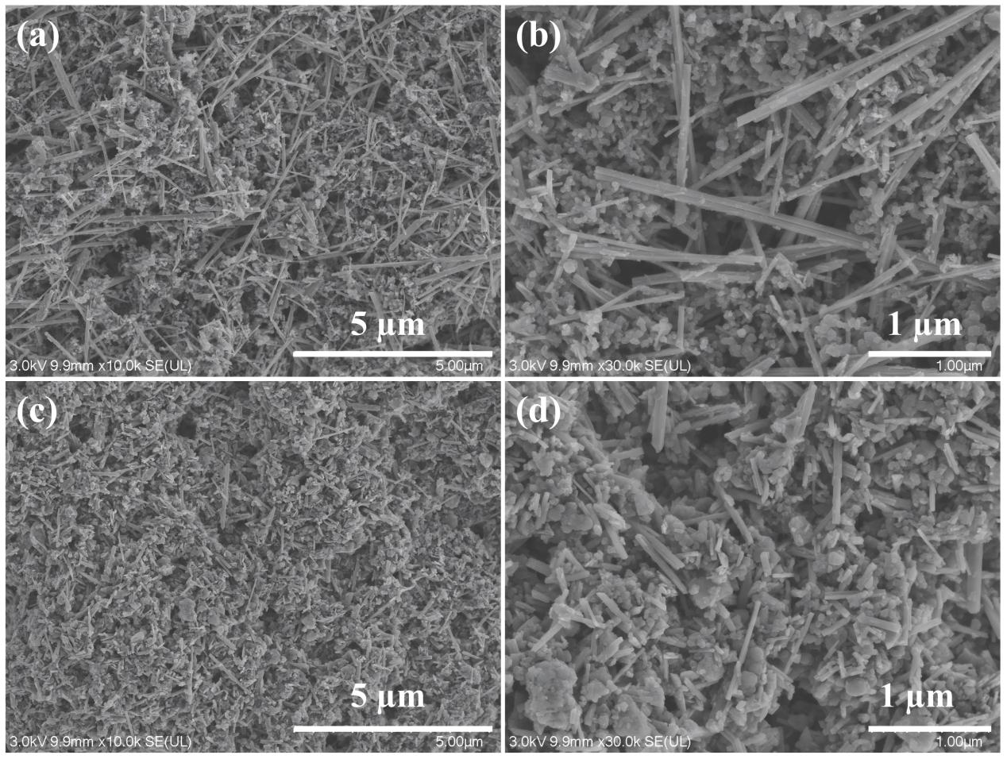
Figure S6 FESEM images of the Ti-doped (a-b) and pristine (c-d) α-MnO₂ electrodes before cycling.

