Supporting Information

Origin of Mn dissolution-triggered chain reactions in aqueous sodium-ion batteries

1. Experimental section
1.1 Raw materials
Na₄Fe(CN)₆∙10H₂O (analytical reagent, 99.7%), MnAc₂·4H₂O (analytical reagent, 99.7%) and Acetamide (analytical reagent, 99%) were purchased from Shanghai Aladdin. Tetrasodium ethylenediaminetetraacetate dihydrate (EDTA tetrasodium, 99%) and 3,4,9,10-perylenetetracarboxylic diimide (95%) were purchased from Macklin. Na₂SO₄ (99%) and NaClO₄ (ACS reagent, >98%) were purchased from Sigma–Aldrich. All the chemicals and reagents were used without further purification.

1.2 Preparation of MnHCF, Fe-doped MnHCF and electrolyte
MnHCF was synthesized by a co-precipitation method with the assistance of a chelating agent. Firstly, 4 mmol EDTA tetrasodium and 4 mmol MnAc₂·4H₂O were dissolved in 50 mL deionized water, labeled solution A. 4 mmol Na₄Fe(CN)₆∙10H₂O was dissolved in another 50 mL of deionized water, labeled solution B. Then, solution A was added dropwise into solution B in 12 minutes with constant magnetic stirring. The mixture was aged in air for 4 h. Finally, the precipitate was washed with deionized water three times, and dried at 60 °C in air overnight.
Fe-doped MnHCF was modified by HNO₃, Na₄Fe(CN)₆, and Na₂SO₄, using MnHCF as the precursor. Firstly, 0.2 g MnHCF, 0.4 mmol Na₄Fe(CN)₆∙10H₂O, and 10 g Na₂SO₄ were mixed in 40 mL deionized water and placed in a water bath at 90 °C with constant stirring. When the temperature reaches steady state, 0.2 mL HNO₃ at 1 mol L⁻¹ was added dropwise into the system. Afterwards, the suspension was stirred constantly with its temperature maintaining at 90 °C for 4 h. Finally, the precipitate was washed with deionized water three times and dried at 60 °C under air overnight.
17.6 m NaClO₄ was prepared by dissolving 24.5 g NaClO₄ in 10 mL deionized water. NaClO₄·H₂O-2ACE was prepared by mixing sodium perchlorate monohydrate and acetonitrile with molar ratio of 1:2 with constant stir until the system turns into a clear solution. The molality of NaClO₄ in this mixed acetamide-water system is 7.34 mol/kg.

1.3 Preparation of electrodes
MnHCF and Fe-doped MnHCF were used as cathodes and PTCDI was used as anode. Electrode slurries were composed of 70 wt% active materials, 20 wt% carbon black and 10 wt% PVDF. Carbon paper was used as collector. Each carbon paper was loaded with 1.0–2.0mg cm^{–2} of active material for a 2032-type coin-cell.
All the cycled electrodes for characterizations are at fully discharge state.

1.4 Electrochemical measurements
Linear sweep voltammetry (LSV) was carried out in a three electrode system with Ag/AgCl as the reference electrode at a scan rate of 0.5 mV s−1. Cyclic voltammetry (CV) was carried out at a scan rate of 0.5 mV s−1. The abovementioned tests were conducted on a CHI 600c electrochemical workstation and a DH7003 electrochemical workstation. The galvanostatic discharge/charge measurements were performed on Neware battery system (Neware Technology Ltd.).

1.5 Characterizations
The XRD patterns were measured on a Rigaku diffractometer (Cu Kα radiation, λ =0.154nm). The Raman spectra of the electrolytes and electrodes were collected by an inVia Qontor Raman microscope with a 532 nm laser. The SEM images of the elec- trodes were observed using a Regulus 8230 at 5 kV, and EDS was obtained at 10 kV. The FTIR spectra of the electrolytes were collected by a Fourier transform infrared spectrometer (NICOLET 6700). The XPS spectra were collected by a Thermo ECSALAB 250. High-angle annular dark-field images (HAADF), STEM-mapping images of the electrodes were obtained by TEM (FEI Tecnai G2 F30, 300 kV) with an accelerating voltage of 300kV using a lacey support film.
Insitu pH detection was conducted on a beaker-type cell containing 5 mL electrolyte, MnHCF cathode, PTCDI anode and pH electrode. The cathode and anode were linked with Neware battery system to carry out the charge-discharge process. Meanwhile, the pH electrode can real-time monitor the pH of the electrolyte.

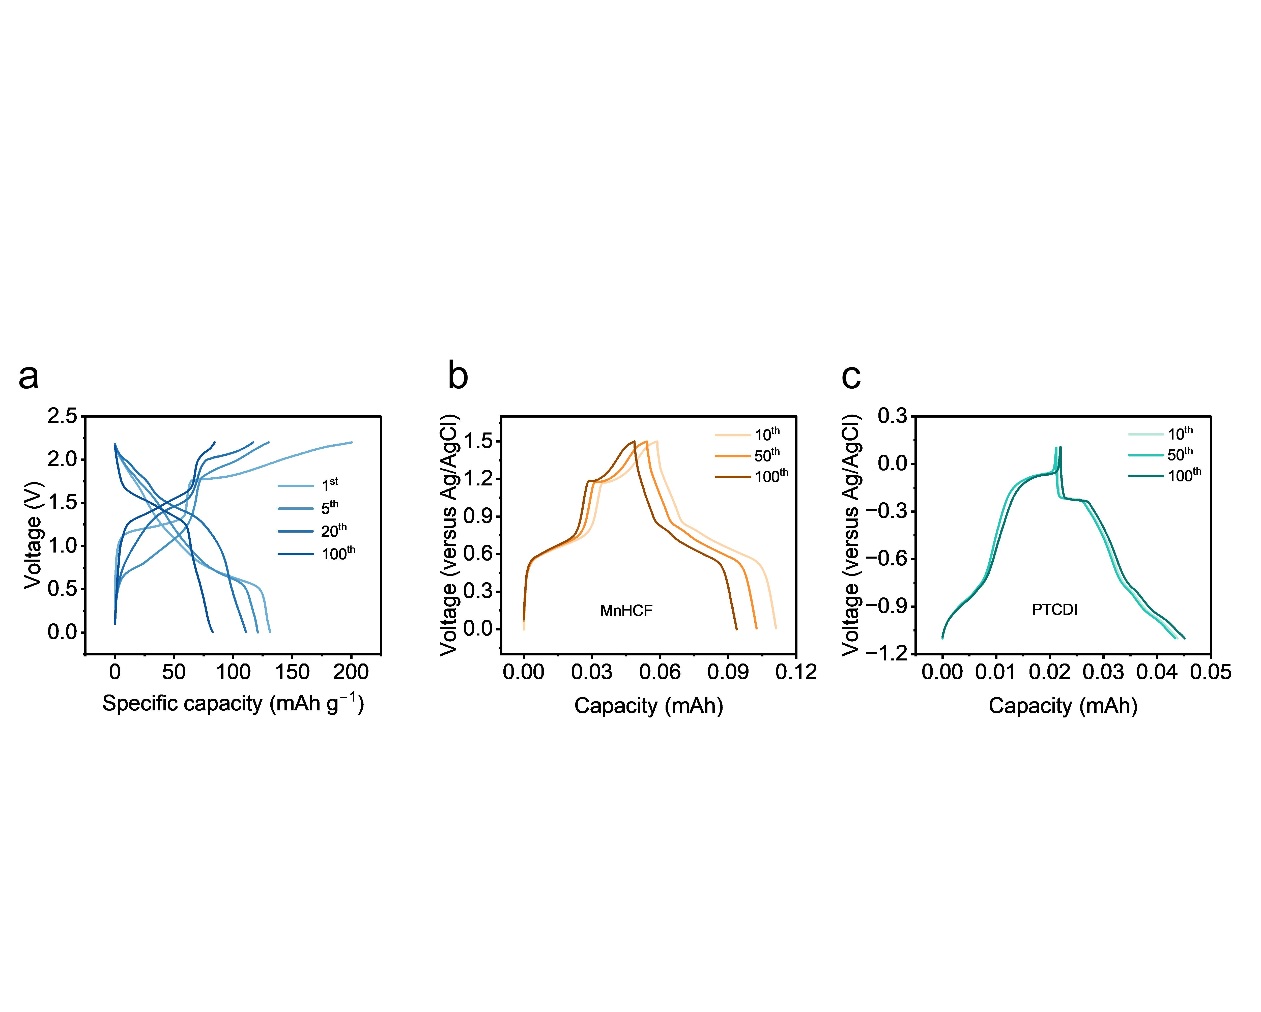
2. Supplementary figures
Figure S1. (a) Charge-discharge curves of different cycles in 17.6 m NaClO₄. (b) Charge/discharge curves of MnHCF measured in a three-electrode configuration. (c) Charge/discharge curves of PTCDI measured in a three-electrode configuration. Counter electrode: graphite rod, reference electrode: Ag/AgCl.

As shown in Figure S1a, the charge–discharge curves and the discharge median voltage evolve markedly during cycling. To clarify the origin of this behavior, we carried out three-electrode measurements on both MnHCF and PTCDI. Figure S1b reveals that, although the high-voltage Mn²⁺/Mn³⁺ plateau of MnHCF gradually shortens upon cycling, its plateau voltage remains essentially unchanged. In comparison, both the plateau length and plateau voltage of the PTCDI anode remain largely stable during cycling (Figure S1c). These results indicate that the voltage evolution in PTCDI║MnHCF arises primarily from a redistribution of cathode–anode half-reaction matching, rather than from an intrinsic voltage drift of either electrode. Specifically, as the Mn-related plateau become shortened, part of the low-voltage PTCDI capacity that was initially matched with Mn becomes progressively pair with the subsequent Fe-related reaction, shifting the Fe-related plateau to a higher voltage and thereby increasing the median voltage in PTCDI║MnHCF.

Figure S2. Color changes of separator (a) before cycling and (b) after cycling.

Figure S3. The SEM images of electrodes with different median voltage in 17.6 m NaClO₄. (a-c) Electrodes with 1.0 V, 1.1 V and 1.2 V median voltage, respectively.

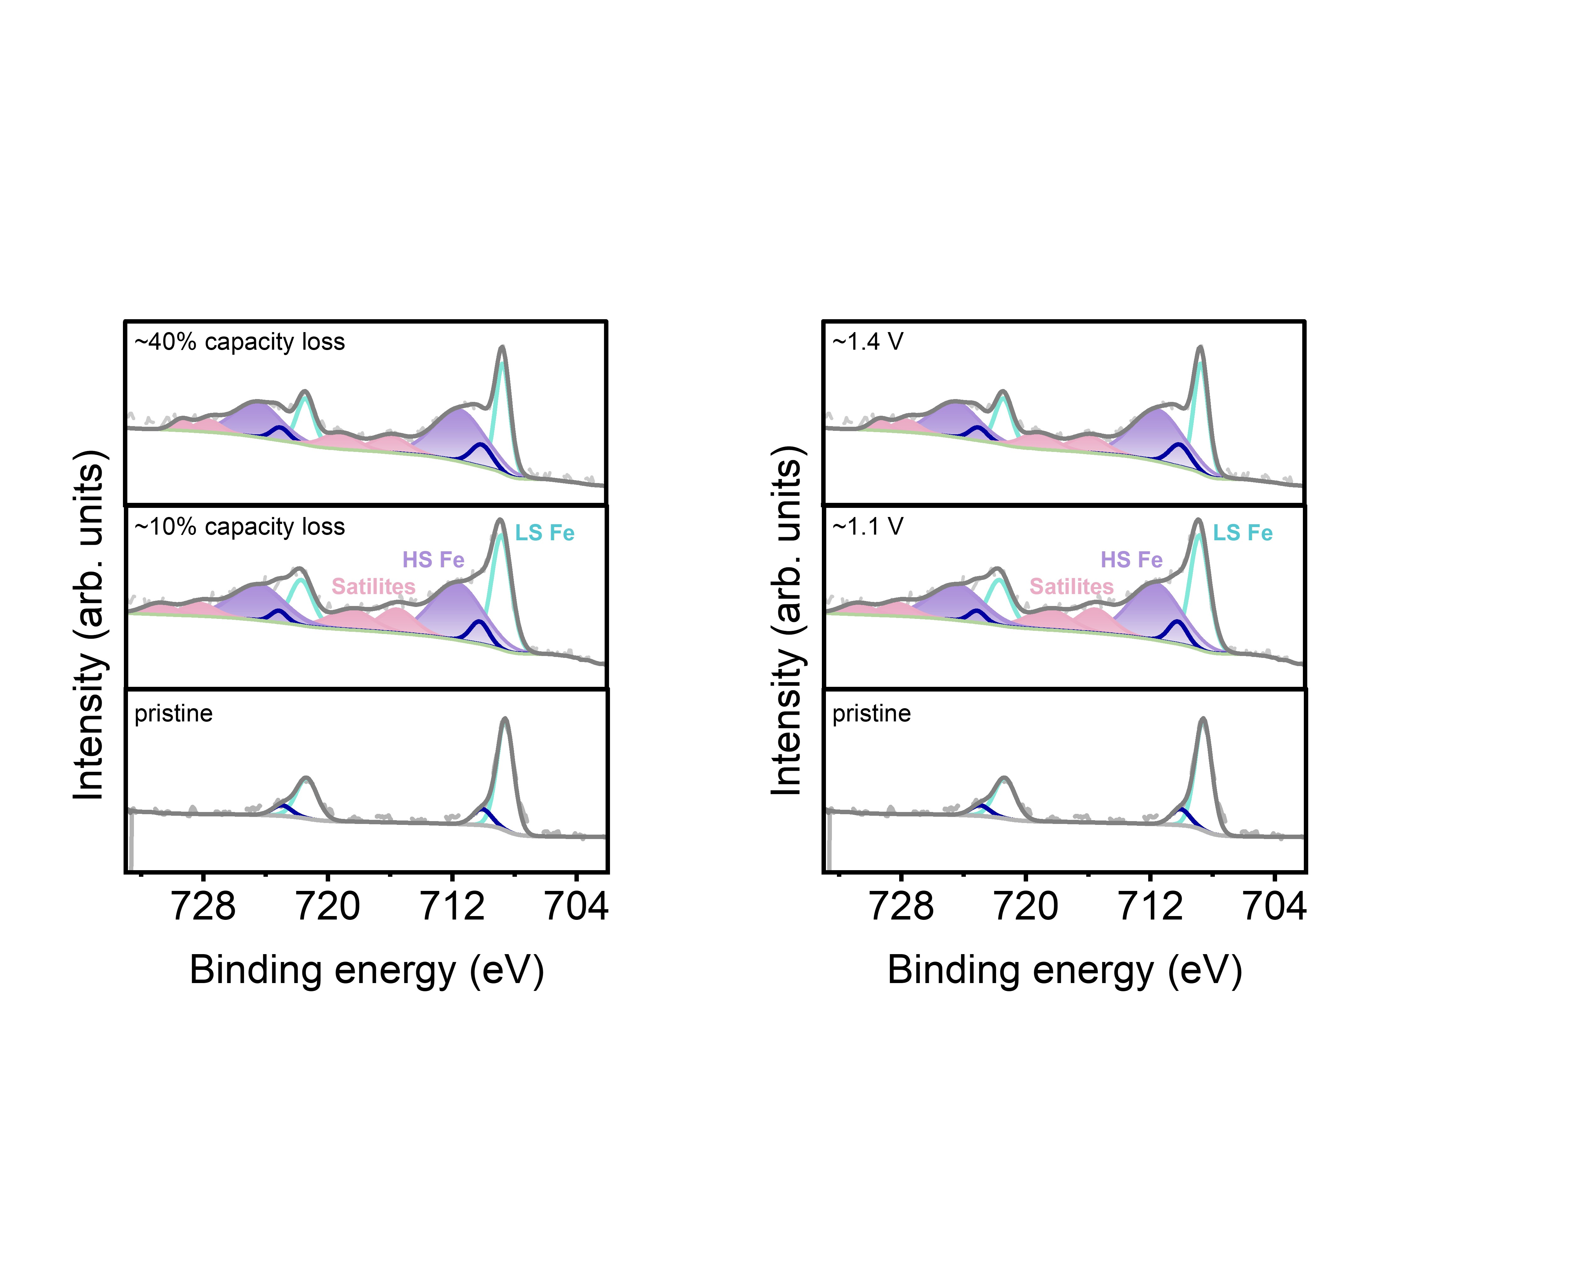
Figure S4. Fe 2p XPS of electrodes at different states in 17.6 m NaClO₄.

Figure S5. The SEM images comparison of (a) the pristine electrode and (b) the reconstructed electrode (with median voltage stabilized at 1.4 V).

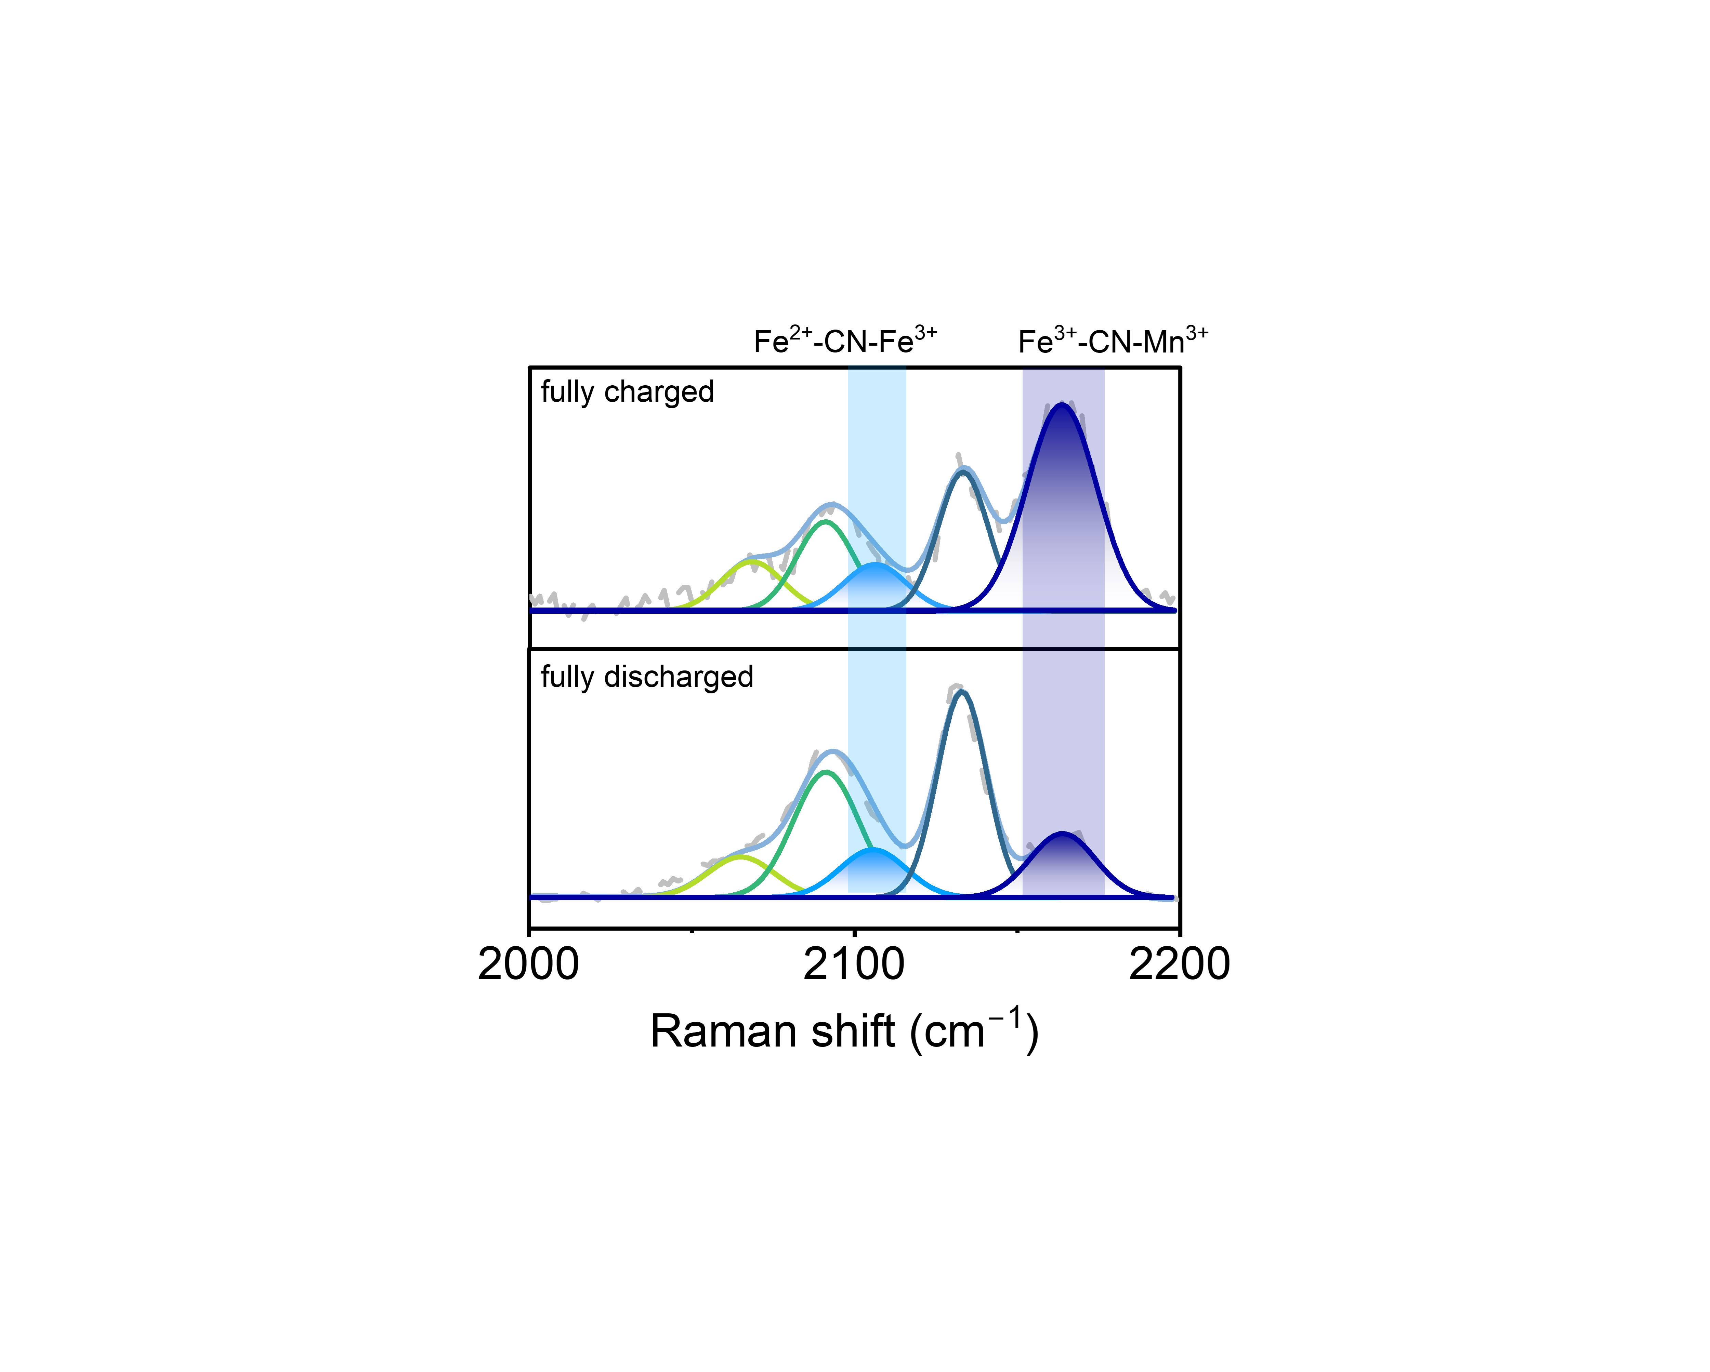
Figure S6. Raman spectra of different states of MnHCF in 17.6 m NaClO₄.

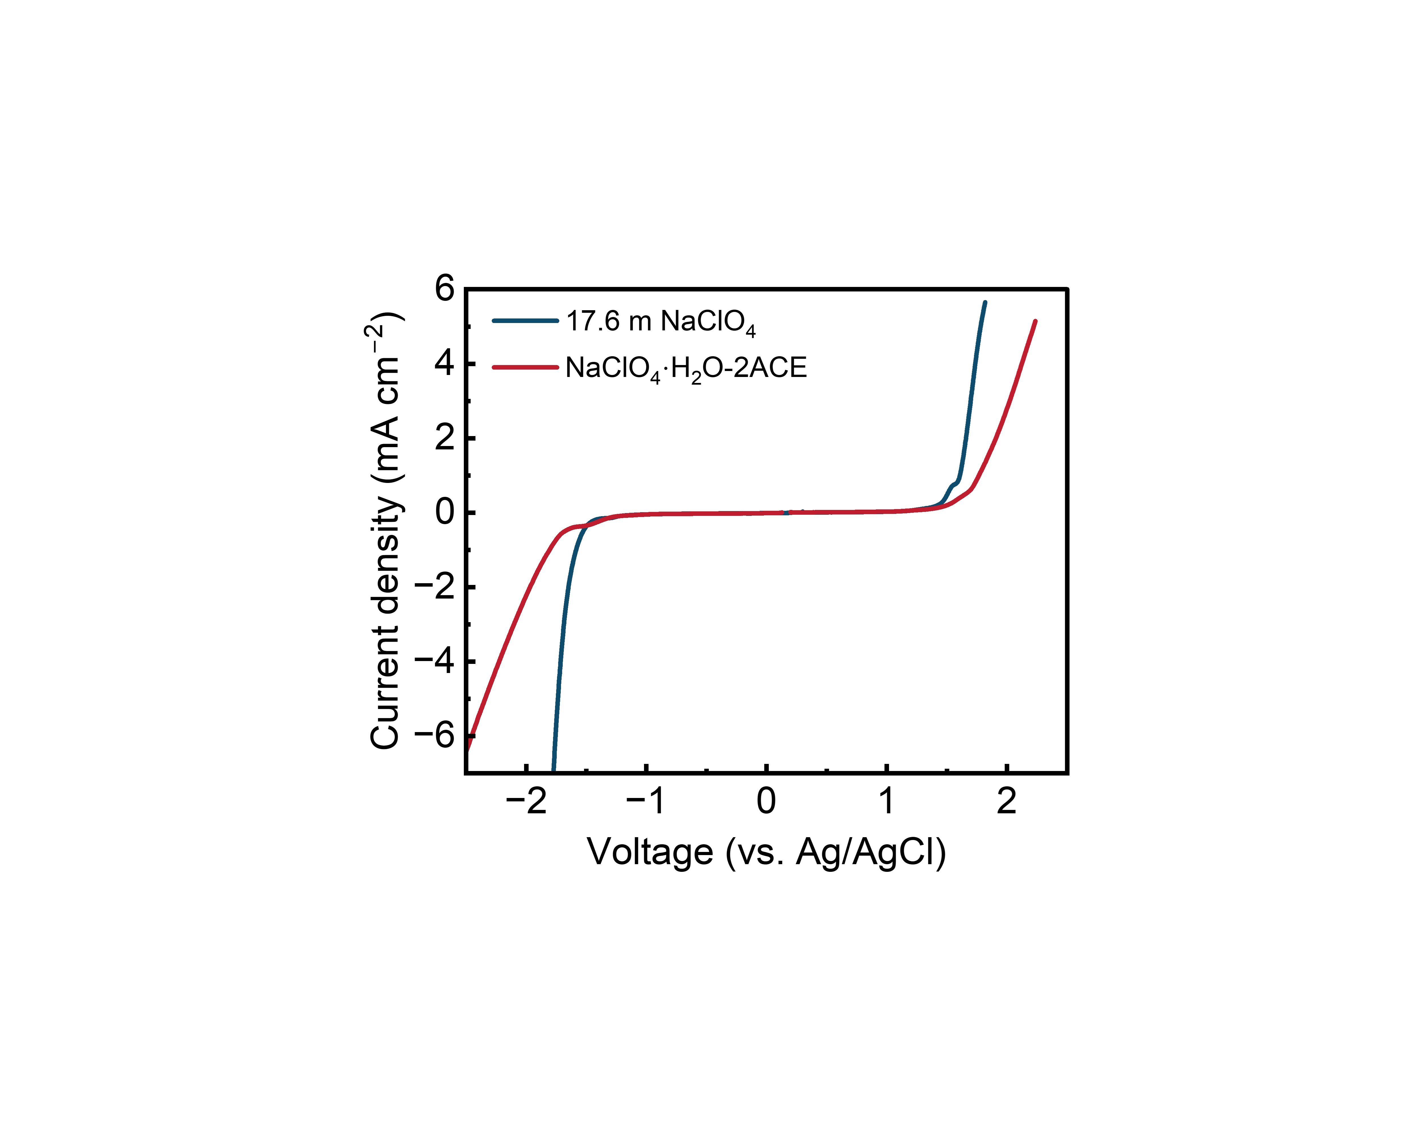
Figure S7. Electrochemical stability window of different electrolytes on a three-electrodes-system obtained by LSV. The reference electrode is Ag/AgCl.

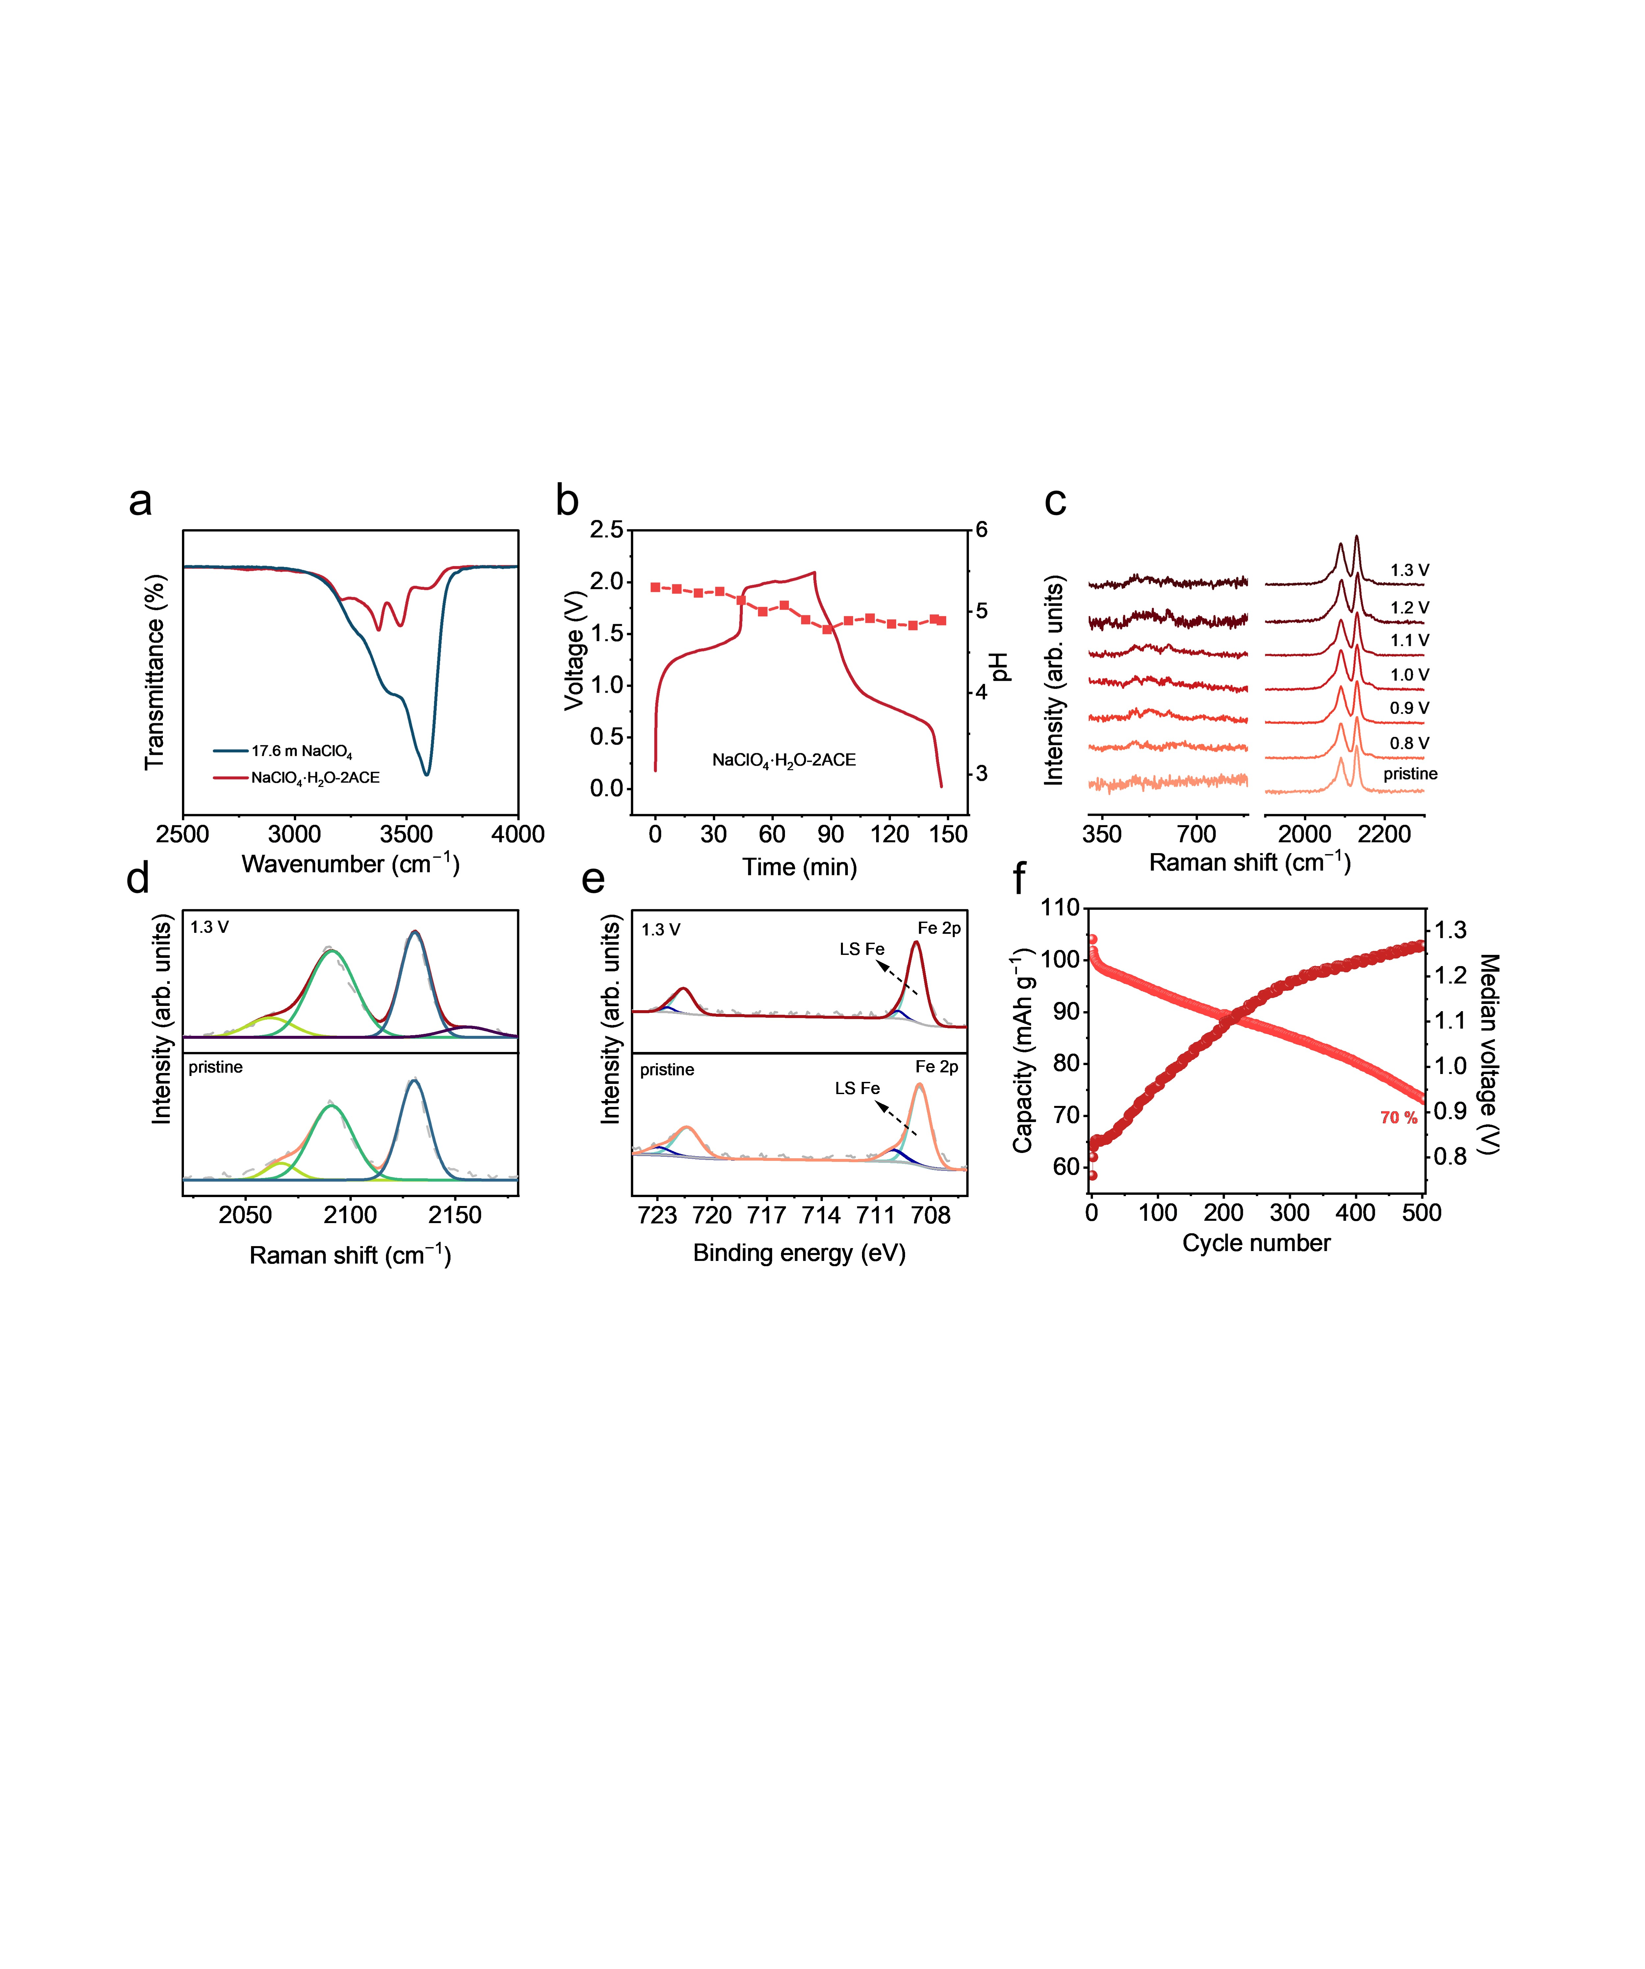
Figure S8. Cycling performance and median voltage evolution of MnHCF in NaClO₄·H₂O-2ACE.

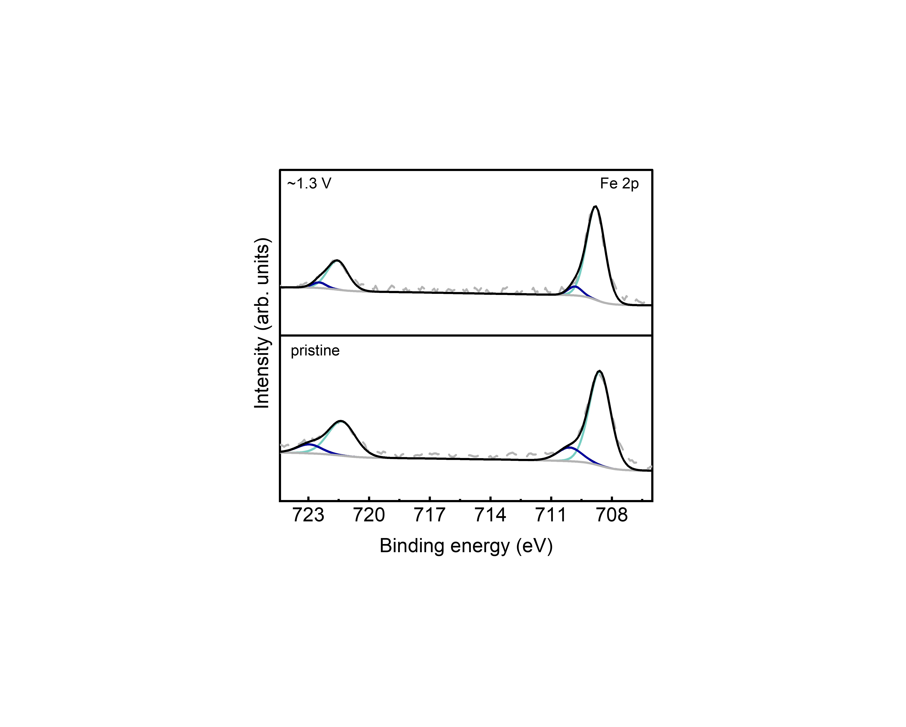
Figure S9. Fe 2p XPS of electrodes at different states in NaClO₄·H₂O-2ACE.

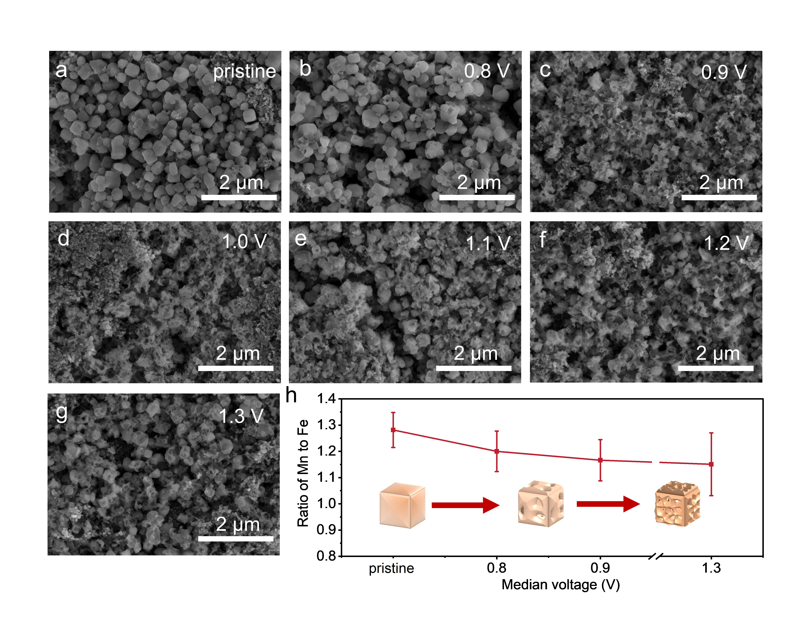
Figure S10. (a-g) The SEM images of the pristine electrode and the cycled electrode in NaClO₄∙H₂O-2ACE with median voltage of 0.8 V, 0.9 V, 1.0 V, 1.1 V, 1.2 V and 1.3 V, respectively. (h) Mn-to-Fe ratio variation detected by STEM-EDS and schematic diagram of the electrode particles morphology evolution. The error bars indicate a 68.4% confidence interval.

Figure S11. In situ XRD of MnHCF and corresponding charge-discharge curves in NaClO₄∙H₂O-2ACE.

Figure S12. The cycling performance of MnHCF and Fe-doped MnHCF at 0.5 A g⁻¹ in (a) NaClO₄∙H₂O-2ACE and (b) 17.6 m NaClO₄.

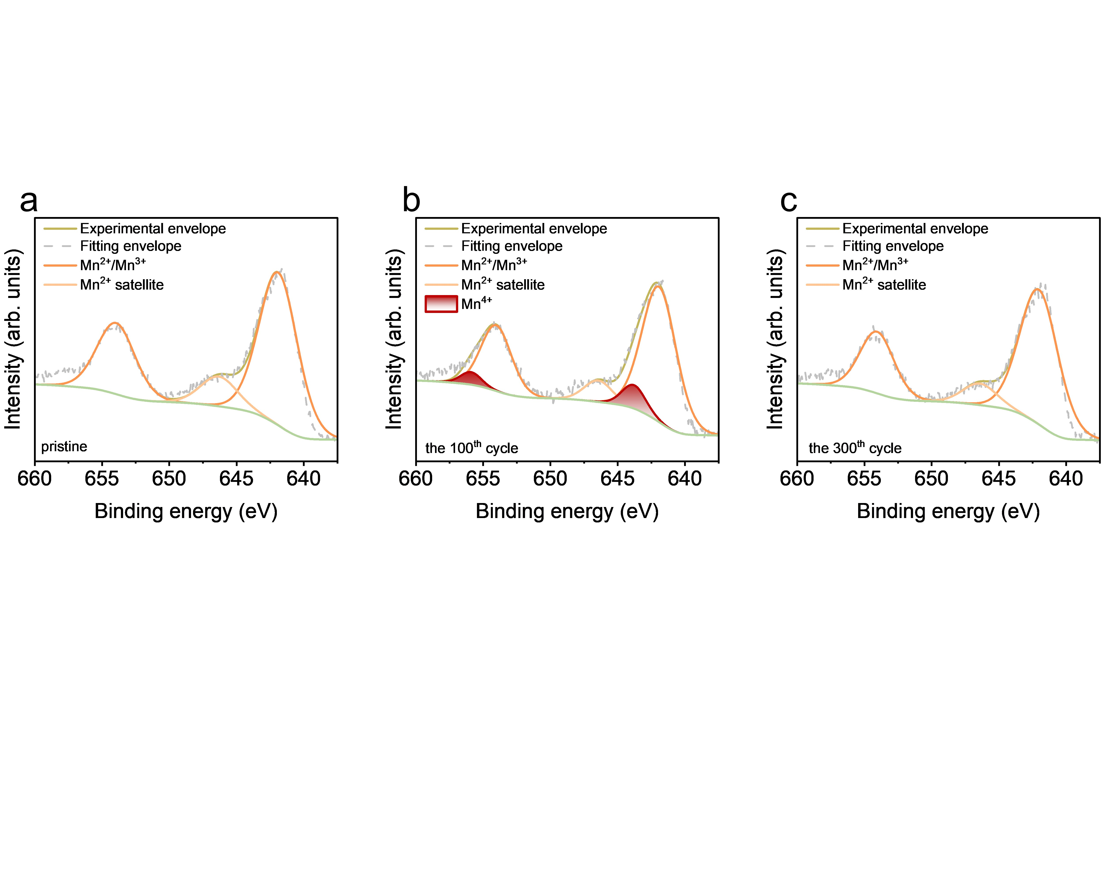
Figure S13. Mn 3s XPS of Fe doped MnHCF (a) at pristine state and (b) after 100 cycles.

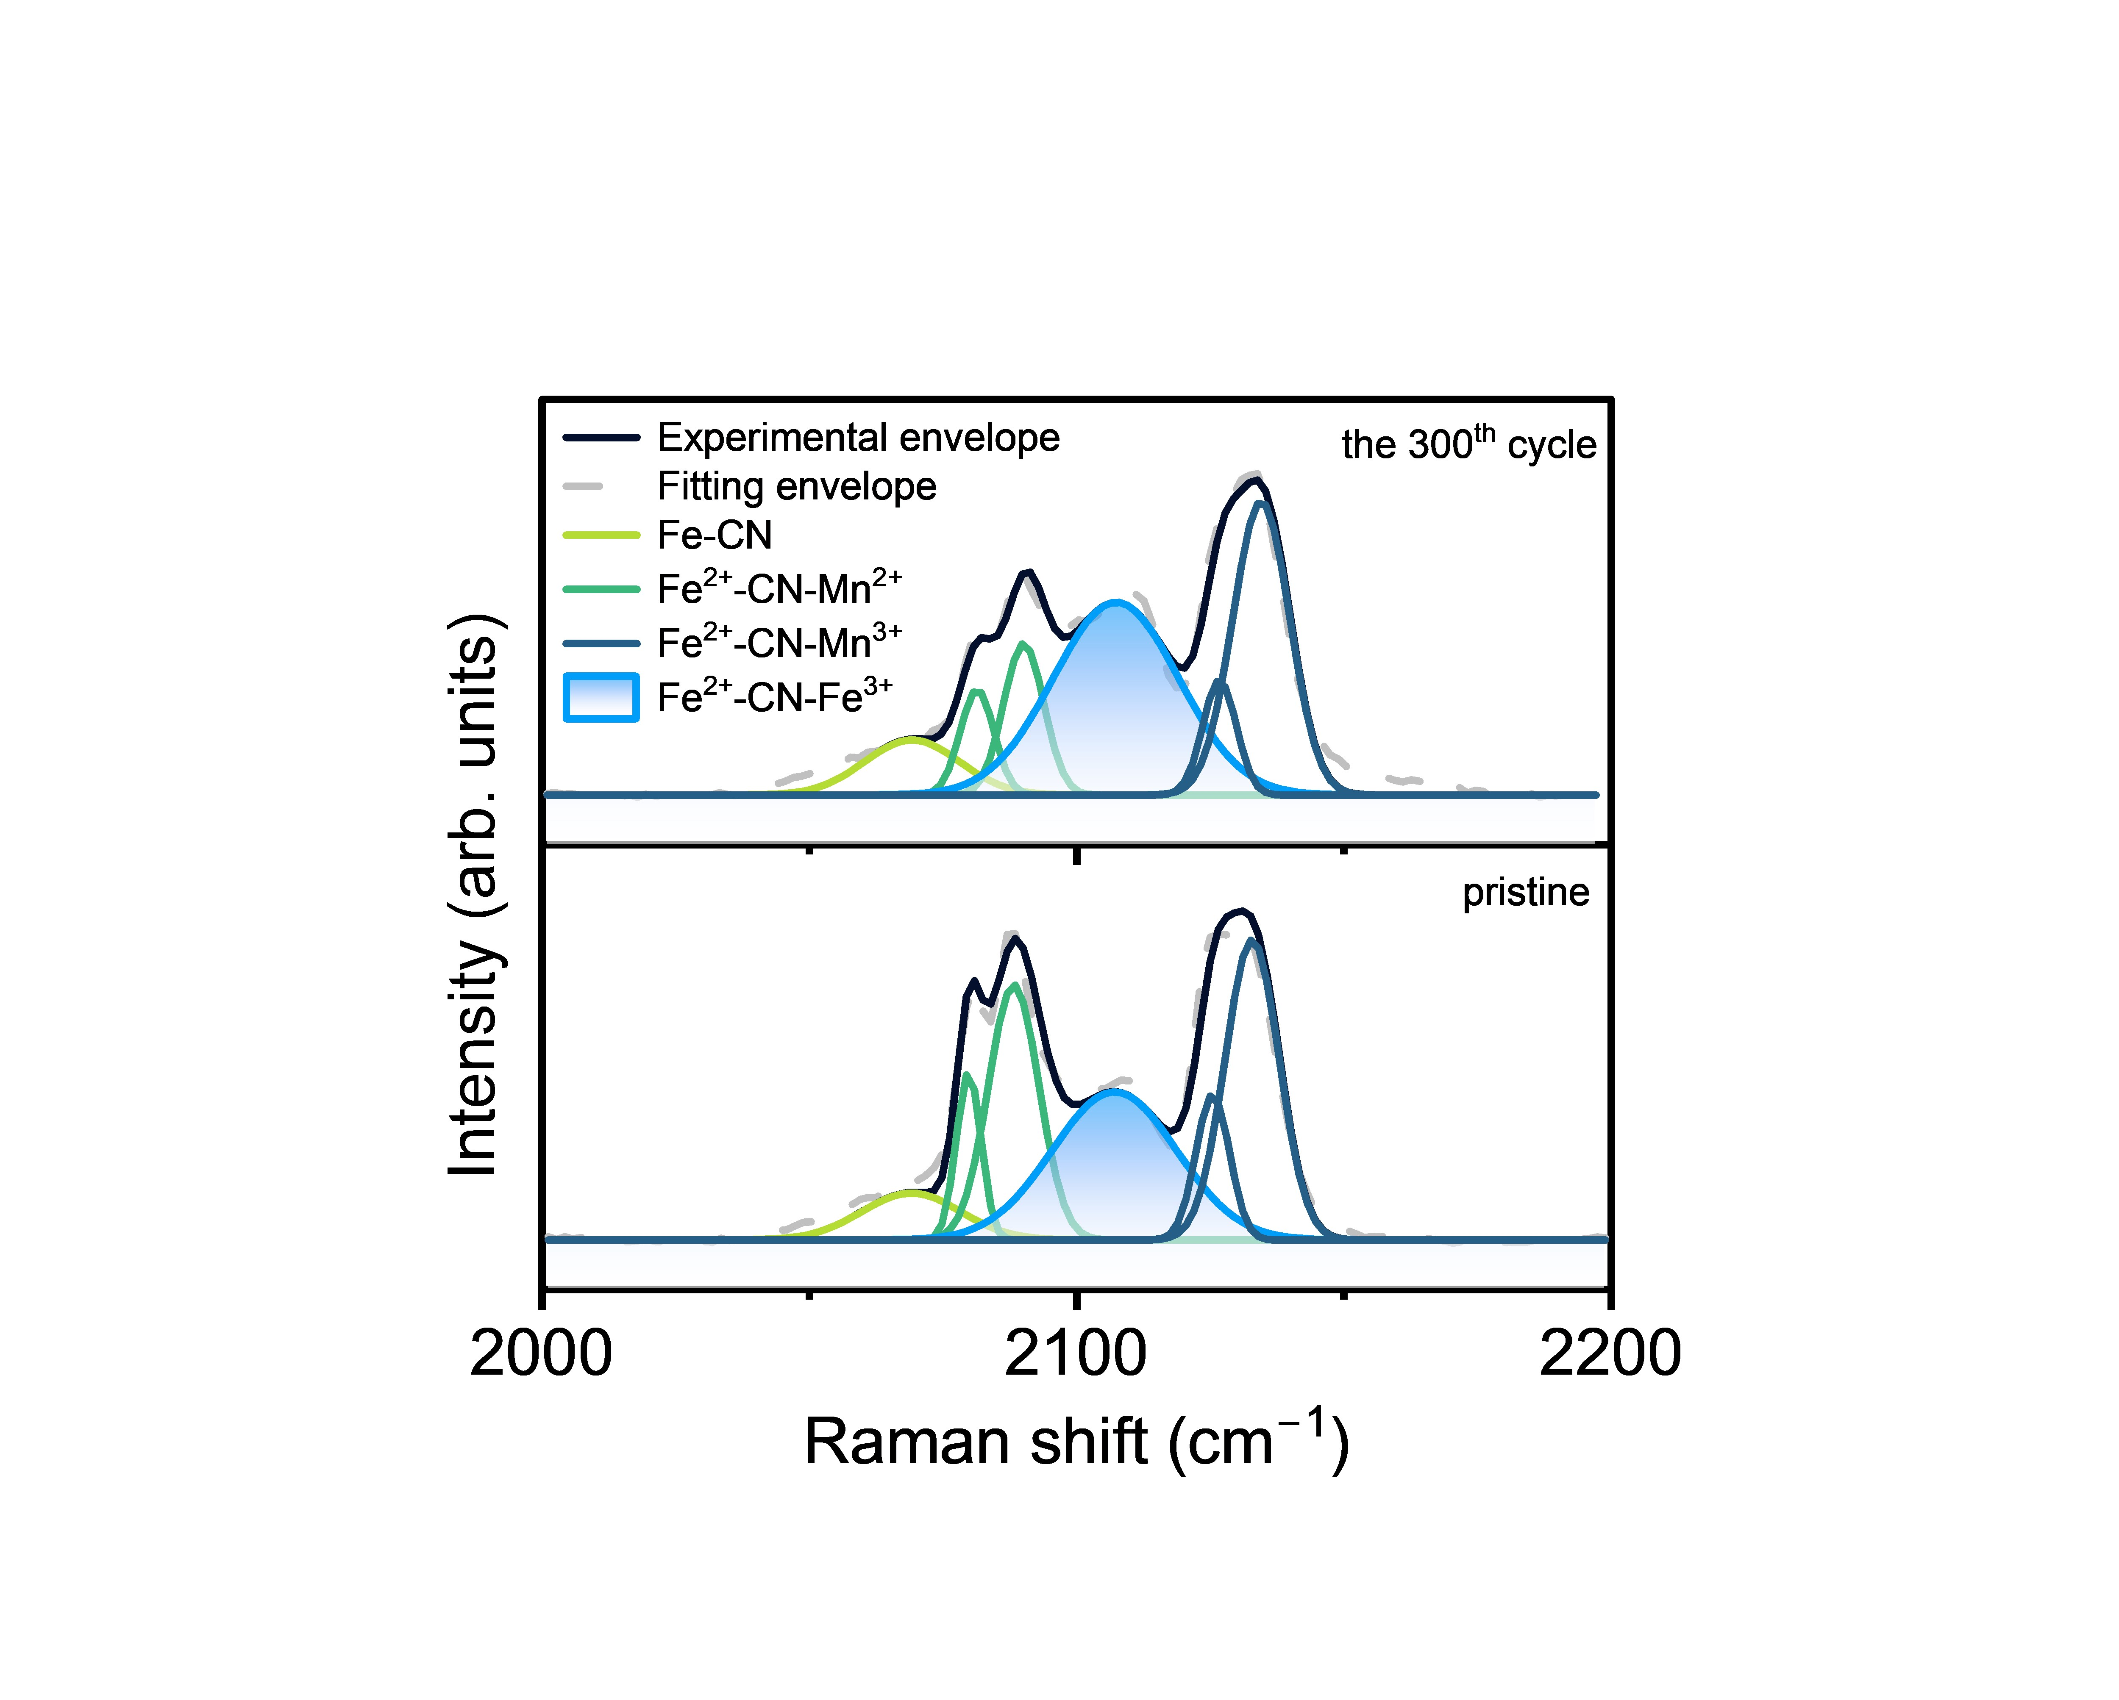
Figure S14. Raman spectra of Fe doped MnHCF at different states.

Figure S15. The charge-discharge curves of Fe-doped MnHCF at different current density in (a) 17.6 m NaClO₄ and (b) NaClO₄∙H₂O-2ACE.

