Supporting Information
Calcination Tuned Mn₂O₃ Hierarchical Microspheres Enable High-Performance Aqueous Zinc-Ion Batteries
Ruiqi Yue, Fen Qiao *
School of Energy & Power Engineering, Jiangsu University, Zhenjiang 212013, P. R. China
Charaterization measurements
Material morphology was examined using a Zeiss field-emission scanning electron microscope (SEM).And crystal phase composition was determined by X-ray diffraction (XRD, Bruker D8 Advance diffractometer with Cu Kα radiation), with crystallinity quantified via Rietveld refinement. Regarding surface chemistry, elemental valence states and chemical environments were characterized by X-ray photoelectron spectroscopy (XPS, ThermoFisher ESCALAB 250Xi system).
Electrochemical measurements
Cyclic voltammetry (CV) tests were conducted within a potential window of 0.8–1.9V using a CHI760e electrochemical workstation, and electrochemical impedance spectroscopy (EIS) was recorded over the frequency range of 100kHz to 0.01Hz. Galvanostatic charge/discharge (GCD) and cycling tests were carried on a Neware battery testing system within a potential window of 0.8–1.9V.
Based on the mass of the cathode active material, the specific capacity of the electrode was calculated using formula (S1):
#(S1)
where Q (mAh g⁻¹) is the specific capacity of the electrode, I is the discharge current, Δt is the discharge time (h), and m is the weight of active materials. The energy density and power density normalized to the cathode active material were calculated using formula (S2) :
$$\begin{aligned}\text{P}\text{=}\frac{\text{E}}{\text{∆}\text{t}}\#\left(\text{S}\text{2}\right)\end{aligned}$$
Where E (mWh g⁻¹) is the discharge specific energy, and Δt is the discharge time (h).
The crystallite sizes of the samples calcined at different temperatures were quantitatively calculated using the Debye-Scherrer formula to quantify the differences in crystallinity. The Debye-Scherrer formula is given as:
$$\begin{aligned}\text{D}\text{=}\frac{\text{K}\text{λ}}{\text{β}\text{cos}{\text{θ}}}\#\left(\text{S}\text{3}\right)\end{aligned}$$
Three characteristic diffraction peaks, (222), (044), and (622), were selected for analysis and calculation. The results are summarized in Table S1 below.The selection of parameters for the Debye-Scherrer equation was based on the following rationale:
Scherrer Constant (K value): This value is dependent on the crystallite shape and the (hkl) planes being measured. Given that the as-prepared Mn₂O₃ samples in this study exhibit a uniform spherical morphology (as evidenced by SEM images), the value of K= 0.89 was adopted. This is the most commonly used and accepted approximation for spherical particles when the full width at half maximum (FWHM) is the measured breadth [1].
GITT Calculations
Galvanostatic intermittence titration technique (GITT) technique was used to calculate the Zn²⁺ diffusivity coefficient reflecting the kinetic behavior of Mn₂O₃ and the Zn²⁺ diffusivity coefficient was calculated based on equation:
D = $\frac{\text{4}{\text{L}}^{\text{2}}}{\text{πτ}}{\text{(}\frac{\text{∆}\text{Es}}{\text{∆}\text{Et}}\text{)}}^{\text{2}}$#(S4)
Where$\text{τ}$ is the relaxation time (s), L is diffusion length (cm) of Zn²⁺ which is equal to thickness of electrode, and ∆Es is the steady-state potential change (V) by the current pulse. ∆Et is the potential change (V) during the constant current pulse after eliminating the iR drop. Current pulse of 0.1 mA g⁻¹ was applied for 20 minutes while the followed relaxation time is 20 minutes[2].
The X-ray diffractometer used in this work was equipped with a Cu source, which generates Kα radiation with a characteristic wavelength of λ = 0.15406 nm. This is a fixed physical constant for the calculation[3].
Notably, the decrease in crystallite size for the sample calcined at 600°C, consistent with the observed peak broadening, points towards structural disordering induced by the excessively high calcination temperature.

Table S1. Crystallite size calculation based on the Debye-Scherrer equation
Calcination Temp. (°C) | Plane (hkl) | 2θ (°) | FWHM (°) | Crystallite Size D (nm)
400 | (222) | 32.7 | 0.462 | 17.705
 | (044) | 55.1 | 0.592 | 14.964
 | (622) | 65.7 | 0.688 | 13.599
500 | (222) | 32.7 | 0.312 | 26.217
 | (044) | 55.1 | 0.322 | 24.459
 | (622) | 65.7 | 0.440 | 21.235
600 | (222) | 32.7 | 0.366 | 22.394
 | (044) | 55.1 | 0.406 | 21.803
 | (622) | 65.7 | 0.515 | 18.144

Table S2. The XRD diffraction peak of Mn₂O₃-1 sample

Sample | Peak position (221) | Peak position (222) | Peak position (400) | Peak position (323) | Peak position (413) | Peak position  (044) | Peak position  (622)
Mn₂O₃-1 | 22.77 | 32.71 | 38.03 | 44.97 | 49.21 | 55.06 | 65.66
Shifted value | 0.33 | 0.05 | 0.28 | 0.18 | 0.20 | 0.02 | 0.10

Table S3. The XRD diffraction peak of Mn₂O₃-2 sample
Sample | Peak position (221) | Peak position (222) | Peak position (400) | Peak position (323) | Peak position (413) | Peak position  (044) | Peak position  (622)
Mn₂O₃-2 | 22.93 | 32.71 | 37.99 | 44.87 | 49.11 | 55.06 | 65.62
Shifted value | 0.17 | 0.05 | 0.32 | 0.28 | 0.30 | 0 | 0.14
Table S4. The XRD diffraction peak of Mn₂O₃-3 sample
Sample | Peak position (221) | Peak position (222) | Peak position (400) | Peak position (323) | Peak position (413) | Peak position  (044) | Peak position  (622)
Mn₂O₃-3 | 22.77 | 32.61 | 37.93 | 44.81 | 49.11 | 54.95 | 65.66
Shifted value | 0.07 | 0.15 | 0.38 | 0.34 | 0.30 | 0.09 | 0.10

Table S5. The fitted EIS parameters of the samples.
Sample | Rs/ Ω | Rct/ Ω | Wo/ Ω
Mn₂O₃-1 | 1.4 | 87.1 | 96.5
Mn₂O₃-2 | 1.3 | 37.0 | 27.8
Mn₂O₃-3 | 1.5 | 59.6 | 57.4

Fig. S1. The BJH desorption pore size distribution curve of the optimal Mn₂O₃-2 sample.

.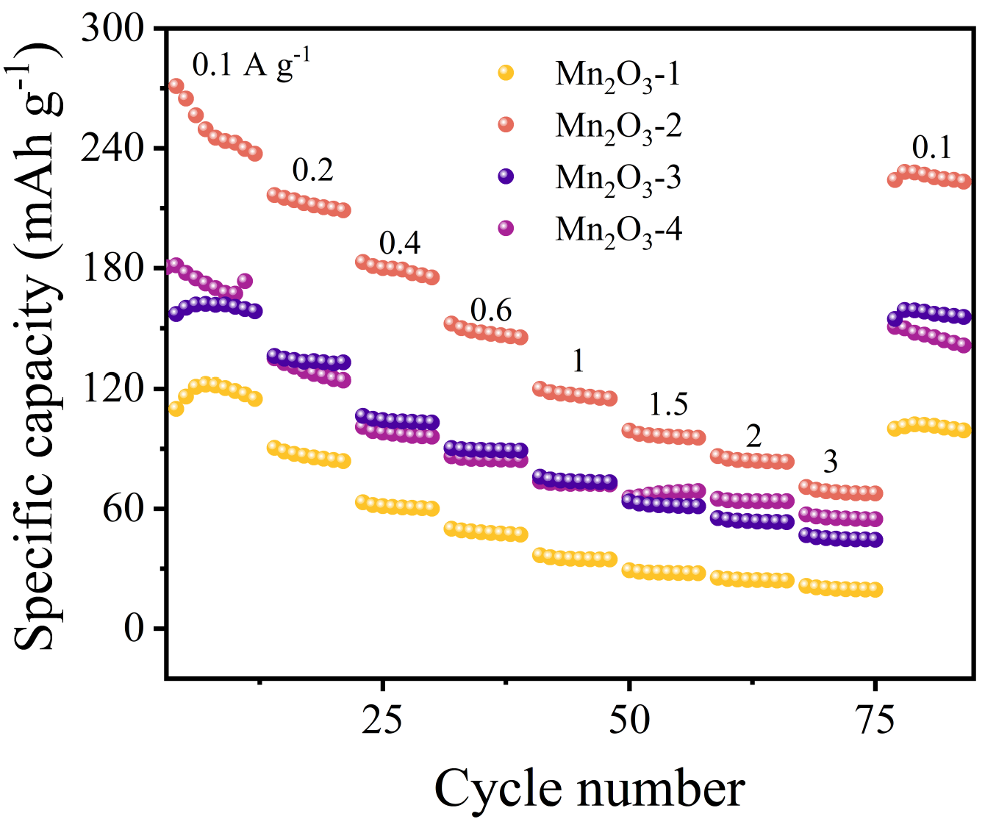
Fig. S2. Rate performance of Mn₂O₃ with different calcination temperatures at different current densities.
Following the same nomenclature as the previous samples, the Mn₂O₃ obtained via calcination at 550 °C is designated as Mn₂O₃-4, as presented in Fig. S2.
Fig. S3. (a) SEM image and (b) ex-situ XRD pattern of the Mn₂O₃-2 electrode after 1000 cycles at a current density of 3 A g⁻¹.
The strong peak at ~25° in the XRD pattern is mainly ascribed to the carbon cloth current collector and the acetylene black conductive additive.

Fig. S4. Ragone plot of the zinc-ion battery employing the Mn₂O₃-2 cathode.
As shown in Fig. S4, the battery device exhibits a high energy density at a relatively low power density of approximately 100 W kg⁻¹. As the power density increases beyond 1000 W kg⁻¹, the energy density shows a gradual decreasing trend, which is primarily due to enhanced polarization effects under high-rate charging and discharging. Notably, the decreasing slope of the energy density versus power density curve is relatively gentle. This observation is consistent with the conclusion drawn in the main text, clearly confirming that the battery can maintain considerable energy density even at elevated power densities. This result directly corroborates the practical application potential endowed to the device by the material properties optimized through the 500℃ calcination process [6-7].

Fig. S5. (a) GITT voltage profiles of Mn₂O₃ with different calcination temperatures.(b) The D_{Zn}²⁺ calculated from the GITT curves during the discharge and charge processes.

Fig. S6. Schematic diagram of the flexible quasi-solid-state zinc-ion battery based on Mn₂O₃-2

Fig. S7. Cyclic voltammetry curves of the Mn₂O₃-2 flexible electrode under different bending states

.
Fig. S8. Demonstration of the Mn₂O₃-2 flexible device illuminating an LED under bent conditions
Fig. S9. (a) Long-term cycling performance of the flexible quasi-solid-state device at 0.1 A g⁻¹ (b) GCD profiles sequentially recorded under bending angles of 0°, 90°, and 180° at 0.1 A g⁻¹.

References
- K. Jagtap, R. Barde, K. Nemade and S. Waghuley, J. Electron. Mater., 2025, 54, 1218–1227.
- Y. Jiang, M. Jia, Y. Wan, M. Guo, Z. Zhang, C. Duan and X. Zhang, J. Colloid Interface Sci., 2024, 664, 588–595.
- M. Basak, M. L. Rahman, M. F. Ahmed, B. Biswas and N. Sharmin, J. Alloys Compd., 2022, 895, 162694.
- G. Pan, Z. Wang, J. Zhang, M. Cao, L. Zhang and J. Zhang, Energy Technol., 2025, 13, 2401690.
- R. Sun, Q. Liu and W. Deng, Chin. J. Struct. Chem., 2022, 41, 2205085–2205092.

