Supporting Information

Dual-cations modulating δ-MnO₂ as a high-performance cathode material for aqueous zinc-ion batteries
Haixiang Luoª, Hui-Juan Zhang^{a,*}, Yiming Taoª, Zhu Heª, Zhengyu Liª, Yuhua Xueª
ª School of Materials and Chemistry, University of Shanghai for Science and Technology, 516 Jungong Rd, Yangpu 200093, Shanghai, China
*E-mail address: hjzhang@usst.edu.cn.

1. Material characterizations
To analyze the crystal structure, X-ray diffraction (XRD) was conducted on a Bruker X-ray diffractometer (D8 Advance) at a range of 10°-80° with a scan rate of 5° per minute. Scanning electron microscopy (SEM) images were analyzed on ZEISS GeminiSEM 300. Transmission electron microscopy (TEM), high resolution transmission electron microscope (HR-TEM), high angle angular dark field-scanning transmission electron microscopy (HAADF-STEM) and its elemental mapping images were conducted on board FEI Talos F200X. X-ray photoelectron spectroscopy (XPS) measurements were performed on a Thermo Scientific K-Alpha.
2. Electrochemical measurements
Electrochemical performance was evaluated by assembling CR2032 coin cells. The cathode materials, acetylene black (ACET), and polyvinylidene fluoride (PVDF) were mixed in a ratio of 8:1:1 and dissolved in N-methyl-2-pyrrolidone (NMP) to prepare a slurry. The slurry was then coated onto stainless steel foil and dried under vacuum at 80°C for 8 hours. Zinc foil, glass fiber membrane (GF/A, Whatman), and a 2.0 M ZnSO₄ aqueous solution with 0.2 M MnSO₄ were used as the anode, separator, and electrolyte, respectively. Galvanostatic charge-discharge (GCD) tests were conducted at various current densities within a voltage range of 0.8-1.8 V using a NEWARE battery testing system. Cyclic voltammetry (CV) and electrochemical impedance spectroscopy (EIS) were measured using a CHI 660E electrochemical workstation. The CV curves were recorded at different scan rates between 0.8 and 1.8 V. The frequency range for EIS testing was 0.01-10⁶ Hz with an amplitude of 5 mV.

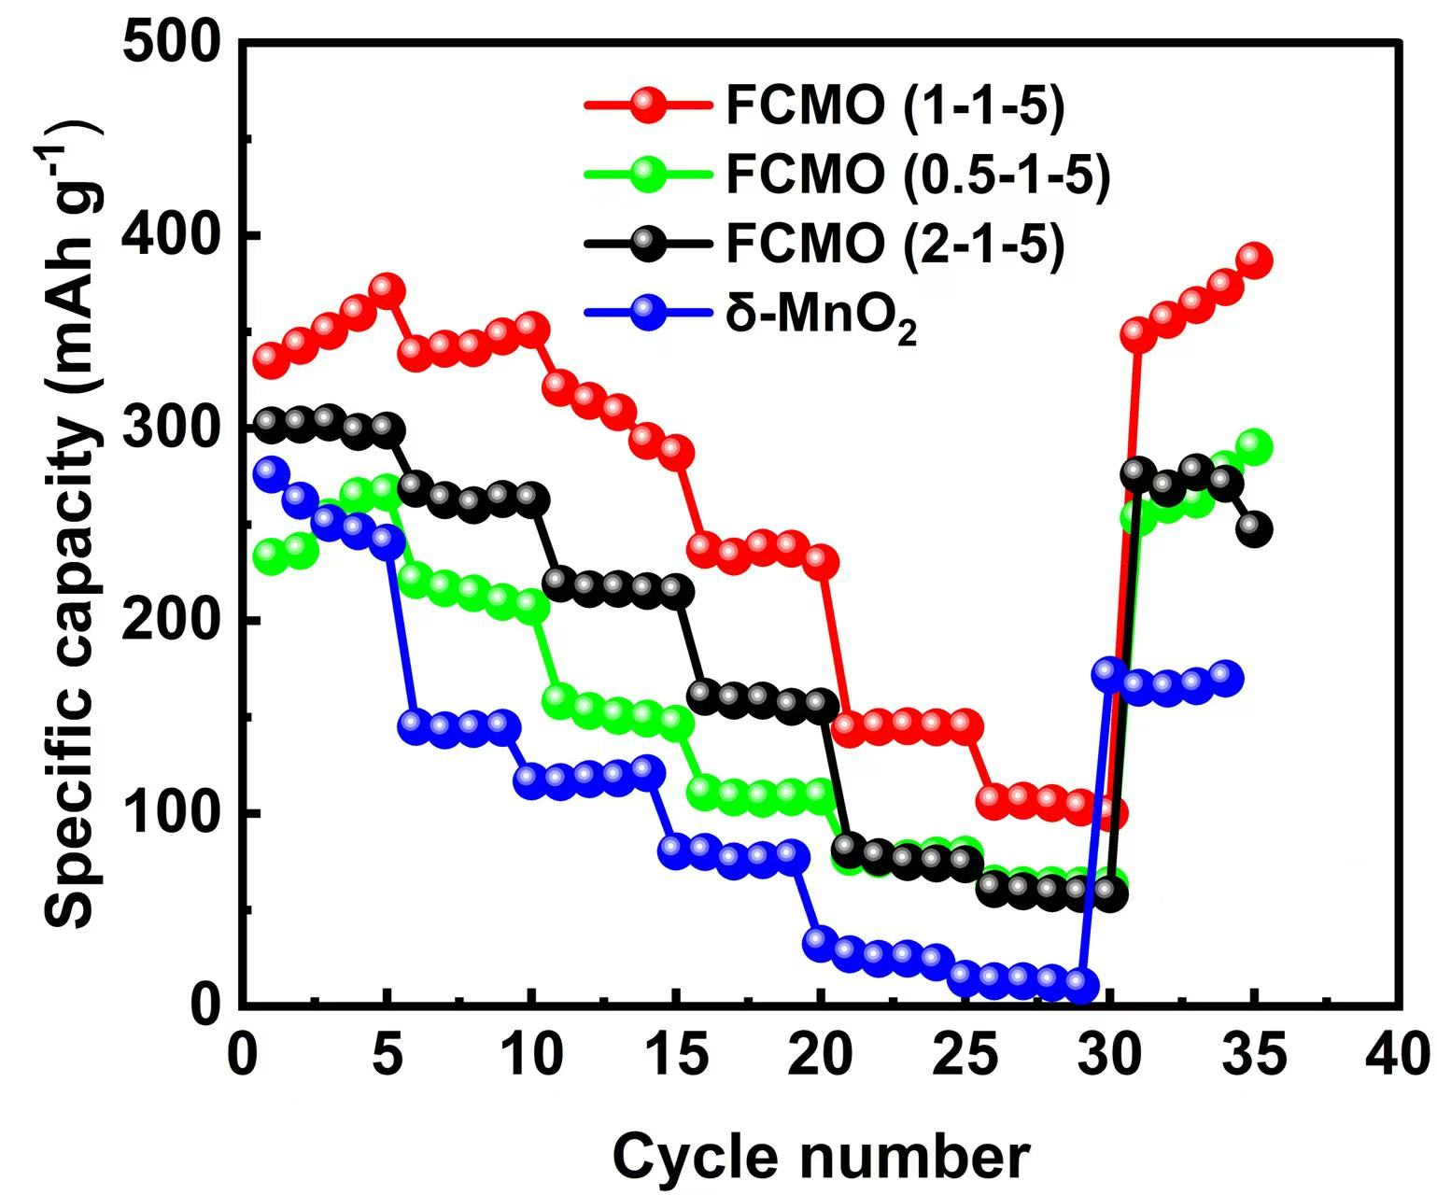
Fig. S1 Rate preformances of FCMO with different Fe dopings.

Fig. S2 Rate preformances of FCMO with different Co dopings.

Table S1. Comparison of electrochemical properties of FCMO with other reported Mn-based cathode materials.
Cathode | Capacity/(mAh·g⁻¹) | Retention/cycles/rate | References
FCMO | 371.1 (0.1 A g⁻¹) | 94.7%/1000/1 A g⁻¹ | This work
Cr-MnO₂ | 229.2 (0.1 A g⁻¹) | 86%/300/0.1 A g⁻¹ | [1]
α-MnO₂@ZIF-67 | 313.4 (0.1 A g⁻¹) | 65%/1500/1 A g⁻¹ | [2]
W-MnO₂ | 240.6 (0.1 A g⁻¹) | 79.8%/1000/1 A g⁻¹ | [3]
ε-MnO₂/CPAN | 288.6 (0.2 A g⁻¹) | 90%/1000/1 A g⁻¹ | [4]
MnO₂@CODs | 160 (0.1 A g⁻¹) | 95.4%/500/1 A g⁻¹ | [5]
Al_{x}-MnO₂ | 327.9 (0.2 A g⁻¹) | 87%/1000/1 A g⁻¹ | [6]
CN_{x}/MnO₂ | 249 (0.1 A g⁻¹) | 77%/500/1 A g⁻¹ | [7]
MgMn₂O₄ | 269 (0.1 A g⁻¹) | 80%/500/0.5 A g⁻¹ | [8]
F-MO | 288 (0.1 A g⁻¹) | 96%/200/0.5 A g⁻¹ | [9]
Ag_{0.4}Mn₈O₁₆ | 227 (0.1 A g⁻¹) | 50%/800/1 A g⁻¹ | [10]
NS-MnO₂ | 295 (0.2 A g⁻¹) | / | [11]
NCMO | 313.4 (0.1 A g⁻¹) | 97.4%/700/1 A g⁻¹ | [12]
Se, P-MnO₂ | 366.6 (0.1 A g⁻¹) | / | [13]
Mo, P-MnO₂ | 367.6 (0.1 A g⁻¹) | / | [14]
Na_{0.08}MnO₂·0.57H₂O | 368 (0.1 A g⁻¹) | 83.7%/500/0.5 A g⁻¹ | [15]
WKMO | 315(0.2 A g⁻¹) | / | [16]

Fig. S3 CV curves of δ-MnO₂ at various current densities.

Fig. S4 Logarithmic plots of peak current (log i) versus scan rate (log v).

Fig. S5 Various contribution ratios of capacitance at different scanning rates in δ-MnO₂.

Table S2. The fitting results of Nyquist plots for δ-MnO₂ and FCMO.
 | δ-MnO₂ | FCMO
R1/ohm | 6.958 | 3.422
R2/ohm | 38.86 | 24.09
R3/ohm | 201.7 | 85.87

References
[1] X. Ding, Y. Wen, C. Qing, Y. Wei, P. Wang, J. Liu, Z. Peng, Y. Song, H. Chen, Q. Rong, Cr-induced enhancement of structural stability in δ-MnO₂ for aqueous Zn-ion batteries, Journal of Alloys and Compounds 986 (2024) 174041-174049.
[2] M. Bai, S. Li, C. Zhang, Y. Liu, Z. Wen, J. Sun, Novel composite cathode material α-MnO₂@ZIF-67 for high performance aqueous rechargeable Zn-ion battery, Journal of Electroanalytical Chemistry 957 (2024) 118104-118113.
[3] Y. Gan, P. Shi, J. Pan, Y. Yang, J. Yao, L. Lv, H. Wan, H. Wang, High valence tungsten driven high stability phase and conductivity γ-MnO₂ cathodes for durable aqueous zinc ion batteries, Journal of Energy Storage 127 (2025) 117176-117184.
[4] W. Fu, Y. Hou, L. Zhang, T. Ma, G. Duan, S. Yang, 3D ε-MnO₂/electrospun carbon fiber cathodes for aqueous zinc-ion batteries, New Journal of Chemistry 49 (2025) 11254-11260.
[5] F. Zhang, H. Pan, L. Shuai, Y. Zheng, X. Huang, T. Wang, J. Yu, D. Wu, J. Dou, X. Chen, Coal-derived carbon quantum dots modified MnO₂ nanowires as cathode for enhanced aqueous zinc-ion battery, Diamond and Related Materials 157 (2025) 112565-112574.
[6] Y. Zhao, S. Zhang, Y. Zhang, J. Liang, L. Ren, H.J. Fan, W. Liu, X. Sun, Vacancy-rich Al-doped MnO₂ cathodes break the trade-off between kinetics and stability for high-performance aqueous Zn-ion batteries, Energy & Environmental Science 17 (2024) 1279-1290.
[7] Z. Ni, L. Zhao, H. Zhao, C. Jin, B. Ge, W. Li, In-situ growth of MnO₂ nanorods on CN generates a heterostructure with the stability for zinc ion battery, Journal of Alloys and Compounds 967 (2023) 171834-171841.
[8] V. Soundharrajan, B. Sambandam, S. Kim, V. Mathew, J. Jo, S. Kim, J. Lee, S. Islam, K. Kim, Y.-K. Sun, J. Kim, Aqueous Magnesium Zinc Hybrid Battery: An Advanced High-Voltage and High-Energy MgMn₂O₄ Cathode, ACS Energy Letters 3 (2018) 1998-2004.
[9] D. Wang, Z. Liu, X.-W. Gao, Q. Gu, L. Zhao, W.-B. Luo, Massive anionic fluorine substitution two-dimensional δ-MnO₂ nanosheets for high-performance aqueous zinc-ion battery, Journal of Energy Storage 72 (2023) 108740-108746.
[10] F.W. Fenta, B.W. Olbasa, M.-C. Tsai, N.T. Temesgen, W.-H. Huang, T.M. Tekaligne, Y. Nikodimos, S.-h. Wu, W.-N. Su, H. Dai, B.J. Hwang, Structural engineering of α-MnO₂ cathode by Ag⁺ incorporation for high capacity aqueous zinc-ion batteries, Journal of Power Sources 548 (2022) 232010-232018.
[11] J. Liang, Y. Zhao, L. Ren, M. Li, Q. Zhang, Y. Wang, X. Sun, M. Chuai, X. Wang, W. Liu, Dual Anions Doping Enhanced Conductivity and Stability of Layered δ‐MnO₂ Cathode for Aqueous Zinc-Ion Battery, Advanced Functional Materials 35 (2025) 1-10.
[12] J. Zeng, Z. Zhang, Y. Chen, G. Peng, M. Zhao, Y. Zhou, K. Bai, H. He, Boosting the synergistic activaion of δ-MnO₂ as cathode for aqueous zinc-ion batteries through Ni, Co co-doping, Journal of Electroanalytical Chemistry 973 (2024) 118682-118692.
[13] K. Ma, S. Ge, R. Fu, C. Feng, H. Zhao, X. Shen, G. Liang, Y. Zhao, Q. Jiao, Uncovering Se, P co-doping effect in MnO₂ toward high-performance aqueous zinc-ion batteries, Chemical Engineering Journal 484 (2024) 149525-149534.
[14] K. Ma, G. Liang, Q. Jiao, H. Jin, Y. Su, N. Li, J. Li, Z. Xiong, C. Feng, Y. Zhao, Unlocking Mo, P co-doping to boost proton intercalation in MnO₂ as a high-performance cathode material for aqueous zinc-ion batteries, Journal of Materials Chemistry C 13 (2025) 4727-4736.
[15] G. Liu, Z. Ye, Z. Jiang, P. Zhou, Z. Li, Q. Luo, W. Li, Z. Huang, L. Liu, Sodium-Ion/Crystal Water Cointercalated δ-MnO₂ with Improved Performance for Aqueous Zinc-Ion Batteries, ACS Applied Energy Materials 7 (2024) 9746-9755.
[16] G. Miao, Z. Wang, F. Sun, Y. Liu, F. Lin, Y. Fang, X. Yang, P. Li, X. Qu, Modulating the interlayer H⁺ migration in MnO₂ via W and K co-doping engineering to high-capacity aqueous zinc-ion batteries, Journal of Colloid and Interface Science 693 (2025) 137636-137644.

