Dublin City University
School of Computing
Year 4 Project
SecureYAC

Technical Manual

Student: | Eryk Zygmunt Styczynski 21753851
Student: | Liucija Paulina Adomaviciute 21790411
Supervisor: | Geoff Hamilton
Date of Completion: | XX/04/2025

SecureYAC is a messaging application with a focus on encryption and security. The goal of the project is to provide a cryptographically secure communications channel that does not depend on third-parties. It establishes a direct connection between users using a custom peer-to-peer networking protocol based on Tox. The identity creation, verification, and authentication is handled by a key agreement protocol based on the Signal’s X3DH specification. Messages between users are encrypted using Signal’s Double Ratchet algorithm.

Table of Contents
1. Motivation 3
2. Research 3
2.1 Encryption and Cryptographic Protocols 3
2.2 Curve25519, Ed25519, and X25519 4
2.3 XEdDSA 5
2.4 X3DH 8
2.5 Double Ratchet 11
3. Design 13
3.1 Class Structure and Interactions 13
3.2 Cryptography 13
3.3 Network Protocol 13
3.4 User Interface 13
4. Implementation 13
4.1 X25519 13
4.2 X3DH 13
4.3 XEdDSA 13
4.4 Double Ratchet 13
4.5 Integration of Cryptographic Protocols 13
5. Sample Code 13
6. Problems Solved 13
7. Results 13
8. Future Work 13
References 14

Motivation
Due to data breaches becoming increasingly common and rising privacy concerns, there has been a significant interest in ways to protect personal data. Most everyday communication happens over the Internet, and we wish to explore ways to protect our communication channels. End-to-end encryption technology provides a solution. Our project aims to investigate the design and implementation of network and cryptographic protocols to understand their mechanisms of action and potential risks.
We are aware that due to security concerns, the standard and recommended practice is to use cryptographic libraries developed by professional cryptographers. By implementing the cryptographic protocols ourselves from the ground up, using native tools provided by our chosen programming language, we aim to gain a better understanding of how elliptic curve and public key cryptography work and to explore lesser-known and uncommon cryptographic protocols that do not have widely used standard libraries. Due to the lack of experience in the field of cryptography, we do not guarantee cryptographic security or the correctness of our application.
[Add bit about UI and peer-to-peer network protocols.]

Research

Encryption and Cryptographic Protocols
Algorithms used for identity generation and verification and message encryption are the focus of our application. While multiple cryptographic protocols were considered, we decided to use Signal’s X3DH[2] and Double Ratchet[3] protocol specifications as the basis for our application’s cryptography.
The X3DH key protocol requires Signal’s signature scheme XEdDSA[4]. Double Ratchet specification includes integration of the X3DH key agreement protocol. Together, they cover identity generation, verification, and message encryption.
These protocols have been chosen for their non-standard expansion and implementation of more commonly used cryptographic protocols (Diffie-Hellman key exchange algorithm and EdDSA digital signature scheme). Currently, no programming language offers native implementation of these protocols, and the only available open-source implementation written in Java and Kotlin is developed and maintained by Signal.
While the specifications of these algorithms were designed and described by professional cryptographers, due to lack of experience in cryptography, our implementation does not guarantee correctness or security.
Notation
A || B denotes a concatenation of byte arrays A and B.

Curve25519, Ed25519, and X25519
Curve25519
An elliptic curve is a smooth, projective, algebraic curve of genus one, on which there is a specified point O[5]. These curves have been successfully applied in elliptic curve cryptography (ECC) to provide robust security with smaller keys. ECC fundamentally relies on the Elliptic Curve Discrete Logarithm Problem (ECDLP)[6], where determining the scalar k from points P and kP on the curve is computationally challenging.
Curve25519 is an elliptic curve, where E is the curve equation , and p is the prime number [7] used to define the finite field 𝔽p.
Curve25519 offers a 128-bit security level, and has the following properties:
Name | Definition
Montgomery curve equation
A | 486662
Prime number defining the prime field 𝔽p (p)
Order of the prime-order subgroup | 2²⁵² + 0x14def9dea2f79cd65812631a5cf5d3ed
Cofactor | 8
u-coordinate of base point P on a Montgomery curve (U(P)) | 9
v-coordinate of base point P on a Montgomery curve (V(P)) | 0x20ae19a1b8a086b4e01edd2c7748d14c923d4d7e6d7c61b229e9c5a27eced3d9

The shape of this curve and the use of compressed elliptic points (only x-coordinate) allow for fast point calculations[7].
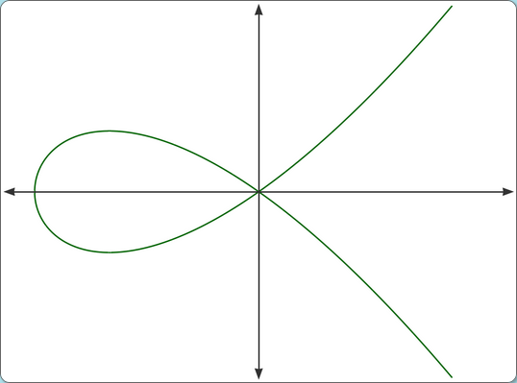Figure 1: Curve25519 in real numbers [1]
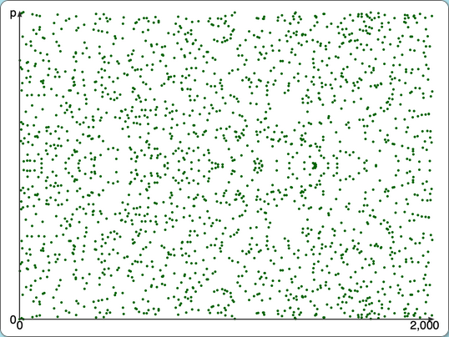Figure 2: Curve25519 calculated in 𝔽p[1]
Ed25519
Curve25519 is birationally equivalent to a twisted Edwards curve, called Edwards25519[8]. This curve is used in EdDSA and XEdDSA signature schemes for fast creation and verification of signatures.
Ed25519 is EdDSA created using Edwards25519 elliptic curve and has the following parameters[8], [9], [10]:
Name | Definition
b | 256
Hash (H) | SHA-512
Prime number defining the prime field 𝔽p (q)

X25519
X25519 is a function that performs scalar multiplication on Montgomery form Curve25519 elliptic curve for key generation. It takes a scalar (an array of randomly generated bytes) and a u-coordinate as inputs and produces a u-coordinate as an output. Using this function, each user generates 32-byte long keys. These keys are subsequently used in elliptic curve Diffie-Hellman (ECDH) calculations in the X3DH key agreement protocol. The values of these keys are congruent to the value modulo p and are stored in little-endian order.
To encode the output as X25519 key, the following bit clamping operation is performed: the three least significant bits of the first byte and the most significant bit of the last byte are set to 0, and the second most significant bit of the last byte is set to 1. This results in an integer of the form 2²⁵⁴ plus eight times a value between 0 and (inclusive)[11].
The implementation of this function is designed to be fast and constant-time but does not guarantee protection from side-channel attacks[11].

XEdDSA
XEdDSA Elliptic Curves
XEdDSA is a signature scheme used to create EdDSA-compatible signatures using X25519 or X448 elliptic curve Diffie-Hellman functions[4]. XEdDSA allows the reuse of the same key pair for both ECDH calculations and signatures.
XEdDSA uses the following elliptic curve parameters[4]:
Name | Definition
B | Base point
I | Identity point
u | Curve25519 Montgomery public key u-coordinate
P | Edwards curve twisted point
p | Field prime
| p |
q | Order of base point (prime; q < p; qB = I)
| q |

Curve Conversion
The keys generated using X25519 are calculated using the Montgomery ladder and each user’s key is a Montgomery u-coordinate. EdDSA (and XEdDSA) are defined on a twisted Edwards curve, where the key (twisted Edwards point P) consists of a twisted Edwards y-coordinate along with a sign bit (0 or 1). Point P from the Montgomery u-coordinate can be calculated with [11]. Since Montgomery keys do not store the v-coordinate, it is impossible to determine the twisted Edwards sign bit. Instead, the sign bit is forced to 0[4].
Conversion of Montgomery private key k to Edwards private and public keys A, a is done by multiplying k by the twisted Edwards base point B, forcing the sign bit of A to 0 and adjusting a if necessary to produce a sign bit of 0. The following pseudocode for elliptic curve conversion is given in the XEdDSA specification[4]:
calculate_key_pair(k):
E = kB
A.y = E.y
A.s = 0
if E.s == 1:
a = -k (mod q)
else:
a = k (mod q)
return A, a

Hash Functions
XEdDSA uses a cryptographic hash function. The default hash function is SHA-512. hash is a function that applies cryptographic hash to an input byte sequence and returns a hashed byte sequence. To provide cryptographic domain separation, given curve constants p and b, a family of hash functions, indexed by non-negative integers i, such that 2|p| - 1 - i > p, is defined[4]:
hashi(X):
return hash(2b - 1 - i || X)
hash₁ changes the first byte of input data to 0xFE.

The Algorithm
All calculations in the algorithm are done modulo q. The XEdDSA signing and verification functions take the following inputs[4]:
Signing |  | Verifying
Name | Definition | Name | Definition
k | Montgomery private key | u | Montgomery public key
M | Message to sign (byte array) | M | Message to verify (byte array)
Z | 64 bytes of secure random data | R || s | Signature to verify

Signing
To sign a message M using Montgomery key k, first, k has to be converted to Ed25519 keys using calculate_key_pair(k) method defined above. First, a nonce r is calculated by applying hash₁ to a concatenation a || M || Z. A point R on twisted Edwards curve is calculated by multiplying r by the base point B. A hash h is made by applying hash (SHA-512) function to concatenation R || A || M and the signature is calculated by adding hash h multiplied by private key a to the nonce r.
The Signal’s documentation provides the following pseudocode for XEdDSA signing function[4]:
xeddsa_sign(k, M, Z):
A, a = calculate_key_pair(k)
r = hash1(a || M || Z) (mod q)
R = rB
h = hash(R || A || M) (mod q)
s = r + ha (mod q)
return R || s

Verification
To verify a signature, the algorithm performs a series of checks to determine the validity of values. If any of these checks fail, the function returns false.
First, the verification function checks if the inputs (Montgomery public key u, Edwards point R and the signature) are valid values. If they are, the Montgomery public key is converted to the Edwards public key (point on a twisted Edwards curve), and the function confirms that such a point exists on the curve.
If all validity checks succeed, a hash function is applied to the byte concatenation of R || A || M modulo q. A verification calculation is done by subtracting hash h multiplied by Edwards public key A from signature s multiplied by Edwards elliptic curve base point B. If the resulting value R_{check} equals the Edwards point R appended to the signature, the signature is valid[4].
The following proof breaks down the verification function mathematically:
Theorem: R_{check} = R.
Let:
pK = Edwards form private key.
epK = Edwards form ephemeral key used in XEdDSA signature.
random = 64 bytes of secure randomly generated data.
B = Ed25519 base point.
q = Ed25519 order.
PK = pK * B (mod q)
R = hash₁(pK, epK) * B (mod q)
hash = hash(R, PK, epK)
Sig = hash₁(pK, epK, random) + hash(R, PK, epK) * pK (mod q)
Proof:

Therefore, R_{check} = R.

Signal provides the following pseudocode[4]:
xeddsa_verify(u, M, (R || s)):
if u >= p or R.y >= 2|p| or s >= 2|q|:
return false
A = convert_mont(u)
if not on_curve(A):
return false
h = hash(R || A || M) (mod q)
Rcheck = sB - hA
if bytes_equal(R, Rcheck):
return true
return false

X3DH
Protocol Parameters
Extended Triple Diffie-Hellman (X3DH) is a key agreement protocol that establishes a shared secret key between two parties who mutually authenticate each other based on public keys. The protocol uses three parameters:
- curve (X25519 or X448),
- hash (SHA-256 or SHA-512),
- info (ASCII string).
In Signal’s specification, three roles are defined: Alice, Bob and a server. Alice and Bob are users who want to exchange data and establish connections, and the server stores the key bundles of the users[2]. Due to our application’s server-less nature, the server role is omitted from our implementation, and the following description of the protocol will reflect this change.
X3DH uses the following elliptic curve public keys for calculations[2]:
Name | Definition
IK_{A} | Alice’s identity key
EK_{A} | Alice’s ephemeral key
IK_{B} | Bob’s identity key
SPK_{B} | Bob’s signed prekey
OPK_{B} | Bob’s one-time prekey

It is assumed that each public key has a corresponding private key. The protocol requires the following functions[2]:
- Encode(PK) – encoding function to encode an X25519 or X448 public key PK into a byte array;
- DH(PK1, PK2) – an Elliptic Curve Diffie-Hellman calculation function that returns a shared secret value from calculations involving public keys PK1 and PK2, whose form depends on the curve parameter;
- Sig(PK, M) – XEdDSA[4] signature on the byte sequence M that is verified with a public key PK and was created by signing M with PK’s corresponding private key;
- KDF(KM) – 32-byte output from HKDF algorithm[2].

The Protocol
Each user has a long-term identity key (IK_{A/B}). During the protocol run, Alice generates an ephemeral key pair (EK_{A}). Bob has a signed prekey pair and a set of one-time prekey pairs that are exported into a key bundle and exchanged with Alice before the beginning of the protocol. After the calculations, Alice and Bob share a 32-byte secret key (SK), which is used as an initial value in the Double Ratchet protocol[2].
X3DH has three phases:
- Bob exports a key bundle (IK_{B}, SPK_{B}, Sig(IK_{B}, Encode(SPK_{B})), OPK_{B}) and exchanges it with Alice through a trusted communications channel.
- Alice imports a key bundle and uses it to send an initial message to Bob.
- Bob receives and processes Alice’s initial message.

Sending Initial Message
When Alice imports a key bundle, she verifies the prekey signature. If the verification fails, Alice aborts the protocol. Otherwise, Alice generates a pair of ephemeral keys EK_{A} and performs the following calculations using the public keys[2]:
DH1 = DH(IK_{A}, SPK_{B})
DH2 = DH(EK_{A}, IK_{B})
DH3 = DH(EK_{A}, SPK_{B})
DH4 = DH(EK_{A}, OPK_{B})
SK = KDF(DH1 || DH2 || DH3 || DH4)
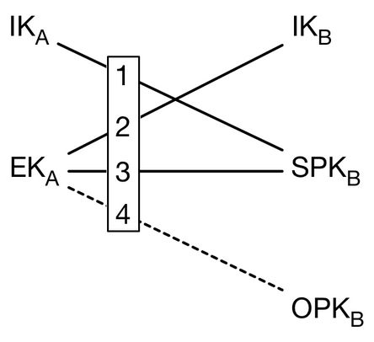Figure 3: Alice's Diffie-Hellman calculations[2]
After performing these calculations, Alice deletes her ephemeral keys and intermediate Diffie-Hellman values. Then she calculates additional data AD, that contains identity information of both users:
AD = Encode(IK_{A}) || Encode(IK_{B}).
The initial message contains:
- Alice’s identity public key IK_{A},
- Alice’s ephemeral public key EK_{A},
- Bob’s OPK_{B},
- Initial ciphertext encrypted using post-X3DH encryption protocol.

Receiving Initial Message
Bob, after extracting keys and ciphertext from the message, performs the following calculations:
DH1 = DH(IK_{B}, EK_{A})
DH2 = DH(SPK_{B}, IK_{A})
DH3 = DH(SPK_{B ,} EK_{A})
DH4 = DH(OPK_{B ,} EK_{A})
SK = KDF(DH2 || DH1 || DH3 || DH4)
Now, Bob and Alice have the same secret key and post-X3DH protocol can be initialised for message encryption and decryption.

Double Ratchet
The Double Ratchet algorithm is used to exchange encrypted messages between two users. The users agree on a shared secret key using the key agreement protocol. In our implementation, the key agreement protocol used in X3DH. For each new message, new keys are derived, and the results of the Diffie-Hellman calculations are mixed into the key generation process. These steps prevent previous keys from being calculated from the prior ones and give the users some protection in the case of key compromisation[3].
Each user keeps track of the following variables for the Double Ratchet algorithm[3]:
Name | Definition
DHs | Diffie-Hellman ratchet “sending” key pair
DHr | Diffie-Hellman ratchet “receiving” key pair
RK | 32-byte root key
CKr | 32-byte “receiving” chain keys
CKs | 32-byte “sending” chain keys
Ns | Message number for sending
Nr | Message number for receiving
PN | Number of messages in the previous sending chain
MKSKIPPED | Skipped-over message keys, indexed by ratchet public key and message number
MAX_SKIP | Maximum number of messages that can be skipped in a single chain
The algorithm requires the following functions[3]:
- GENERATE_DH(): generates a new Diffie-Hellman key pair;
- DH(dh_priv, dh_pub): return the result of Diffie-Hellman calculations using private key dh_priv and dh_pub;
- KDF_RK(rk, dh_out): return a 32-byte root key and 32-byte chain key as a result of applying KDF keyed by a rk to Diffiel-Hellman output dh_out;
- KDF_CK(ck): return a 32-byte chain key and 32-byte message key as a result of applying KDF keyed by a ck to some constant;
- ENCRYPT(mk, plaintext, associated_data): return AEAD encryption of plaintext using message key mk. associated_data is authenticated, but not included in the ciphertext;
- DECRYPT(mk, ciphertext, associated_data): return AEAD decryption of ciphertext using message key mk;
- HEADER(dh_pub, pn, n): generate a new message header, containing DH ratchet public key dh_pub, previous chain length pn and the message number n.
Key Derivation Function Chains
Key Derivation Function (KDF) chain is a core concept in the Double Ratchet algorithm.
KDF is defined as a cryptographic function that takes a key and some input data and return output data that is indistinguishable from random.
KDF chain is when the output from some KDF function is used to replace the input KDF key[3].
A KDF chain has the following properties[3]:
- Resilience: the output keys appear random without knowing the input KDF keys.
- Forward security: previous output keys appear random even if a KDF key is known.
- Break-in recovery: future output keys appear random even if a previous KDF key is known.
In Double Ratchet session, KDF keys are used for three chains: root chain, sending chain and receiving chain. //As users exchange message, they also exchange Diffie-Hellman values.
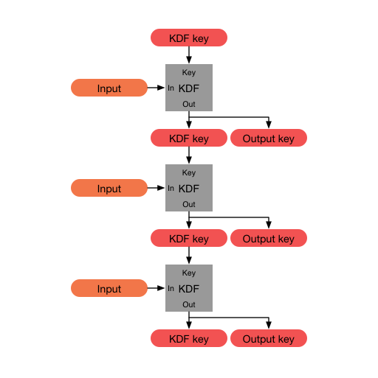Figure 4: KDF chain[3]
Symmetric-Key Ratchet
Symmetric-key ratchet is a step, where KDF chain is used with a constant input to produce a chain and a message key. The chain key is used as an input for the next symmetric-key ratchet step, while the message key is used for encryption. Because the input to the KDF chain is constant, symmetric-key ratchet does not provide break-in recovery.
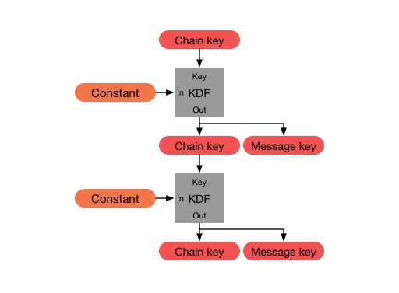Figure 5: Two steps of the symmetric-key ratchet[3]
Diffie-Hellman Ratchet
Diffie-Hellman (DH) ratchet updates the chain keys based on DH outputs.
Each party first generates a pair of keys, which become their ratchet key pair. The current public ratchet key is included in the message header. When a new public ratchet key is received, a DH value is calculated and a DH ratchet step is performed to replace the ratchet keys.

Design

Class Structure and Interactions

Cryptography

Network Protocol

User Interface

Implementation

X25519

X3DH

XEdDSA

Double Ratchet

Integration of Cryptographic Protocols

Sample Code

Problems Solved

Results

Future Work

References
[1] M. Driscoll, ‘Hands-on: X25519 Key Exchange’. Accessed: Apr. 08, 2025. [Online]. Available: https://x25519.xargs.org/
[2] M. Marlinspike, ‘The X3DH Key Agreement Protocol’. Signal, Nov. 04, 2016. Accessed: Mar. 25, 2025. [Online]. Available: https://signal.org/docs/specifications/x3dh/
[3] M. Marlinspike, ‘The Double Ratchet Algorithm’. Signal, Nov. 20, 2016. Accessed: Mar. 25, 2025. [Online]. Available: https://signal.org/docs/specifications/doubleratchet/
[4] T. Perrin, ‘The XEdDSA and VXEdDSA Signature Schemes’. Signal, Oct. 20, 2016. Accessed: Apr. 03, 2025. [Online]. Available: https://signal.org/docs/specifications/xeddsa/
[5] ‘Elliptic curve’, Wikipedia. Mar. 17, 2025. Accessed: Apr. 08, 2025. [Online]. Available: https://en.wikipedia.org/wiki/Elliptic_curve
[6] H. C. A. van Tilborg and S. Jajodia, Eds., Encyclopedia of cryptography and security, 2nd ed. in Springer reference. New York: Springer, 2011.
[7] D. J. Bernstein, ‘Curve25519: New Diffie-Hellman Speed Records’, in Public Key Cryptography - PKC 2006, vol. 3958, M. Yung, Y. Dodis, A. Kiayias, and T. Malkin, Eds., in Lecture Notes in Computer Science, vol. 3958. , Berlin, Heidelberg: Springer Berlin Heidelberg, 2006, pp. 207–228. doi: 10.1007/11745853_14.
[8] D. J. Bernstein, N. Duif, T. Lange, P. Schwabe, and B.-Y. Yang, ‘High-speed high-security signatures’, J. Cryptogr. Eng., vol. 2, no. 2, pp. 77–89, Sep. 2012, doi: 10.1007/s13389-012-0027-1.
[9] D. J. Bernstein, S. Josefsson, T. Lange, P. Schwabe, and B.-Y. Yang, ‘EdDSA for more curves’. Cryptology {ePrint} Archive, Jul. 05, 2015. Accessed: Apr. 13, 2025. [Online]. Available: https://eprint.iacr.org/2015/677.pdf
[10] J. Brendel, C. Cremers, D. Jackson, and M. Zhao, ‘The Provable Security of Ed25519: Theory and Practice’, in 2021 IEEE Symposium on Security and Privacy (SP), San Francisco, CA, USA: IEEE, May 2021, pp. 1659–1676. doi: 10.1109/SP40001.2021.00042.
[11] A. Langley, M. Hamburg, and S. Turner, Elliptic Curves for Security, Jan. 2016. Accessed: Apr. 08, 2025. [Online]. Available: https://www.rfc-editor.org/rfc/rfc7748

