
SecureYAC
User Manual

Eryk Zygmunt Styczynski (21753851), Liucija Paulina Adomaviciute (21790411)

Supervisor: Geoff Hamilton

SecureYAC is a messaging application with a focus on encryption and security. The goal of the project is to provide a cryptographically secure communications channel that does not depend on third-parties. It establishes a direct connection between users using a custom peer-to-peer networking protocol based on Tox. The identity creation, verification, and authentication is handled by a key agreement protocol based on the Signal’s X3DH specification. Messages between users are encrypted using Signal’s Double Ratchet algorithm.

Dublin City University
School of Computing
May 2025
Table of Contents
1. Installation 3
2. User Guide 3

Installation
Download the SecureYAC release folder from
https://drive.google.com/drive/folders/1LwEiIDlBUTSa8cSkw28geuJ_9MK5wB2Y?usp=sharing
It includes everything you need to run our application on a modern Windows machine, ranging from all the necessary libraries to Java itself. Once downloaded, navigate to SecureYAC\runtime\bin and run the program using SecureYAC.bat. Within a few seconds you should see the login screen described in the next section.

User Guide
Upon successfully running the application, you will be met with a login screen which should look like this:
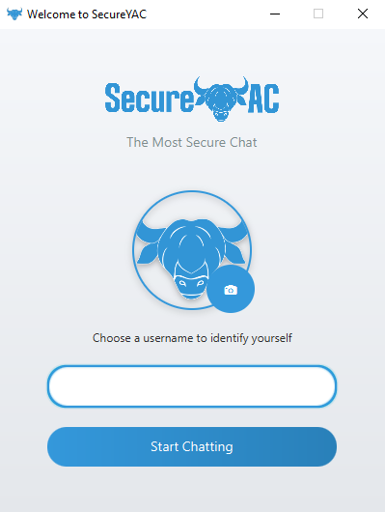
Following the on-screen instructions, you may proceed by entering your username and clicking on the “Start Chatting” button below. Note that you will not be allowed to proceed unless you input something in the username field. You also have the opportunity to change your profile picture by clicking on the Camera icon. Otherwise, you will continue with the default profile picture.
After proceeding to the next screen, you will see a welcome screen, urging you to add your first contact like so:
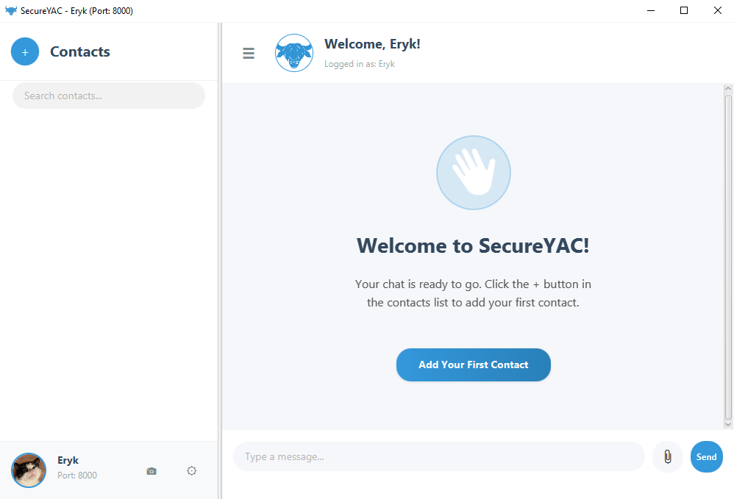
By clicking on the “Add Your First Contact” button or the “+” button in the upper right corner, you will be able to add your first friend to your contacts list.
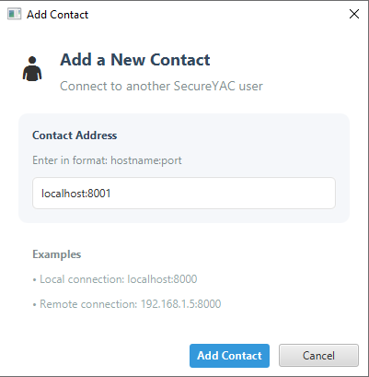

Simply input your friend’s IP address and port to add them in your app. Note that before you will be able to message each other, your friend will have to add you back, despite immediately showing in your contacts list. For you to be able to add someone, they must be online, otherwise you might see an error message:
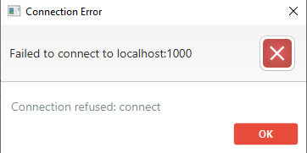
After successfully adding your friend, you will see them in your friends list. You can click on them to start chatting!
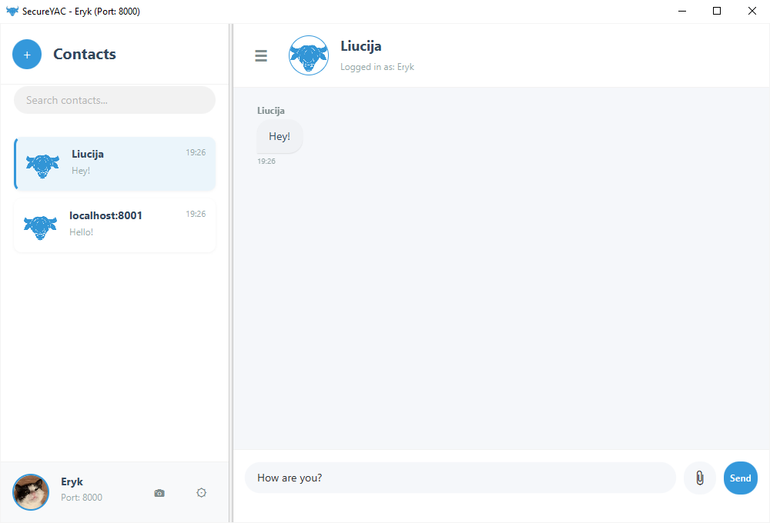
Press “Send” button or Enter on your keyboard to send a message to your selected contact.
Aside from regular messages, you have the option to send any kind of file you want up to 100MB. To do this, you need to press the paperclip button next to the chat box in the bottom right corner of your screen and then choose a file of your liking:
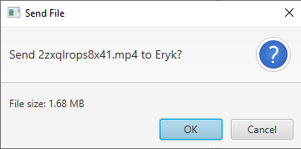
Click OK and your file will send to your connected person.
