Functional Specification
- Table of contents
1. Introduction 1
1.1 Overview 1
1.2 Glossary 1
2. General Description 1
2.1 Product / System Functions 1
2.2 User Characteristics and Objectives 1
2.2.1 User Characteristics 1
2.3 Operational Scenarios 2
2.4 Constraints 2
3. Functional Requirements 2
4. System Architecture 3
5. High-Level Design 3
6. Preliminary Schedule 3
7. Appendices 3

Introduction

Overview
The main goal of this application is secure messaging. Server-less and using Double Ratchet protocol combined with Extended Triple Diffie-Hellman key agreement protocol, this application offers secure, peer-to-peer messaging platform with clean and easy-to-use graphical user interface that does not rely on the security of third-parties, such as servers or the service provider. The goal is to not obscure the fact that the communication is happening between two users, but to secure the contents of the conversation.

Glossary
Chain keys – the Key Derivation Function keys for receiving and sending chains.

2. General Description

2.1 Product / System Functions

- Message encryption and identity verification using X3DH with The Double Ratchet Algorithm
- File compression using Huffman Coding Algorithm

2.2 User Characteristics and Objectives

2.2.1 User Characteristics
(goal, challenge, typical behaviour, interests, frustrations, objective, motivation, skill level)
This application is aimed at security and privacy-conscious users who have at least minimal computer skills. The user’s goal is to have secure and private conversations with other users without relying on servers or service provider. The typical customer will use other privacy-enhancing features such as secure browsing and limiting data sharing with third-parties, and carefully selects applications they use based on how much data they collect, share and who has access to that data. The main challenge for the user is to find reliable, trustworthy and secure open-source applications to use for daily activities such as conversations and file sharing. To achieve more privacy and security these users are willing to sacrifice some functionality and convenience.

Describes the features of the user community, including their expected expertise with software systems and the application domain. Explain the objectives and requirements for the system from the user's perspective. It may include a "wish list" of desirable characteristics, along with more feasible solutions that are in line with the business objectives.

2.3 Operational Scenarios

- Log in
- Identity verification between two actors
- Sending message between two actors
- Sending a file between two actors
- Identity verification between multiple actors
- Sending message between multiple actors
- Sending a file between multiple actors
This section should describe a set of scenarios that illustrate, from the user's perspective, what will be experienced when utilizing the system under various situations.
In the article Inquiry-Based Requirements Analysis (IEEE Software, March 1994), scenarios are defined as follows:
In the broad sense, a scenario is simply a proposed specific use of the system. More specifically, a scenario is a description of one or more end-to-end transactions involving the required system and its environment. Scenarios can be documented in different ways, depending up on the level of detail needed. The simplest form is a use case, which consists merely of a short description with a number attached. More detailed forms are called scripts.

2.4 Constraints
Lists general constraints placed upon the design team, including speed requirements, industry protocols, hardware platforms, and so forth.

3. Functional Requirements

3.x The X3DH Key Agreement Protocol
- Description
- Criticality - Essential
- Technical issues -
- Dependencies with other requirements -
- Others as appropriate
3.x The Double Ratchet Algorithm
- Description
The Double Ratchet algorithm is used by two parties to exchange encrypted messages using a shared secret key. To prevent an attacker from stealing one party’s keys and decrypting future messages, the symmetric-key ratchet is combined with Diffie-Hellman ratchet which updates the chain keys based on the Diffie-Hellman output.
The parties derive new keys that have Diffie-Hellman calculation results mixed in for every message so that the later keys cannot be calculated using the earlier ones. If the key isn’t known, the output data is indistinguishable from random. Diffie-Hellman public values are sent attached to the message.
Key Derivation Function
A Key Derivation Function is a cryptographic function that takes a secret and random KDF key and some input data and returns output data. In this application the secret KDF key is the output of the function defined in X3DH key agreement.
KDF chain
A Key Derivation Function chain is when some of the output from KDF is used as an output key and is used to replace the KDF key, which then may be used with another input.
Diffie-Hellman ratchet
As the parties exchange messages, they also exchange new Diffie-Hellman public keys and the output secrets of the Diffie-Hellman become the inputs to the root chain.
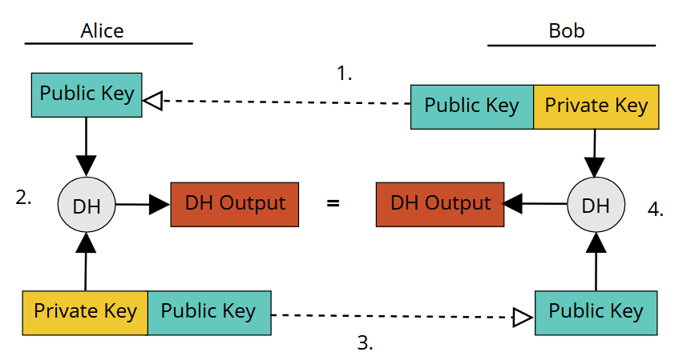

Key exchange between Alice and Bob
Every message is encrypted with a unique chain key. Calculating the next chain key and message key from a given chain key is a single ratchet step in the symmetric-key ratchet.
In a Double Ratchet session between two users, each party stores a Key Derivation Function key for three chains: a root, a sending and a receiving chain. One party’s sending chain matches other’s receiving chain.
–
- Criticality - Essential
- Technical issues -
- Dependencies with other requirements – Depends on output generated by X3DH.

This section lists the functional requirements in ranked order. Functional requirements describes the possible effects of a software system, in other words, what the system must accomplish. Other kinds of requirements (such as interface requirements, performance requirements, or reliability requirements) describe how the system accomplishes its functional requirements.

As an example, each functional requirement could be specified in a format similar to the following:
- Description - A full description of the requirement.
- Criticality - Describes how essential this requirement is to the overall system.
- Technical issues - Describes any design or implementation issues involved in satisfying this requirement.
- Dependencies with other requirements - Describes interactions with other requirements.
- Others as appropriate

4. System Architecture
This section describes a high-level overview of the anticipated system architecture showing the distribution functions across (potential) system modules. Architectural components that are reused or 3rd party should be highlighted.

5. High-Level Design
This section should set out the high-level design of the system. It should include one or more system models showing the relationship between system components and the systems and its environment. These might be object-models, DFD, etc.

6. Preliminary Schedule
//TODO: GANTT
This section provides an initial version of the project plan, including the major tasks to be accomplished, their interdependencies, and their tentative start/stop dates. The plan also includes information on hardware, software, and wetware resource requirements. The project plan should be accompanied by one or more PERT or GANTT charts.

7. Appendices
7.1 Sources

[1] Marlinspike, Moxie. “The X3DH Key Agreement Protocol.” Open Whisper Systems, 4 Nov. 2016, https://signal.org/docs/specifications/x3dh/. Accessed 5 Nov. 2024.
[2] Marlinspike, Moxie. “The Double Ratchet Algorithm.” Open Whisper Systems Signal, 20 Nov. 2016, https://signal.org/docs/specifications/doubleratchet/. Accessed 5 Nov. 2024.

