Functional Specification

PROJECT NAME

|  |  |
| --- | --- |
| Student Name: | Liucija Paulina Adomaviciute |
| Student ID: | 21790411 |
| Student Name: | Eryk Zygmunt Styczynski |
| Student ID: | 21753851 |
| Date of Submission: | /11/2024 |

**Table of Contents**

1. Introduction 3

1.1. Overview 3

1.2. Glossary 3

2. General Description 3

2.1. Product / System Functions 3

2.2. User Characteristics and Objectives 3

2.2.1. User Characteristics 3

2.2.2. User Objectives 3

2.3. Operational Scenarios 3

2.4. Constraints 4

3. Functional Requirements 4

3.1. The X3DH Key Agreement Protocol 4

3.2. The Double Ratchet Algorithm 4

3.3. Placeholder 5

4. System Architecture 6

5. High-Level Design 6

6. Preliminary Schedule 6

7. Appendices 7

7.1. Sources 7

# Introduction

## Overview

The main goal of this application is secure messaging. With Double Ratchet protocol combined with Extended Triple Diffie-Hellman key agreement protocol, this application offers secure, peer-to-peer messaging platform with clean and easy-to-use graphical user interface that does not rely on the security of third-parties, such as servers or the service provider. The goal is to not obscure the fact that the communication is happening between two users, but to secure the contents of the conversation.

## Glossary

**Chain keys** – the Key Derivation Function keys for receiving and sending chains.

# General Description

## Product / System Functions

1. Message encryption and identity verification using X3DH with The Double Ratchet Algorithm

2. File compression using Huffman Coding Algorithm

## User Characteristics and Objectives

### User Characteristics

This application is aimed at security and privacy-conscious users who have at least minimal computer skills. The user’s goal is to have secure and private conversations with other users without relying on servers or service provider. The typical customer will use other privacy-enhancing features such as secure browsing and limiting data sharing with third-parties, and carefully selects applications they use based on how much data they collect, share and who has access to that data. The main challenge for the user is to find reliable, trustworthy and secure open-source applications to use for daily activities such as conversations and file sharing. To achieve more privacy and security these users are willing to sacrifice some functionality and convenience.

### User Objectives

## Operational Scenarios

1. Log in

2. Identity verification between two actors

3. Sending message between two actors

4. Sending a file between two actors

5. Identity verification between multiple actors

6. Sending message between multiple actors

7. Sending a file between multiple actors

## Constraints

# Functional Requirements

## The X3DH Key Agreement Protocol

* **Description**
* **Criticality** – Essential
* **Technical issues**
* **Dependencies with other requirements**
* **Others as appropriate**

## The Double Ratchet Algorithm

* **Description**

The Double Ratchet algorithm is used by two parties to exchange encrypted messages using a shared secret key. To prevent an attacker from stealing one party’s keys and decrypting future messages, the symmetric-key ratchet is combined with Diffie-Hellman ratchet which updates the chain keys based on the Diffie-Hellman output.

The parties derive new keys that have Diffie-Hellman calculation results mixed in for every message so that the later keys cannot be calculated using the earlier ones. If the key isn’t known, the output data is indistinguishable from random. Diffie-Hellman public values are sent attached to the message.

**Key Derivation Function**

A Key Derivation Function is a cryptographic function that takes a secret and random KDF key and some input data and returns output data. In this application the secret KDF key is the output of the function defined in X3DH key agreement.

**Key Derivation Function Chain**

A Key Derivation Function chain is when some of the output from KDF is used as an output key and is used to replace the KDF key, which then may be used with another input.

**Symmetric-Key Ratchet**

Every message is encrypted with a unique chain key. Calculating the next chain key and message key from a given chain key is a single ratchet step in the symmetric-key ratchet.

**Diffie-Hellman Ratchet**

As the parties exchange messages, they also exchange new Diffie-Hellman public keys and the output secrets of the Diffie-Hellman become the inputs to the root chain.

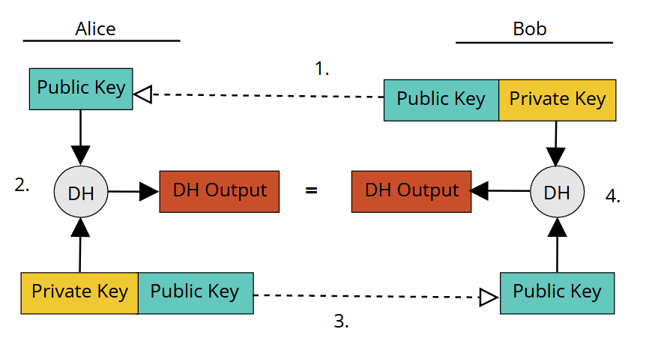

Key exchange between Alice and Bob

During the Diffie-Hellman key exchange between Alice and Bob, a ratchet happens in four steps:

1. Alice initializes using Bob’s public key.

2. Alice performs Diffie-Hellman calculations using her private key and Bob’s public key, which results in Diffie-Hellman output.

3. Alice sends a message to Bob and advertises her public key to him.

4. Bob performs Diffie-Hellman calculations using his private key and Alice’s public key extracted from the message. This results in Diffie-Hellman output value equivalent to the output value Alice calculated.

After this, Bob repeats the ratchet using Alice’s advertised public key to calculate Diffie-Hellman output using new pair of his public and private keys

In a Double Ratchet session between two users, each party stores a Key Derivation Function key for three chains: a root, a sending and a receiving chain. One party’s sending chain matches other’s receiving chain.

* **Criticality –** Essential
* **Technical issues**
* **Dependencies with other requirements**
* **Others as appropriate**

## Placeholder

* **Description**
* **Criticality** – Essential
* **Technical issues**
* **Dependencies with other requirements**
* **Others as appropriate**

# System Architecture

# High-Level Design

# Preliminary Schedule

# Appendices

## Sources

[1] Marlinspike, Moxie. “The X3DH Key Agreement Protocol.” Open Whisper Systems, 4 Nov. 2016, https://signal.org/docs/specifications/x3dh/. Accessed 5 Nov. 2024.

[2] Marlinspike, Moxie. “The Double Ratchet Algorithm.” Open Whisper Systems, 20 Nov. 2016, https://signal.org/docs/specifications/doubleratchet/. Accessed 5 Nov. 2024.