多视图切换

例子：

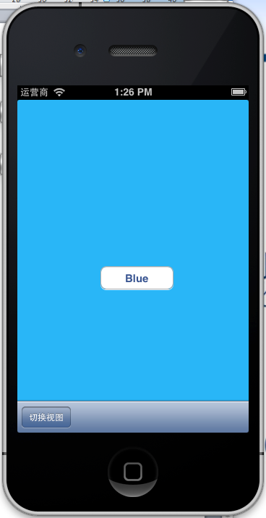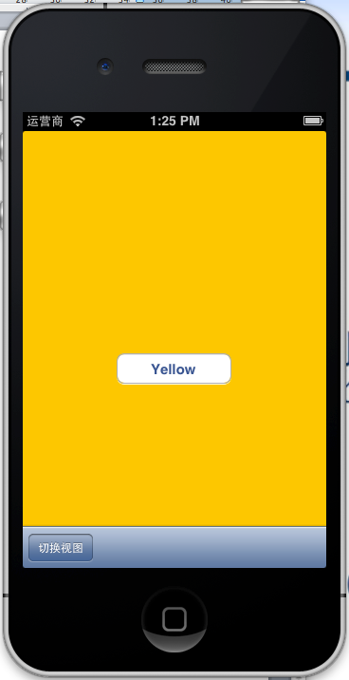  
通过切换视图按钮切换两个视图

在程序第一次载入的时候，在跟视图控制器里面的ViewDidLoad里面添加如下代码

BlueViewController \*blueCon=[[BlueViewController alloc] initWithNibName:@"BlueViewController" bundle:nil];

self.blueViewContorller=blueCon;

[blueCon release];

[self.view insertSubview:blueViewContorller.view atIndex:0];

首先加载蓝色视图

当点击切换视图都时候，

if(self.yellowViewContorller.view.superview==nil)

{

if(self.yellowViewContorller.view==nil)

{

YellowViewController \*YellowCon=[[YellowViewController alloc] initWithNibName:@"YellowViewController" bundle:nil];

self.yellowViewContorller=YellowCon;

[YellowCon release];

}

[self.blueViewContorller.view removeFromSuperview];

[self.view insertSubview:yellowViewContorller.view atIndex:0];

}

else

{

BlueViewController \*blueCon=[[BlueViewController alloc] initWithNibName:@"BlueViewController" bundle:nil];

self.blueViewContorller=blueCon;

[blueCon release];

//[self.view insertSubview:blueViewContorller.view atIndex:0];

[self.yellowViewContorller.view removeFromSuperview];

[self.view insertSubview:blueViewContorller.view atIndex:0];

}

这句：self. yellowViewContorller.view.superView==nil

这句代码为true都情况有2种，

第一：yellowViewContorller没有实例化。第二是yellowViewContorller已经创建，但是yellowViewContorller的视图没有添加到父视图里面去，

接下来判单当前的YellowViewContorller是否实例化，如果没有的话，可以通过

YellowViewController \*YellowCon=[[YellowViewController alloc] initWithNibName:@"YellowViewController" bundle:nil];实例化Contorller对象，

self.yellowViewContorller=YellowCon;//将实例化的Contorller对象赋值给当前跟控制器的所对应的Contorller成员变量

[YellowCon release];

}

//当我们获取到了当前的Contorller对象，可以通过Contorller.view获取当前视图

[self.blueViewContorller.view removeFromSuperview];

//通过[self.view inserSubview的方法，插入当前实例化的视图

[self.view insertSubview:yellowViewContorller.view atIndex:0];