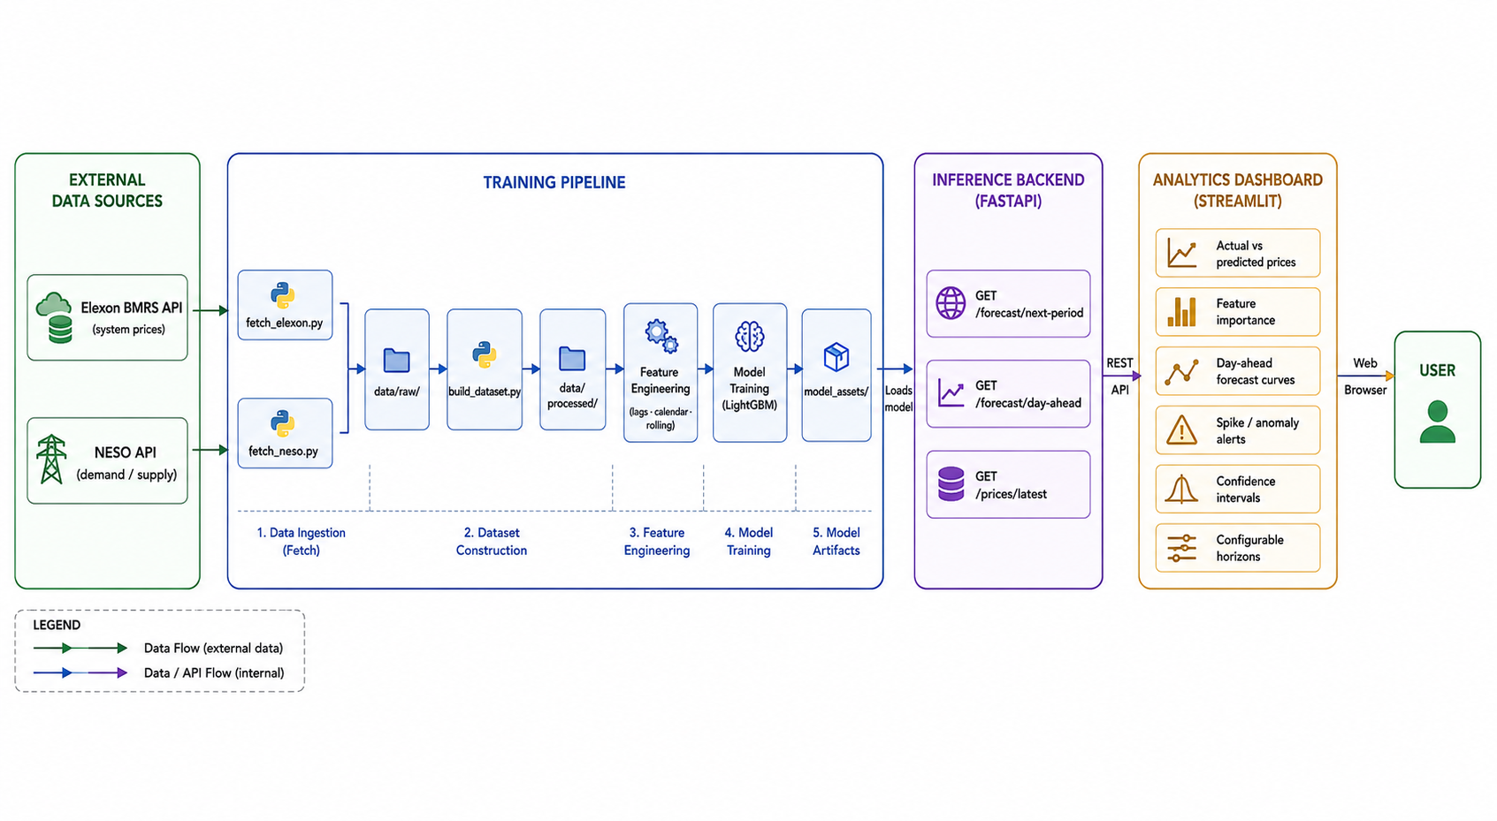
Project Brief: UK Electricity Price Forecasting Platform

Fig(1): Solution Architecture diagram
Advanced Analytics & Decision Support Tool

1. Executive Overview
This project delivers a high-fidelity forecasting and analytics platform designed to navigate the complexities of the UK electricity market. By integrating real-time data from Elexon (BMRS) and NESO, the platform transforms raw market signals into actionable insights, helping participants manage price volatility and optimize energy assets.
The Business Challenge
UK electricity prices can spike or crash within minutes due to shifts in weather, renewable output, and system demand. Without visibility into these "Settlement Period" (30-minute) price swings, traders and asset operators face significant financial risk, inefficient asset utilization, and eroded margins.

2. Strategic Business Value
Operational Impact
- Asset Optimization: Precisely time battery charge/discharge cycles.
- Risk Mitigation: Reduce exposure to expensive system imbalances.
- Strategic Trading: Support intraday and day-ahead market positioning.
Core Users
- Electricity Traders & Retailers
- Battery Storage Operators
- Flexibility & Demand-Side Teams

3. Solution Architecture
See Fig.(1) above.

4. Solution Capabilities (The Product)
The solution is more than a model; it is an end-to-end Decision Support System accessible via an interactive dashboard:
- Multi-Horizon Forecasting: Real-time views for the next 30 minutes, the next few hours, and upcoming day-ahead periods.
- Spike Intelligence: Advanced detection of price anomalies and extreme market events before they occur.
- Interpretable Analytics: Visual "Confidence Intervals" and "What-If" scenarios (e.g., “What happens if wind output drops by 20%?").
- Historical Backtesting: Evaluate performance against past market regimes to ensure reliability.

5. Delivery Roadmap
Phase 1: Minimum Viable Product (MVP)
Establishment of core data pipelines, the primary forecasting engine, and a functional Streamlit dashboard focusing on price explainability.
Phase 2: Enhanced Intelligence
Integration of dedicated anomaly detection models, weather API enhancements, and automated retraining schedules to maintain accuracy as market dynamics shift.

